Task 1:
What is an Actuator in Spring boot?
Spring Boot Actuator is a tool that helps you monitor and manage your application while it’s running.
It provides ready-made endpoints like:
- /health → to check if the app is working
- /metrics → to see performance
- /info → basic details
Actuator is like a health check dashboard for your Spring Boot app.

Task 2:
Advantages of Actuator

Advantages of Spring Boot Actuator
Easy monitoring : Check app health anytime
Ready-made endpoints : No need to build from scratch
Helps in debugging : Quickly find issues
Production support : Useful for live applications
Shows performance data : Like memory, CPU, requests

Actuator makes it easy to monitor, manage, and troubleshoot your application in real time.

Task 3:
What are the commonly used Actuator end points?

Commonly Used Actuator Endpoints
/actuator/health → Shows if the app is running
/actuator/info → Basic app details
/actuator/metrics → Performance data
/actuator/env → Environment properties
/actuator/beans → List of Spring beans

These endpoints help you check health, view info, monitor performance, and debug your app easily.

Task 4:
Create a Small demo of Actuator to know the functionality.

Add the dependency Spring Boot Actuator

package com.example.ActuatorDemo;

import org.springframework.boot.SpringApplication;
import org.springframework.boot.autoconfigure.SpringBootApplication;

@SpringBootApplication
public class ActuatorDemoApplication {

public static void main(String[] args) {
SpringApplication.run(ActuatorDemoApplication.class, args);
}

}

Task 5:
What is Spring Security Architecture?

Spring Security Architecture is the system that protects your app by checking:
Who you are (authentication)
What you can access (authorization)

It acts like a security layer that filters every request and allows or blocks it based on rules.

Task 6:
What are the core components of Spring security architecture?

Core Components of Spring Security
Security Filter Chain → Checks every request
Authentication Manager → Verifies user login
UserDetailsService → Loads user data
Password Encoder → Secures passwords
Authorization → Decides access (allow/deny)

These components work together to authenticate users and control access to your application.

Task 7:
Can you create a diagrammatic representation of Spring Security architecture?

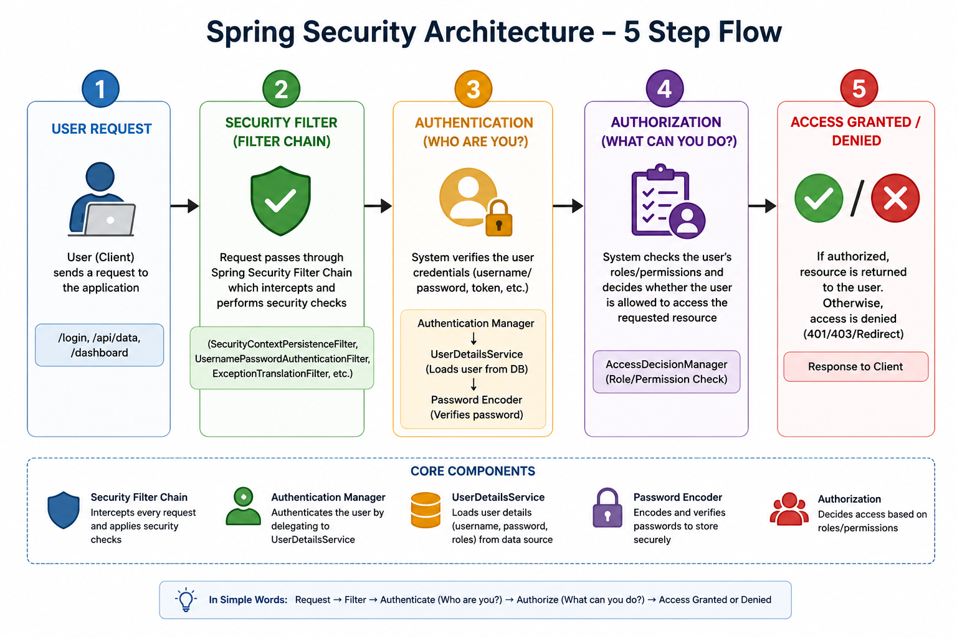

Task 8:
What is a Security filter chain? Give example code.

A Security Filter Chain is a series of filters in Spring Security that:
intercepts every request
checks authentication & authorization

Think of it like a security checkpoint line. Each filter checks something before letting the request go ahead.

We can just add a configuration file to the above actuator demo

package com.example.ActuatorDemo.config;

import org.springframework.context.annotation.Bean;
import org.springframework.context.annotation.Configuration;
import org.springframework.security.config.annotation.web.builders.HttpSecurity;
import org.springframework.security.web.SecurityFilterChain;
import org.springframework.security.config.Customizer;

@Configuration
public class SecurityConfig {

@Bean
public SecurityFilterChain securityFilterChain(HttpSecurity http) throws Exception {

http
.authorizeHttpRequests(auth -> auth
.requestMatchers("/actuator/health").permitAll()
.requestMatchers("/actuator/**").authenticated()
.anyRequest().authenticated()
)
.httpBasic(Customizer.withDefaults());;

return http.build();
}
}

/actuator/health → anyone can access
/actuator/info, /actuator/metrics or other APIs → need login

Task 9:
What is an Authentication Manager? Give example code

An Authentication Manager in Spring Security is the component that:
checks if a user’s credentials are correct or not

It takes username & password
Verifies them
Returns success (authenticated) or failure
Authentication Manager means the “login checker” of your application.

Modified the same code in SecurityConfig.java above

package com.example.ActuatorDemo.config;

import org.springframework.context.annotation.Bean;
import org.springframework.context.annotation.Configuration;
import org.springframework.security.authentication.AuthenticationManager;
import org.springframework.security.config.Customizer;
import org.springframework.security.config.annotation.authentication.configuration.AuthenticationConfiguration;
import org.springframework.security.config.annotation.web.builders.HttpSecurity;
import org.springframework.security.core.userdetails.*;
import org.springframework.security.provisioning.InMemoryUserDetailsManager;
import org.springframework.security.web.SecurityFilterChain;

@Configuration
public class SecurityConfig {

// ✅ Authentication Manager
@Bean
public AuthenticationManager authenticationManager(AuthenticationConfiguration config) throws Exception {
return config.getAuthenticationManager();
}

// ✅ User (for login)
@Bean
public UserDetailsService userDetailsService() {
UserDetails user = User
.withUsername("admin")
.password("{noop}password") // no encoding for demo
.roles("USER")
.build();

return new InMemoryUserDetailsManager(user);
}

// ✅ Security Filter Chain
@Bean
public SecurityFilterChain securityFilterChain(HttpSecurity http) throws Exception {

http
.authorizeHttpRequests(auth -> auth
.requestMatchers("/actuator/health").permitAll()
.requestMatchers("/actuator/**").authenticated()
.anyRequest().authenticated()
)
.httpBasic(Customizer.withDefaults()); // basic login popup

return http.build();
}
}

Task 10:
What are Authentication Providers? Give example and code

An Authentication Provider in Spring Security is a component that actually verifies the user’s credentials.

While:

AuthenticationManager = manages authentication
AuthenticationProvider = does the real checking

Types of Authentication Providers - Common ones:

DaoAuthenticationProvider → uses database / UserDetailsService
InMemoryAuthenticationProvider → in-memory users
JwtAuthenticationProvider → for JWT tokens
Custom provider → your own logic

Added this in above code
AuthProviderConfig.java
package com.example.ActuatorDemo.config;

import org.springframework.context.annotation.Bean;
import org.springframework.context.annotation.Configuration;

import org.springframework.security.authentication.dao.DaoAuthenticationProvider;
import org.springframework.security.core.userdetails.UserDetailsService;

import org.springframework.security.crypto.password.PasswordEncoder;
import org.springframework.security.crypto.factory.PasswordEncoderFactories;

@Configuration
public class AuthProviderConfig {

// ✅ Password Encoder
@Bean
public PasswordEncoder passwordEncoder() {
return PasswordEncoderFactories.createDelegatingPasswordEncoder();
}

// ✅ FIXED: Constructor injection
@Bean
public DaoAuthenticationProvider authenticationProvider(
UserDetailsService userDetailsService,
PasswordEncoder passwordEncoder) {

DaoAuthenticationProvider provider =
new DaoAuthenticationProvider(userDetailsService); // ✅ FIX

provider.setPasswordEncoder(passwordEncoder);

return provider;
}
}

Task 11:
What is USerDeatilsService? Give example

UserDetailsService is an interface in Spring Security used to:
Load user data (username, password, roles)
Help authenticate users during login

It tells Spring Security where to get user details from (memory, database, etc.)

UserDetailsService is used to fetch user information for authentication.

package com.example.ActuatorDemo.service;

import org.springframework.security.core.userdetails.*;
import org.springframework.stereotype.Service;

@Service
public class CustomUserDetailsService implements UserDetailsService {

@Override
public UserDetails loadUserByUsername(String username)
throws UsernameNotFoundException {

if ("admin".equals(username)) {
return User.withUsername("admin")
.password("{noop}password")
.roles("USER")
.build();
}

throw new UsernameNotFoundException("User not found");
}
}

Task 12:
What is a password encoder? Give example

A Password Encoder in Spring Security is used to:

Convert plain passwords into a secure (encoded/hashed) format
Compare entered password with stored password during login

Password Encoder is used to securely store and verify passwords.

Example Code Password Encoder Bean:
import org.springframework.context.annotation.Bean;
import org.springframework.security.crypto.password.PasswordEncoder;
import org.springframework.security.crypto.factory.PasswordEncoderFactories;

@Bean
public PasswordEncoder passwordEncoder() {
return PasswordEncoderFactories.createDelegatingPasswordEncoder();
}

Task 13:
What is SecurityContextHolderr?

It is used to:

Store details of the currently logged-in user
Provide authentication info anywhere in the application

So SecurityContextHolder stores the current user's authentication details.

Task 14:
Finally give the security Architecture internal functionality? How actually it works internally… step by step if you can explain

Spring Security works using a filter chain that intercepts requests, authenticates users via AuthenticationManager and AuthenticationProvider, fetches user details using UserDetailsService, verifies password using PasswordEncoder, stores user in SecurityContextHolder, and then performs authorization before allowing access.

Think of it like a security gate:

Request
↓
Security Filter Chain
↓
AuthenticationManager
↓
AuthenticationProvider
↓
UserDetailsService
↓
PasswordEncoder
↓
SecurityContextHolder (store user)
↓
Authorization Check
↓
Controller

Task 15:
What is Thymeleaf? Explain? Why is it used?

Thymeleaf is a server-side template engine used in Spring Boot to create dynamic web pages.

It allows you to write normal HTML and add dynamic data using special attributes like:

<p th:text="${name}"></p>

Thymeleaf is a template engine used to generate dynamic HTML pages in Spring Boot.

Why is Thymeleaf used?

1. Dynamic HTML
Displays data from backend in UI
2. Easy to learn
Looks like normal HTML
No complex syntax
3. Tight integration with Spring Boot
Works seamlessly with controllers

Task 16:
Create a demo on thymeleaf .

HomeController.java
package com.example.ThymeLeafDemo.controller;

import org.springframework.stereotype.Controller;
import org.springframework.ui.Model;
import org.springframework.web.bind.annotation.GetMapping;

@Controller
public class HomeController {

@GetMapping("/home")
public String home(Model model) {

model.addAttribute("name", "John");

return "home";
}
}

home.html
<!DOCTYPE html>
<html xmlns:th="http://www.thymeleaf.org">
<head>
<title>Thymeleaf Demo</title>
</head>
<body>

<h1>Hello!</h1>

<p th:text="${name}"></p>

</body>
</html>

Task 17:
What do you think are the advantages of using thymeleaf?

Advantages of Thymeleaf

Thymeleaf is popular because it is simple and works smoothly with Spring Boot.
Key Advantages
1. Easy to Learn
Looks like normal HTML
No complex syntax

2. Natural Templates

You can open the HTML file directly in a browser
It still looks correct even without backend

3. Tight Spring Boot Integration

Works perfectly with controllers and models
No extra configuration needed

Task 18:
What is Caching in Springboot?

Caching in Spring Boot means storing frequently used data temporarily so it can be retrieved faster next time without recalculating or fetching again.

Caching is a technique used to store data in memory to improve performance and reduce repeated processing.

Task 19:
What are the features of caching in SpringBoot?

Features of Caching in Spring Boot

In Spring Boot, caching provides several useful features to improve performance.

Key Features
1. Annotation-Based Caching
Easy to use with annotations like:
@Cacheable
@CachePut
@CacheEvict

2. Automatic Cache Management

Spring handles storing and retrieving data automatically
No need to write manual cache logic

3. Multiple Cache Providers Support

Works with:

Simple in-memory cache
EhCache
Redis

Task 20:
What are the types of Caching ?explain each type

Types of Caching in Spring Boot

In Spring Boot, main caching types are:

1. In-Memory Cache

Stored in application RAM
Fast but lost when app stops

2. Distributed Cache

Stored in external systems (like Redis)
Shared across multiple servers

3. Persistent Cache

Stored on disk
Data survives restart
Slower

4. Browser (HTTP) Cache
Stored in user’s browser
Reduces server requests

Task 21:
List down annotations of Caching with usage
Caching Annotations in Spring Boot

In Spring Boot, caching is mainly done using these annotations:

1. @EnableCaching

Enables caching in the application

@EnableCaching
@SpringBootApplication

2. @Cacheable

Stores result in cache (used for read operations)

@Cacheable("users")
public String getUser() {
return "John";
}

3. @CachePut

Updates cache every time method is called

@CachePut("users")
public String updateUser() {
return "John Updated";
}
4. @CacheEvict

Removes data from cache

@CacheEvict(value = "users", allEntries = true)
public void deleteUsers() {}

5. @Caching

Used to combine multiple cache operations

@Caching(
evict = { @CacheEvict("users") },
put = { @CachePut("users") }
)

Task 22:

What do you think @InjectMocks annotation does?

In Mockito, @InjectMocks is used to create an object and automatically inject its dependencies (mocks).

Instead of manually doing this:

BankService service = new BankService(mockRepo);

Mockito does it for you using:

@InjectMocks
BankService service;

Task 23:
Write about @spy annotation and explain the functionality in a small piece of code.

@Spy is used to create a partial mock.
It means:
Real object is created
Real methods are called by default
But you can mock specific methods if needed
So,
@Mock → completely fake
@Spy → real + override some behavior

Task 24:
Why is @Mock annotation used?

@Mock is used to create a fake (mock) object of a class.

Why we use it?

✔ To avoid calling real database/API
✔ To isolate the class under test
✔ To control method behavior

Example
@Mock
BankRepository repo;

Instead of real DB call:

when(repo.findById(1)).thenReturn(new BankAccount());

Task 25:
What is Partial mocking? Which annotation is used for partial mocking?
Partial mocking = Real object + Mocked methods

Meaning:
Some methods → REAL
Some methods → FAKE
Annotation Used:
@Spy

Task 26:
For the code given what is @verify annotation used for and why do we use it?
verify() is used to check whether a method was called or not

Why do we use it?

✔ Ensure correct interaction
✔ Validate behavior
✔ Check method call count

Task 27:
List down a few more annotations that we use for mocking ..

1. @InjectMocks

Injects mocks into the class being tested

@InjectMocks
BankService service;

2. @Spy

Partial mocking (real + mock)

3. @Captor

Captures arguments passed to methods

@Captor
ArgumentCaptor<BankAccount> captor;

