Task 1:

Can you create a Maven based spring project using ide.. To print a welcome..note

- Create Maven Project
- Configure Project
- Add Spring Dependency
- Create Java Class

package com.example;

public class Welcome {
public void showMessage() {
System.out.println("Welcome to Spring Project!");
}
}

5.Create Spring Config File
<beans xmlns="http://www.springframework.org/schema/beans"
xmlns:xsi="http://www.w3.org/2001/XMLSchema-instance"
xsi:schemaLocation="
http://www.springframework.org/schema/beans
http://www.springframework.org/schema/beans/spring-beans.xsd">

<bean id="welcomeBean" class="com.example.Welcome"/>
</beans>

6. Create Main Class
package com.example;

import org.springframework.context.ApplicationContext;
import org.springframework.context.support.ClassPathXmlApplicationContext;

public class MainApp {
public static void main(String[] args) {
ApplicationContext context =
new ClassPathXmlApplicationContext("applicationContext.xml");

Welcome obj = (Welcome) context.getBean("welcomeBean");
obj.showMessage();
}
}

7. Run it.

Task 2:

Now create a POJO class for student so that can be managed as a spring bean.

Student class
package com.example;

public class Student {

private int id;
private String name;

// Default constructor
public Student() {}

// Parameterized constructor
public Student(int id, String name) {
this.id = id;
this.name = name;
}

// Getter and Setter methods
public int getId() {
return id;
}

public void setId(int id) {
this.id = id;
}

public String getName() {
return name;
}

public void setName(String name) {
this.name = name;
}

// Display method
public void display() {
System.out.println("ID: " + id + ", Name: " + name);
}
}

applicationContext.xml

<beans xmlns="http://www.springframework.org/schema/beans"
xmlns:xsi="http://www.w3.org/2001/XMLSchema-instance"
xsi:schemaLocation="
http://www.springframework.org/schema/beans
http://www.springframework.org/schema/beans/spring-beans.xsd">

<bean id="welcomeBean" class="com.example.Welcome"/>
<bean id="studentBean" class="com.example.Student">
<property name="id" value="101"/>
<property name="name" value="John"/>
</bean>
</beans>

MainApp.java

package com.example;

import org.springframework.context.ApplicationContext;
import org.springframework.context.support.ClassPathXmlApplicationContext;

public class MainApp {
public static void main(String[] args) {
ApplicationContext context =
new ClassPathXmlApplicationContext("applicationContext.xml");

Welcome obj = (Welcome) context.getBean("welcomeBean");
obj.showMessage();

Student student = (Student) context.getBean("studentBean");
student.display();
}
}

Task 3:
Configure the above Student bean in the bean-factory-demo.xml file.
That means you need to configure the Student bean in the XML file so the BeanFactory knows how to create it.
And create a main class and run it.. A pictorial rep of the scenario is given below

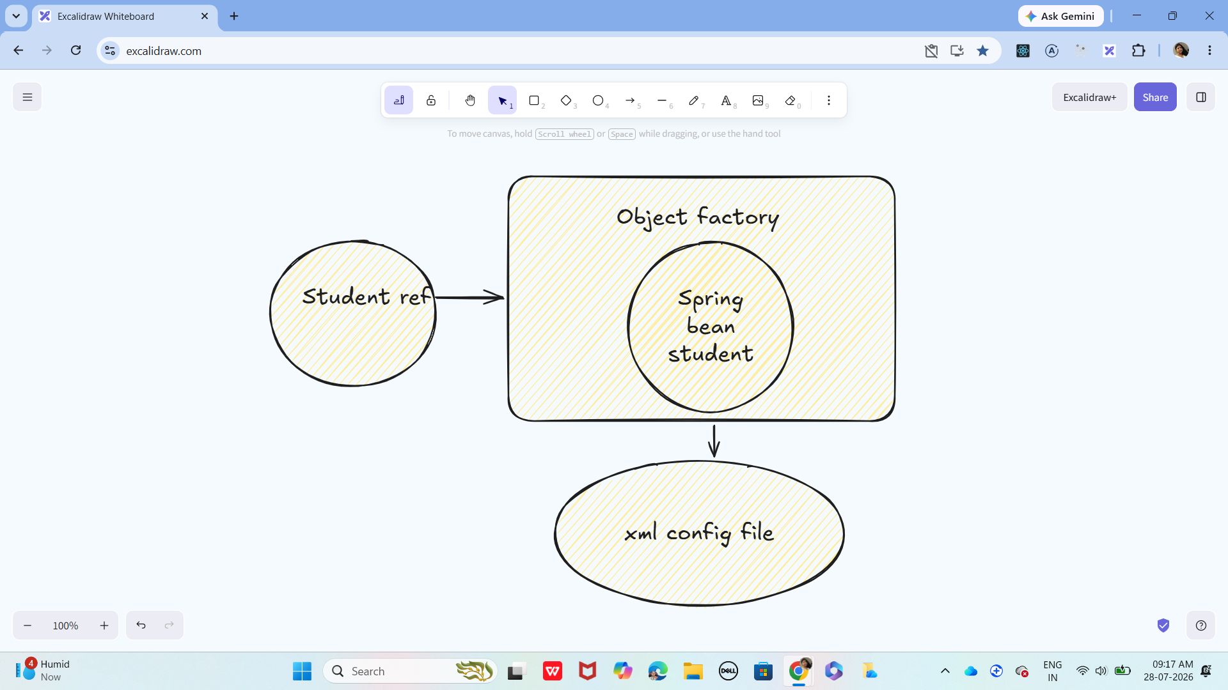

Student class:
package com.example;

public class Student {

private int id;
private String name;

// Default constructor
public Student() {}

// Getters and Setters
public int getId() {
return id;
}

public void setId(int id) {
this.id = id;
}

public String getName() {
return name;
}

public void setName(String name) {
this.name = name;
}

public void display() {
System.out.println("Student ID: " + id);
System.out.println("Student Name: " + name);
}
}

bean-factory-demo.xml

<?xml version="1.0" encoding="UTF-8"?>

<beans xmlns="http://www.springframework.org/schema/beans"
xmlns:xsi="http://www.w3.org/2001/XMLSchema-instance"
xsi:schemaLocation="
http://www.springframework.org/schema/beans
http://www.springframework.org/schema/beans/spring-beans.xsd">

<!-- Student Bean Configuration -->
<bean id="studentBean" class="com.example.Student">
<property name="id" value="101"/>
<property name="name" value="Alice"/>
</bean>

</beans>

MainApp.java

package com.example;

import org.springframework.beans.factory.BeanFactory;
import org.springframework.core.io.ClassPathResource;
import org.springframework.beans.factory.xml.XmlBeanFactory;

public class MainApp {
public static void main(String[] args) {

// Load XML file
ClassPathResource resource =
new ClassPathResource("bean-factory-demo.xml");

// Create BeanFactory
BeanFactory factory = new XmlBeanFactory(resource);

// Get Bean
Student student = (Student) factory.getBean("studentBean");

// Call method
student.display();
}
}

Task 4:
Can you explain application context with the syntax..

ApplicationContext is a Spring container used to create, configure, and manage objects known as beans. It reads the configuration file (XML or annotations) and automatically creates all the required beans at the start of the application.
It is more advanced than BeanFactory because it provides extra features like event handling and automatic initialization of beans.
Syntax:
ApplicationContext context =
new ClassPathXmlApplicationContext("applicationContext.xml");

Student student = (Student) context.getBean("studentBean");

Task 5:
Why use application context .. plz list some uses?
- It creates and manages beans automatically
- It loads configuration files (XML or annotations)
- It provides dependency injection
- It allows easy access to objects using getBean()
So in short, ApplicationContext is used to manage and configure beans, provide dependency injection and allow easy access to those objects.

Task 6:

What are features of Spring Framework .. list them with 1 or 2 lines explanation?
- DI - Dependency injection
It helps us to loosely couple classes by autowiring dependencies.
- AOP - Aspect Oriented Programming
It helps us to separate cross cutting concerns like logging, security, transactions from business logic through AOP
- IoC - Inversion of Control
Framework manages object creation and lifecycle, so it shifts the control from the developer to framework.
- Integration
Plays well with Hibernate, JPA, JMS, REST APIs, and modern cloud tools.

Task 7:

Why do you think we use spring framework.. Advantages list them down?

1)Reduces Code
Spring reduces boilerplate code using dependency injection.
2)Loose Coupling
Classes are not tightly dependent on each other, making code flexible.
3)Easy to Test
Supports unit testing and makes testing easier.
4)Lightweight
It is not heavy and can be used easily in small applications.
5)Good Integration
Easily works with other frameworks like Hibernate, JDBC, etc.

Task 8:
What do you understand by IoC? Explain with a diagram..

IoC (Inversion of Control) means that the control of object creation and management is transferred from the programmer to the Spring framework.
In normal Java programs, the developer is responsible for creating and managing objects. But in Spring, using features like Dependency Injection, the framework handles object creation and its lifecycle.
So, the control is inverted from the developer to the framework.
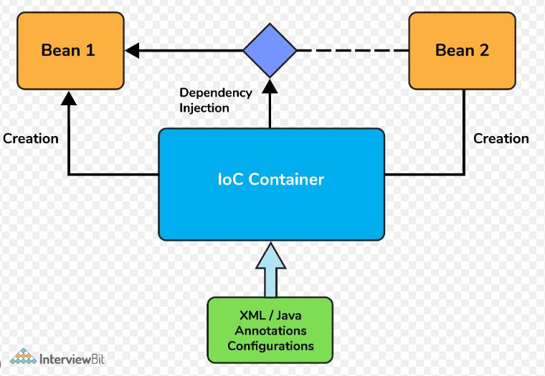

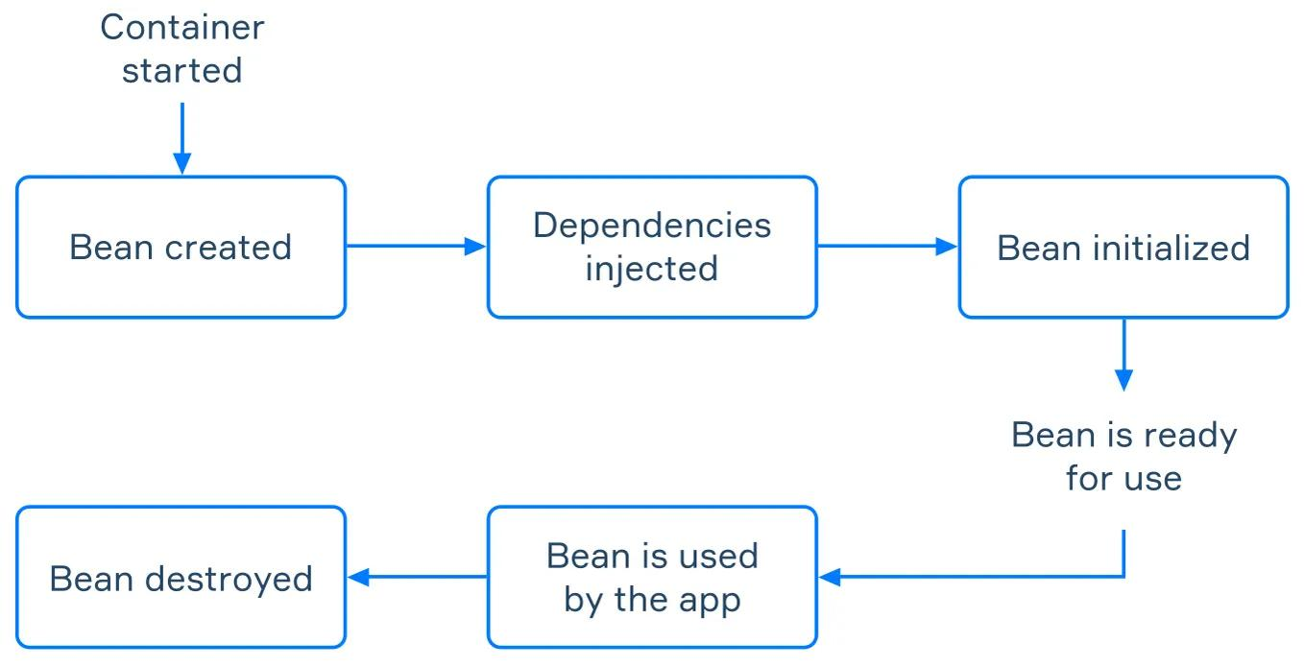

Task 9:
How many types of IOC do you have in spring?
What are they with explanation

In Spring, IoC is mainly achieved using Dependency Injection, which has 2 types:
Constructor Injection
- Dependencies are provided through the constructor of the class.
- The container calls the constructor and passes required values while creating the object.
Used when dependencies are mandatory.
Setter Injection
- Dependencies are provided using setter methods.
- The container first creates the object, then sets values using setters.
Used when dependencies are optional or can be changed later.

Task 10:

What is DI in spring?
Dependency Injection (DI) is a concept in Spring where the Spring container provides the required objects (dependencies) to a class instead of the class creating them itself. It is a technique where the container injects dependencies into a class instead of the class creating them.

Task 11:
How many types of DI do we have?
Explain

In Spring, IoC is mainly achieved using Dependency Injection, which has 2 types:
Constructor Injection
- Dependencies are provided through the constructor of the class.
- The container calls the constructor and passes required values while creating the object.
Used when dependencies are mandatory.
Setter Injection
- Dependencies are provided using setter methods.
- The container first creates the object, then sets values using setters.
Used when dependencies are optional or can be changed later.

Task 12:
What is Spring Application Configuration?

Spring Application Configuration is the process of telling the Spring framework which objects (beans) to create and how to connect them. It acts like a set of instructions (usually in XML, Java, or annotations) so Spring can manage your application automatically without you writing all the object-creation code yourself.

Task 13:
What are the different ways to configure spring applications?

Spring applications can be configured in three main ways:
- XML-based configuration – using XML files like beans.xml to define beans and dependencies.
- Java-based configuration – using Java classes with @Configuration and @Bean annotations.
- Annotation-based configuration – using annotations like @Component, @Autowired for automatic setup.
These methods help Spring manage objects and their relationships easily.

Task 14:
Why do we need spring application configuration?

We need Spring Application Configuration to tell Spring how to create and manage objects in an application. It helps reduce manual coding, makes the code cleaner, and allows easy changes without modifying the main program.
In simple terms, it makes application development easier and more flexible.

Task 16:
What is bean scope .. give different scopes with description

Bean Scope in Spring defines how many instances of a bean are created and how long they live in the application.
Different types of bean scopes:
- Singleton (default) – Only one object is created for the entire Spring container.
- Prototype – A new object is created every time the bean is requested.
- Request – One object is created per HTTP request (used in web apps).
- Session – One object is created per user session.
- Application – One object is created for the whole web application.
In simple words, bean scope controls the lifecycle and number of objects created by Spring.

Task 17:
What is autowiring in spring?

Autowiring in Spring is a feature that automatically connects (injects) dependent objects into a class without manually configuring them.
Instead of creating and linking objects yourself, Spring does it for you.
In simple words: Autowiring helps reduce boilerplate code by letting Spring handle object dependency automatically.

Task 18:
What are diff ways of autowiring?

Autowiring in Spring is a feature that automatically injects required dependencies into a bean. It reduces manual configuration. The main types are by type, by name, constructor-based, setter-based, and using @Qualifier when multiple beans exist.

Task 19:
What is the difference between a normal java object and Spring bean?

A normal Java object is created using the new keyword, and its lifecycle (creation, destruction, dependencies) is fully managed by the developer.
A Spring Bean, on the other hand, is an object that is created, configured, and managed by the Spring container. Spring takes care of things like dependency injection, lifecycle management, and configuration automatically. In simple terms:
A normal object is managed by you, while a Spring bean is managed by Spring.

Task 20:
What is diff between @ component and @ bean

@Component vs @Bean in Spring:
- @Component is used to automatically detect and create beans by Spring during component scanning. You place it directly on the class.
- @Bean is used to manually define a bean inside a configuration class using a method.
- In simple words:
@Component = Spring creates the object automatically
@Bean = You tell Spring how to create the object manually

Task 21:
A different way to create an application using
https://start.spring.io/ try it .. and let me know what is it?

https://start.spring.io/ is a website used to quickly create a Spring Boot project.
It allows us to select dependencies (like Web, JPA, etc.), choose project details, and then download a ready-made project structure. In simple words:
It is an online tool that helps you generate a Spring Boot application without setting everything manually.

Task 23:
We have spring annotations:
Like
@bean
@controller
@value
@conponentScan
@configuration
@service
@repository
@Qualifier
@required
@component
@autowired
@scope

Can you give a liner about these
@Bean – Used to manually create a bean inside a configuration class.
@Controller – Marks a class as a web controller to handle HTTP requests.
@Value – Injects values (like properties or constants) into variables.
@ComponentScan – Tells Spring where to scan for components (classes).
@Configuration – Marks a class as a source of bean definitions.
@Service – Indicates a service class that contains business logic.
@Repository – Used for database access layer (DAO) classes.
@Qualifier – Specifies which bean to use when multiple beans exist.
@Required – Ensures a property must be set (otherwise error).
@Component – Marks a class as a Spring-managed bean.
@Autowired – Automatically injects dependencies.
@Scope – Defines the scope of a bean (singleton, prototype, etc.).

Task 24:

What are the features of springboot?

Features of Spring Boot:
- Auto-configuration – Automatically configures the application based on dependencies.
- Standalone – Can run applications without external servers.
- Embedded servers – Comes with built-in servers like Tomcat.
- Starter dependencies – Simplifies dependency management.
- No XML configuration – Uses annotations instead of XML.
- Production-ready – Provides features like monitoring and metrics.
- Easy setup – Quick project creation using Spring Initializer.
In simple words, Spring Boot makes it faster and easier to build and run Spring applications with minimal configuration.

Task 25:
What are the advantages of Spring boot?
Advantages of Spring Boot:
- Reduces development time – Less configuration and quick setup
- Easy to use – Simple and beginner-friendly
- No XML required – Uses annotations
- Embedded server – No need to install external servers
- Auto-configuration – Automatically sets up the application
- Production-ready features – Includes monitoring and health checks
- Microservices support – Easy to build scalable applications
In simple words:
Spring Boot makes development faster, easier, and more efficient with minimal effort.

Task 26:
What are the key components of Spring boot?

Key components of Spring Boot:
- Spring Boot Starters – Predefined dependencies to simplify setup
- Auto-Configuration – Automatically configures the application
- Spring Boot CLI – Command-line tool to run Spring apps quickly
- Actuator – Provides monitoring and management features
- Embedded Server – Built-in servers like Tomcat or Jetty
- Spring Initializer – Tool to create Spring Boot projects easily

Task 27:
Why spring boot over spring?

Spring Boot is preferred over Spring because it reduces configuration and makes development faster and easier. It provides auto-configuration, embedded servers, and ready-to-use setups, whereas Spring requires more manual configuration.

Task 28:
Can you explain the internal working of spring boot?

When a Spring Boot application starts, the main method calls SpringApplication.run(), which starts the Spring container. It performs auto-configuration based on the dependencies present, scans components using annotations, creates and manages beans, and starts an embedded server (like Tomcat). Finally, it runs the application and makes it ready to handle requests.

Task 29:
List out the starter dependencies for spring boot,

- spring-boot-starter-web – For building web applications (REST APIs)
- spring-boot-starter-data-jpa – For database access using JPA
- spring-boot-starter-jdbc – For JDBC-based database operations
- spring-boot-starter-security – For authentication and security
- spring-boot-starter-test – For testing applications
- spring-boot-starter-thymeleaf – For building web UI using Thymeleaf
- spring-boot-starter-actuator – For monitoring and management

Task 30:
import org.springframework.boot.SpringApplication;
import org.springframework.boot.autoconfigure.SpringBootApplication;
@SpringBootApplication
public class MyApplication
{
public static void main(String[] args) {
SpringApplication.run(MyApplication.class, args);
}
}
In this above code ..
What is the internal working of above code ..
Give the step by step explanation

Main method starts execution
1.Java starts running from:
main(String[] args)

2. SpringApplication.run() is called
This is the entry point of Spring Boot
SpringApplication.run(MyApplication.class, args);

3. Spring Boot starts the container
It creates and starts the Spring Application Context (container)

4. @SpringBootApplication is processed
This annotation is a combination of:
- @Configuration → defines beans
- @EnableAutoConfiguration → auto setup
- @ComponentScan → scans classes

5. Auto-Configuration happens
Spring Boot checks:
- Which dependencies are present
- Automatically configures required settings

6. Component Scanning
Spring scans the package:
- Finds classes with @Component, @Service, @Controller, etc.
- Creates objects (beans)

7. Beans are created & dependencies injected
Spring:
- Creates objects
- Injects dependencies using @Autowired

8. Embedded server starts
Spring Boot starts internal server like:
- Tomcat (default)

9. Application is ready
Now your app is:
- Running
- Ready to handle requests

Task 31:
What is the syntax to change the port of the embedded Tomcat server in Spring Boot?

Syntax to change the port of embedded Tomcat in Spring Boot:
In application.properties file:
server.port=9090
Alternative (command line):
java -jar app.jar --server.port=9090
We can change the default port (8080) by setting server.port in properties or passing it while running the application.

