Task 1:

What is an ER diagram? Draw an entity relationship diagram with datatypes .

An ER (Entity-Relationship) Diagram is a visual representation of a database structure.
It shows:
Entities (tables)
Attributes (columns)
Relationships (connections between tables)

Key Components:
Component Meaning
Entity Real-world object (e.g., Customer, Account)
Attribute Properties of entity (e.g., name, balance)
Primary Key Unique identifier
Relationship Connection between entities

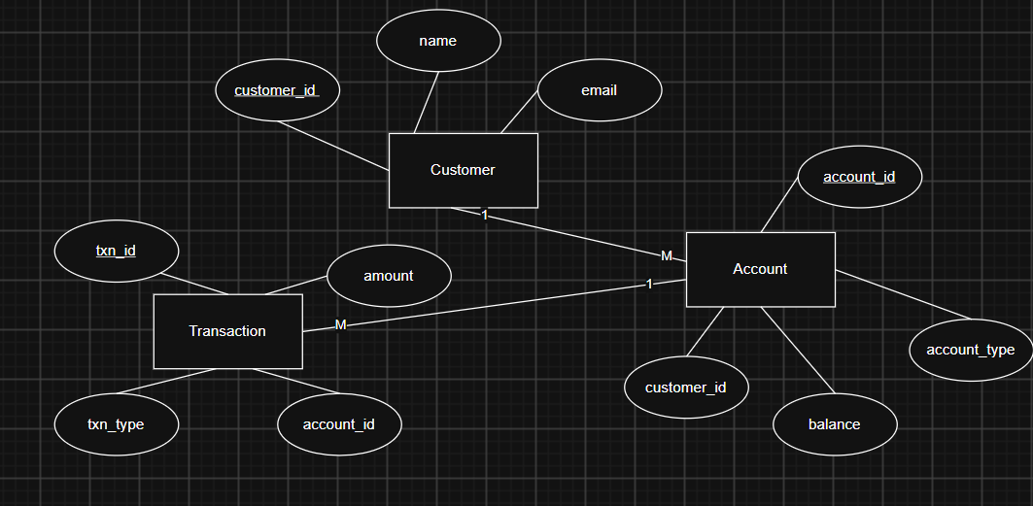

Task 2:

What do you understand by indexing in DBMS? How does it work?

Indexing is a technique used to speed up data retrieval in a database.

It works like an index in a book:

Instead of scanning the whole table
DBMS directly jumps to the required data

How It Works

Without Index:

SELECT * FROM Account WHERE account_id = 101;
→ DB scans entire table (slow)

With Index:

Index created on account_id
→ DB directly finds the record (fast)

🔹 Example
CREATE INDEX idx_account_id
ON Account(account_id);

Task 3:

Do you think Indexing strategy improves the query performance ? explain .

Yes, indexing significantly improves query performance.

Why Indexing Improves Performance?

Indexing works like a book index
Instead of scanning the whole table, the DBMS:

Uses the index
Directly locates required data
Example:

Without Index:
SELECT * FROM Account WHERE account_id = 101;
DB scans entire table (Full Table Scan)
Slow for large data

With Index:
CREATE INDEX idx_acc ON Account(account_id);
DB uses index (like shortcut)

Task 4:

What are the ACID properties in RDBMS? Explain.

ACID properties ensure reliable and safe database transactions

1. Atomicity (All or Nothing)

A transaction either:

Fully completes, or
Fully fails
Example:
Transfer ₹100 from A → B
If money deducted from A but not added to B
→ Transaction is rolled back

2. Consistency

Database must remain in a valid state

Example:
Balance cannot become negative (if rule exists)
Constraints (PK, FK) must be maintained

3. Isolation

Transactions run independently

Example:
Two users updating same account
One transaction should not see incomplete data of another

4. Durability

Once transaction is committed:
Data is permanently stored

Example:
Even if system crashes
Data remains saved

Create a database;

Create database BankDB;

Create table

Create table Account {
Id Serial,
custName varchar(10)
};

Insert values to your table

insert into Accounts values (101, 'Prasunamba');
insert into Accounts values (102, 'Mehr');
insert into Accounts values (103, 'K');

Query the details of your table

select * from Accounts;

Drop the table

Drop table Accounts;

Delete all records in a table

Truncate table Accounts;

-- table with a primary key
create table Customer(
id int primary key,
name varchar(20),
age int
);

insert into Customer values (101,'Rama',50);
insert into Customer values (102,'Sita',45);
insert into Customer values (103,'Lakshman',48);

insert into customer values (101, 'Ravan', 55);
Gives an error

ERROR: duplicate key value violates unique constraint "customer_pkey"
Key (id)=(101) already exists.

-- this will begin the transaction.. if there is no error it will commit all the trans ..
-- if error -- rollsback all the trans
begin;
insert into Customer values (104,'Urmila',20);
insert into Customer values (105,'Raghava',45);
insert into Customer values (101,'Lakshman',48); // error..
commit;
rollback;
insert into customer values (101, 'Ravan', 55);

select * from Customer;

101 "Rama" 50
102 "Sita" 45
103 "Lakshman" 48

Only 3 records due to error.

Task 5:

Alter a table to add a column with unique key

For existing attribute:
ALTER TABLE Accounts
ADD UNIQUE (acc_no);

INSERT INTO Accounts VALUES (105, 'Ram', 10400); this produces an error

ERROR: duplicate key value violates unique constraint "accounts_acc_no_key"
Key (acc_no)=(10400) already exists.

For new attribute:
ALTER TABLE Accounts
ADD COLUMN phone_no INT UNIQUE;

Yes, acc_no can be NULL even with UNIQUE constraint
Because PostgreSQL allows multiple NULLs in UNIQUE columns
To prevent NULLs, we must add a NOT NULL constraint

Task 6:
Add a check constraint to your column (eg: balance > 0)

ALTER TABLE Accounts
ADD COLUMN balance NUMERIC CHECK (balance > 0);
Here they give the constraint a default name accounts_balance_check

We can find the default name by
SELECT conname
FROM pg_constraint
WHERE conrelid = 'accounts'::regclass;
Now drop the constraint:
ALTER TABLE Accounts
DROP CONSTRAINT accounts_balance_check;

Now add new constraint:
Alter table Accounts
ADD constraint acc_balance CHECK (balance>=0);

Task 7:
use where clause and check if it works.

UPDATE Accounts
SET balance=0 WHERE id=102;

SELECT * from Accounts
where id=103;

Task 8:
Use order by.

SELECT * FROM Accounts
order by custName;

SELECT * FROM Accounts
order by custName DESC;

Task 9:
use limit.

SELECT * FROM Accounts limit 3;

Shows 3 records

Task 10:
Create queries for:
left outer join
Right outer join
Inner join
Cross join
Outer join
and full outer join..(use union and try)
Basically all the joins to see its functionality..

1) select * from frontend_developers, backend_developers;
It is same as:
SELECT * FROM frontend_developers CROSS JOIN backend_developers;

2)SELECT * FROM frontend_developers, backend_developers
WHERE frontend_developers.project_id = backend_developers.project_id;

It is same as:
SELECT * FROM frontend_developers f INNER JOIN backend_developers b
ON f.project_id = b.project_id;

3)SELECT * FROM frontend_developers f LEFT OUTER JOIN backend_developers b
ON f.project_id = b.project_id;

LEFT OUTER JOIN returns all records from the left table and matching records from the right table
If no match exists, NULL values are returned for the right table.

4)SELECT * FROM frontend_developers f RIGHT OUTER JOIN backend_developers b
ON f.project_id = b.project_id;

5) OUTER JOIN
You must specify which type of OUTER JOIN:

You must use:
- LEFT OUTER JOIN
- RIGHT OUTER JOIN
- FULL OUTER JOIN
SELECT * FROM frontend_developers f FULL OUTER JOIN backend_developers b
ON f.project_id = b.project_id;

6) UNION
UNION is used to combine results of two queries (vertically)

JOIN → combines columns (horizontal)
UNION → combines rows (vertical)

SELECT * FROM frontend_developers UNION SELECT * FROM backend_developers;

SELECT * FROM frontend_developers UNION ALL SELECT * FROM backend_developers;

NOTE:
NO difference at all between
LEFT JOIN and LEFT OUTER JOIN

Explanation:
These two are exactly the same:
OUTER is just optional keyword
SQL allows you to write it for clarity

Task 11:

Try playing with indexes on your table.. And see the performance
sample:
-- Create a simple B-tree index
CREATE INDEX idx_custname
ON accounts (custname);
Speeds up queries like:
SELECT * FROM accounts WHERE custname = 'Anna';

-- Create a unique index
Ensures no duplicate account numbers

CREATE UNIQUE INDEX idx_acc_no_unique
ON accounts (acc_no);
Prevents:
INSERT INTO accounts VALUES (105, 'John', 10100, 500);
duplicate acc_no, so will not allow

-- Create a partial index
Only index rows that satisfy a condition
CREATE INDEX idx_zero_balance
ON accounts (balance)
WHERE balance = 0;
Optimized for:
SELECT * FROM accounts WHERE balance = 0;

-- Create a GIN index for JSONB
CREATE INDEX idx_data_json ON documents USING GIN (data);
When to Use GIN Index
Use it when working with:
JSONB columns
Arrays
Full-text search

Task 12:
Schemas
Trying creating a schema .. and inside create a table ..

Sample:
-- Create schema
CREATE SCHEMA bank;

-- Create schema with owner
CREATE SCHEMA AUTHORIZATION postgres;

-- Create table in schema
CREATE TABLE bank.accounts (
id INT PRIMARY KEY,
custname TEXT,
acc_no INT UNIQUE,
balance NUMERIC CHECK (balance >= 0)
);
-- Drop schema
DROP SCHEMA bank;
-- Drop schema with objects
DROP SCHEMA bank CASCADE;

Task 13:
Can you create a java code and connect with the postgresql

In pom.xml

<dependency>
<groupId>org.postgresql</groupId>
<artifactId>postgresql</artifactId>
<version>42.7.3</version>
</dependency>
try {
// Step 1: Establish connection
Connection conn = DriverManager.getConnection(url, user, password);
System.out.println("Connected to PostgreSQL!");

// Step 2: Create statement
Statement stmt = conn.createStatement();

// Step 3: Execute query
ResultSet rs = stmt.executeQuery("SELECT * FROM public.accounts");

// Step 4: Process result
while (rs.next()) {
System.out.println(
rs.getInt("id") + " | " +
rs.getString("custname") + " | " +
rs.getInt("acc_no") + " | " +
rs.getDouble("balance")
);
}

Home Tasks:

Task 1:
What are window functions in Postgresql?
Window functions perform calculations across a set of rows (window) related to the current row without grouping the result into a single row.

Unlike GROUP BY, they do not reduce rows.

Example:
SELECT id, balance,
RANK() OVER (ORDER BY balance DESC) AS rank
FROM accounts;

Gives ranking while still showing all rows

Task 2:
What are the keywords that we use in window functions?
Main keywords:

OVER() → defines window
PARTITION BY → divides rows into groups
ORDER BY → ordering within partition
ROWS / RANGE → frame specification
Example:
SELECT *,
SUM(balance) OVER (PARTITION BY custname ORDER BY id)
FROM accounts;

Task 3:
What are the types of window functions in postgres?
1. Ranking Functions
RANK()
DENSE_RANK()
ROW_NUMBER()

2. Aggregate Functions
SUM()
AVG()
COUNT()

3. Value Functions
LEAD()
LAG()
FIRST_VALUE()
LAST_VALUE()

Task 4:
What are the rules while working on window functions?
- Must use OVER()
- Can use with SELECT and ORDER BY
- Cannot be used in WHERE
- Executed after WHERE, GROUP BY
- Works on result set, not raw table

Task 5:
Do we have JSON/JSONB data types in postgresql ? What is the difference between them?

Yes, PostgreSQL supports both.

Feature JSON JSONB
Storage Text Binary
Speed Slower Faster
Indexing Limited Supports indexing
Order Preserved Not preserved

Use JSONB in most cases (better performance)

Task 6:
What is full text search in postgresql? Explain briefly?
It allows searching text efficiently, like Google search.

Instead of LIKE '%word%', it uses:

indexing
linguistic processing

Task 7:
What do you understand by full text search in postgresql?
Uses:

to_tsvector() → converts text into searchable format
to_tsquery() → query format
Example:
SELECT *
FROM documents
WHERE to_tsvector(content) @@ to_tsquery('postgres');

Finds rows containing "postgres"

Task 8:
What does savepoint do in postgres?

A SAVEPOINT creates a checkpoint inside a transaction.

You can rollback partially, not fully.

Example:
BEGIN;

INSERT INTO accounts VALUES (105, 'Test', 500);

SAVEPOINT sp1;

INSERT INTO accounts VALUES (101, 'Duplicate', 1000); -- error

ROLLBACK TO sp1;

COMMIT;

Only the second insert is undone.

