I configured students_role

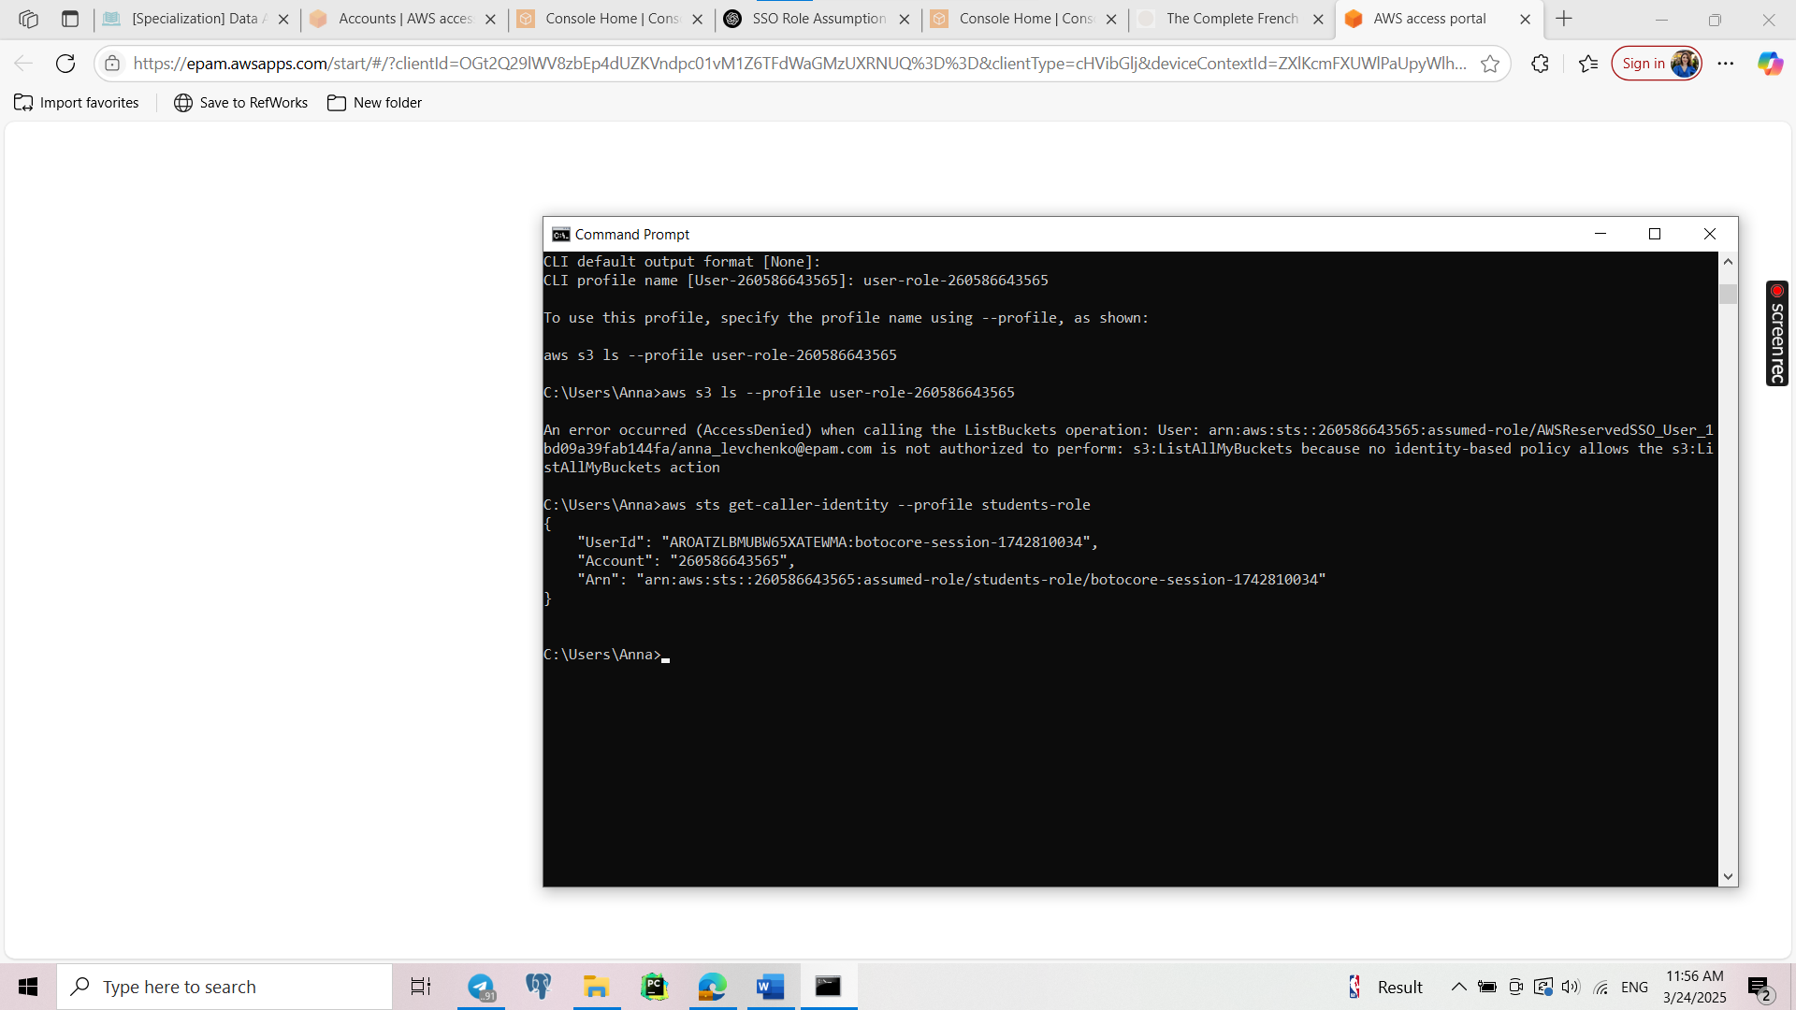

I created a bucket.

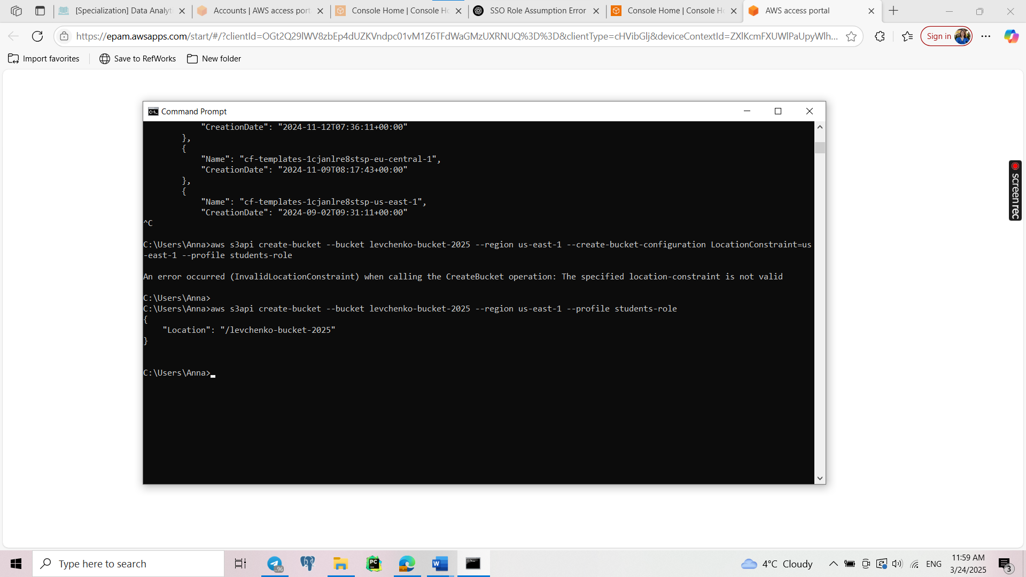

Here I copied table dim_customers from PostgreSQL to customer_data.csv.

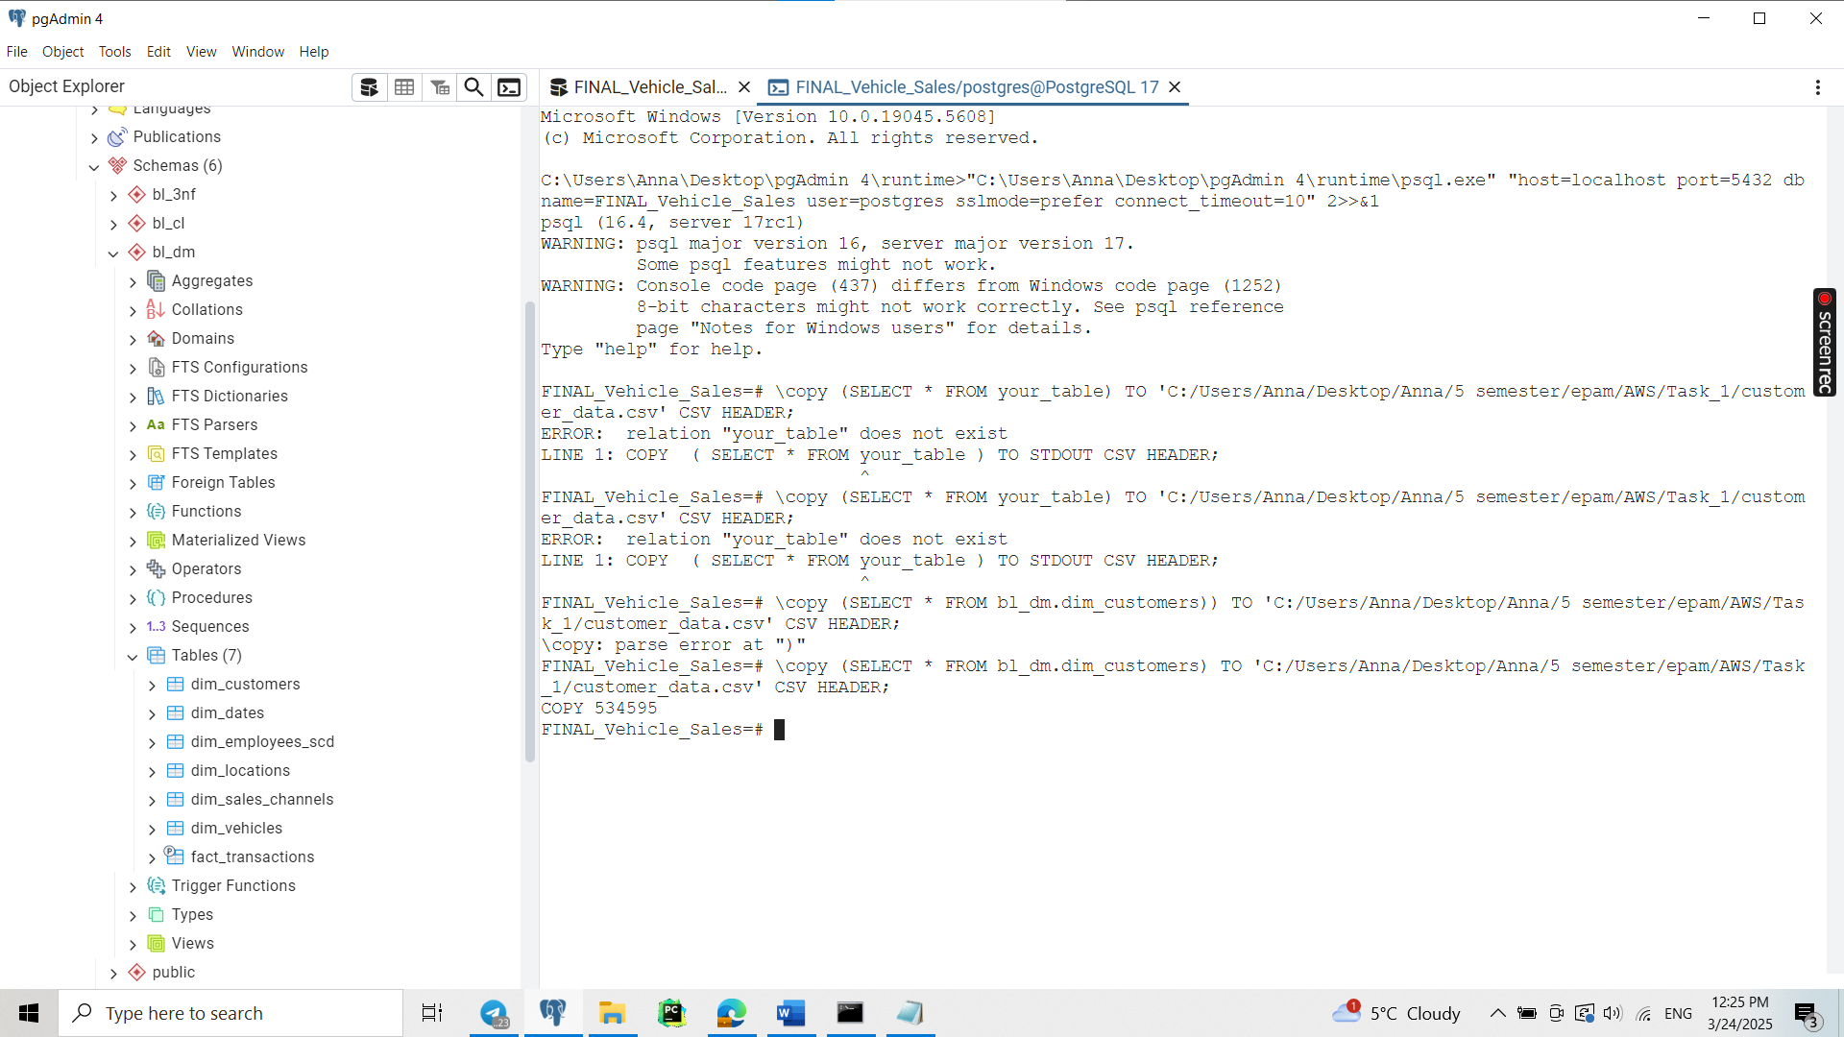

Then I uploaded it to S3.

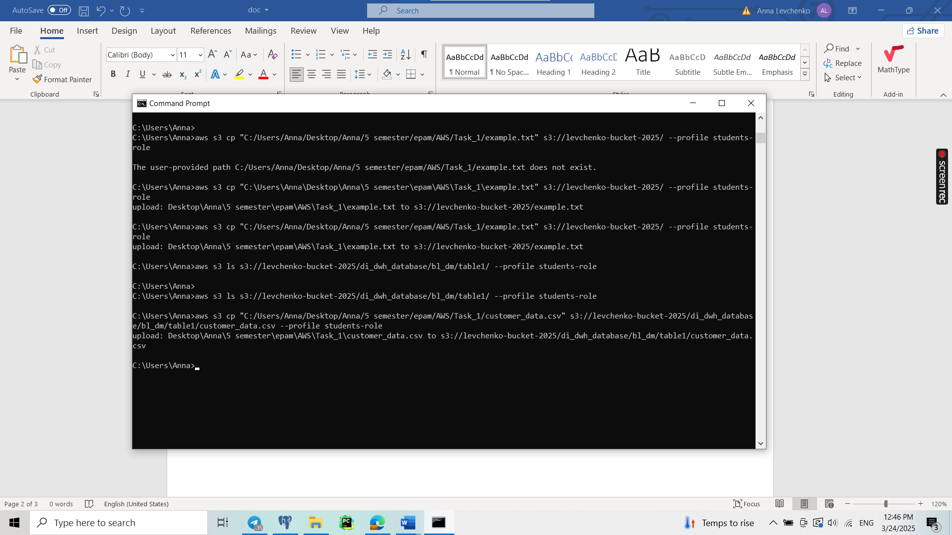

The I created clawer.

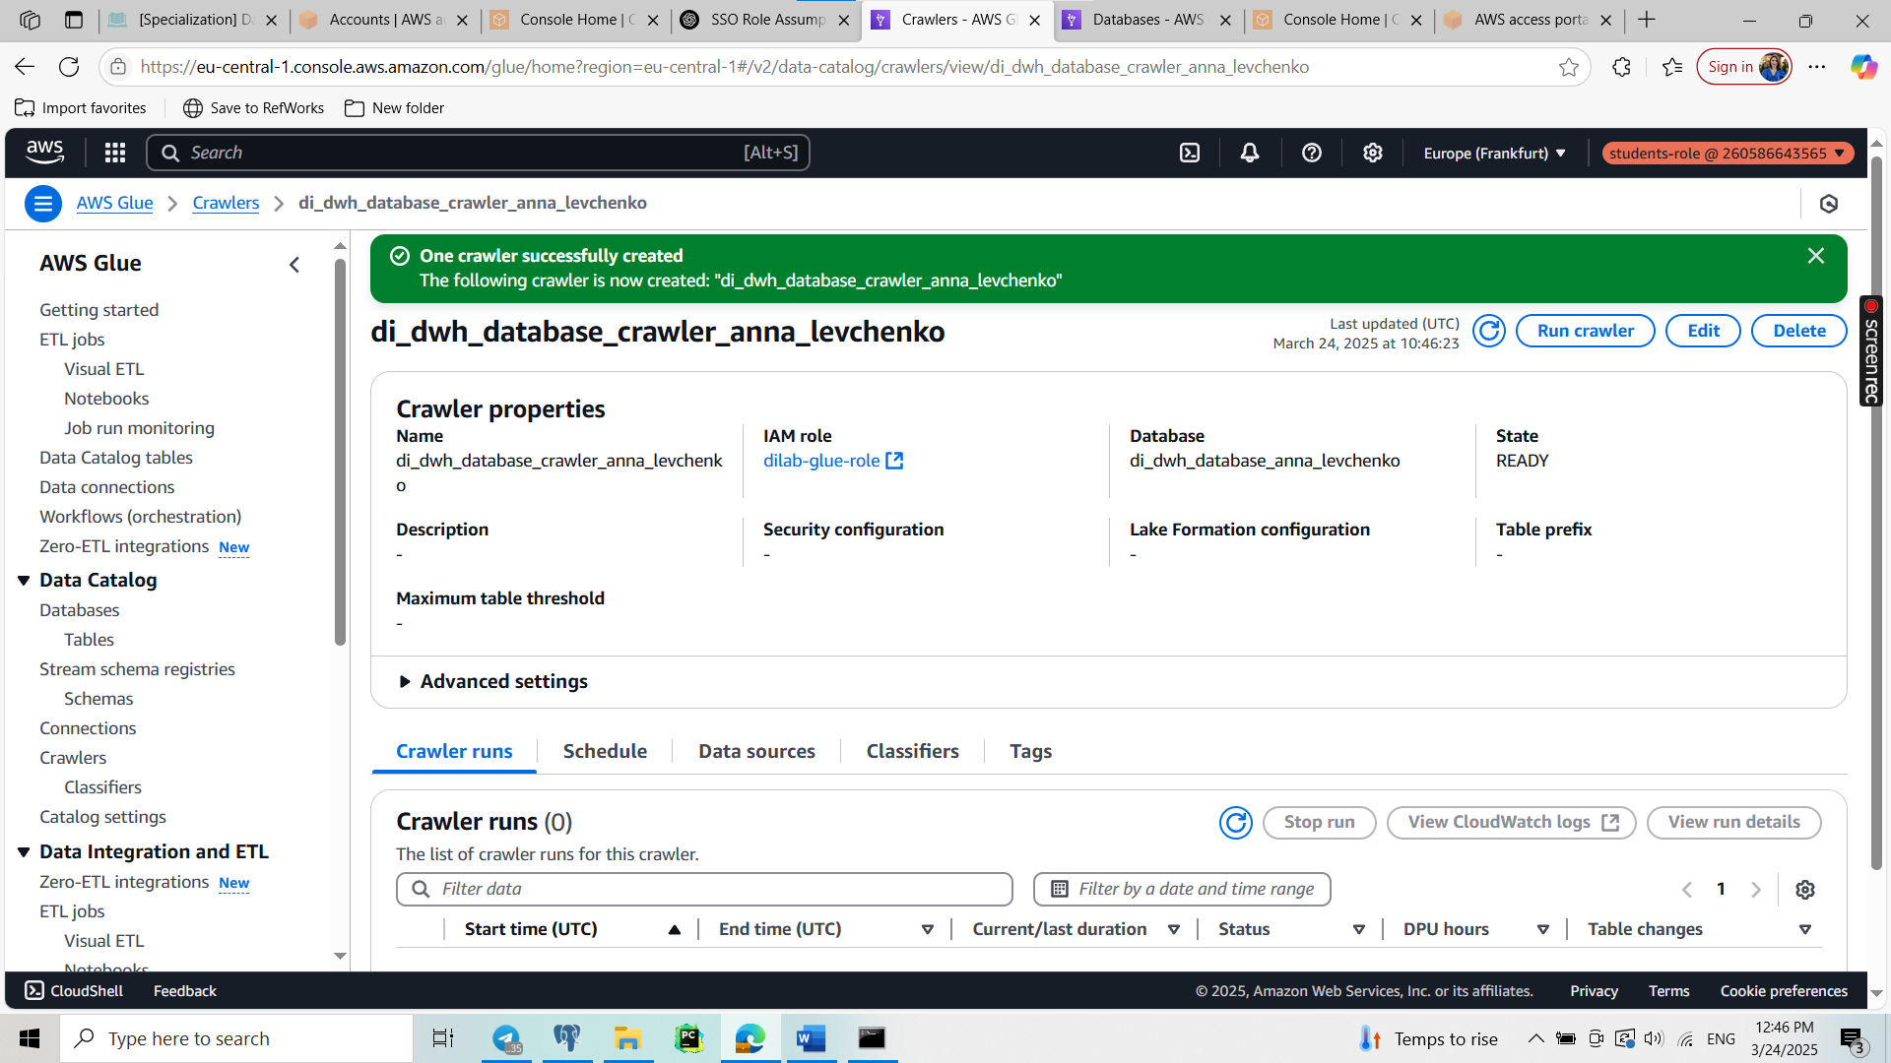

Then I run it and 1 table was uploaded.

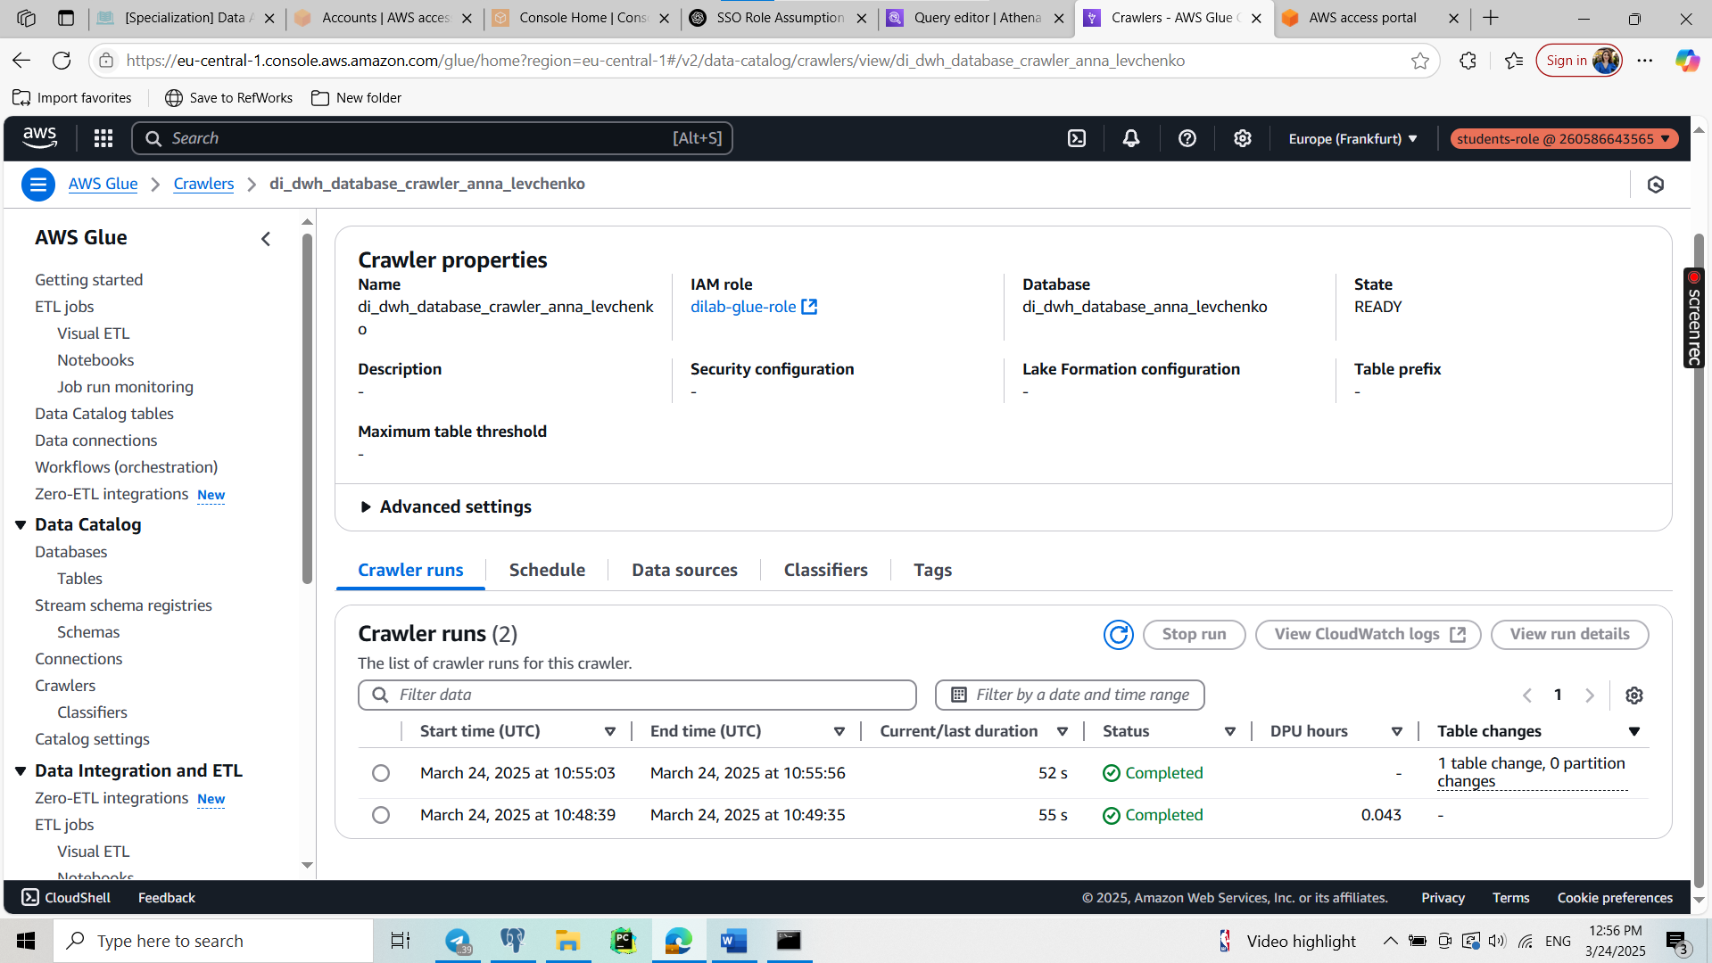

Then I queried it in Athena.

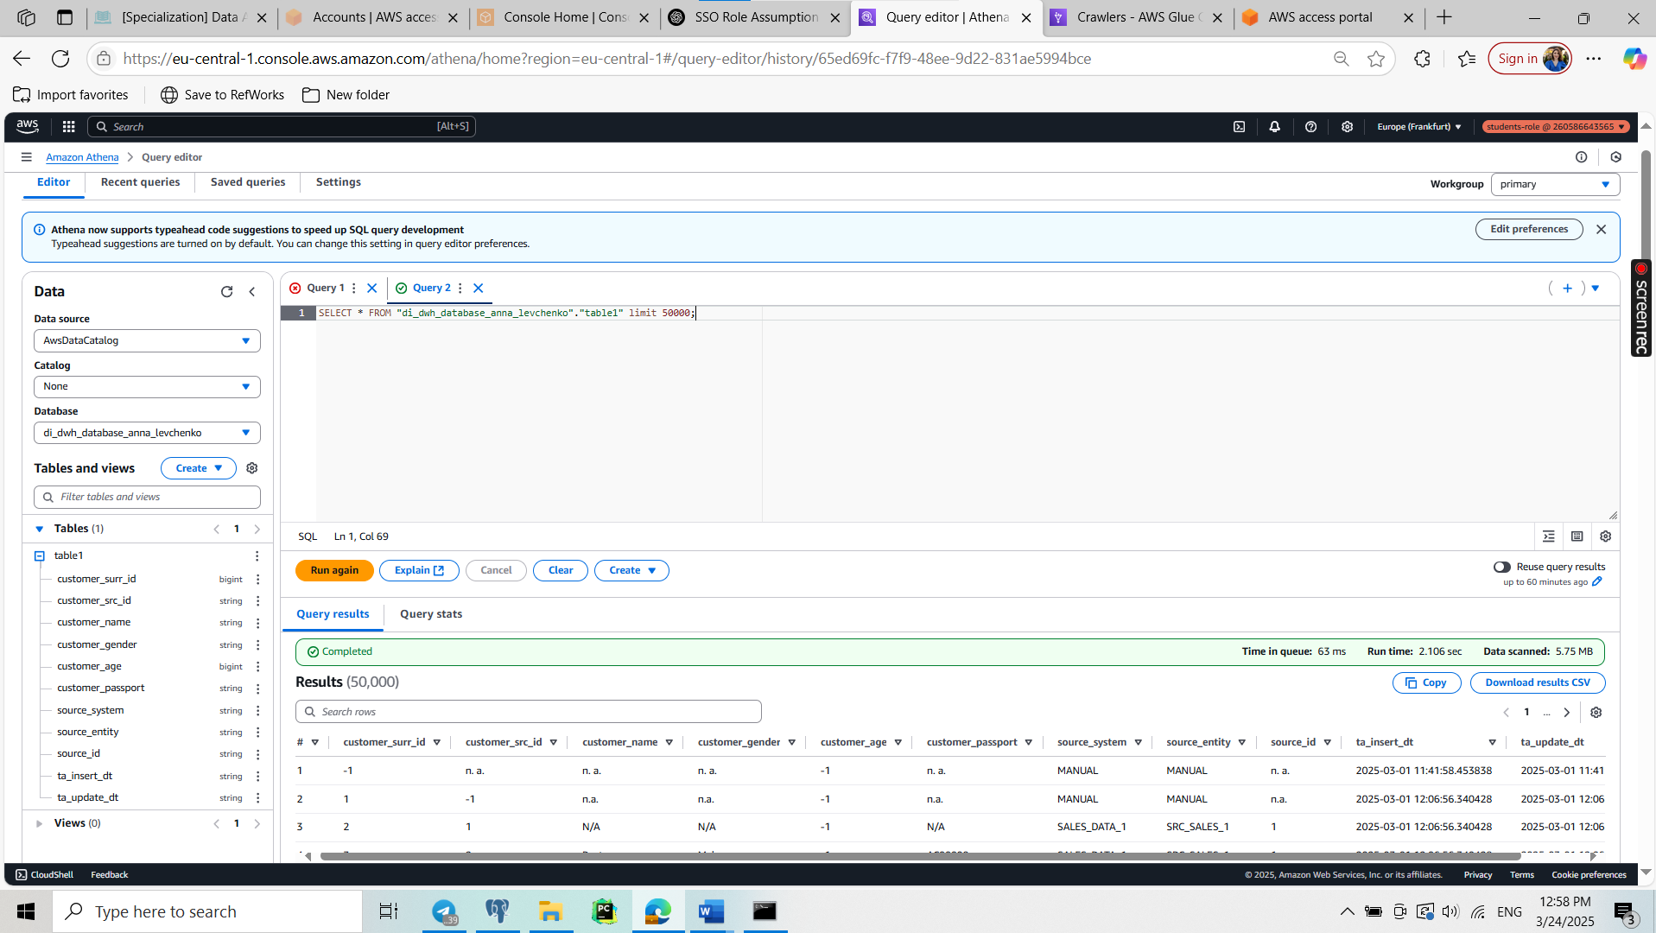

Then I performed the same with rest tables. Therefore, now +6 tables in S3.

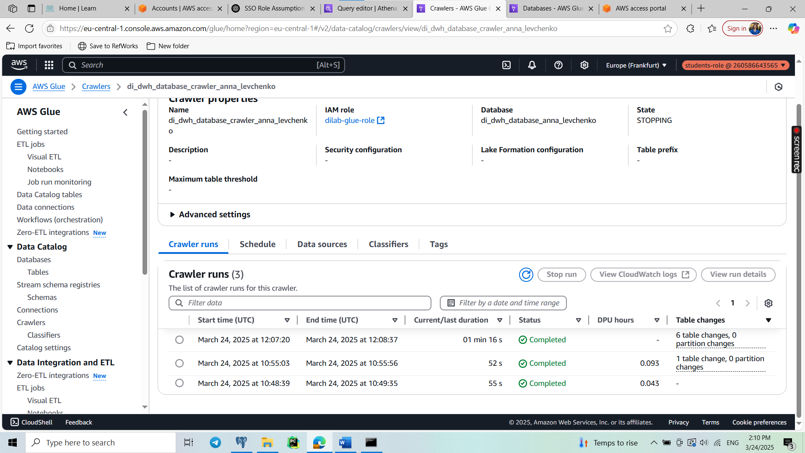

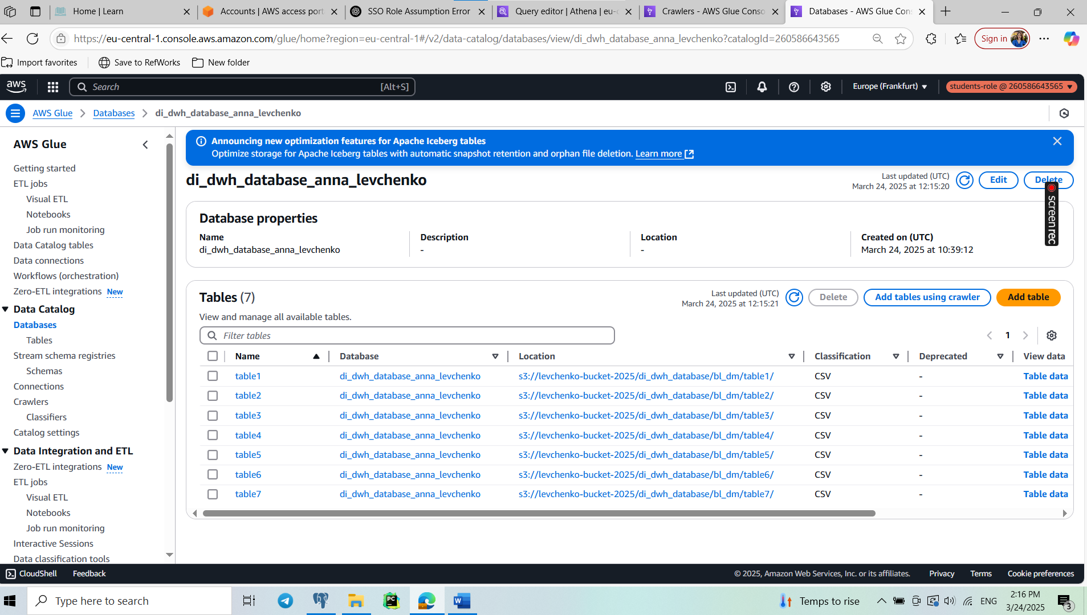

Complex query:

Transactions that occurred in the last year, with total amounts greater than $50,000

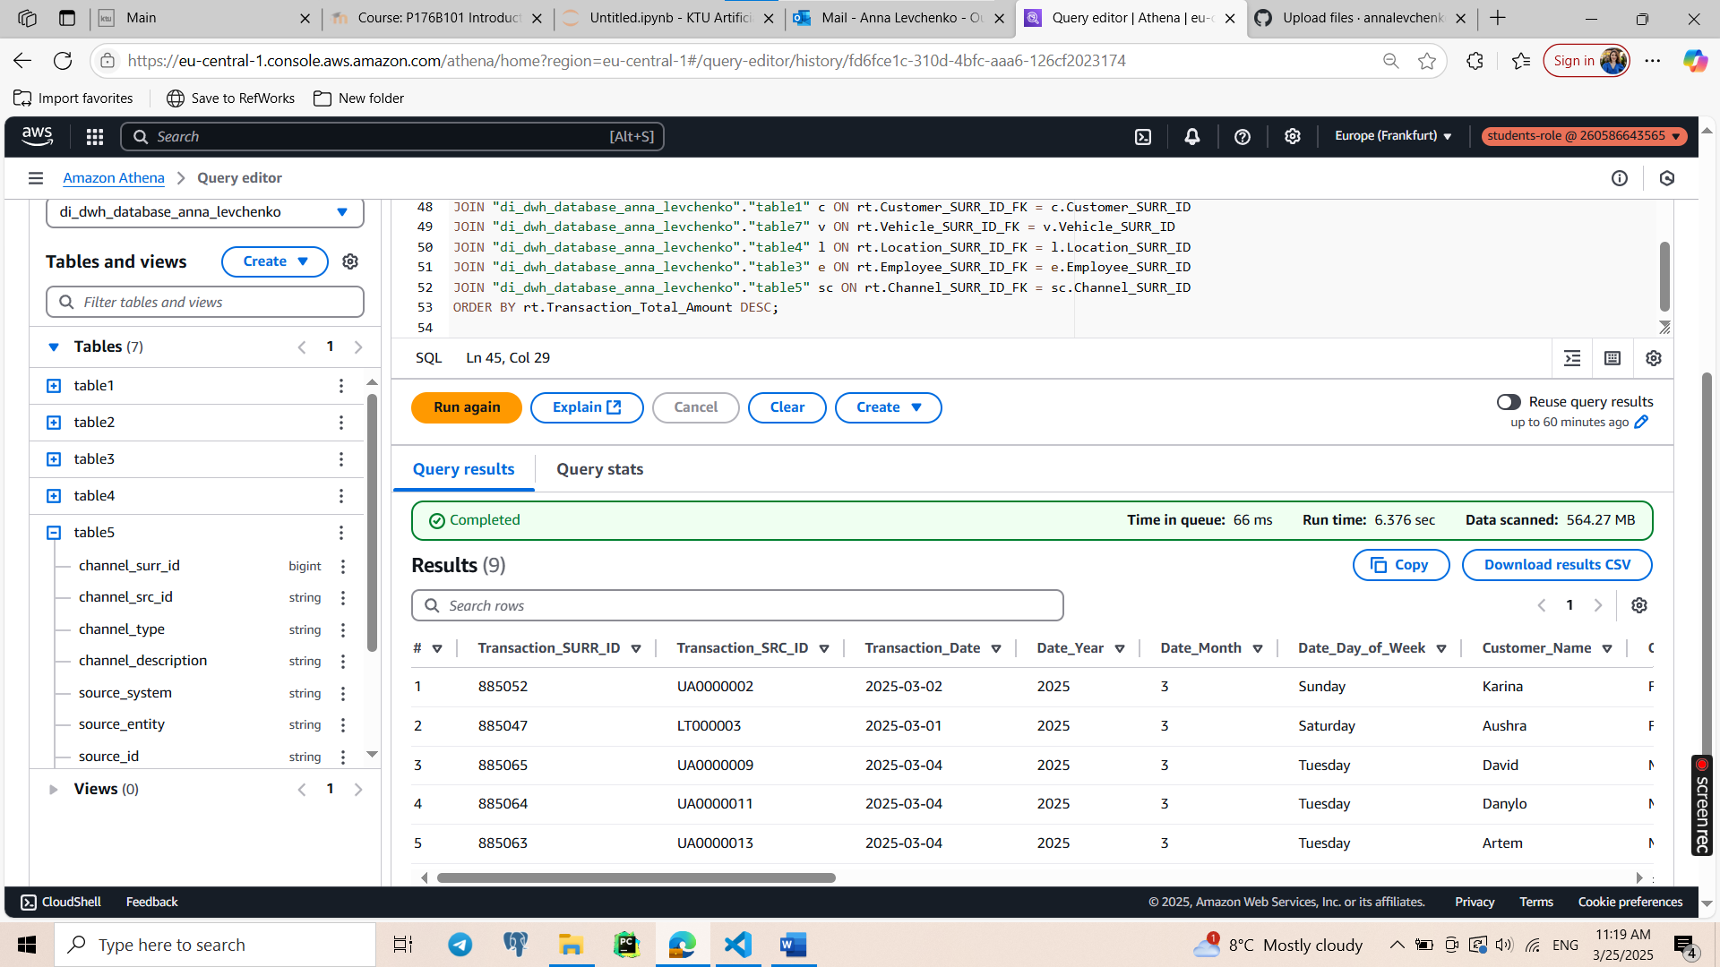

WITH Recent_Transactions AS (

SELECT

ft.Transaction_SURR_ID,

ft.Transaction_SRC_ID,

ft.Event_DT_FK,

ft.Customer_SURR_ID_FK,

ft.Vehicle_SURR_ID_FK,

ft.Location_SURR_ID_FK,

ft.Employee_SURR_ID_FK,

ft.Channel_SURR_ID_FK,

ft.Transaction_Amount,

ft.Transaction_Quantity,

ft.Transaction_Discount,

ft.Transaction_Total_Amount,

dd.Date_Full,

dd.Date_Year,

dd.Date_Month,

dd.Date_Day_of_Week

FROM "di_dwh_database_anna_levchenko"."table6" ft

JOIN "di_dwh_database_anna_levchenko"."table2" dd ON ft.Event_DT_FK = dd.Date_ID

WHERE CAST(dd.Date_Full AS DATE) >= DATE_ADD('year', -1, CURRENT_DATE)

AND ft.Transaction_Total_Amount > 50000

)

SELECT

rt.Transaction_SURR_ID,

rt.Transaction_SRC_ID,

rt.Date_Full AS Transaction_Date,

rt.Date_Year,

rt.Date_Month,

rt.Date_Day_of_Week,

c.Customer_Name,

c.Customer_Gender,

c.Customer_Age,

v.Vehicle_Model_Name,

v.Vehicle_Year,

v.Vehicle_Color,

l.Location_City_Name,

l.Location_State_Name,

e.Employee_Name AS Sales_Rep,

e.Employee_Email,

sc.Channel_Type AS Sales_Channel,

rt.Transaction_Amount,

rt.Transaction_Quantity,

rt.Transaction_Discount,

rt.Transaction_Total_Amount

FROM Recent_Transactions rt

JOIN "di_dwh_database_anna_levchenko"."table1" c ON rt.Customer_SURR_ID_FK = c.Customer_SURR_ID

JOIN "di_dwh_database_anna_levchenko"."table7" v ON rt.Vehicle_SURR_ID_FK = v.Vehicle_SURR_ID

JOIN "di_dwh_database_anna_levchenko"."table4" l ON rt.Location_SURR_ID_FK = l.Location_SURR_ID

JOIN "di_dwh_database_anna_levchenko"."table3" e ON rt.Employee_SURR_ID_FK = e.Employee_SURR_ID

JOIN "di_dwh_database_anna_levchenko"."table5" sc ON rt.Channel_SURR_ID_FK = sc.Channel_SURR_ID

ORDER BY rt.Transaction_Total_Amount DESC;