I created new bucket and then copied all files from us region to eu region

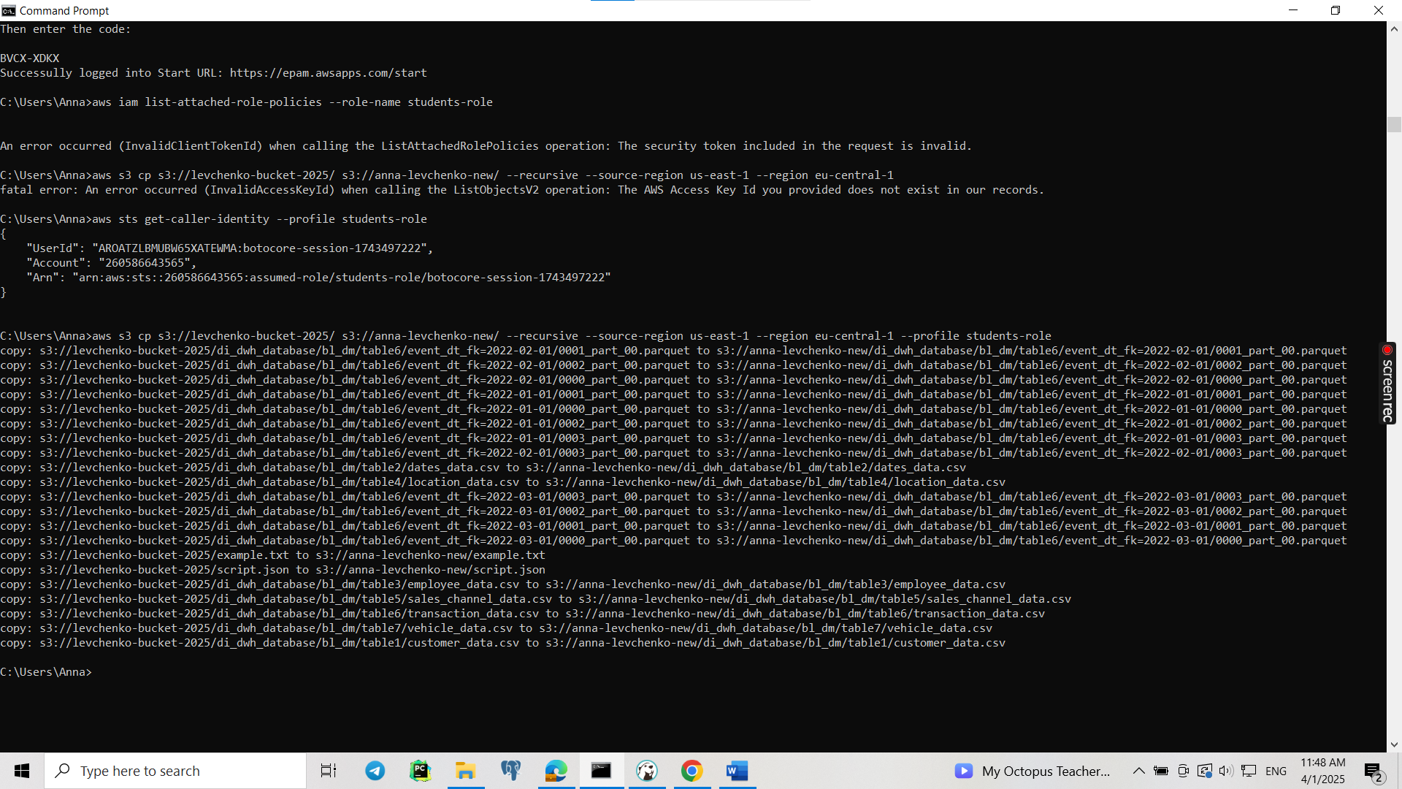

Then added to my crawler(from 1st hw) new source-bucket ‘anna_levchenko_new’

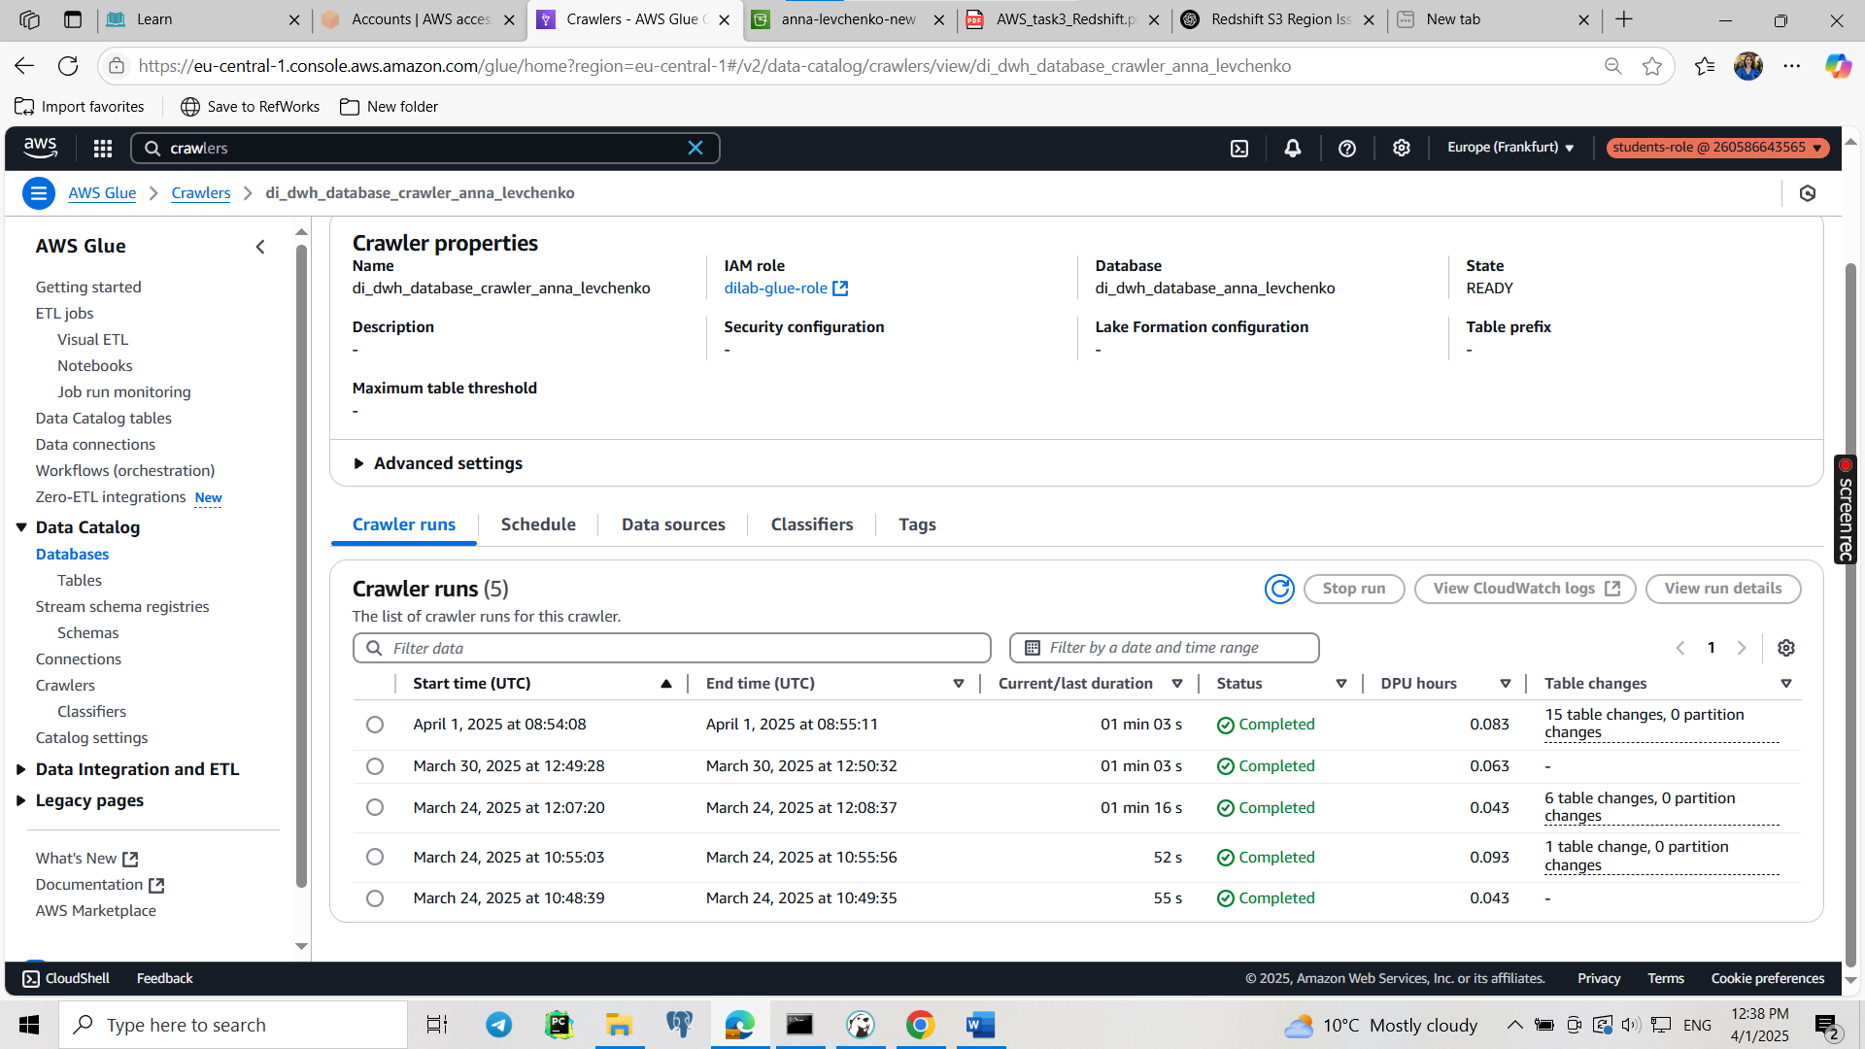

Then created new script:

**CREATE** **EXTERNAL** **SCHEMA** user_dilab_student51_ext

**FROM** **DATA** **CATALOG**

**DATABASE** 'di_dwh_database_anna_levchenko'

IAM_ROLE 'arn:aws:iam::260586643565:role/dilab-redshift-role'

REGION 'eu-central-1';

**CREATE** **EXTERNAL** **TABLE** user_dilab_student51_ext.ext_student_partitioned (

transaction_surr_id **BIGINT**,

transaction_src_id **VARCHAR**(255),

customer_surr_id_fk **BIGINT**,

vehicle_surr_id_fk **BIGINT**,

location_surr_id_fk **BIGINT**,

employee_surr_id_fk **BIGINT**,

channel_surr_id_fk **BIGINT**,

transaction_payment_method_id **BIGINT**,

transaction_payment_method_name **VARCHAR**(255),

transaction_amount **BIGINT**,

transaction_quantity **BIGINT**,

transaction_discount **BIGINT**,

transaction_total_amount **BIGINT**,

source_system **VARCHAR**(255),

source_entity **VARCHAR**(255),

source_id **BIGINT**,

ta_insert_dt **VARCHAR**(255),

ta_update_dt **VARCHAR**(255)

)

PARTITIONED **BY** (event_dt_fk **VARCHAR**(255)) -- Changed to VARCHAR

STORED **AS** PARQUET

**LOCATION** 's3://anna-levchenko-new/di_dwh_database/bl_dm/table6/';

**ALTER** **TABLE** user_dilab_student51_ext.ext_student_partitioned

**ADD** **PARTITION** (event_dt_fk = '2022-01-01')

**LOCATION** 's3://anna-levchenko-new/di_dwh_database/bl_dm/table6/event_dt_fk=2022-01-01/';

**ALTER** **TABLE** user_dilab_student51_ext.ext_student_partitioned

**ADD** **PARTITION** (event_dt_fk = '2022-02-01')

**LOCATION** 's3://anna-levchenko-new/di_dwh_database/bl_dm/table6/event_dt_fk=2022-02-01/';

**ALTER** **TABLE** user_dilab_student51_ext.ext_student_partitioned

**ADD** **PARTITION** (event_dt_fk = '2022-03-01')

**LOCATION** 's3://anna-levchenko-new/di_dwh_database/bl_dm/table6/event_dt_fk=2022-03-01/';

**SELECT** *

**FROM** user_dilab_student51_ext.ext_student_partitioned

**SELECT** **Count**(*t*.*)

**FROM** user_dilab_student51.transactions *t*

**JOIN** user_dilab_student51.date *d* **ON** *t*.event_dt_fk = *d*.date_id

**WHERE** *d*.date_full >= '2022-01-01' **AND** *d*.date_full < '2022-02-01'

**SELECT** **Count**(*t*.*)

**FROM** user_dilab_student51.transactions *t*

**JOIN** user_dilab_student51.date *d* **ON** *t*.event_dt_fk = *d*.date_id

**WHERE** *d*.date_full >= '2022-02-01' **AND** *d*.date_full < '2022-03-01'

**SELECT** **Count**(*t*.*)

**FROM** user_dilab_student51.transactions *t*

**JOIN** user_dilab_student51.date *d* **ON** *t*.event_dt_fk = *d*.date_id

**WHERE** *d*.date_full >= '2022-03-01' **AND** *d*.date_full < '2022-04-01'

**SELECT** **COUNT**(*)

**FROM** user_dilab_student51_ext.ext_student_partitioned

**WHERE** event_dt_fk = '2022-01-01';

**SELECT** **COUNT**(*)

**FROM** user_dilab_student51_ext.ext_student_partitioned

**WHERE** event_dt_fk = '2022-02-01';

**SELECT** **COUNT**(*)

**FROM** user_dilab_student51_ext.ext_student_partitioned

**WHERE** event_dt_fk = '2022-03-01';

**SELECT** **COUNT**(*)

**FROM** user_dilab_student51_ext.ext_student_partitioned

**EXPLAIN**

**SELECT** *

**FROM** user_dilab_student51_ext.ext_student_partitioned

**WHERE** event_dt_fk >= '2022-03-01' **AND** event_dt_fk < '2022-04-01'

