

|  |
| --- |
| **An Auction House** |
| **Anna Levchenko** |

Contents

1 Business Description 3

1.1 Business background 3

1.2 Problems. Current Situation 3

1.3 The benefits of implementing a database. Project Vision 3

2 Model description 4

2.1 Definitions & Acronyms 4

2.2 Logical Scheme 5

2.3 Objects 5

# 

# Business Description

## Business background

The company specializes in auctioning antiques and artwork. The primary stakeholders are:

* Sellers: Individuals or entities who legally own the antiques and artwork and wish to sell them through the auction house.
* Buyers: Individuals or entities interested in purchasing items at auction.

The business operates by receiving items from sellers, determining at which auction to present them, and managing the auction process. Every item is assigned a lot number before an auction. Multiple sellers can offer items at the same auction, and sellers are also allowed to be buyers.

## Problems. Current Situation

The current system of managing auction data seems to rely on manual or semi-automated methods, possibly spreadsheets or paper records, which likely lead to several issues:

Duplication of lot numbers: Items sold at different auctions might have the same lot number, which could create confusion or errors when tracking individual items.

Inconsistent record-keeping: The details of each auction, such as time, date, and item specifics (starting price, seller information, etc.), are manually recorded, increasing the likelihood of data entry errors.

Limited integration: There is no centralized database where all transactions (auction information, item specifics, and sales records) are connected.

Difficulty in tracking buyer-seller relationships: Since the same individual or firm can act as both a buyer and seller, this dual role might create further complications in record-keeping.

## the Benefits of implementing a database. Project Vision

The implementation of a relational database system would streamline and organize auction house operations. The benefits include:

* Data integrity and organization: A structured database would eliminate the confusion of duplicate lot numbers by ensuring each item’s details are tied to specific auctions and sales records.
* Efficiency in record-keeping: Automating the recording of auction details (date, place, lot numbers, etc.) and item specifics will reduce human error, make data easily retrievable, and improve overall business efficiency.
* Improved buyer-seller tracking: The database will provide clear tracking of relationships, allowing the system to distinguish between a seller and a buyer, even if they are the same entity.
* Better client services: Buyers and sellers will benefit from faster, more accurate transactions and communications, improving the company's reputation and business operations.

The vision of the project is to create an efficient and centralized auction management system that allows seamless tracking of items, buyers, sellers, and auction details. This will enable better business decisions, reduce operational risks, and improve customer satisfaction.

# Model description

## Definitions & Acronyms

|  |  |
| --- | --- |
| Term/Acronym | Definition |
| Auction | A public sale where items are sold to the highest bidder. |
| Item | An object (artwork, antique, etc.) that is placed in the auction for sale. |
| Bid | A proposal to buy an item at a certain price, made by a buyer during the auction. |
| Buyer | A person or entity that makes a bid to purchase items in an auction. |
| Seller | A person or entity that provides items to the auction house for sale. |
| Lot Number | A unique identifier assigned to each item in an auction for tracking and organization purposes. |
| Auction House | A company or entity that organizes and facilitates auctions. |
| Final Price | The final amount at which an item is sold to the highest bidder during the auction. |
| Payment | The amount paid by the buyer after winning an auction bid. |
| Category | The classification of an item (e.g., artwork, antique, jewelry) used to organize items in the auction. |
| Auction Record | A record of the auction that includes details of sold items and final prices. |
| PK | Primary Key - A unique identifier for each record in a database table. |
| FK | Foreign Key - A field in a database table that links to the primary key of another table. |
| UML | Unified Modeling Language - A standardized modeling language used to specify, visualize, and document the components of a system. |

## Logical Scheme

The scheme was developed in Magic Draw (Magic Systems of Systems Architecture)

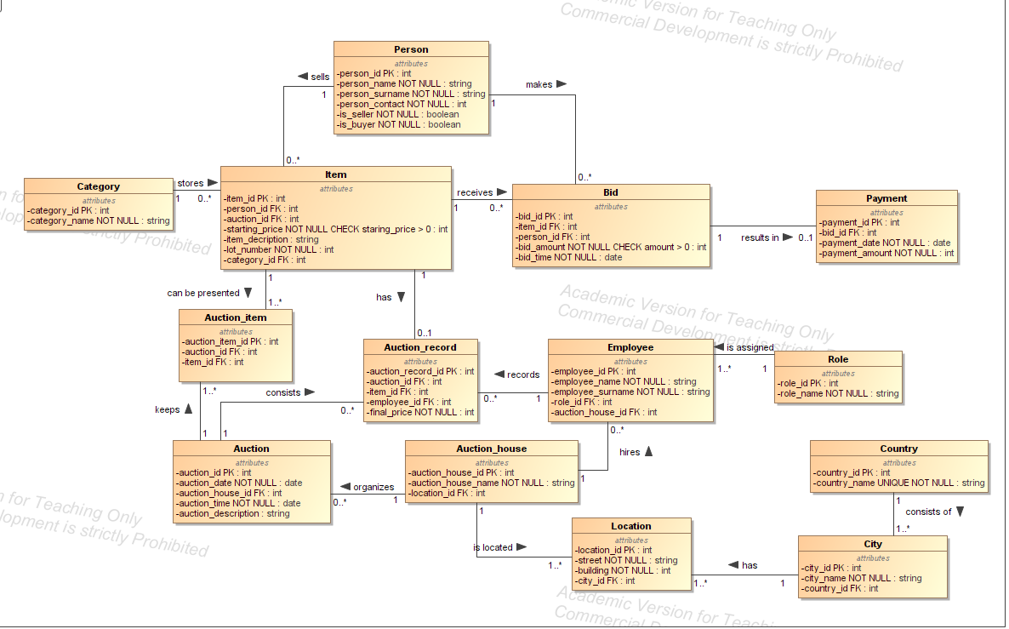

## Objects

Logical schema consists of 10 tables and 43 attributes. Description of each table:

**Person Table**

|  |  |  |
| --- | --- | --- |
| Field Name | Field Description | Data Type |
| person_id | Unique ID for person (PK) | int |
| person_name | Person's first name | string |
| person_surname | Person's last name | string |
| person_contact | Person's contact details | string |
| is_seller | Flag to indicate if person is a seller | boolean |
| is_buyer | Flag to indicate if person is a buyer | boolean |

**Item Table**

|  |  |  |
| --- | --- | --- |
| Field Name | Field Description | Data Type |
| item_id | Item's unique ID (PK) | int |
| person_id | Reference to Person (FK) | int |
| auction_id | Reference to Auction (FK) | int |
| starting_price | Starting price for the item | int |
| item_description | Description of the item | string |
| lot_number | Lot number | int |
| category_id | Reference to Category (FK) | int |

**Category Table**

|  |  |  |
| --- | --- | --- |
| Field Name | Field Description | Data Type |
| category_id | Category's unique ID (PK) | int |
| category_name | Name of the category | string |

**Auction Table**

|  |  |  |
| --- | --- | --- |
| Field Name | Field Description | Data Type |
| auction_id | Auction's unique ID (PK) | int |
| auction_date | Date of the auction | date |
| auction_time | Time of the auction | date |
| auction_house_id | Reference to Auction_House (FK) | int |
| auction_description | Auction's description | string |

**AuctionItem Bridge Table**

|  |  |  |
| --- | --- | --- |
| Field Name | Field Description | Data Type |
| auction_item_id | Unique ID for auction item (PK) | int |
| auction_id | Reference to Auction (FK) | int |
| item_id | Reference to Item (FK) | int |

**Bid Table**

|  |  |  |
| --- | --- | --- |
| Field Name | Field Description | Data Type |
| bid_id | Bid's unique ID (PK) | int |
| item_id | Reference to Item (FK) | int |
| person_id | Reference to Person (FK) | int |
| bid_amount | Bid amount | int |
| bid_time | Time bid was placed | date |

**Payment Table**

|  |  |  |
| --- | --- | --- |
| Field Name | Field Description | Data Type |
| payment_id | Payment's unique ID (PK) | int |
| bid_id | Reference to Bid (FK) | int |
| payment_date | Payment date | date |
| payment_amount | Payment amount | int |

**AuctionRecord Table**

|  |  |  |
| --- | --- | --- |
| Field Name | Field Description | Data Type |
| auction_record_id | Auction record's unique ID (PK) | int |
| auction_id | Reference to Auction (FK) | int |
| item_id | Reference to Item (FK) | int |
| final_price | Final selling price | int |

**Employee Table**

|  |  |  |
| --- | --- | --- |
| Field Name | Field Description | Data Type |
| employee_id | Employee's unique ID (PK) | int |
| employee_name | Employee's first name | string |
| employee_surname | Employee's last name | string |
| role_id | Reference to Role(FK) | int |
| auction_house_id | Reference to Auction_House (FK) | int |

**Role**

|  |  |  |
| --- | --- | --- |
| Field Name | Field Description | Data Type |
| Role_id | Role's unique ID (PK) | int |
| Role_name | Name of role | string |

**AuctionHouseTable**

|  |  |  |
| --- | --- | --- |
| Field Name | Field Description | Data Type |
| auction_house_id | Auction house's unique ID (PK) | int |
| auction_house_name | Auction house's name | string |
| location_id | Reference to Location(FK) | int |

**Location Table**

|  |  |  |
| --- | --- | --- |
| Field Name | Field Description | Data Type |
| location_id | Location unique ID (PK) | int |
| city_id | Reference to City(FK) | int |
| street | Name of Street | string |
| building | Number of building | int |

**City Table**

|  |  |  |
| --- | --- | --- |
| Field Name | Field Description | Data Type |
| city_id | City unique ID (PK) | int |
| country_id | Reference to Country(FK) | int |
| city_name | Name of City | string |

**Country Table**

|  |  |  |
| --- | --- | --- |
| Field Name | Field Description | Data Type |
| country_id | City unique ID (PK) | int |
| country_name | Name of Country | string |

**Comments on table relationships**

Person can be seller or buyer. Seller can sell many items. Category stores many items. Many items can be presents in many auctions. Auction House can organize many auctions. Auction consists of many auction records. Employee can record many auctions records. Role can be assigned to many employees. Auction house can hire many employees. Auction house can be located in many locations. Country consists of many cities. City has many locations. Buyer can make many bids. One item receives many bids. Bid may be result in one payment.

**Example with data**

1. Person Table

|  |  |  |  |  |  |
| --- | --- | --- | --- | --- | --- |
| person_id | person_name | person_surname | person_contact | is_seller | is_buyer |
| 1 | John | Smith | john@mail.com | true | false |
| 2 | Sarah | Connor | sarah@mail.com | true | true |
| 3 | Mike | Ross | mike@mail.com | false | true |
| 4 | Emma | Davis | emma@mail.com | true | true |

2. Item Table

|  |  |  |  |  |  |  |
| --- | --- | --- | --- | --- | --- | --- |
| item_id | person_id | auction_id | starting_price | item_description | lot_number | category_id |
| 101 | 1 | 1001 | 500 | Antique vase | 2001 | 1 |
| 102 | 2 | 1002 | 1200 | Vintage painting | 2002 | 2 |
| 103 | 4 | 1003 | 2000 | 19th-century statue | 2003 | 3 |

3. Category Table

|  |  |
| --- | --- |
| category_id | category_name |
| 1 | Ceramics |
| 2 | Paintings |
| 3 | Sculptures |

4. Auction Table

|  |  |  |  |  |
| --- | --- | --- | --- | --- |
| auction_id | auction_date | auction_time | auction_house_id | auction_description |
| 1001 | 2024-10-01 | 14:00:00 | 801 | Antique auction |
| 1002 | 2024-10-15 | 10:30:00 | 802 | Fine art auction |
| 1003 | 2024-11-05 | 13:00:00 | 803 | Historical artifacts |

5. AuctionItem Bridge Table

|  |  |  |
| --- | --- | --- |
| auction_item_id | auction_id | item_id |
| 501 | 1001 | 101 |
| 502 | 1002 | 102 |
| 503 | 1003 | 103 |

6. Bid Table

|  |  |  |  |  |
| --- | --- | --- | --- | --- |
| bid_id | item_id | person_id | bid_amount | bid_time |
| 301 | 101 | 3 | 600 | 2024-10-01 14:15:00 |
| 302 | 102 | 2 | 1500 | 2024-10-15 10:45:00 |
| 303 | 103 | 3 | 2200 | 2024-11-05 13:30:00 |

7. Payment Table

|  |  |  |  |
| --- | --- | --- | --- |
| payment_id | bid_id | payment_date | payment_amount |
| 401 | 301 | 2024-10-02 | 600 |
| 402 | 302 | 2024-10-16 | 1500 |
| 403 | 303 | 2024-11-06 | 2200 |

8. AuctionRecord Table

|  |  |  |  |  |
| --- | --- | --- | --- | --- |
| auction_record_id | auction_id | item_id | final_price | employee_id |
| 601 | 1001 | 101 | 600 | 701 |
| 602 | 1002 | 102 | 1500 | 702 |
| 603 | 1003 | 103 | 2200 | 703 |

9. Employee Table

|  |  |  |  |  |
| --- | --- | --- | --- | --- |
| employee_id | employee_name | employee_surname | auction_house_id | role_id |
| 701 | David | Johnson | 801 | 1 |
| 702 | Maria | Lee | 802 | 2 |
| 703 | Lucy | Martin | 803 | 3 |

10. Role Table

|  |  |
| --- | --- |
| role_id | role_name |
| 1 | Auctioneer |
| 2 | Sales Manager |
| 3 | Operations Lead |

11. AuctionHouse Table

|  |  |  |
| --- | --- | --- |
| auction_house_id | auction_house_name | location_id |
| 801 | Sotheby's | 10001 |
| 802 | Christie's | 10002 |
| 803 | Artcurial | 10003 |

12. Location Table

|  |  |  |  |
| --- | --- | --- | --- |
| location_id | city_id | street | building |
| 10001 | 1 | Green | 53 |
| 10002 | 2 | Sunny | 89 |
| 10003 | 3 | Love | 156 |

13. City Table

|  |  |  |
| --- | --- | --- |
| city_id | country_id | city_name |
| 1 | 1 | London |
| 2 | 2 | New York |
| 3 | 3 | Paris |

14. Country Table

|  |  |
| --- | --- |
| Country_id | Country_name |
| 1 | England |
| 2 | USA |
| 3 | France |