1. 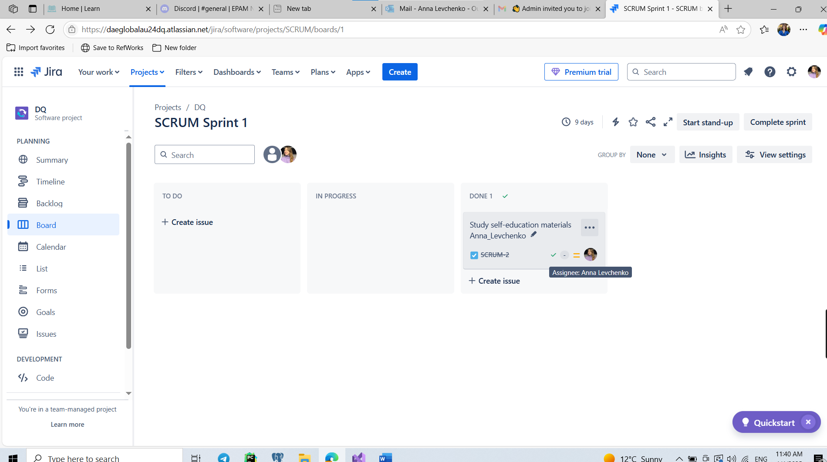

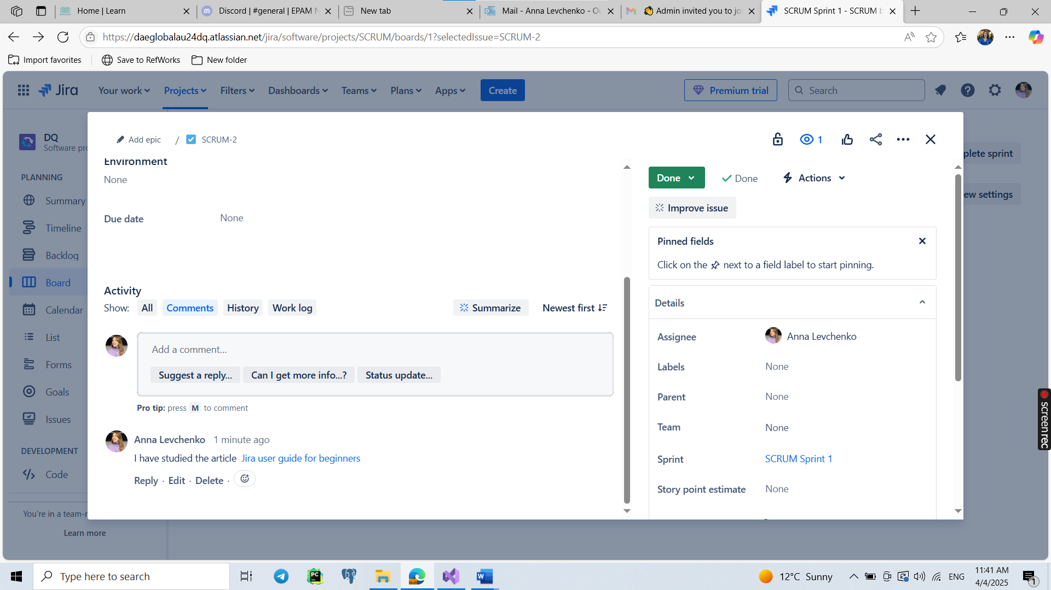

|  |
| --- |
| Quality Assurance Checklist |
| **A checklist is a set of ideas. In testing, checklists come first. They serve as a draft for further activities. Writing and rewriting a checklist is fast and simple. Once the checklist is ready and each item may become the foundation for one or several test cases.** |

|  |  |  |  |
| --- | --- | --- | --- |
| **Project Name** | Air Fryer MODULE | **Project code** | EPM- AF |
| **Object Name** | Air Fryer | **QA Engineer** | Anna Levchenko |
| **Classification by access** | Black box – user interface and functionality tested without internal component access. | | |
| **Object description** | Overview: The Air Fryer is a countertop kitchen appliance that cooks food using hot air circulation, creating a crispy layer similar to frying but using little or no oil. Modern air fryers come with digital control panels, preset programs, temperature adjustment, timers.  Model: [Premium Airfryer XXL HD9650/96 | Philips](https://www.usa.philips.com/c-p/HD9650_96/premium)  Features:   * Fat Removal Technology – removes excess fat while cooking. * Digital Display & QuickControl Dial – easy control of temperature and time. * Temperature Range: 80°C – 200°C * Timer: Up to 60 minutes with auto shutoff. * Preset Cooking Programs: Fries, Chicken, Fish, Meat, Cake, etc. * Dishwasher-Safe Parts: Non-stick basket and tray. * Capacity: 1.4 kg (for up to 6 servings). * Power: 2225W * Dimensions: 43.3 x 32.2 x 31.6 cm * Weight: 8 kg | | |

| **Verification area** | **Test Approach by way of dealing** | **Would be automated?** | **Test Type** | **Expected Result /**  **Comments** |
| --- | --- | --- | --- | --- |
| Power on/off functionality | Positive | No | Functional | Air fryer powers on/off without delay or error. |
| Display & QuickControl Dial | Positive | No | Functional | Buttons and dial respond correctly, display is readable. |
| Start cooking cycle | Positive | No | Functional | Cooking starts, heating and fan activate properly. |
| Auto shutoff on timer expiry | Positive | No | Safety/Functional | Cooking stops and device shuts off when timer runs out. |
| Overheat protection | Negative | No | Safety/Negative | Device shuts off if temperature exceeds safety threshold. |

**SMOKE PATH**

**CRITICAL PATH**

| **Verification area** | **Test Approach by way of dealing** | **Would be automated?** | **Test Type** | **Expected Result /**  **Comments** |
| --- | --- | --- | --- | --- |
| Adjust temperature via dial | Positive | No | Functional | Changing temperature adjusts heating element output. |
| Timer adjustment during cooking | Positive | No | Functional | Timer can be increased/decreased mid-cooking without errors. |
| Use preset program (e.g., Fries) | Positive | No | Functional | Preset automatically adjusts temperature and time. |
| Cooking consistency | Positive | No | Usability | Same food batch cooks evenly multiple times. |
| Basket detection mechanism | Positive | No | Functional | Device pauses when basket is removed, resumes when reinserted. |

**EXTENDED PATH**

| **Verification area** | **Test Approach by way of dealing** | **Would be automated?** | **Test Type** | **Expected Result /**  **Comments** |
| --- | --- | --- | --- | --- |
| Attempt to start without basket | Negative | No | Negative/Safety | Device should not start; error or indicator shown. |
| Maximum temp boundary test | Negative | No | Boundary/Negative | UI prevents setting temperature over 200°C. |
| Multilingual UI test | Positive | No | Usability | Interface displays correct translations for selected language. |
| Dishwasher-safe parts test | Positive | No | Functional | Non-stick basket & tray should be easily cleanable. |
| Stress test: 5 back-to-back cycles | Positive | No | Performance | Device should function correctly without overheating. |