Task 1:

The provided **PostgreSQL PL/pgSQL** procedures load data from two sales data sources (sales_data_1 and sales_data_2) into a **third normal form (3NF) database (BL_3NF)**. Each procedure follows a similar process:

* Each procedure follows these steps:
* **DECLARE** a record (rec) to hold rows from the SELECT query.
* **Iterate (FOR rec IN ... LOOP)** through the data fetched using a SELECT query.
* **Check for duplicates** using a WHERE NOT EXISTS clause.
* **Transform and Standardize Data** before inserting into the target table.
* **Insert Data** into the appropriate target table.
* **Handle Errors** using EXCEPTION to log failed insertions.
* **Commit Changes** at the end of the loop

These procedures implement **incremental data loading** by ensuring **only new and valid records** are inserted into the BL_3NF schema. They use COALESCE(), CASE statements, and WHERE NOT EXISTS to handle missing data and prevent duplicates. The design ensures data integrity, consistency, and maintainability.

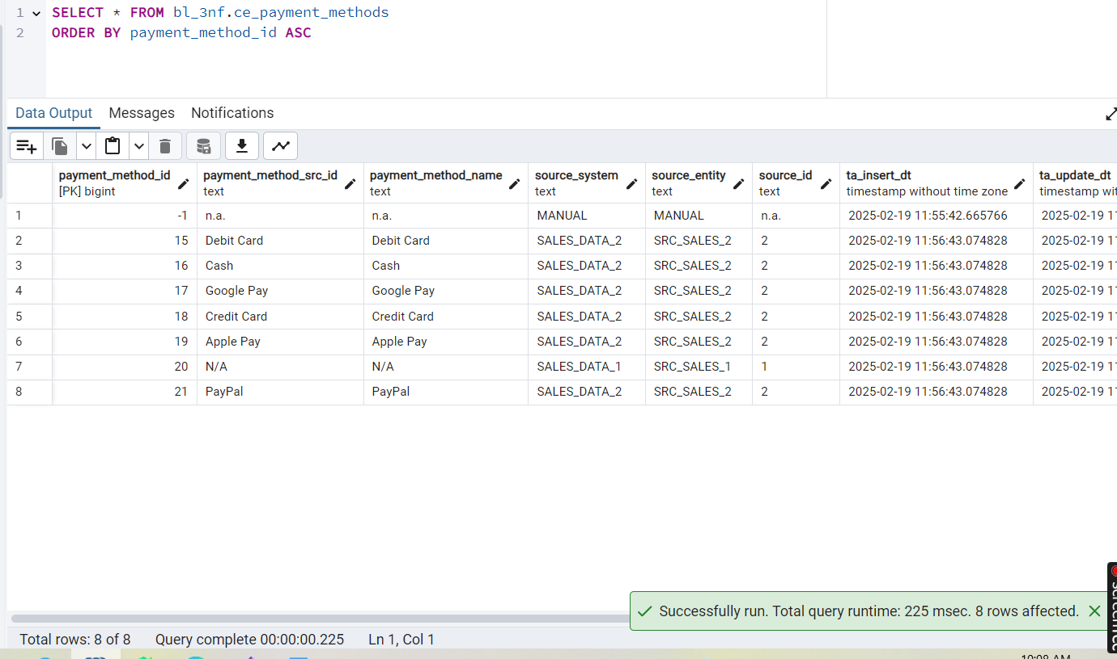

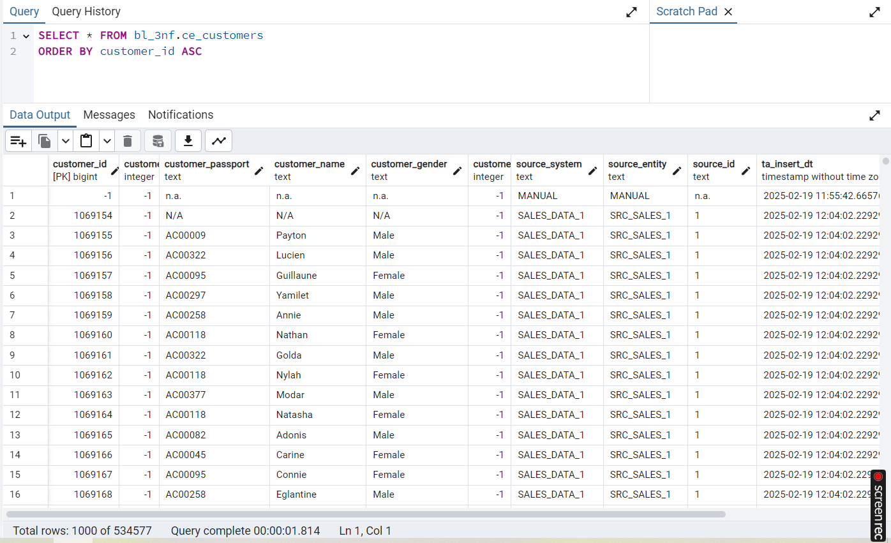

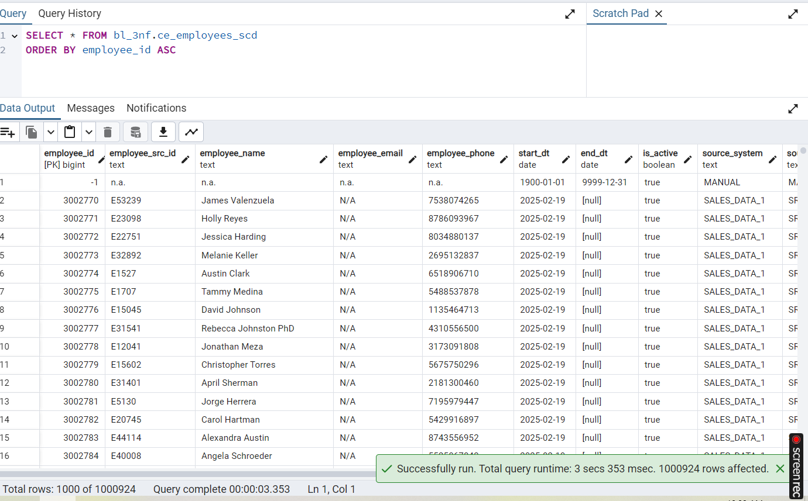

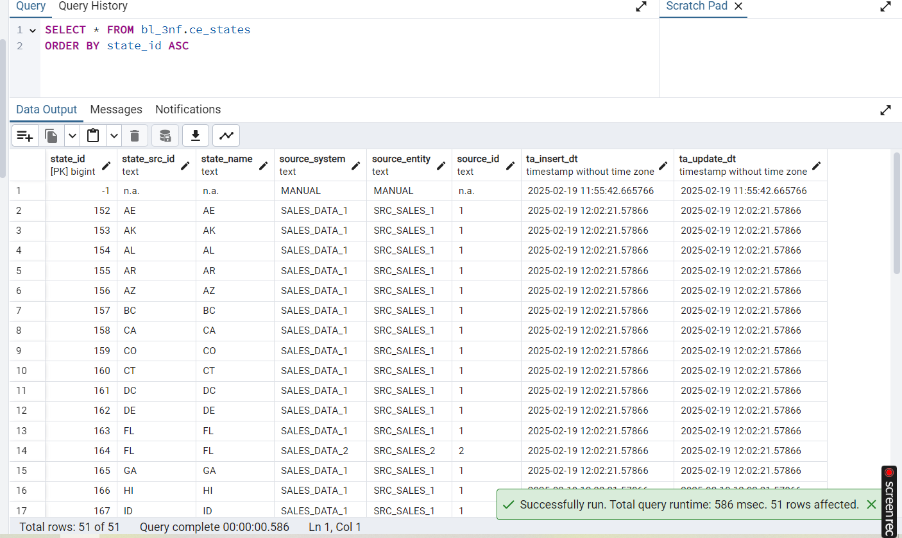

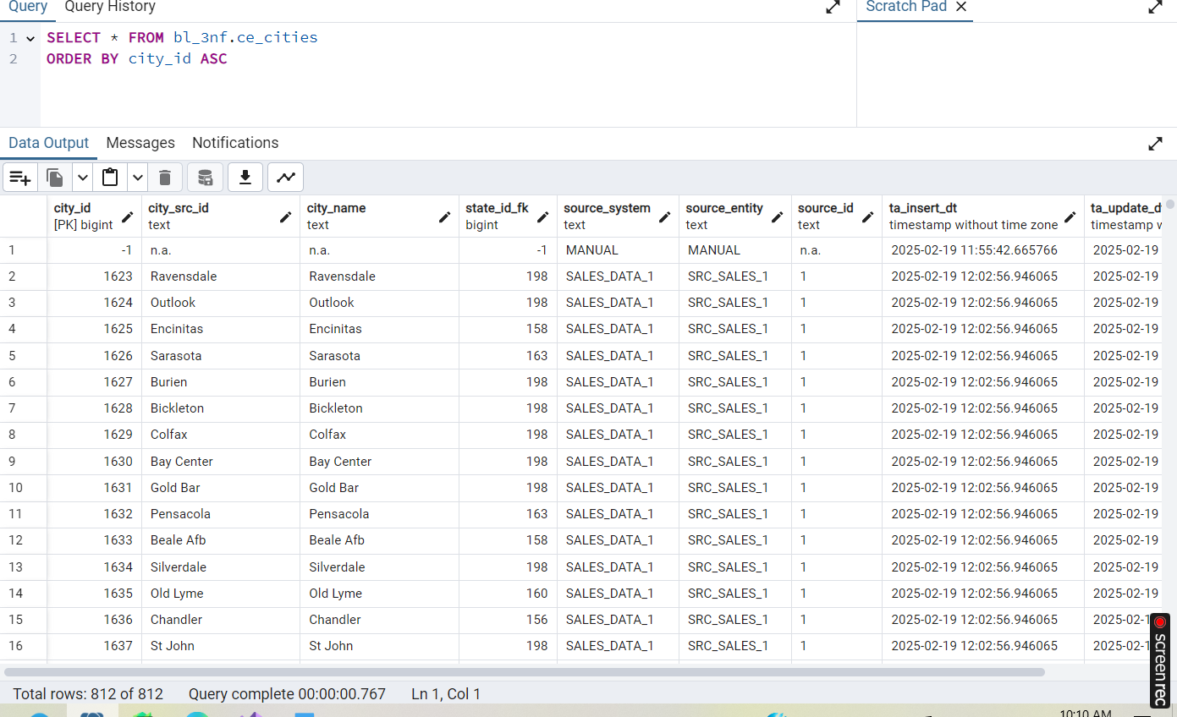

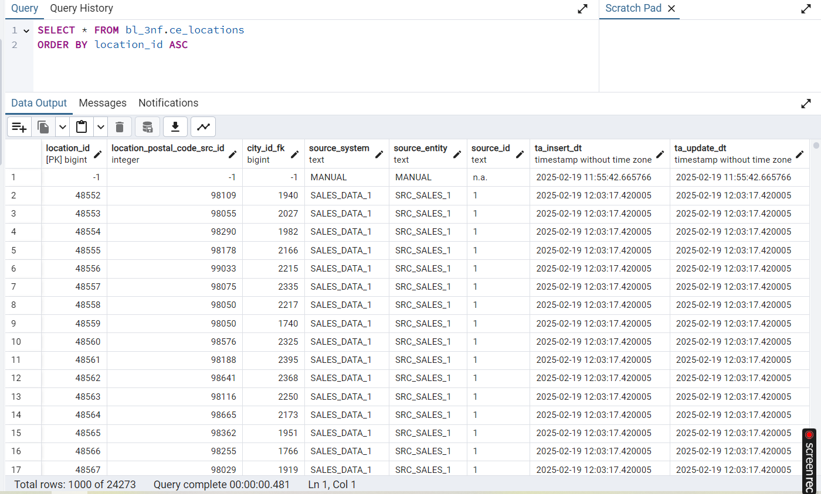

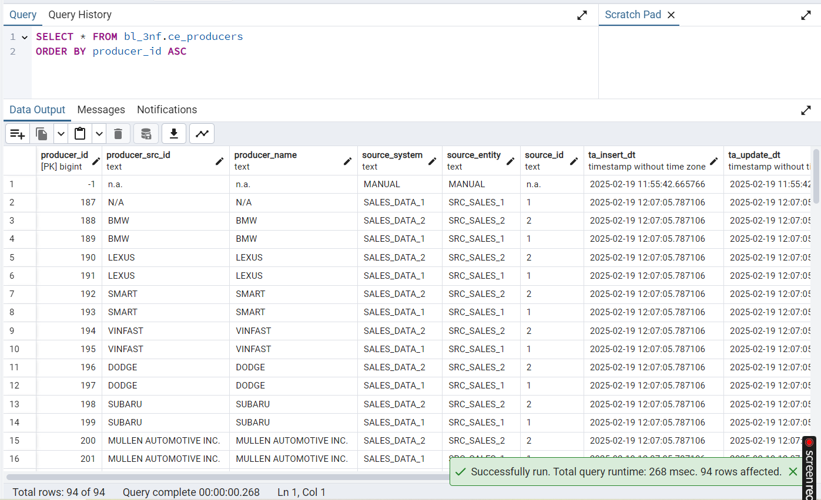

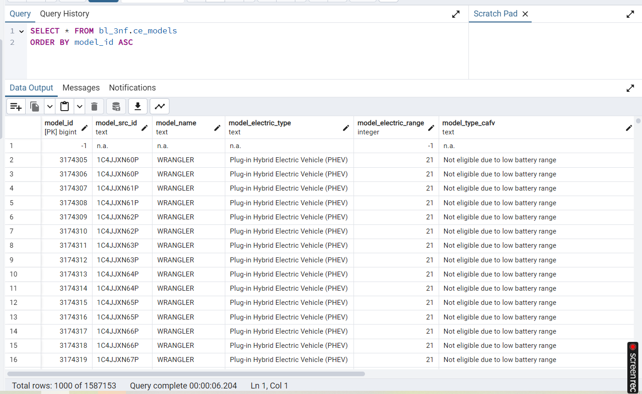

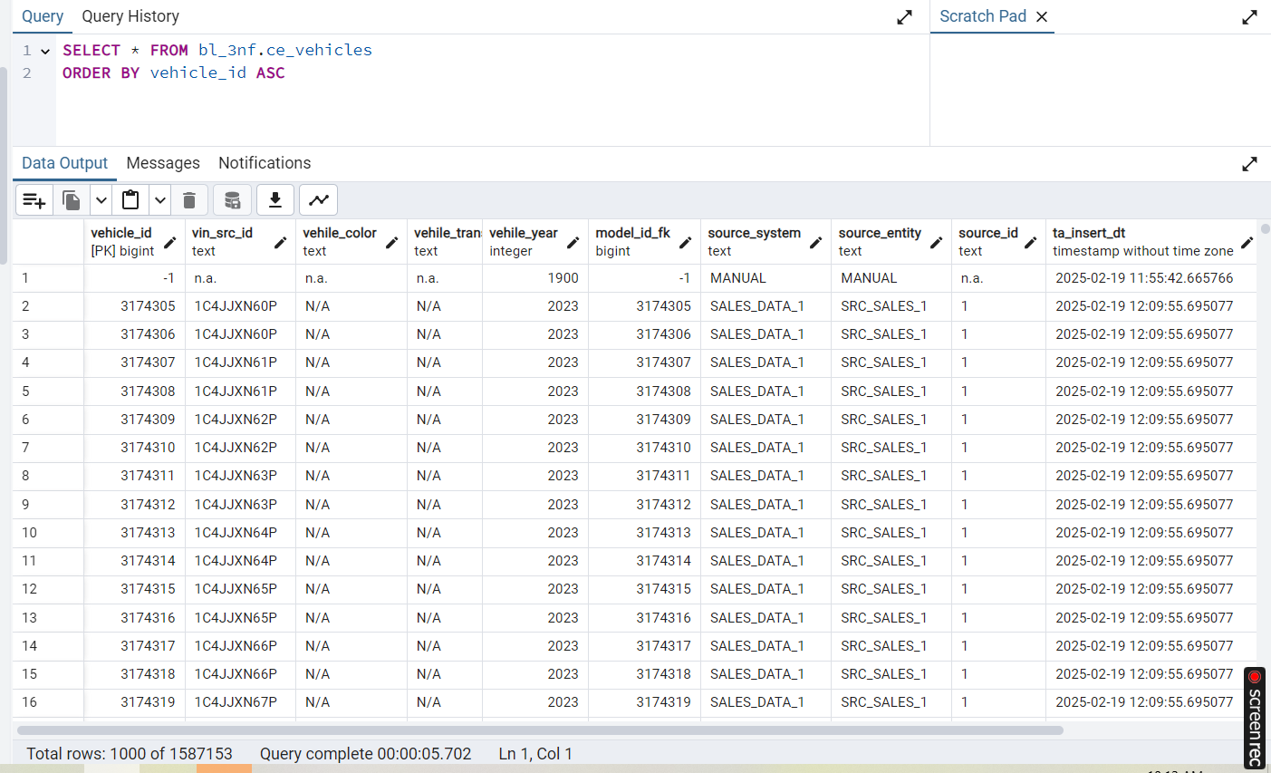

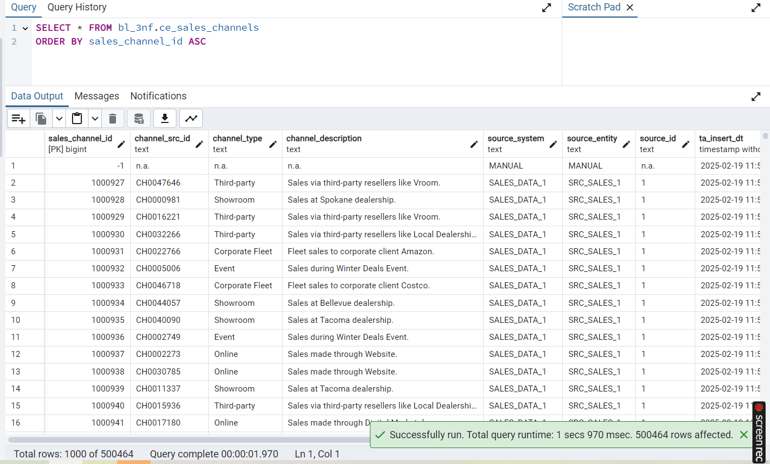

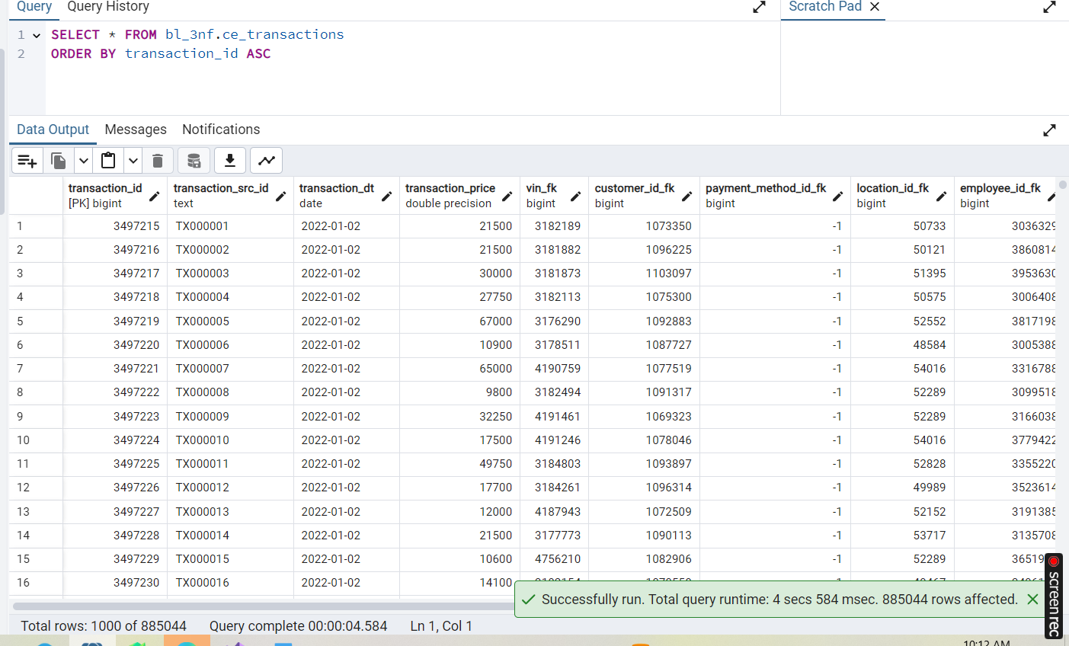

Task 2:

with sales_data_1

* 1st attempt: 0 because I alredy have data in ce_transactions, that's why perform delete.
* 2nd attempt: 500461 rows from sales_data_1
* 3rd attempt: rows_affected value is 0, which is correct

now the same with sales_data_2

* 1st attemt: 384583 new rows to transactions_ce
* 2nd attempt: 0 rows, which is correct

