**TASK 1**

**Data Loading Procedures for Dimensions**

This part outlines the procedures for loading data into various dimensions within the **BL_DM** schema. Each dimension has a corresponding stored procedure that handles the insertion and updating of data, ensuring data integrity and consistency.

**1. Customers Dimension**

**Procedure: bl_cl.load_dim_customers()**

**Description:** This procedure loads customer data into **BL_DM.DIM_CUSTOMERS**. It inserts new records and updates existing ones based on **Customer_SRC_ID** and **SOURCE_System**. A surrogate key is generated using **NEXTVAL('BL_DM.seq_dim_customers')**.

**Key Steps:**

* Log procedure execution.
* Retrieve the latest records from **BL_3NF.CE_CUSTOMERS**.
* Perform an **UPSERT** operation.
* Log success or failure messages.

**Execution:**

CALL bl_cl.load_dim_customers();

**2. Sales Channels Dimension**

**Procedure: bl_cl.load_dim_sales_channels()**

**Description:** This procedure loads sales channel data into **BL_DM.DIM_SALES_CHANNELS**. It retrieves the latest records and inserts or updates them accordingly.

**Key Steps:**

* Retrieve distinct latest records from **BL_3NF.CE_SALES_CHANNELS**.
* Construct dynamic SQL for **UPSERT** operation.
* **Execute** the **dynamic SQL**.
* Usage of cursor For loop.
* **Cursor Variables** – Stores column values from the cursor.
* Log success messages.

**Execution:**

CALL bl_cl.load_dim_sales_channels();

**3. Employees Dimension (Slowly Changing Dimension - SCD)**

**Procedure: bl_cl.load_dim_employees_scd()**

**Description:** This procedure loads employee data into **BL_DM.DIM_EMPLOYEES_SCD**, handling historical changes for employees by marking previous records as inactive.

**Key Steps:**

* Insert new employee records.
* Update existing records.
* Handle **SCD Type 2** changes by marking previous records as inactive when new records arrive.
* Log success messages.

**Execution:**

CALL bl_cl.load_dim_employees_scd();

**4. Locations Dimension**

**Procedure: bl_cl.load_dim_locations()**

**Description:** This procedure loads location data into **BL_DM.DIM_LOCATIONS**. It ensures data consistency by updating existing records when needed.

**Key Steps:**

* Join **CE_LOCATIONS** with **CE_CITIES** and **CE_STATES**.
* Perform an **UPSERT** operation.
* Log success messages.

**Execution:**

CALL bl_cl.load_dim_locations();

**5. Vehicles Dimension**

**Procedure: bl_cl.load_dim_vehicles()**

**Description:** This procedure loads vehicle data into **BL_DM.DIM_VEHICLES**, maintaining consistency across vehicle models and manufacturers.

**Key Steps:**

* Join **CE_VEHICLES** with **CE_MODELS** and **CE_PRODUCERS**.
* Perform an **UPSERT** operation.
* Log success messages.

**Execution:**

CALL bl_cl.load_dim_vehicles();

**6. Fact Transactions**

**Procedure: bl_cl.load_fact_transactions()**

**Description:** This procedure loads transactional data into **BL_DM.FACT_TRANSACTIONS**, linking all necessary dimensions.

**Key Steps:**

* Join transactional data with relevant dimension tables.
* Perform an **UPSERT** operation.
* Log success or failure messages.

**Execution:**

CALL bl_cl.load_fact_transactions();

**6. Date Dimension**

This function bl_cl.insert_dates() populates the BL_DM.DIM_DATES table with a continuous range of dates from January 1, 2010 to December 31, 2030. It ensures that the table contains all necessary date-related attributes to support time-based analysis.

**Key Features:**

* **Date Range Generation:** Uses GENERATE_SERIES() to create a sequential list of dates from 2010 to 2030.
* **Extracting Date Components:** The procedure extracts key components such as year, quarter, month, week, day, and weekday name from each generated date.

**Execution:** SELECT bl_cl.insert_dates();

Add screenshots showcasing the data inserted into the DM layer.

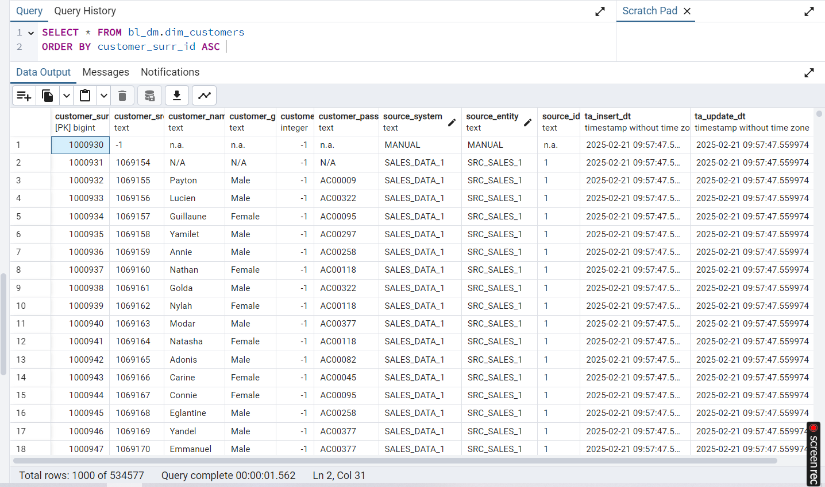

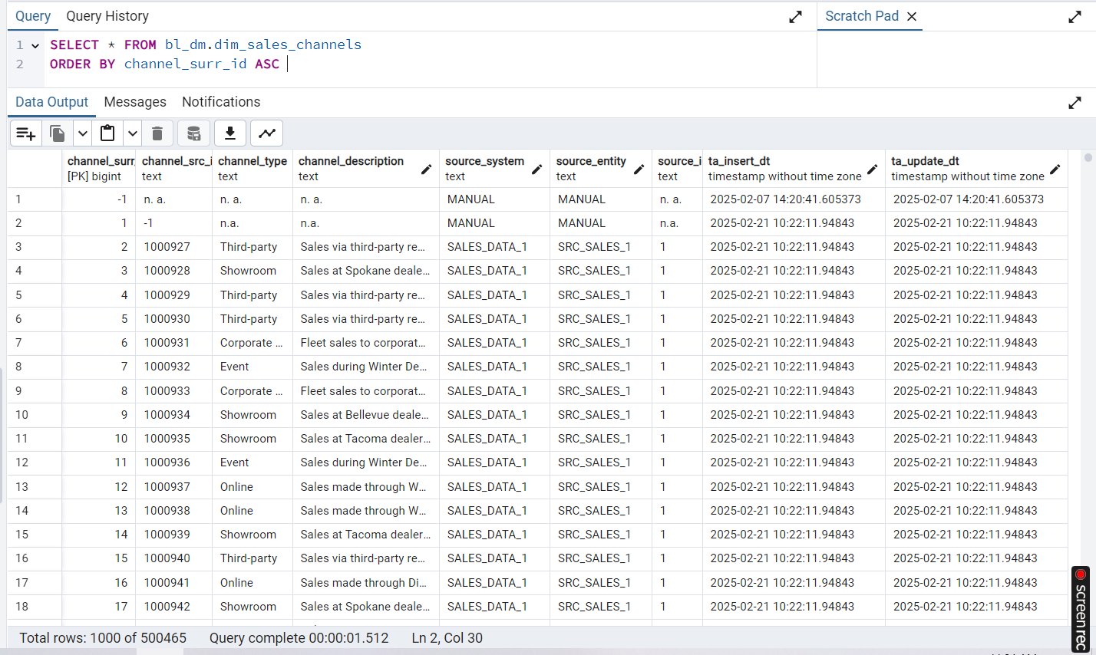

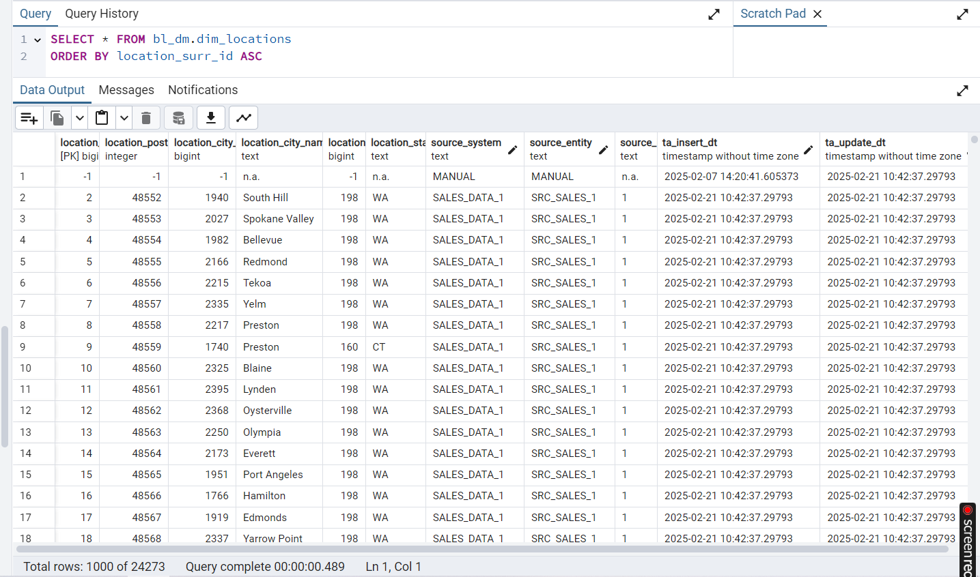

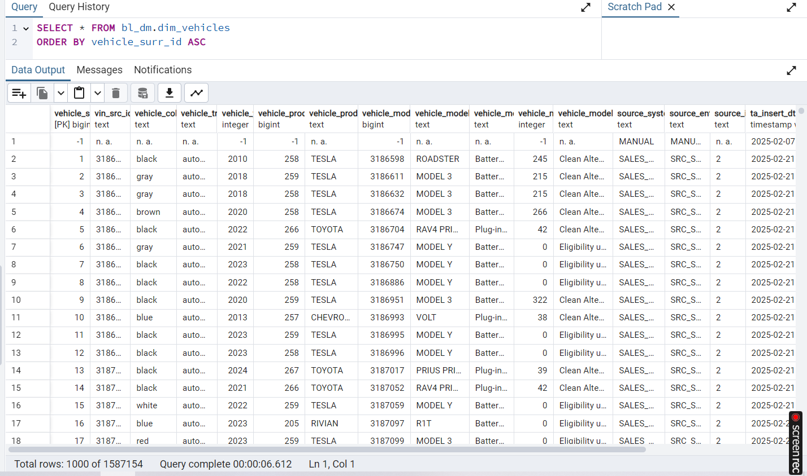

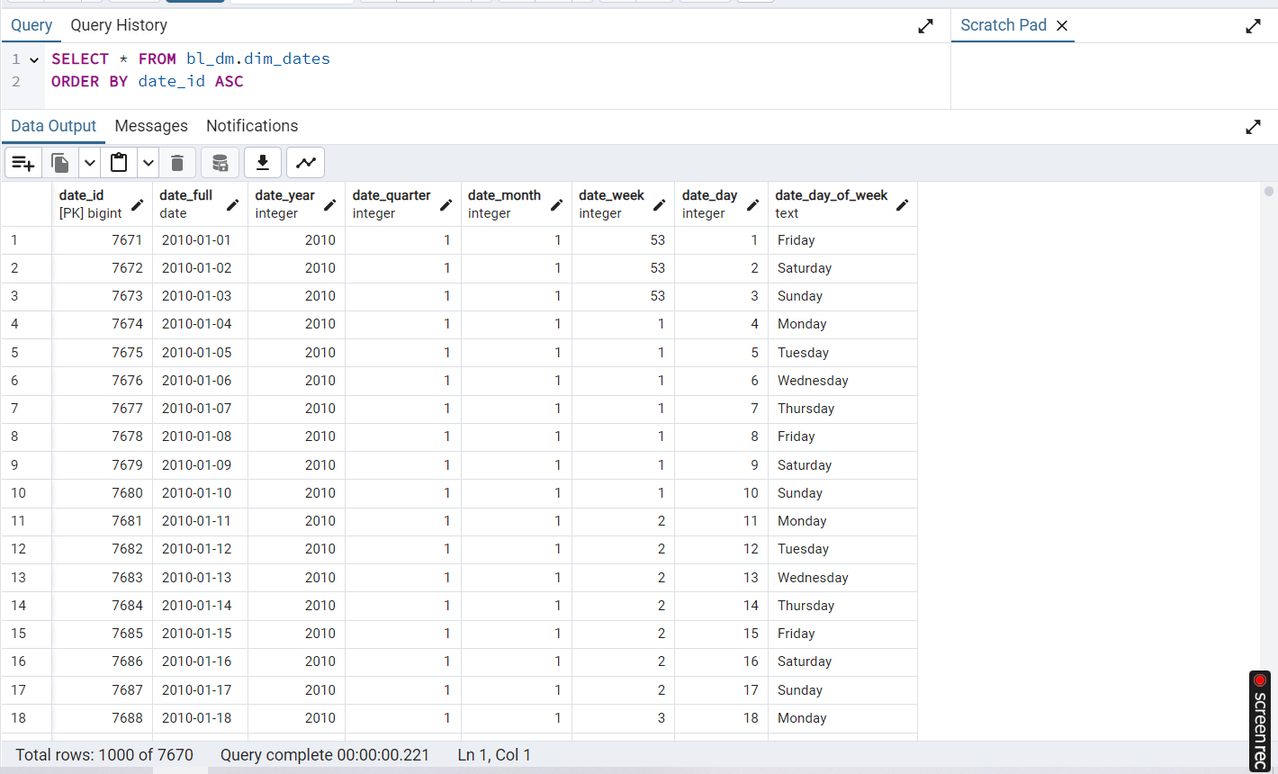

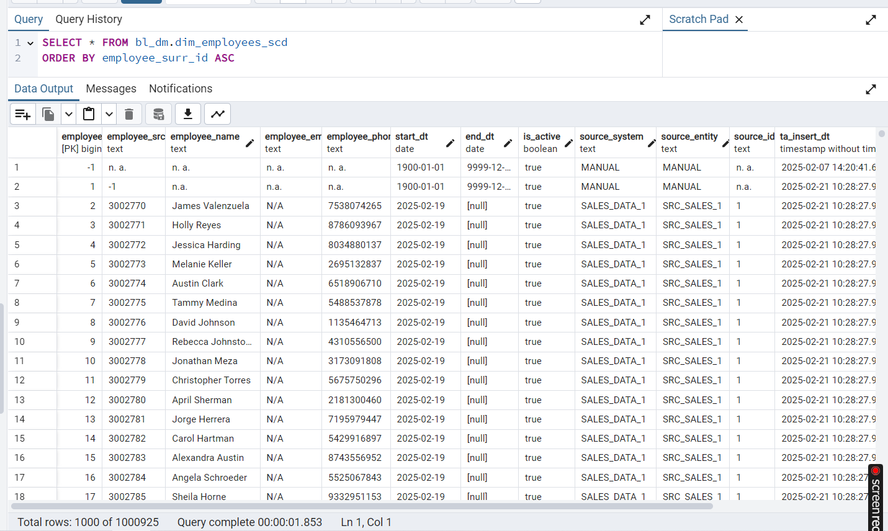

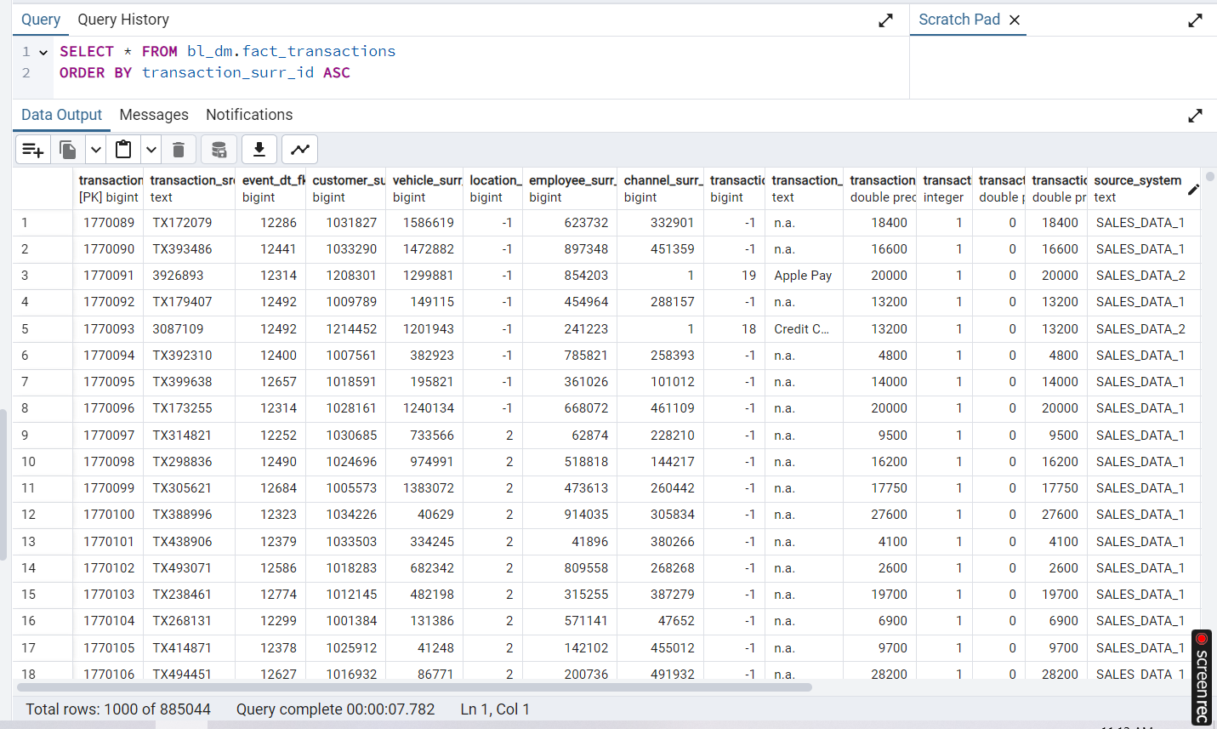

**TASK 2**

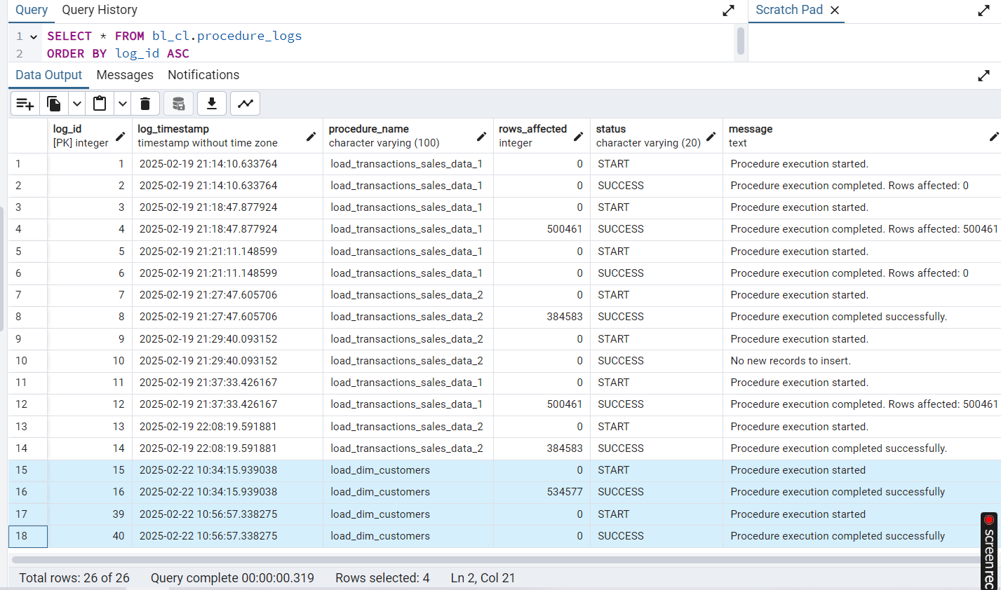

**TASK 3**

I made changes in sales_data_1, this is what I had before:



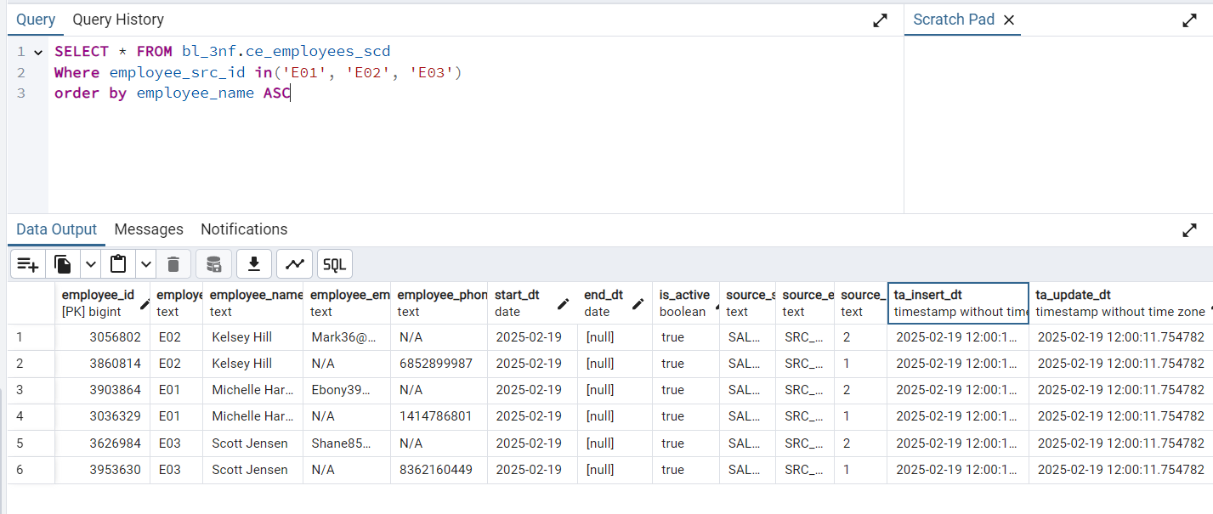

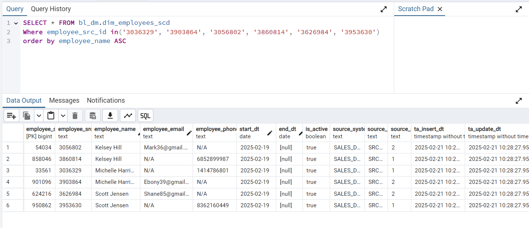

This after I made changes: for E01 set new name, and for E03 changed phone.



So firstly, I looked into external table:

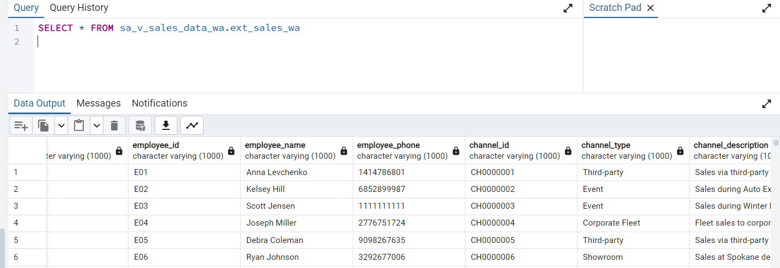

Fine, data was changed automatically.

Then I used a script from some previous hw for inserting into src table and got next result. So here data was changed successfully also.

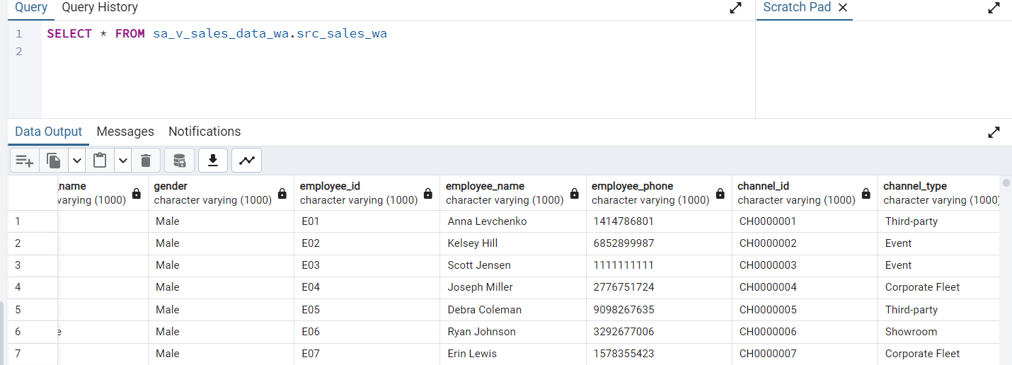

Then I tried to insert data to 3nf but my query from previous hw was not working, then I did a new one, but it runs too long, so that’s why I created only for specific employee_id. You can find new query in emoloyee_3nf_new.sql

And it gives me correct result:

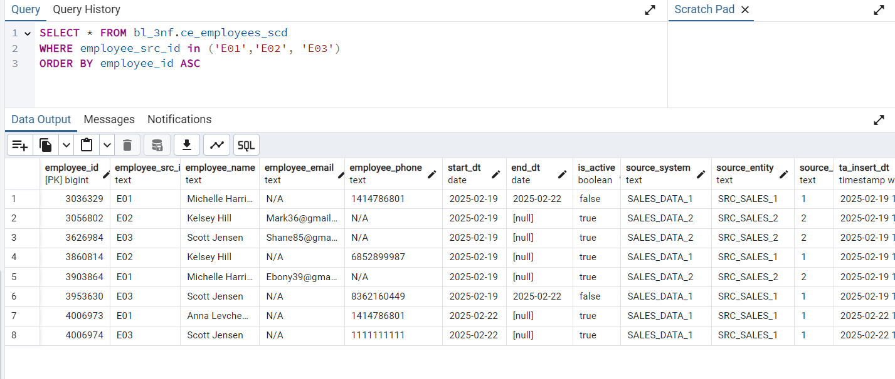

Then I was loading to dim, that takes values from 3nf, so result seems correct:

