* Add screenshot showcasing that procedure can be executed repeatedly with ‘Number of rows affected’ is 0

3nf

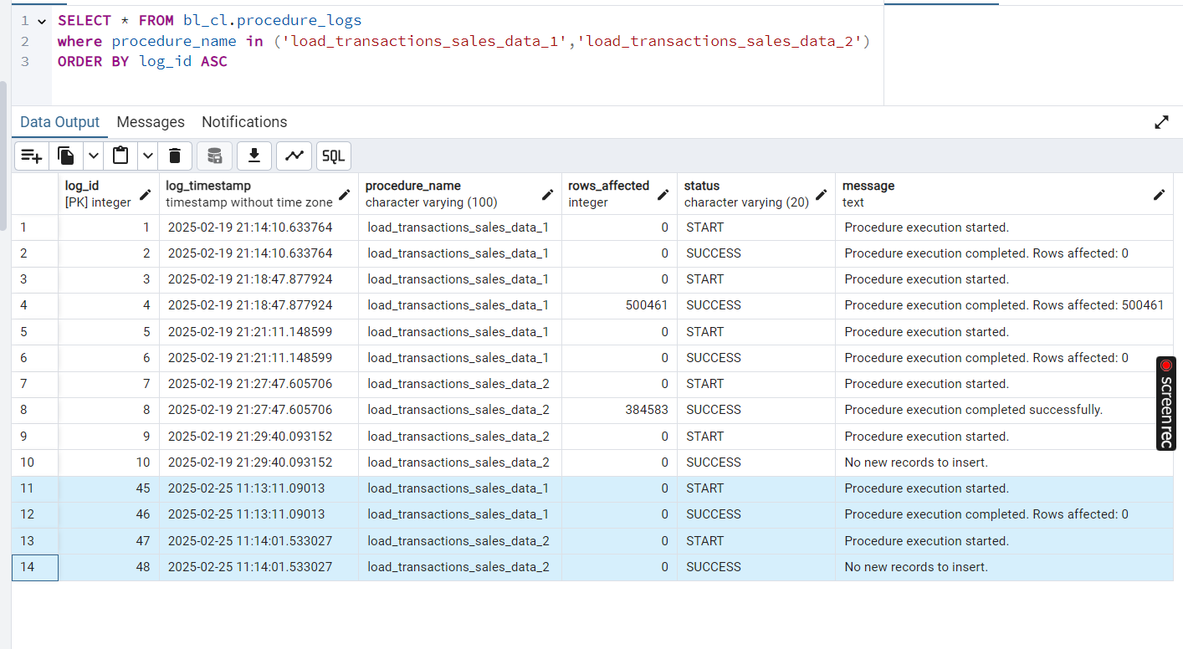

dim

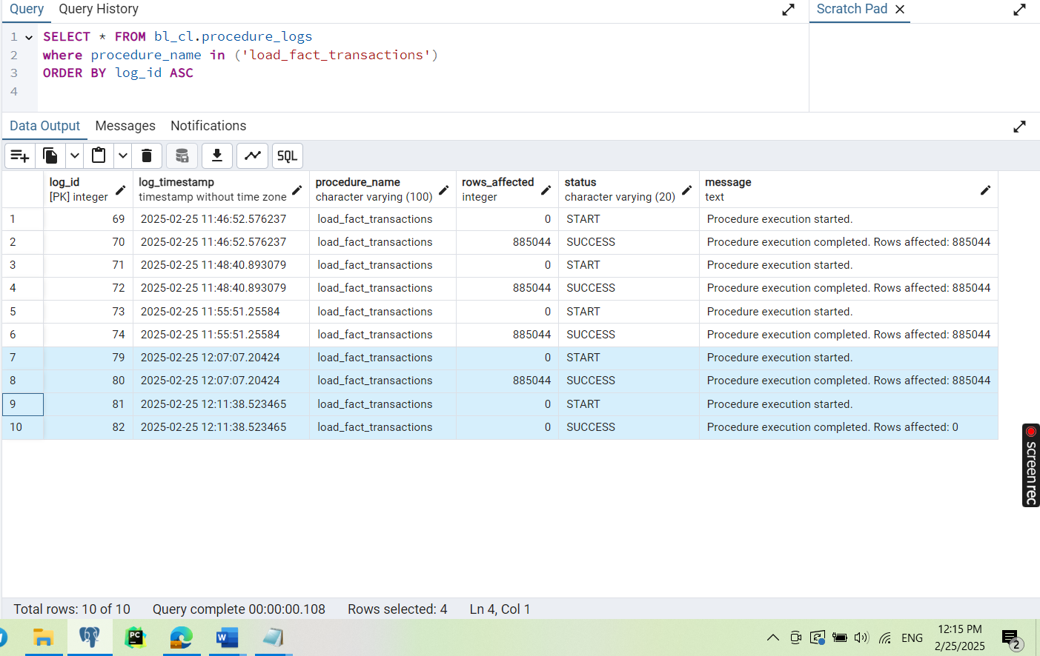

* Add screenshot showcasing the data inserted into fact tables on the 3NF and DM layers.

3nf

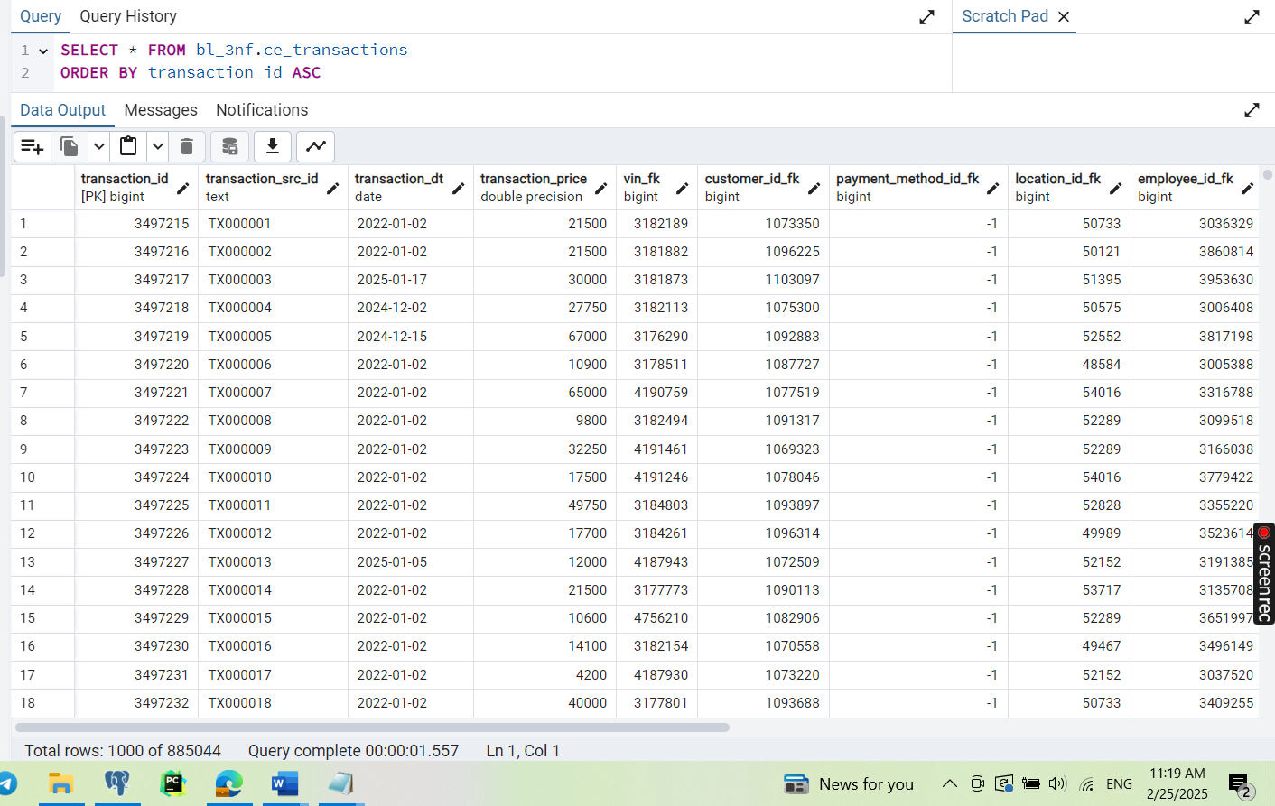

dim

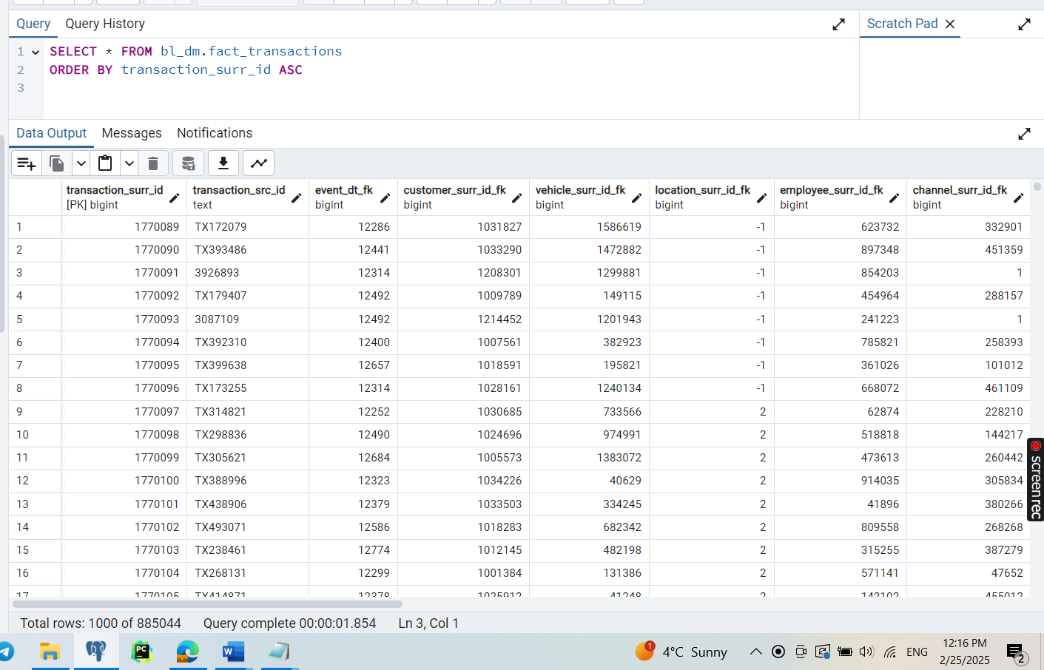

* Add screenshot showcasing that all your objects are loaded correctly, without duplicates

3nf

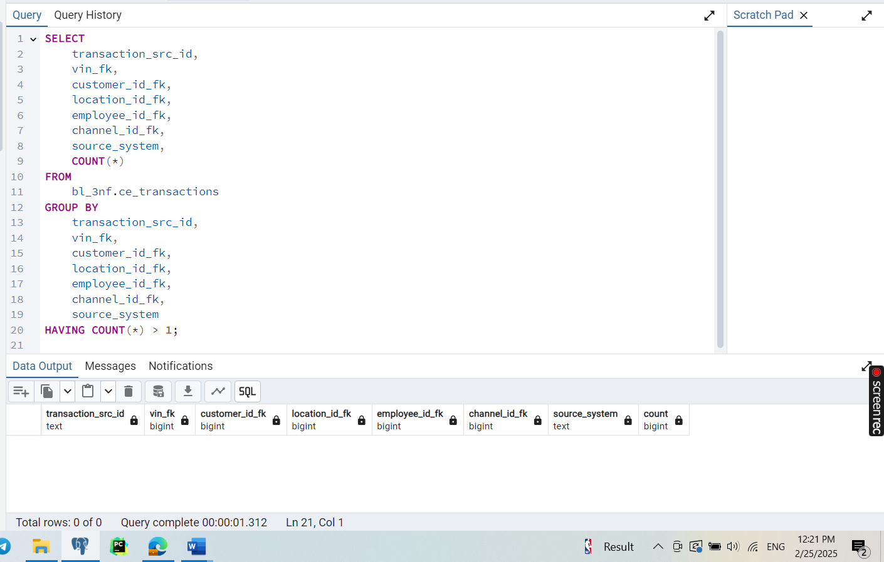

dim

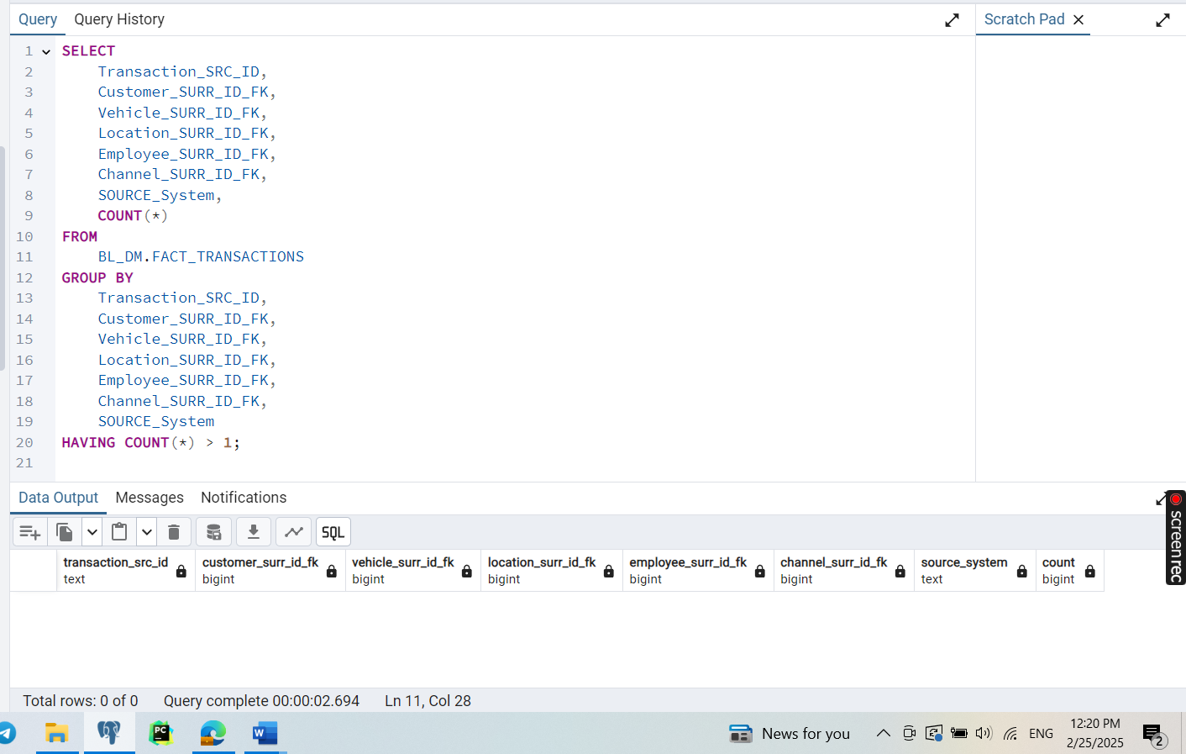

* Implement Fact Table load on DM with use of attaching/detaching PARTITION clause and logic of load for some rolling window period (2-3 months).

For task with partitioning, I changed date_full in some rows to in order to get result for last 3 months (Dec 2024, Jan 2025, Feb 2025)

**Explanation of** bl_cl.load_fact_transactions() **Procedure:**

* Creating partitions for BL_DM.FACT_TRANSACTIONS for a rolling window of months.
* Loading data from BL_3NF.CE_TRANSACTIONS into BL_DM.FACT_TRANSACTIONS while handling duplicates using ON CONFLICT.
* Ensures partitions exist for transactions up to the next month.
* Creates and attaches missing partitions dynamically.
* Uses exception handling to prevent data corruption.

