**Task 1.** Figure out what security precautions are already used in your 'dvd_rental' database. Prepare description

1. Check User Roles and Privileges

-- Check role-specific privileges

SELECT rolname, rolsuper, rolinherit, rolcreaterole, rolcreatedb, rolcanlogin

FROM pg_roles;

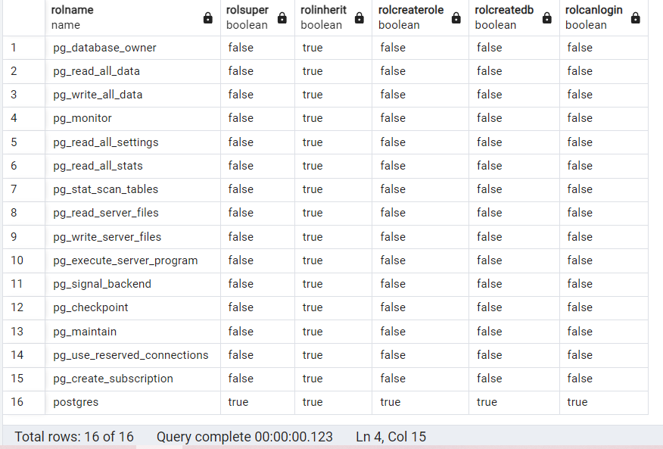

1. Check Role Memberships

-- Show role memberships

SELECT roleid::regrole AS member, member::regrole AS role

FROM pg_auth_members;

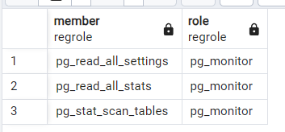

1. Check Database Object Permissions

-- List all schemas and their owners

SELECT schema_name, schema_owner

FROM information_schema.schemata;

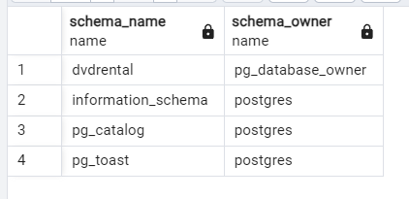

-- Check table privileges

SELECT grantee, privilege_type, table_schema, table_name

FROM information_schema.role_table_grants;

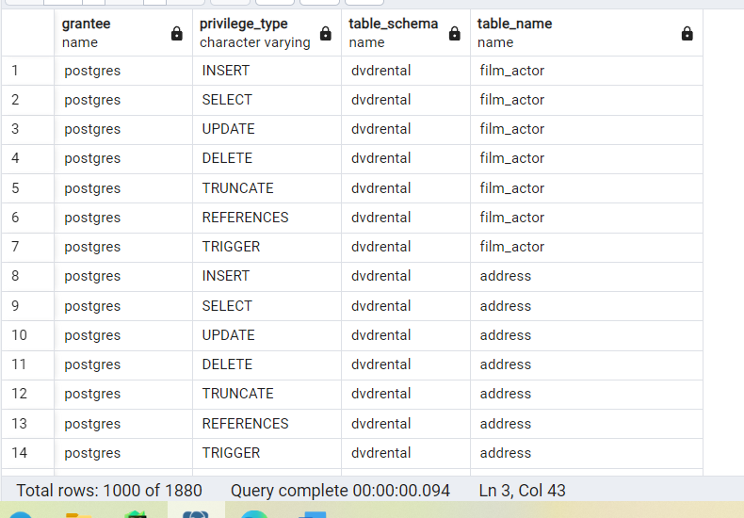

-- Check function privileges

SELECT grantee, privilege_type, routine_schema, routine_name

FROM information_schema.role_routine_grants;

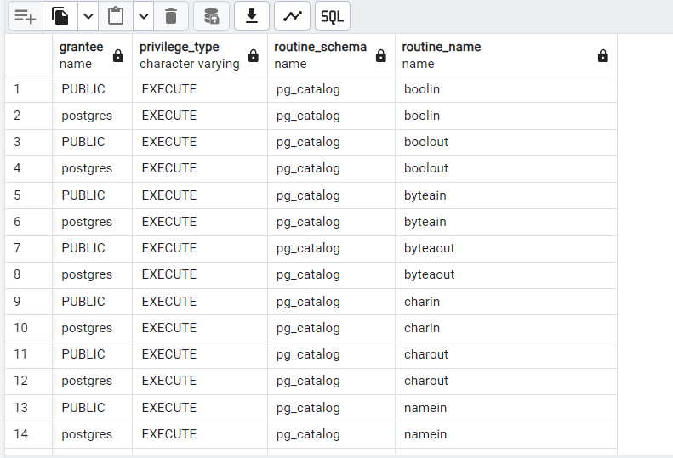

1. Password and Authentication

-- Check password-encryption status

SELECT rolname, rolpassword

FROM pg_authid

WHERE rolpassword IS NOT NULL;

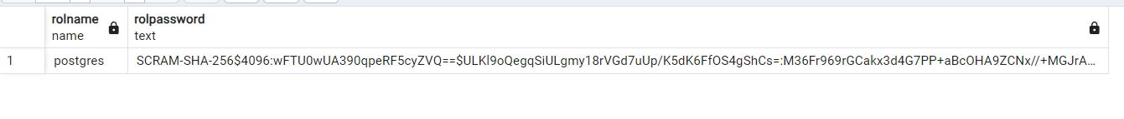

-- Check the PostgreSQL configuration for authentication

SHOW password_encryption;

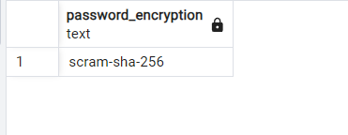

1. Database-Level Security Settings

-- Check security-related settings

SHOW ssl; -- SSL enabled

SHOW client_min_messages; -- Minimum log level for client connections

SHOW log_connections; -- Logging connection attempts

SHOW log_disconnections; -- Logging disconnections

SHOW log_hostname; -- Logging client hostname

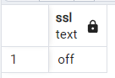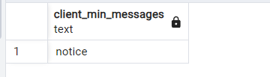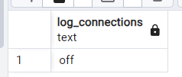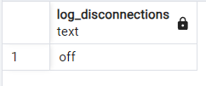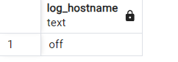

1. Monitor and Detect Intrusions

-- Look for extensions or audit tools

SELECT extname, extversion

FROM pg_extension;

