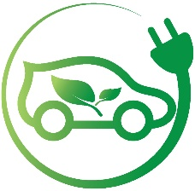**Business Model Overview**

**Company Name**: GreenDrive Motors

**Field of Activity**: GreenDrive Motors is a forward-thinking electric vehicle (EV) dealership specializing in the sales, promotion, and distribution of Battery Electric Vehicles (BEVs) and Plug-in Hybrid Electric Vehicles (PHEVs). The company strives to provide eco-friendly and efficient transportation options, contributing to a sustainable future. GreenDrive Motors is committed to delivering cutting-edge EV solutions while embracing innovation and ensuring customer satisfaction

**Business Process to Expose and Analyze**

GreenDrive Motors primarily engages in the sale of electric vehicles across the Washington (WA) and Florida (FL) markets. The business process that will be exposed and analyzed in the report involves the **sales transactions of electric vehicles**. This includes understanding the relationship between various factors such as vehicle type (BEVs or PHEVs), customer demographics, sales channels, employee performance, and pricing trends. By analyzing these elements, GreenDrive Motors aims to optimize its sales strategy, forecast future demand, and improve customer satisfaction.

**Key Aspects of the Business Process**:

* **Sales Data**: Detailed transactional data, including VIN, sale price, date, and associated employee and customer.
* **Customer Demographics**: Insights into customer profiles, such as gender, age, and location (city and state).
* **Product Information**: Vehicle specifications, including make, model, year, electric range, and CAFV eligibility.
* **Employee Data**: Sales performance metrics for employees involved in the transaction.
* **Sales Channel**: Identifying which sales channels (e.g., online, showroom, event) are most effective in driving purchases.

**Purpose of the Report**

The primary purpose of this report is to provide GreenDrive Motors with actionable insights that support strategic decision-making. The report will enable the company to assess its current performance, identify market trends, and optimize its sales approach by leveraging data. By analyzing sales patterns, customer behaviors, and employee performance across different states and channels, the report will help the company make informed decisions about product offerings, pricing strategies, and market expansion.

Key objectives of the report:

1. To track and analyze sales trends for BEVs and PHEVs in Washington and Florida.
2. To identify the most effective sales channels and assess the performance of employees.
3. To better understand customer preferences, such as which vehicle features and price points are most attractive to different demographics, which payment methos is in demand.
4. To forecast future demand based on historical sales data and trends.
5. To identify opportunities for improving customer satisfaction and employee performance.

**End User of the Report**

The primary end users of this report are:

* **Sales Managers and Executives**: Responsible for overseeing sales performance and strategic direction. They will use the report to track sales metrics, evaluate the effectiveness of sales strategies, and adjust business plans.
* **Marketing Team**: To assess customer demographics and trends, the marketing team will use the report to tailor advertising campaigns and promotional activities.
* **Product Development Team**: To understand consumer preferences for vehicle models, features, and electric ranges, allowing them to make decisions about future product offerings and improvements.
* **Operational Managers**: To streamline sales operations, employee performance, and identify areas for improvement.

**Business Questions and Problems Addressed by the Report**

The report aims to resolve the following business questions and challenges:

1. **Sales Performance**:
   * **Business Question**: Which vehicle models are selling the most in Washington and Florida? What car is in the highest demand? Sales amount this and previous year.
   * **Business Problem**: Difficulty in understanding the product demand in each market, which hinders inventory management and forecasting.
2. **Sales Channel Effectiveness**:
   * **Business Question**: Which sales channels (e.g., online, showroom, event) are most effective in generating sales for BEVs and PHEVs?
   * **Business Problem**: Uncertainty regarding the return on investment in different sales channels, making it challenging to allocate resources effectively.
3. **Employee Performance**:
   * **Business Question**: Which employees are driving the highest sales? What factors contribute to their success?
   * **Business Problem**: Insufficient data on employee performance, which limits the ability to reward top performers or identify training needs.
4. **Pricing Strategy**:
   * **Business Question**: How do vehicle pricing trends affect customer purchasing behavior? Are there pricing patterns that correlate with higher sales volumes?
   * **Business Problem**: Difficulty in setting optimal prices that balance profitability and competitiveness in the market.
5. **Customer Segmentation**:
   * **Business Question**: What are the demographic characteristics of our customers (age, gender, location)? How do these factors influence vehicle sales?
   * **Business Problem**: Lack of insights into customer characteristics, making it difficult to tailor product offerings.
6. **Payment Method Demand**:
   * **Business Question**: What payment methods are the most popular?
   * **Business Problem**: Lack of insights into payment method preferences, making it difficult to tailor marketing strategies.

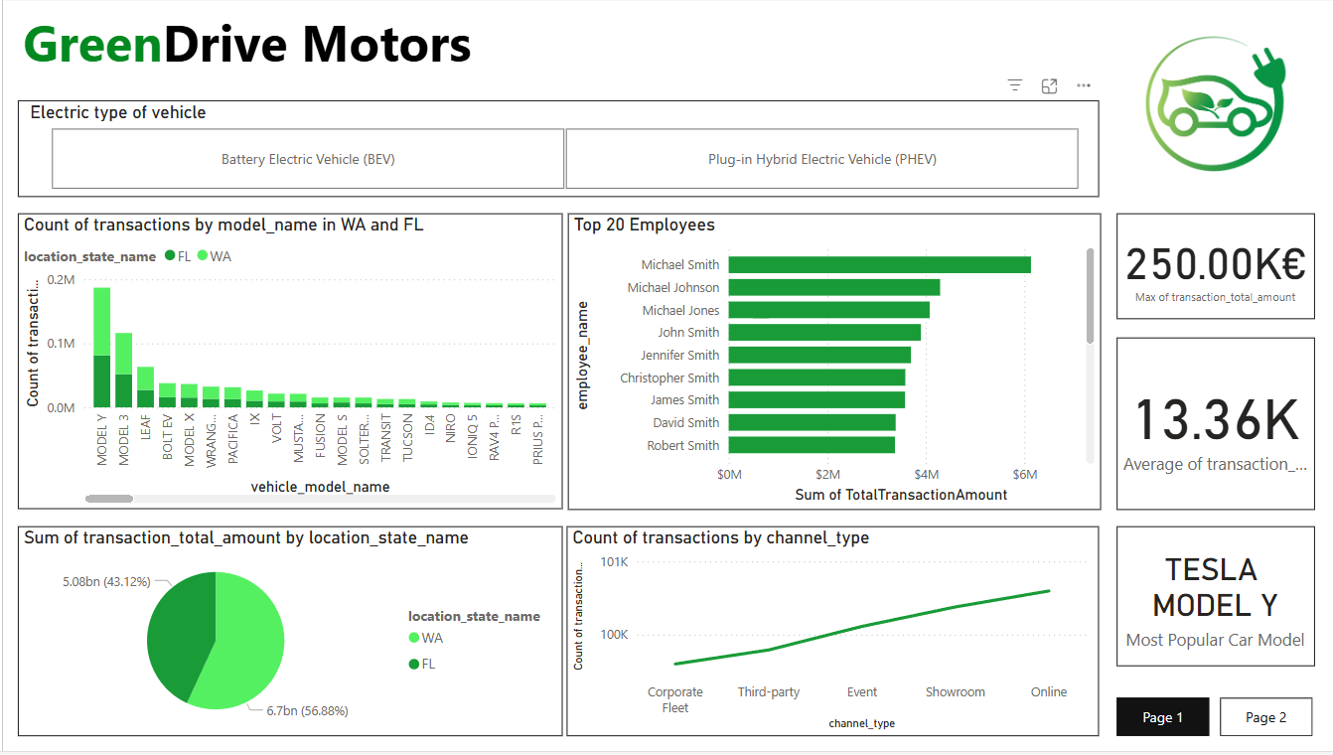

Figure 1. Page 1

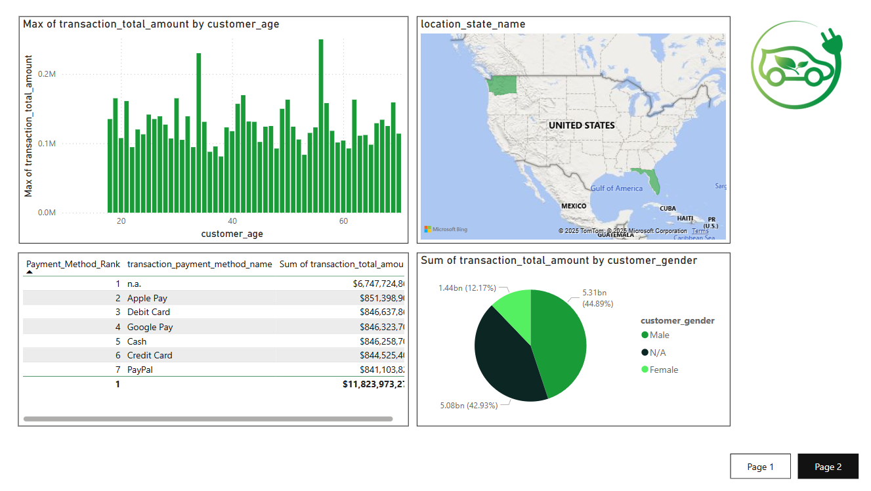

Figure 2. Page 2

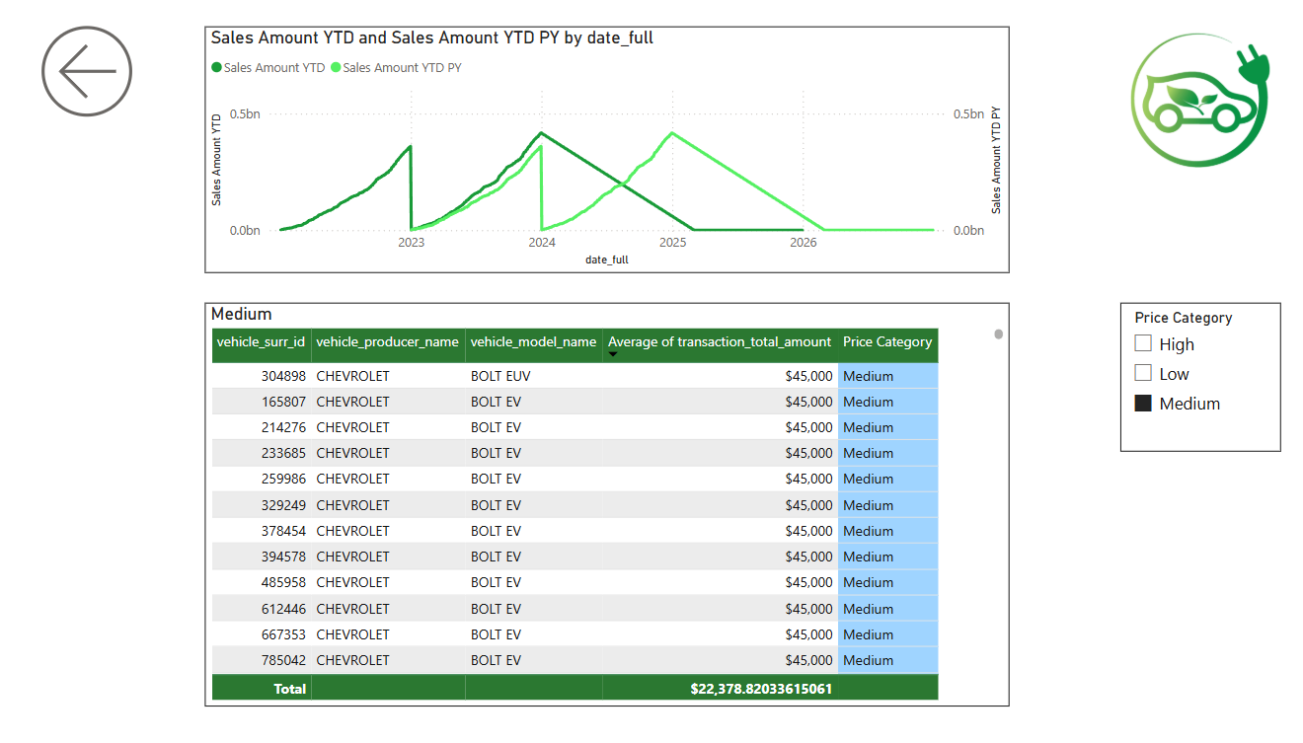

Figure 3. Drill-through page

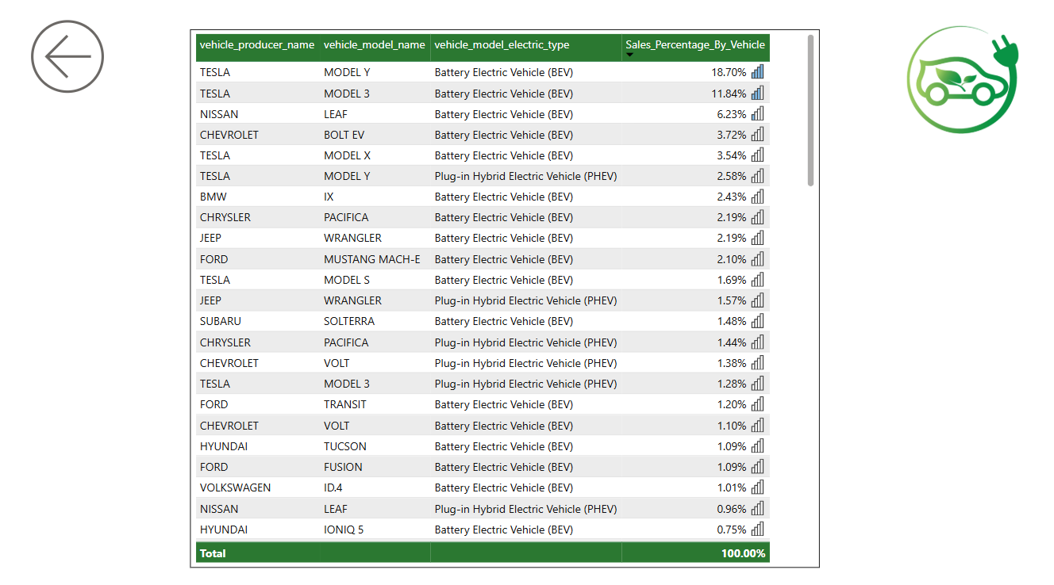

Figure 4. Drill-through page

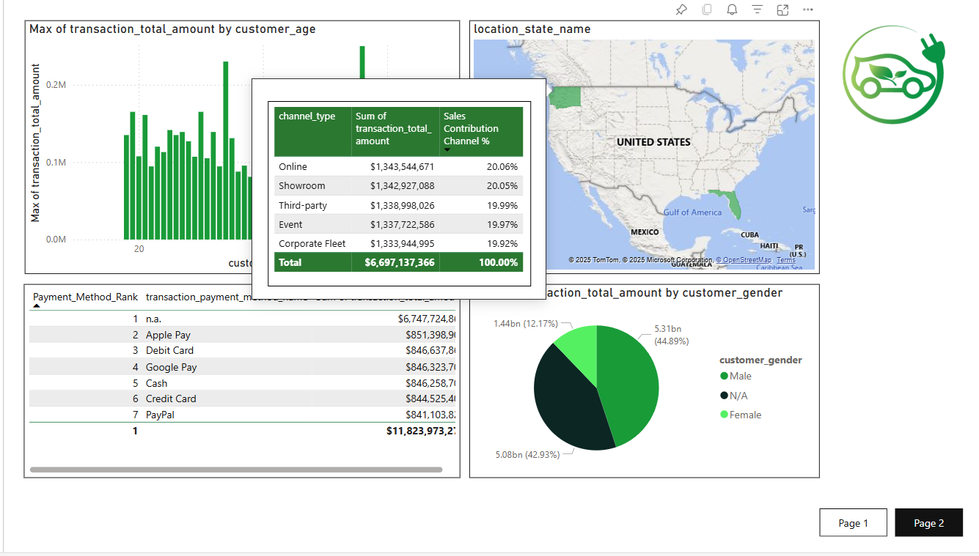

Figure 5. Tooltip page

Download file:

<https://drive.google.com/drive/folders/1gv9sycEuxTP0FIQlNxvSaAJfaufkqk3R?usp=drive_link>

Power BI Service:

<https://app.powerbi.com/links/P--nDACw8y?ctid=b41b72d0-4e9f-4c26-8a69-f949f367c91d&pbi_source=linkShare&bookmarkGuid=1777d7ce-c1d2-41cc-a175-2352fc451e16>