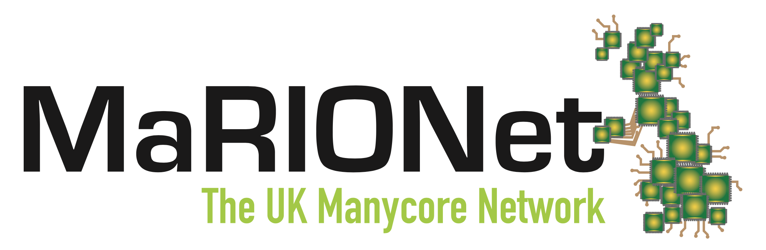

Welcome to the launch meeting of the UK Manycore Network. The Manycore Research, Innovation and Opportunities Network is funded by EPSRC throughout 2016-19. Our aim is to enhance the capability of the UK manycore research community through focused engagement of academic and industrial researchers.

At this initial event we will assess the current state of manycore research and plan our coordinated actions for the next few years.

We are delighted to invite you to the event dinner which will take place from 17:30 today

the address of the restaurant will be announced at the close of the meeting

at a location nearby Imperial College, Huxley Building.

With compliments of the project coordination team in Glasgow.
http://manycore.org.uk/

Launch Meeting Agenda

0930 | Coffee on arrival
1000 | Welcome and Overview
1020 | Steve Furber: Manycore, past, present and future
1100 | Coffee
1115 | Academic Lightning Session - 2 min talks
1200 | Industrial Lightning Session - 2 min talks
1230 | Matchmaking A – speeed-date for collaborations
1300 | Lunch
1400 | Matchmaking B - speed-date for collaborations
1430 | Adam Luqmani: EPSRC Cross-ICT Priorities
1500 | Panel Discussion with Alastair Murray, Bodo Scholz and Phil Trinder
1530 | Coffee
1550 | Simon McIntosh-Smith: Parallel Programming - State of the Nation
1630 | close
1730 | Optional dinner --- for people who can stay later

Delegates

