Data Warehouse Lab
Runescape Market Data

Software Needs Assessment

Prepared for
Application Development Lab

Prepared by
Anna Williams

Last Updated: | October 7, 2019
Document Version: | 1
Document:

Table of Contents
Version History 1
1.0 Introduction 2
1.1 Purpose 2
1.2 Scope 2
1.3 References 2
1.4 Overview of Document 3
2.0 System Overview 3
2.1 Project Perspective 3
2.2 System Context 3
2.3 General Constraints 3
2.4 Assumptions and Dependencies 3
3.0 Domain Model 3
3.1 Class Diagrams 4
3.2 Class Specifications 4
4.0 Throw-Away Prototyping 4
5.0 Requirements 4
5.1 Use Case Requirements 4
5.1.1 Actor List 4
5.1.2 Use Case Diagrams 5
5.1.3 Use Case Specifications 6
5.1.4 Use Case Standard Template 7
5.2 Business Rules 7
5.3 Non-Functional Requirements 7
5.3.1 System Requirements 7
5.3.2 Usability Requirements 8
5.3.3 Performance Requirements 8
5.3.4 Security Requirements 8
5.3.5 Delivery Requirements 8
5.3.6 Legal Requirements 8
5.3.7 Interoperability Requirements 8
5.3.8 Scalability Requirements 8
5.3.9 Data Retention Requirements 8
5.4 Interface Requirements 8
5.4.1 Machine Interfaces 8
5.4.2 External System Interfaces 8
5.4.3 Human-Computer Interface Considerations 9
5.4.4 Input and Output Requirements 9
6.0 Project Issues 9
6.1 Projected Development Effort 9
6.2 Proposed Project Schedule 9
6.3 Conversion / Load Requirements 9
6.3.1 Data Population 9
6.3.2 Reference tables and Baseline Data 9
6.3.3 Data Conversion Strategy 9
6.3.4 Data Conversion Assumptions and Constraints 9
7.0 Appendices 9
Sign-Off 11

Version History
Document Version | Date | Author(s) | Details/Description
1.0.0 | 2019-10-7 | Anna Williams

Introduction

Purpose
The purpose of this lab is to create a data warehouse from a data repository.

Scope
The data warehouse must be able to do the following things
- Provide Flexibility for data retrieval and reporting
- Provide the ability to drill down
- Ensure data consistency

References
Runescape_Market_Data.xlsx

Overview of Document
<Summarize the contents of each section of this document.>

System Overview
This data warehouse will be built around a data set of the runescape market. While for the purposes of this lab the dataset is static it was collected with a scraper and that could be implemented into a future version of this project.

Project Perspective
This system is a data warehouse extension for handling data from the data scraper built by Nixonite on github. This data scraper gathers data from grandexchangewatch.com and then places them in an xml file.

System Context
Using the data provided in the xml file this software will extract, transform, and load the data into a data warehouse. This data warehouse will then provide the end user with the ability to slice and drill down the resulting data.

General Constraints

This system will be entirely utility and will focus on utility over design. Because of this the current plan is to use a simple SPA to drill up and down the data. Along with a list of the data provided this system will use phpChart to provide helpful graphs.

Assumptions and Dependencies

Assumptions
      - That I know how to use phpChart
      - That the user can read English
      - That the user has access to a mouse or keyboard
      - That the user has internet access
      - Due to the large amount of data being observed and the graphs being used it is assumed that the end user has a screen and is able to use it

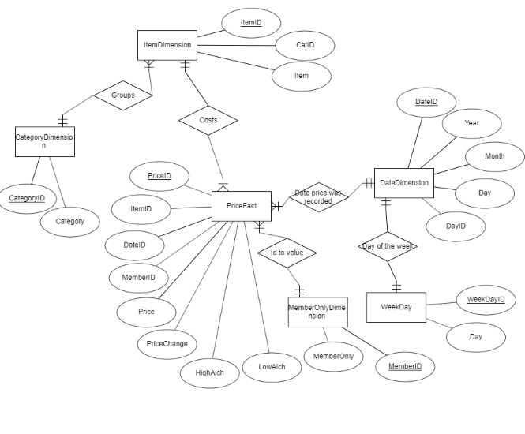

Ending notes
-I would have added a slice (WHERE) and and sort (ORDER BY) buttons. I know how to I just don’t have the time and need to move on the next lab
-I couldn’t get PHPGraph to work but I could also try something like a jquery library but again not enough time

