Original pipeline of the code (there are actually 3 phases, stage 1, stage 2, and stage 4, where stage 3 is external functions and stage 5 is included in the Montecarlo loop):
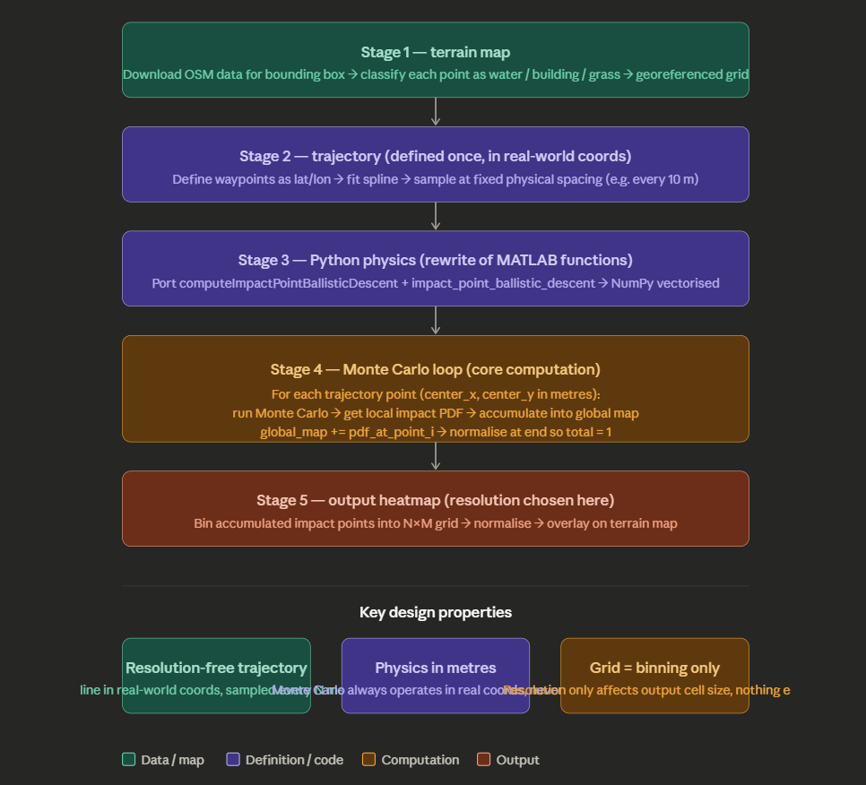

Explanation of degrees and UTM coordinates:
The idea is that we need to translate a sphere coordinates in meters coordinates. The sphere coordinates are in degrees, and the 0's of this coordinate system are the equator and the greenwitch meridian. The bounding box i chose is defined by these degree coordinates, which are included in the .OSM file. THEN, we need to convert it into plane coordinates. This means that we need to use the UTM system. This UTM system divides the earth into zones which, depending on the allocation of the bounding box i am analysing, i have different levels of distortion. The idea is that every one of these boxes has its own ad-hoc conversion precisely because of these different levels of distortion. There is a python package (contains the to_utm function, I think) which automatically does this conversion for me. I indicate the zone in which my city is located, and the sphere-to-plane conversion happens automatically. The output of this conversion is in x (easting) and y (northing) coordinates, in metres. The origin of this new coordinate system is the equator for northing, and a False Easting for Easting, meaning that the easting is artificially summed +500,000m to the central meridian of the zone. This is done to avoid negative eastings. My bounding box is therefore in metres in this northing-easting system

Rettangolo di mappa individuato:
- South: 45.039 (waypoints go down to 45.0407, minus a small margin)
- North: 45.10247 (keep existing north edge)
- West: 7.672 (waypoints go left to 7.6742, minus a small margin)
- East: 7.73095 (keep existing east edge)
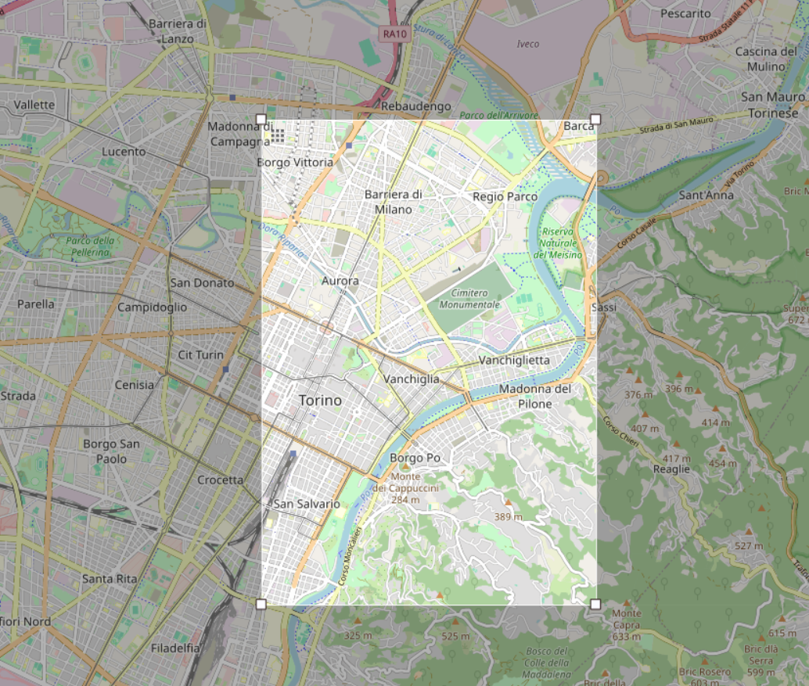

Definizione della traiettoria – Bertelli 2021
- Fase 1: Decollo verticale fino a quota 75m da Molinette
- Fase 2: buffer Molinette – Po (Traiettoria ben definita)
- Fase 3: transito sul Po fino all’end buffer (inizio fase 4)
- Fase 4: buffer sopra la città vs. buffer considerato Stura + parco. Stura + parco viene scelta perché ha una P_totale_casualty minore rispetto al caso sopra la città (1.67 * 10^-5 h^-1 vs. 1.73∙ 10^−5ℎ^-1) (pg. 86 tesi Bertelli)
- Fase 5: atterraggio verticale al San Giovanni Bosco – mia decisione contraria a Bertelli, in un’ottica in cui si sviluppa un dispositivo di safety voglio poter atterrare sul tetto dell’ospedale
Dati .osm presi da: https://extract.bbbike.org
Montecarlo simulation inputs
- Grid: 500x500 (squares)
- Road buffer: 5m
- Rivers:
  - Dora buffer: 0.0002°
  - Po buffer: 0.0007°
  - Small streams: 0.0001°
- Sample spacing for the trajectory points: 10m
Output grid (independent of Phase 1 terrain grid – resolution of the impact probability heat map!!!
- N1 = 2000, N2 = 2000

# --- Physical parameters (payload) ---
- g = 9.81 # gravity (m/s^2)
- densita = 1.225 # air density (kg/m^3)
- massa = 1.0 # payload mass (kg) - da aggiornare quando avrò il cad della supposta!!!
- superficie = 0.04 # reference area (m^2) da aggiornare col cad!!!

# --- Uncertain parameters (mean, std) ---
- altezza_mu = 75.0; altezza_sigma = 5.0 # altitude at failure (m)
- Cd_mu = 1.0; Cd_sigma = 0.1 # drag coefficient
- Vx_i_mu = 17.0; Vx_i_sigma = 6.0 # horizontal velocity at separation (m/s)
- Vy_i_mu = 0.0; Vy_i_sigma = 0.5 # vertical velocity at separation (m/s)
- mu_vento = 2.0; sigma_vento = 4.0 # wind speed (m/s)
- mu_drone = 0.0; sigma_drone = 90.0 # wind direction (degrees)

# --- Monte Carlo samples per trajectory point ---
- GUESS = 5000 # ← increase to 1000+ for statistically meaningful results

- Spiegazione del codice e delle funzioni di phase 3:
in compute_impact_point:
- `Gamma` is the **terminal velocity** of the payload — the maximum speed it reaches in free fall when drag exactly balances gravity: F_gravity = m × g F_drag = c × V² At terminal velocity: m × g = c × V² → V_terminal = sqrt(m × g / c) = Gamma
- Vy_i = np.where(Vy_i < 0, 0.0, Vy_i)
If the payload has downward vertical velocity at separation (Vy_i < 0), it is clipped to zero. This means the model assumes the worst-case scenario is the payload separating while the drone is flying level — any downward velocity at separation is treated as zero upward velocity, skipping Phase 1 entirely.

Role of drag in the ballistic calculations:
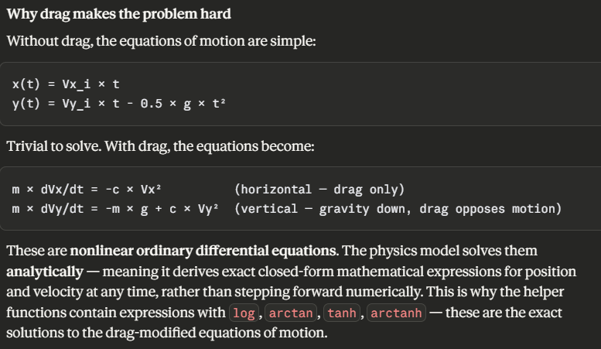
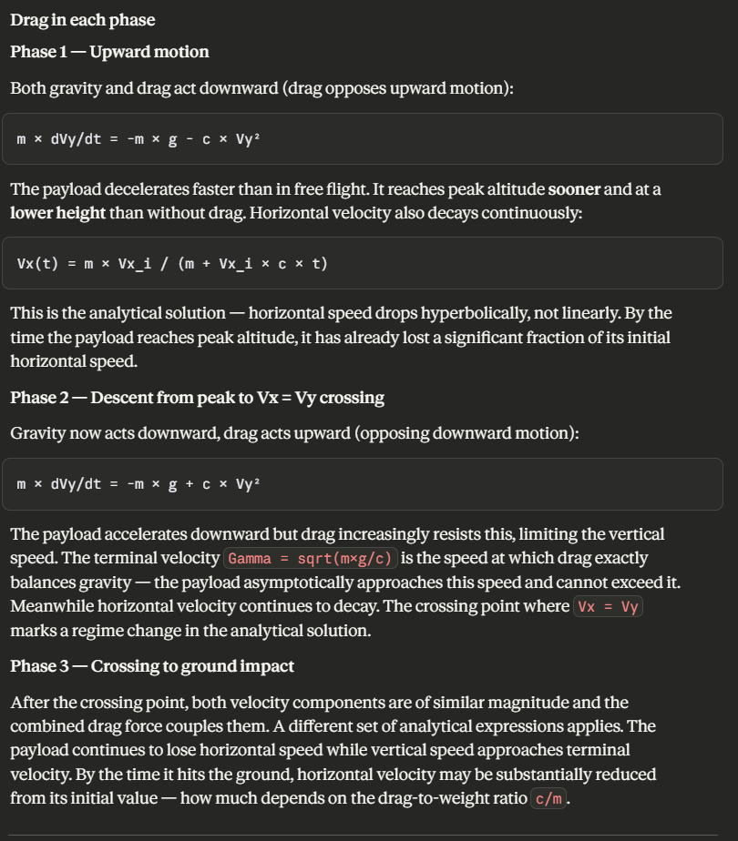
Gamma = np.sqrt(m * g / c)
```

This single quantity controls everything about how drag affects the trajectory:

- **High Gamma** (heavy payload, small area, low Cd) → drag is weak relative to gravity → payload behaves almost like a projectile → lands far from the drop point
- **Low Gamma** (light payload, large area, high Cd) → drag is strong → payload slows quickly → lands close to the drop point

For your payload (`m=1.5 kg`, `S=0.04 m²`, `Cd=1.0`, `ρ=1.225`):
```
c = 0.5 × 0.04 × 1.225 × 1.0 = 0.0245
Gamma = sqrt(1.5 × 9.81 / 0.0245) ≈ 24.5 m/s
```
Terminal velocity of ~24.5 m/s means the payload reaches a maximum downward speed of about 88 km/h. Since the drone's cruise speed is ~23 m/s — almost exactly equal to terminal velocity — the horizontal and vertical velocities are of similar magnitude at impact, producing impact angles of roughly 45° from horizontal.

---

### How drag affects the impact point location

Without drag the payload would travel:
```
horizontal range ≈ Vx_i × t_fall (simple projectile)

