Camping Resource Site Plan

Rick Cantrell

WDD 130

Overview

Purpose
To provide beginners and experienced campers with the knowledge and resources to be successful. To give them some basic knowledge.

Audience
Anyone with an interest in camping.

Branding

Website Logo
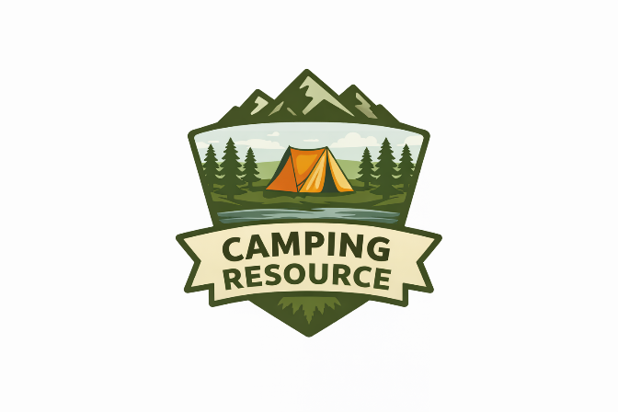

Style Guide

Color Palette
Primary | Secondary | Accent 1 | Accent 2
#2F5D3A  DARK GREEN | #E6D8B8  Light tan | #E67E22  Dark orange | #4A7C8C  Light blue

Typography

Heading Font: Montserrat

Paragraph Font: Open Sans

Navigation
Home Page2 Page3

Content

Home Page (index.html content)
Site Title:
Camp & Trail
Tagline:
Simple camping plans. Better outdoor trips.
Intro Paragraph:
Camp & Trail is a straightforward resource for planning camping trips. This site helps you find great destination ideas and understand what gear you need without overcomplicating things. Whether you’re heading into the mountains, camping by a lake, or staying in the forest, you’ll find simple guidance to get started.
What You’ll Find:
- Easy camping destination ideas
- Basic gear lists for different environments
- Practical planning tips for beginners
Navigation Links:
- Destination Ideas
- Gear Lists

Gear Lists Page (gear.html)
Page Title:
Camping Gear Lists
Intro Sentence:
These are simple gear lists based on different camping environments.

Mountain Gear
- Tent (weather-resistant)
- Sleeping bag (rated for colder temps)
- Sleeping pad
- Warm layers (jacket, hat)
- Headlamp or flashlight
- Portable stove
- Food and water

Lakeside Gear
- Tent
- Sleeping bag
- Camp chairs
- Cooler
- Water shoes or sandals
- Fishing gear (optional)
- Bug spray

Forest Gear
- Tent or hammock
- Sleeping bag
- Tarp or rain fly
- Rope or straps
- Headlamp
- Cooking supplies
- Extra socks and layers

Desert Gear
- Tent with good ventilation
- Sleeping bag (lightweight)
- Lots of water
- Sun protection (hat, sunscreen)
- Sunglasses
- Lightweight clothing
- Portable shade (optional)

Beach Gear
- Tent or sun shelter
- Sleeping bag or blanket
- Cooler
- Towels
- Sand stakes
- Sunscreen
- Extra water

Destination Ideas Page (destinations.html)
Page Title:
Destination Ideas
Intro Sentence:
Here are some popular camping destinations across the United States known for great scenery and outdoor experiences.

Yellowstone National Park (Wyoming, Montana, Idaho)
One of the most famous camping destinations in the U.S., known for geysers, wildlife, and large campgrounds.

Yosemite National Park (California)
A top destination for camping with iconic cliffs, waterfalls, and scenic valley campsites.

Grand Canyon National Park (Arizona)
Offers unforgettable views and well-known campgrounds like Mather Campground along the rim.

Zion National Park (Utah)
Known for red rock canyons and hiking trails like Angels Landing and The Narrows.

Glacier National Park (Montana)
Popular for alpine scenery, lakes, and scenic drives like Going-to-the-Sun Road.

Great Smoky Mountains National Park (Tennessee, North Carolina)
One of the most visited parks, offering forest camping, waterfalls, and wildlife.

Joshua Tree National Park (California)
A unique desert camping experience with rock formations and clear night skies.

Olympic National Park (Washington)
A diverse destination with mountains, forests, and coastline all in one park.

Big Bend National Park (Texas)
Remote desert camping with some of the best stargazing in the country.

Rocky Mountain National Park (Colorado)
High elevation camping with mountain views, wildlife, and hiking access.

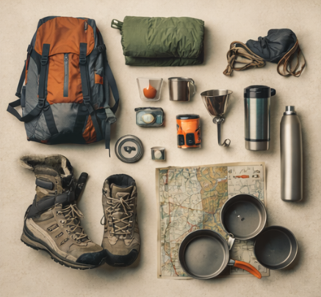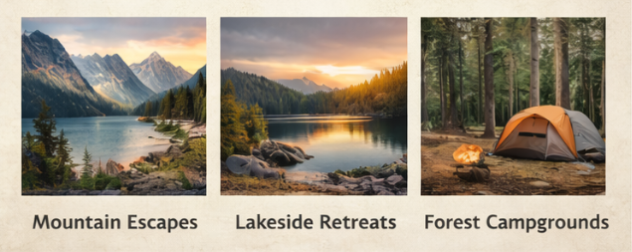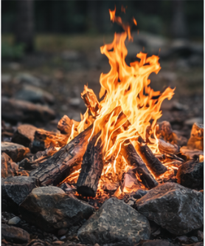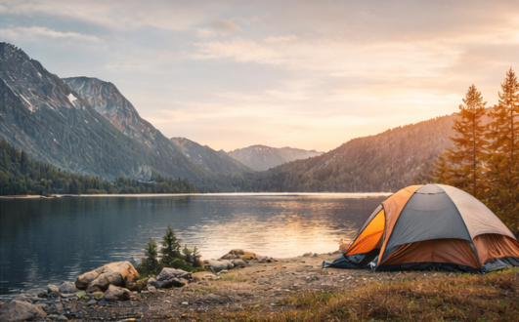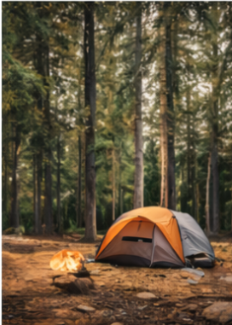

Wireframes

Home
