Barbershop Music Site Plan

Anna Burke

WDD 130

Overview

Purpose
To introduce people to how cool Barbershop Quartets can be! This site will cover a brief history of Barbershop music, the many genres of modern barbershop, and feature a few great songs.

Audience
Anyone who is interested in Barbershop Quartets, music, vocal performance, and wants to learn more or find new music.

Branding

*No images have been optimized

Website Logo
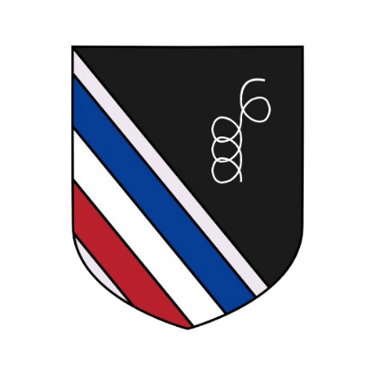

Style Guide

Color Palette
Primary | Secondary | Accent 1 | Accent 2
#063f95  (blue) | #bb212c  (red) | #1b1b1b  (dark grey) | #ffffff  (white)

Typography

Heading Font: Karopapier

https://www.dafont.com/karopapier.font

Paragraph Font: Arial

Navigation
Home Page2 Page3

Content

I will get back to you when I have written all the text, but for now you can use Lorem Ipsum.

Header background image:

History images:
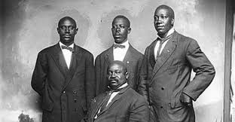
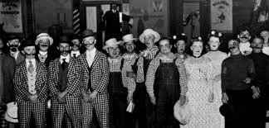

Other images:
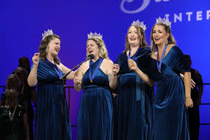
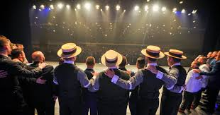
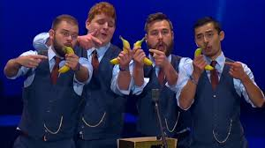
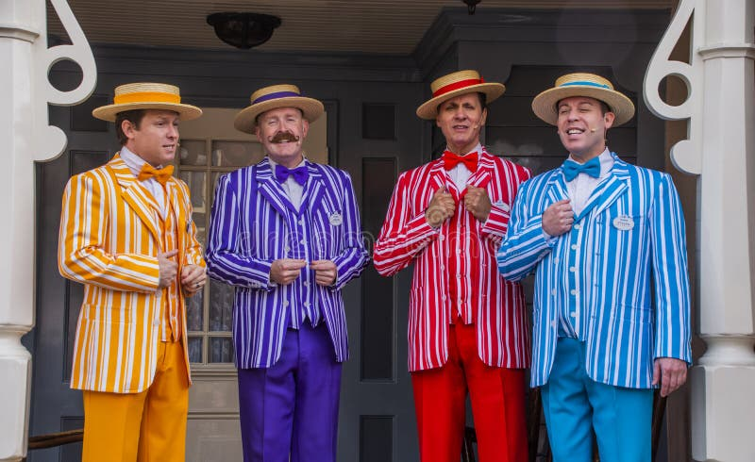
(use ^this one if the youtube video doesn’t work on the home page)

Links to videos:
Comedy: https://www.youtube.com/watch?v=mjcIpSSk30E
Home Page: https://www.youtube.com/watch?v=Qo_N9_ZFBhs
Women’s quartet: https://www.youtube.com/watch?v=z1ZBzT_b1C4
Competition winners: https://www.youtube.com/watch?v=Ta_LlRYvifg
historical: https://www.youtube.com/watch?v=2BDnLoRJHps&list=RD2BDnLoRJHps&start_radio=1

Wireframes

Home

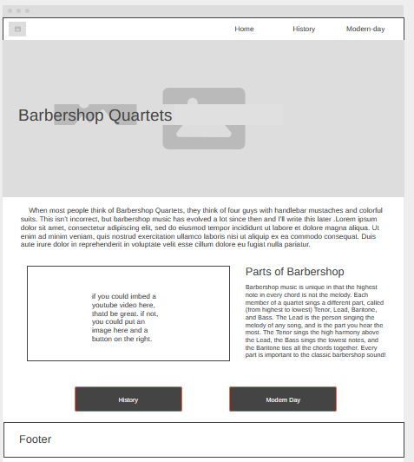

History 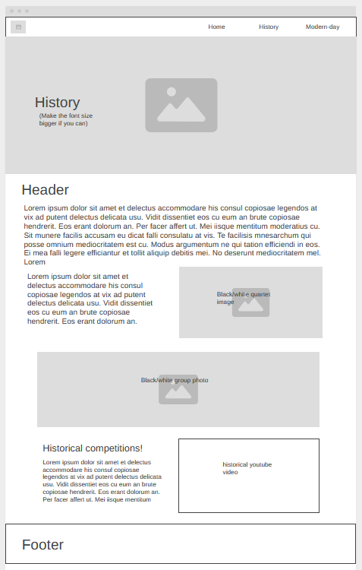

Modern day 