**Business Correspondence_Home Task**

Analyze one of your emails based on the rule of 5c and attach it to the Courses.

Please, do not analyze news, announcements etc.

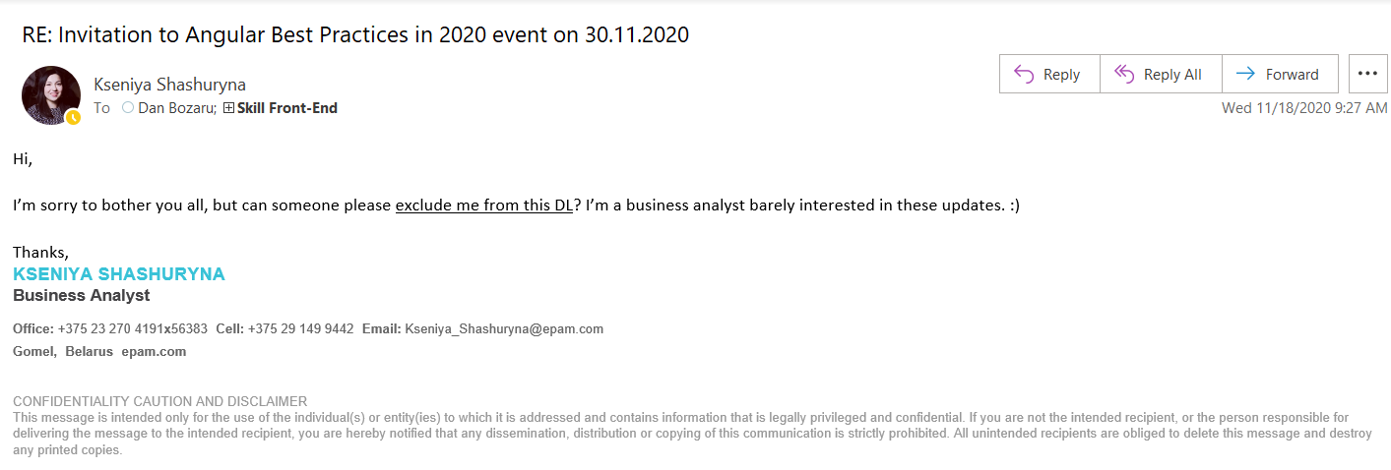

+ Correct – the letter does not contains any mistakes. This is short and grammarly correct letter.

+ Concise – the letter is not excessively wordy, so it contains short and logical body message

- Complete – the letter is not complete, since is not clear who is the recipient (and obviously the letter should not be sent out to all participants of current mailing, but instead it should be obtained by Dan Bozaru only). And as well instead of phrase “exclude me from this DL” would be more correct to clarify which Designated List author means (because we can see the related mailing only from Re-Mailing).

+ Courteous – the author message is polite and friendly, and with humor. This is not official letter.

- Clear – the letter is clear with the purpose but is not clear why everyone for this mailing received this letter and what other recipients should do with this request