
Ingatestone Hall symbol, https://www.ingatestonehall.com/

Audley Court

“It lay down in a hollow.” So Mary Elizabeth Braddon begins Lady Audley’s Secret. The “it” here is the country house, Audley Court, scene of the novel’s most memorable incidents: the discovery, in her boudoir, by Phoebe and Luke Marks of Lady Audley’s past maternity; a midnight expedition which reveals to George Talboys that his wife is alive and has taken on a new identity; George’s near-fatal plunge into a well; and Lady Audley’s dramatic confession to her husband, Sir Michael. Repeatedly, Braddon returns us to this home, with its Gothic resonances and seemingly fatal secrets. Audley Court represents the culmination of Lucy Graham’s desires, to be the mistress of a fine house; it’s the prison her lies have constructed; and it’s a symbol of continuing patriarchal and upper-class rule. Such houses, argues Elizabeth Langland, “metaphorically and metonymically stood for power and one’s moral entitlement to that power” (6-7).

Readers and scholars have attempted to find the originals of other famous literary homes, with three candidates for the original of Mr. Darcy’s Pemblerly: Lyme Park in Cheshire, Chatsworth House and Wentworth Woodhouse, both in Yorkshire.

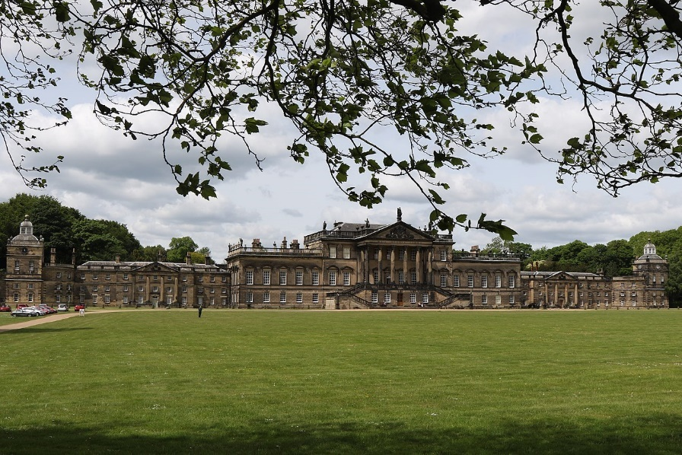
Wentworth Woodhouse, Wikipedia, https://en.wikipedia.org/wiki/Wentworth_Woodhouse

Three homes have been said to be the inspiration for Wuthering Heights: the now demolished High Sunderland Hall in Halifax; Ponden Hall, and the ruined farmhouse Top Withens, both near the Brontes’ village of Haworth.

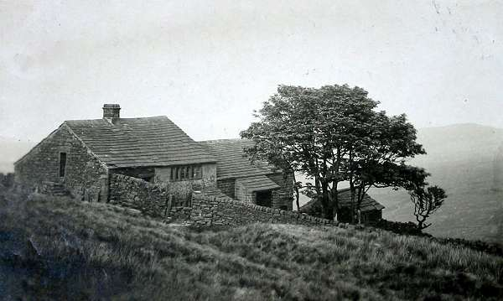
Top Withens in the 1920s, Reader’s Guide to Wuthering Heights, https://wuthering-heights.co.uk/locations/top-withens

Two houses have been offered as the model for Thornfield Hall in Jane Eyre: High Sunderland Hall in Halifax and North Lees Hall in the village of Hathersage, near Sheffield.
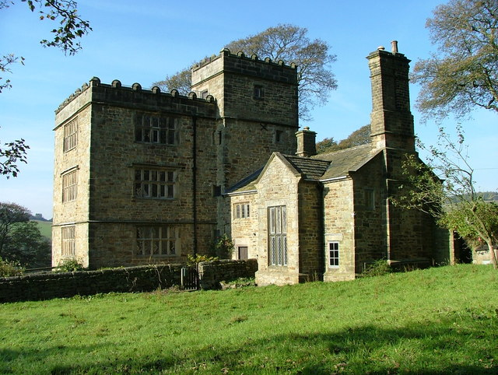
North Lees Hall, Wikipedia Commons, https://commons.wikimedia.org/wiki/File:North_Lees_Hall,_near_Hathersage_-_geograph.org.uk_-_591175.jpg

Often, the alleged literary connections of these houses become a matter of fact and a selling point for tourists. Now a national park, North Lees Hall, for instance, announces on its website that “In 1845 Charlotte Bronte visited the Hall several times while staying with her friend Ellen Nussey at the Vicarage in nearby Hathersage. It became the principal inspiration for Thornfield Hall in the novel ‘Jane Eyre’, described as: ‘three storeys high; a gentleman’s manor house; battlements round the top gave it a picturesque look’. They still do!” (“North”).
The three inspirations for Pemberly differ in their claims to literary fame. The website for Wentworth Woodhouse makes no such claim at all but does offer visitors the opportunity for “a unique Regency Afternoon Tea, including a Jane Austen experience in the beautiful Whistlejacket Room. Enjoy a lively and entertaining performance, celebrating the life, mind and writings of one of our greatest novelists before heading to the Long Gallery for a delicious afternoon tea and glass of prosecco. This event is certainly a must for all Jane Austen fans!” (“Regency”). This reticence probably is due less to prudence than to the British government’s having justified spending over seven million pounds to refurbish Wentworth by declaring its connection to Austen, to which “the Jane Austen Society [replied] there is no evidence Austen ever went to the house or that a character such as Fitzwilliam Darcy could ever have afforded to live there” (qtd. in Syal and Cain), further explaining that “Jane Austen, herself only too keenly aware of the value of money, and of the need for veracity, would have been savvy enough to know that a building the size of Wentworth Woodhouse with its estimated number of over 300 rooms and its estate of over 15,000 acres could not possibly have been supported on Mr. Darcy’s reported income of a mere £10,000 per annum” (qtd. in Shea).

At Lyme Park, one can take the Pemberly Walk and “Follow in the footsteps of Mr Darcy and the BBC film crew. Discover some of the idyllic filming locations from the 1995 BBC adaptation of Pride and Prejudice” (“Pemberly”). Likewise, Chatsworth House trumpets its connection to a film adaptation. “On your visit,” they advise, “you may recognise the grand staircase and ceiling of the Painted Hall where Lizzie and the Gardiners start their tour of Pemberley. The Sculpture Gallery was used in the scene where Lizzie Bennet sees the bust of Mr Darcy, and his housekeeper describes his many good qualities.” Visitors are also alerted that “As a souvenir from the filming, we still have the bust of Mr Darcy, played by Matthew Macfadyen. The bust is made of resin mixed with marble dust and was created by Nick Dutton in 2004 as a prop for the film. It can be found in the Orangery shop, through the Sculpture Gallery” (“Pride”). In declaring a connection not to Austen films but to Austen’s novel, Chatsworth House carefully qualifies its claim: “It is believed that Jane Austen may have based her idea of Pemberley on Chatsworth House and written the novel while in Bakewell.”
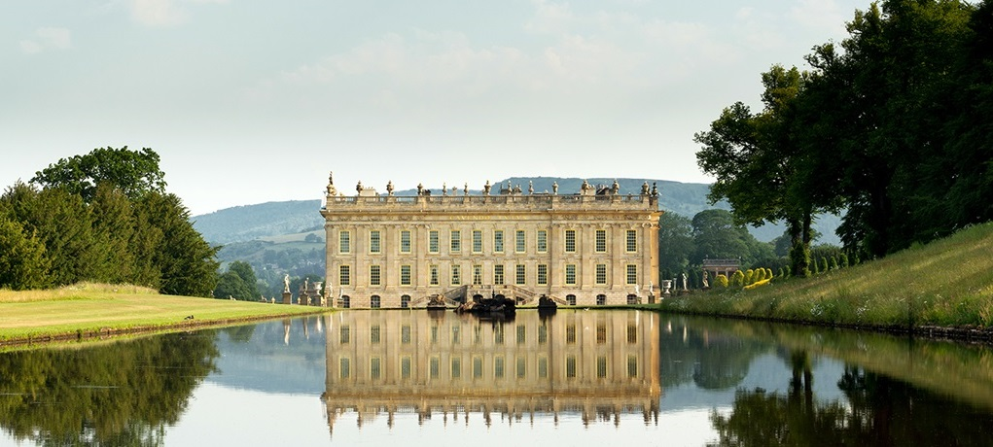
Chatsworth House, Chatsworth House Trust, https://www.chatsworth.org/news-media/chatsworth-on-film/pride-and-prejudice/

While many make pilgrimages to Jane Austen’s grave in Winchester and to Emily and Charlotte’s in Haworth, few seek out Mary Elizabeth Braddon’s grave in London. Likewise, despite its steadily growing literary reputation, Lady Audley’s Secret remains far from the level of popularity at which tourists would seek out its real-world inspirations. In fact, there’s been little discussion, by the public or by scholars, of the inspiration for Audley Court. That wasn’t the case, however, at the height of Braddon’s fame in the 19th century. According to the author and critic Percy Hetherington Fitzgerald, “Lady Audley's mansion, with its well, was, as it might be expected, sought to be identified, and various gloomy abodes in the country were named” (280).

The assumption has been that Audley Court was modeled on a manor home in Essex, Ingatestone Hall. When Fitzgerald wrote, years after the novel’s publication, asking Braddon whether this setting had been inspired by any real location, she responded,

there was a long, narrow avenue of tall limes, very quiet, very secluded, and aloof from the garden of a dear old oak-paneled grange in Essex, and it seemed to me one summer evening, walking with the master of the house, that this lime-walk suggested something uncanny in the history of domestic crime. So I said to my host, “If I were to take this house of yours as the scene of a novel, would you mind very much if I made the inhabitants a rather bad set of people?” “Mind! People it with fiends if you like, my dear !" said he. (Miller 280-81)

In his biography of Braddon, Robert Wolff quotes this passage and adds a note:

Strong local tradition at Ingatestone, Essex, identifies the celebrated family house of the Petre family there—now the Essex Count Records office—with [Braddon’s] Audley Court. And indeed, its clock with one hand over the stables and its avenue of limes make the identification plausible. (437n40).

The author of one local history, E.E. Wilde, also attests that Ingatestone stood as the model for Audley Court, writing, “Miss Braddon laid the scene of her thrilling novel, Lady Audley's Secret, at Ingatestone Hall. Her description of Audley Court is, in the main, a correct description of the Hall, though she is in error in stating that the place had at one time been a convent. Miss Braddon stayed in the vicinity whilst writing the book, and reproduces in it a very good picture of the neighbourhood” (303).

A comparison of Ingatestone with Braddon’s description of Audley Court would seem to confirm this connection. Braddon describes the approach to the Audley house: “you came upon it through an avenue of limes, bordered on either side by meadows” (7). The word “limes” here refers linden or basswood trees. And, sure enough, the approach to Ingatestone is lined with trees.

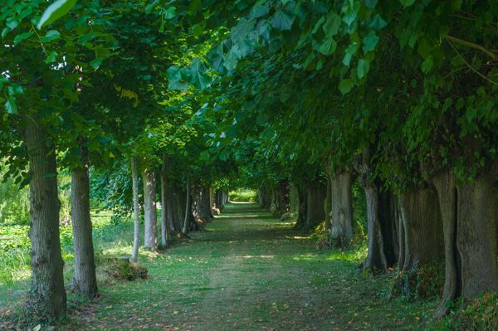
Ingatestone Hall Photo, The Lyme Walk, Britain Express, https://www.britainexpress.com/photo.htm?photo=8901

Of course, many such country houses have long entrances flanked by trees. More substantial proof of the connection between Audley Court and Ingatestone Hall is what we would find if we were to continue down this pleasantly shaded path. Writes Braddon, “At the end of this avenue there was an old arch and a clock tower, with a stupid, bewildering clock, which had only one hand—and which jumped straight from one hour to the next. . . . Through this arch you walked straight into the gardens of Audley Court” (7). This passage is a precise description of the entrance to Ingatestone Hall, down to the missing hand on the clock, which seems, in the spirit of English eccentricity, never to have been replaced and to have even become a proud symbol of the house—although Braddon does not include the Latin motto on this clock, “Sans Dieu Rien” (“Without God, Nothing”), a saying that would fit her novel’s conventional ending but not its overall (and not holy) spirit.

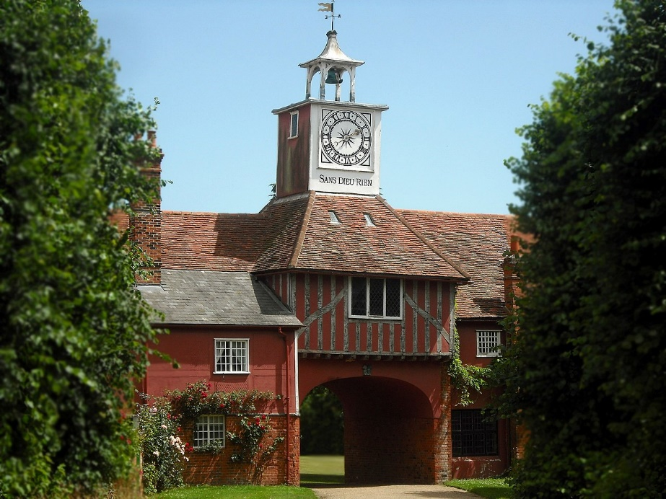
Ingatestone Hall, Wikpedia, https://en.wikipedia.org/wiki/Ingatestone_Hall#/media/File:Ingatestone_Hall_(7710644796).jpg

“To the right,” Braddon continues,

there were the kitchen gardens, the fish-pond, and an orchard bordered by a dry moat, and a broken ruin of a wall, in some places thicker than it was high, and everywhere overgrown with trailing ivy, yellow stonecrop, and dark moss. To the left there was a broad graveled walk, down which, years ago, when the place had been a convent, the quiet nuns had walked hand in hand; a wall bordered with espaliers, and shadowed on one side by goodly oaks, which shut out the flat landscape, and circled in the house and gardens with a darkening shelter. (7)

Again, Braddon’s description mirrors the real Ingatestone Hall, the grounds of which include gardens and walls and a pond and trailing ivy and plenty of trees.

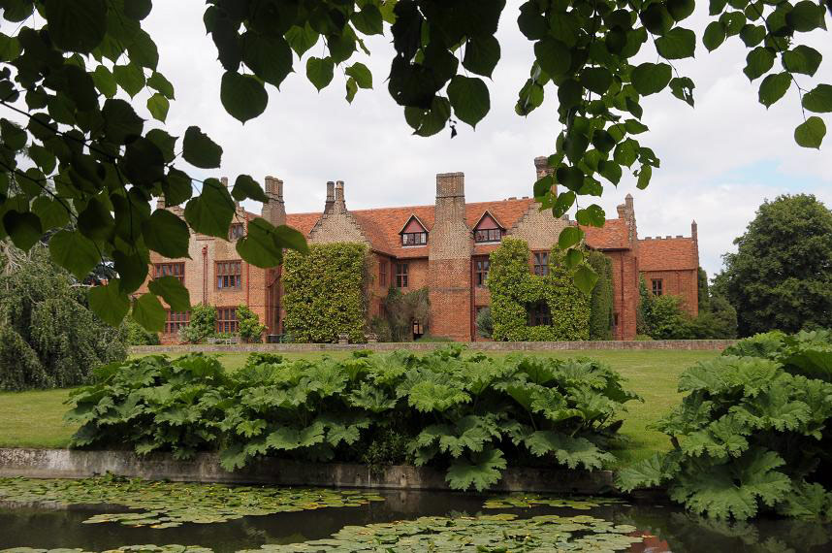
Ingatestone Hall grounds, The Garden Guide: garden.visit.com, www.gardenvisit.com/gardens/ingatestone_hall_garden

Another connection between the two settings is that both the real and the fictional homes were said to have hidden priests during the persecution of Catholics during the Tudor era. As Hazel Steiner explains, “Two priest holes were found by accident [at Ingatestone Hall] by past members of the family. . . . The Petre family were recusants that refused to accept the new Anglican church. For their safety, they kept their Roman Catholic practices hidden from the public, holding covert masses in their private chapel. The priest holes may have been used to store their Bible and so forth in order to prevent nosy visitors from discovering their secret.” Similarly, Braddon describes “a hiding place so small that he who hid there must have crouched on his hands and knees . . and yet large enough to contain quaint old carved oak chest half filled with priests’ vestments which had been hidden away, no doubt, in those cruel days when the life of a man was in danger if he was discovered to have harboured a Roman Catholic priest, or to have had mass said in his house” (9).

And yet I believe that the notion of Ingatestone Hall’s being the sole model for Audley Court incorrect. In his biography of Braddon, Wolff cites Percy Fitzgerald’s correspondence with Braddon, her suggestion that an estate exactly matching Ingatestone Hall inspired the novel. Wolff goes on to tell us that, besides its mirroring the house in Lady Audley’s Secret, there’s evidence—the manuscript of Braddon’s unfinished novel, “Tommy and Harry: The History of a Bad and a Good Boy” postmarked Ingatestone, June 14, 1861—that Braddon visited this house at least once before the composition of the novel, thus supporting both Fitzgerald’s claims and the “strong local tradition.” But Wolff omits a key point from Fitzgerald’s quoting of Braddon’s letter. In answer to his question of whether Audley Court was based on a real place, she wrote, “Well there never was, save in the novelist's imagination. The murderous element in the landscape had to be supplied from the scene-dock’ of fiction.”

The problem with asserting Ingatestone’s patrimony is simply that such authorial inspiration isn’t necessarily so simple. It’s often not a matter of a one-to-one correspondence. When depicting a particular setting, authors may choose an actual place, as, for instance, Hawthorne does in The House of Seven Gables. They may create this place wholly out of imagination. Or they may imaginatively combine places they’ve known, which is what, I believe, Braddon has done. The tree-lined drive, the arch and clock, the pond and ivy-draped building, the walls and garden, multiple chimneys and priestly hiding places are taken from Ingatestone Hall, a setting she visited during the initial stages of the creation of Lady Audley’s Secret and which seems to have imprinted itself vividly in her memory. However, the actual Ingatestone doesn’t correspond with Braddon’s description of Audley Court, notwithstanding E.E. Wilde’s assertion that Braddon’s “description of Audley Court is, in the main, a correct description of the Hall.”

First, its history doesn’t match. Ingatestone Hall, built on Catholic Church land during the dissolution of the monasteries, was purchased by Sir William Petre, secretary of state to Henry VIII. But the history of Audley Court goes much further back, to the Norman conquest, a half a millennium earlier. Additionally. Ingatestone Hall was built according to the principles of Tudor architecture; that is, it follows one style and displays a certain amount of symmetry and regularity, which doesn’t at all match Braddon’s description of Audley Court,

a house that could never have been planned by any mortal architect, but must have been the handiwork of that good old builder, Time, who, adding a room one year, and knocking down a room another year, toppling down a chimney coeval with the Plantagenets, and setting up one in the style of the Tudors; shaking down a bit of Saxon wall, allowing a Norman arch to stand here; throwing in a row of high narrow windows in the reign of Queen Anne, and joining on a dining-room after the fashion of the time of Hanoverian George I, to a refectory that had been standing since the Conquest, had contrived, in some eleven centuries, to run up such a mansion as was not elsewhere to be met with throughout the county of Essex. (8)

What does match this description is a house Braddon knew well, Skisdon Lodge, the Braddon family home in the village of St. Kew, Cornwall. Skisdon was first “mentioned in 1350. . . . It is believed that the property would have originally been two cottages which were then knocked into one single residence. During the Tudor period, a range of rooms were added to the rear of the original property, with remains of the Tudor hearth evident in the main kitchen” (Savills).

Skisdon Lodge, Savills, https://media.onthemarket.com/properties/779835/doc_1_0.pdf

Skisdon Lodge, like Ingatestone Hall (and many other such historic homes), is known for its beautiful and private and tranquil grounds, “A spot,” Braddon describes in her novel, ”in which peace seemed to have taken up her abode, setting her soothing hand on every tree and flower, on the still ponds and quiet alleys, the shady corners of the old-fashioned rooms, the deep window-seats behind the painted glass, the low meadows and the stately avenues” (8). Or as she describes it in a letter to the novelist Edward Bulwer Lytton, it “is a nest in one of the most fertile valleys of Cornwall—mild as Madeira—myrtles & roses climbing to the chimney-pots, tulip trees growing high on the lawn” (qtd. in Wolff 141). “All her life,” Wolff writes, Braddon “loved Skisdon for its warmth, and for the beauty and abundance of its gardens” (19), a sentiment she conveys through her description of Audley Court. Even the names of these two settings, the metrically identical Audley Court and Skisdon Lodge, suggest that the memory of Skisdon remained in Braddon’s thoughts as she created Audley Court.

Presumably, Braddon combined Ingatestone and Skisdon to draw upon features of both, the Gothic forebodingness and privilege of the former and the architectural mélange of the latter. Perhaps that’s why she describes Audley Court, in a seeming contradiction, as both “a glorious old place—a place that visitors are in rapture with” and “a noble place, a house in which you incontinently lost yourself” (8). Braddon emphasizes the house’s mishmash of styles and features, large and small, strong and fragile, old and modern. The house is an accretion of pieces added over time with little sense of logic or coherence. This perception is reinforced by its interior: It is “a house in which you incontinently lost yourself if ever you were so rash as to attempt to penetrate its mysteries alone; a house in which no one room had any sympathy with another, every chamber running off at a tangent into an inner chamber, and through that down some narrow staircase leading to a door which, in its turn, led back into that very part of the house from which you thought yourself the furthest” (8). This description, reminiscent of the labyrinthine passageways common to Gothic fiction, conveys a sense of the uncanny, of something that can’t be understood by rational investigation (much as the novel’s plot meanders and returns at its conclusion to this opening setting).

Additionally, in charting the house’s roots through British history from its current state in the 1850s back to the early 1700s of the Hanoverian reign to the 15 and 1600s of the Tudors to the 1200s through 1400s of the Plantagenets to the Conquest of 1066 and even further (she refers to the house’s “eleven centuries,” which would place its foundation sometime in the 800s, when the Anglo-Saxons were struggling against Viking raids and Beowulf was being composed), she’s doing more than describing shifting architectural styles; she’s suggesting the persistence across centuries of elite—and especially male—rule. And the contradictory nature of the house’s architecture—and its confusing interior—suggest the illogic of this rule.

Skisdon Lodge, Savills, https://media.onthemarket.com/properties/779835/doc_1_0.pdf

But we’re left with the question: if much of the original of this house is based on Skisdon Lodge in Cornwall, why did Braddon set the novel in Essex? The answer is simple. Her narrative requires characters to make frequent trips by train from Audley Court to London. Ingatestone is 25 miles from London, nowadays a 28-minute trip by rail.
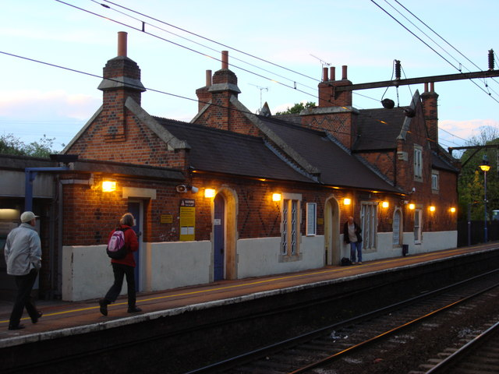
Ingatestone Railway Station, constructed in 1846, Wikipedia, https://commons.wikimedia.org/wiki/File:Ingatestone_railway_station_1.jpg

St. Kew in Cornwall, on the other hand, is 214 miles from London, nowadays a four-hour train ride and a much longer trip in the 19th century; Wolff describes how the Braddons, mother and children, travelled to Skisdon: “By railway to Southampton, thence by coach to Exeter, and on, the next morning, to Wadebridge, where Grandmamma’s carriage would meet them” (30).
After the commercial success of her first novels, in 1867, Braddon bought Skisdon, but its distance from London, it seems, made it impractical. As Wolff relates, “never able to use the house she soon resold it to a Braddon cousin” (141).

Skisdon was again for sale in 2014. Its online real estate brochure tells buyers that Skisdon consists of five holiday apartments which one can “easily revert back into a sensational single-family home,” a total of fourteen bedrooms, eight bathrooms, and “almost 2 acres of enchanting & historic gardens & grounds (Savills). The brochure adds an additional selling point: “During 1866, the house came into the ownership of Mary Elizabeth Braddon, the sensational novelist of ‘Lady Audley’s Secret’. It is understood that she entertained fellow novelist and friend Charles Dickens at Skisdon” (Savills). Despite her recent critical acclaim, it seems, mention of Dickens’ having once been entertained at Skisdon is as much (or more) of a selling point as Braddon’s ownership of it.
Near the end of Lady Audley’s Secret, Audley Court has become a bleak house: it is “shut up, and a grim housekeeper reigns paramount” while “blue mould . . . gathers” (379). But the two houses it’s based on have had happier fates. Ingatestone “remains primarily a private family residence but . . . The public rooms and grounds may be hired for a . . . receptions & dinners, lectures & seminars, concerts and plays, trade promotions & corporate events, garden parties, fairs & exhibitions and film locations” (“Ingatestone”). Skisdon, also a private residence, is not open to the public. But it still seems to be on the market and can be purchased for a mere £1.35 million (Smellie).

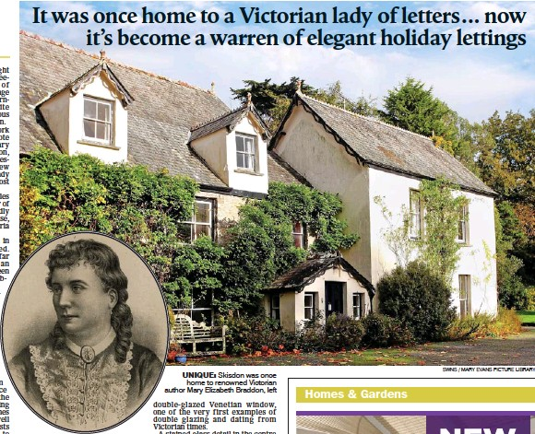

The Daily Mail, 4 Jan. 2014, https://www.dailymail.co.uk/news/article-2533790/A-Cornish-classic-home-Victorian-lady-letters-warren-elegant-holiday-lettings.html

Works Cited

Braddon, Mary Elizabeth. Lady Audley’s Secret. 1862. Oxford Univ. Press, 2012.
Fitzgerald, Percy Hetherington. Memoirs of an Author. London: R. Bently and Son, 1895. Internet Archive, https://archive.org/details/cu31924104096692/.
“Ingatestone Hall.” https://www.ingatestonehall.com/. Accessed 4 Oct. 2022.
“North Lees Hall.” Peak District National Park, 17 Mar. 2016, https://www.peakdistrict.gov.uk/visiting/places-to-visit/stanage-and-north-lees/north-lees-hall.
“Pemberly Walk at Lyme.” National Trust, 6 Mar. 2016, https://www.nationaltrust.org.uk/lyme/trails/pemberley-walk-at-lyme-.
“Pride and Prejudice.” Chatsworth House, 1 Mar. 2017, https://www.chatsworth.org/news-media/chatsworth-on-film/pride-and-prejudice/.
“Regency Afternoon Tea.” Wentworth Woodhouse, https://wentworthwoodhouse.org.uk/whats-on/regency-afternoon-tea/. Accessed 4 Oct. 2022.
Savills, plc. “Skisdon,” https://media.onthemarket.com/properties/779835/doc_1_0.pdf.
Shea, Christopher D. “England to Restore a House With Ties to Jane Austen — or Not.” New York Times, 25 Nov. 2016, https://www.nytimes.com/2016/11/25/books/jane-austen-society-british-government-wentworth-woodhouse.html.
Smellie, Alice. “A Cornish classic: It was once home to a Victorian lady of letters... now it's become a warren of elegant holiday lettings.” The Daily Mail (London): 29 Sep. 2014, www.dailymail.co.uk/news/article-2533790/A-Cornish-classic-home-Victorian-lady-letters-warren-elegant-holiday-lettings.html.
Steiner, Hazel. “Ingatestone Hall.” 20 June 2018. hazelstainer.wordpress.com/2018/06/22/ingatestone-hall/.
Syal, Rajiv and Sian Cain. “'No evidence' Jane Austen ever went to stately home mentioned in autumn statement.” The Guardian, 23 Nov. 2016. https://www.theguardian.com/books/2016/nov/23/jane-austen-inspiration-receives-76m-funding-in-autumn-statement-wentworth-woodhouse.
Wilde, E.E. Ingatestone and the Essex Great Road with Fryerning. London: H. Milford, Oxford Univ. Press, 1913. Internet Archive, https://archive.org/details/ingatestoneande00wildgoog.
Wolff, Robert Lee. Sensational Victorian: The Life & Fiction of Mary Elizabeth Braddon. Garland, 1979.

“Film of Ingatestone Hall featuring Petre family portraits and Essex Record Office exhibition. Black and white film, with commentary. Produced in the early 1960s at a course on cinematography at Wansfell, Theydon Bois, Essex with Essex County Council County Film Service. Transferred to videotape in 1996 from a damaged reel of 8mm film which was subsequently destroyed; digitised from VHS video in 2012.”

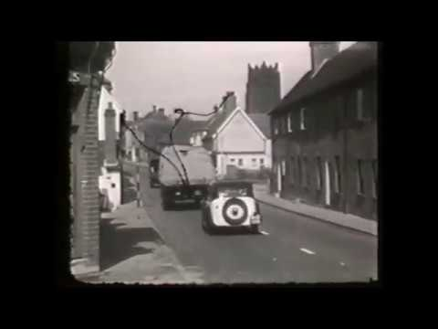
https://youtu.be/ZxpO6eRs9FQ

