**Testing**

Pre-Testing:

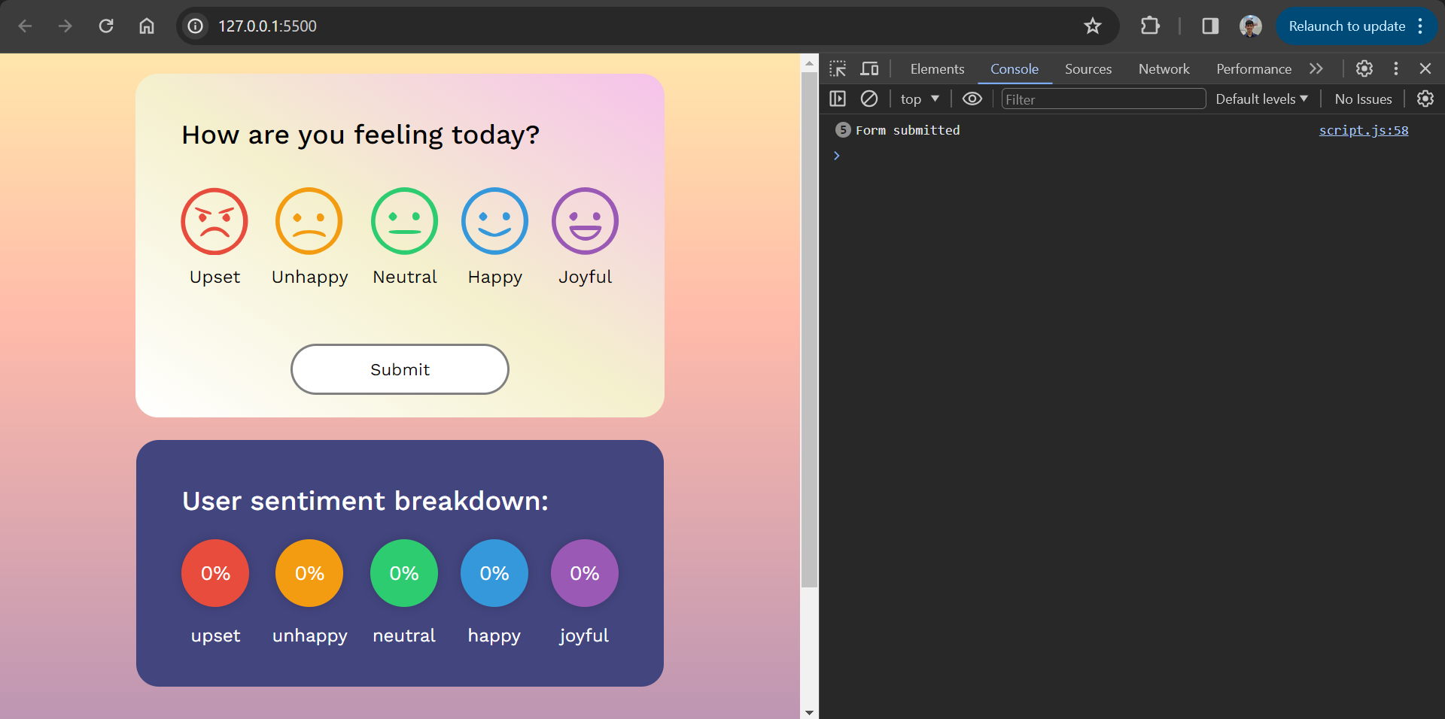

The first thing I did was check the JavaScript console to make sure there are no syntax errors before I write the test cases. A few errors did come up, and I fixed them to make the widget error-proof.

HTML/CSS Testing:

For HTML and CSS testing, I thoroughly tried all various combination of the widget’s UI, and then made sure the calculations were correct on the sentiment breakdown.

JavaScript Testing:

For JavaScript testing, I wrote the following tests:

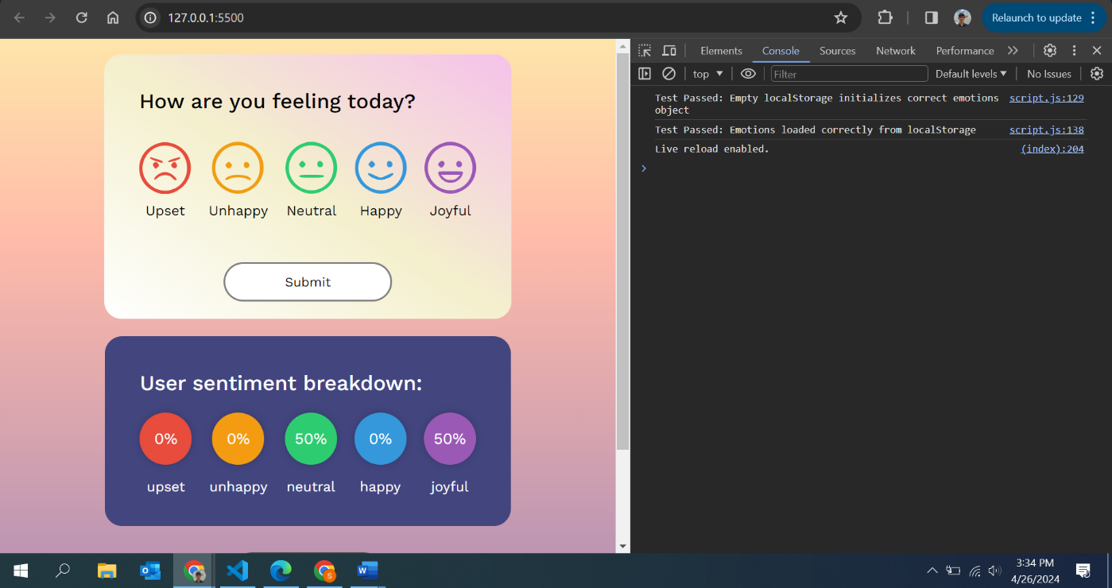**testLoadEmotions**

This function tests whether the loadEmotions function can correctly initialize an emotions object from an empty localStorage or correctly load existing data. The tests passed.

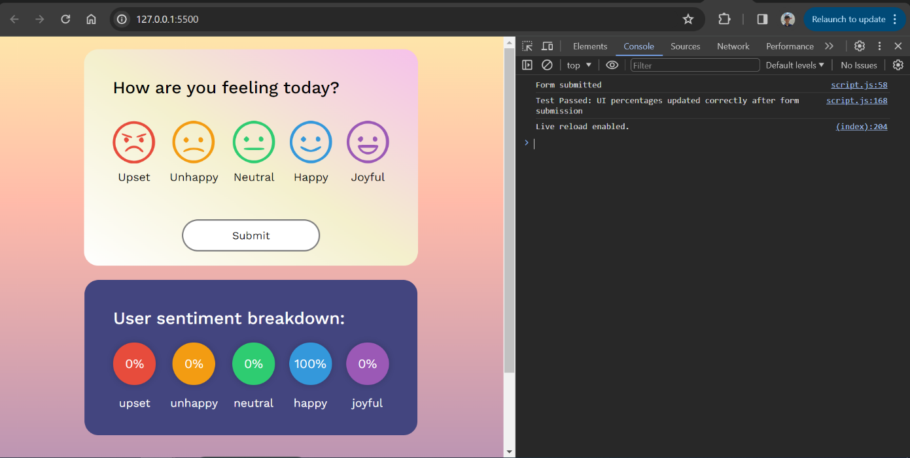  
**testUIPercentageUpdate**

This test ensures that after a form submission simulating an emotional entry, the UI correctly updates to display the new percentage of that emotion relative to the total entries. The tests passed.

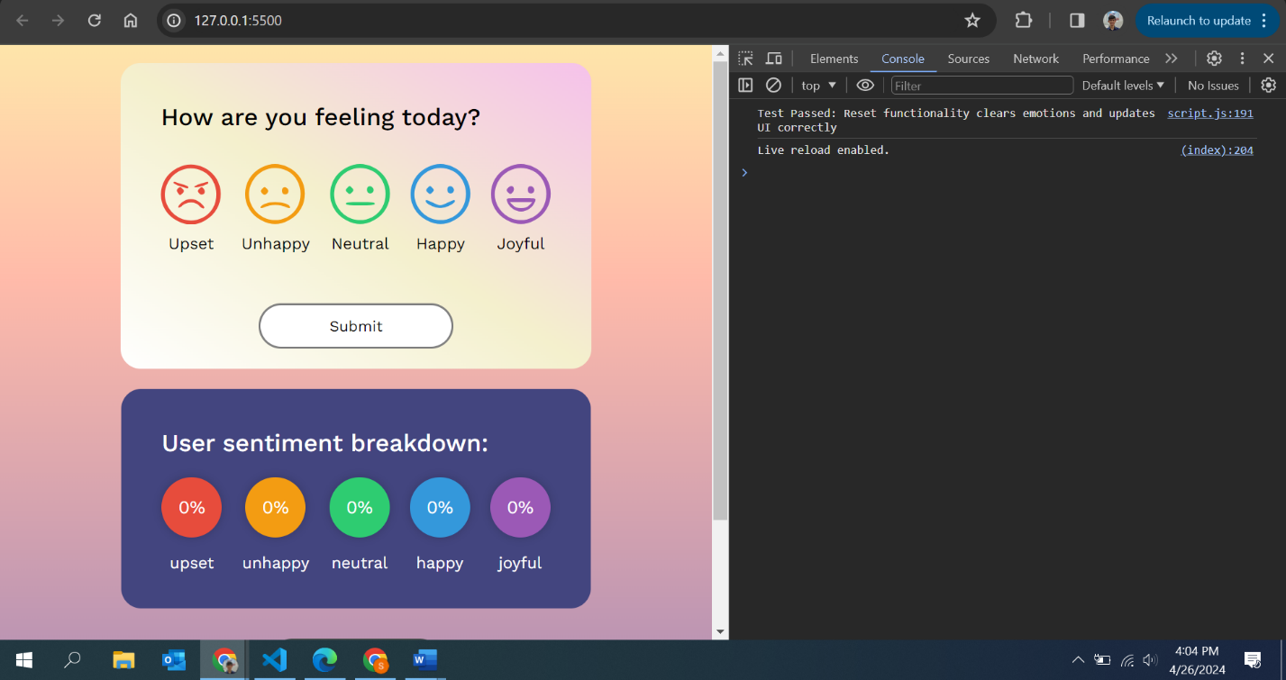**testResetFunctionality**

It checks whether the reset button correctly clears or zeros out the localStorage data and verifies that the UI reflects these changes, particularly checking the percentage display for a specific emotion. The tests passed.

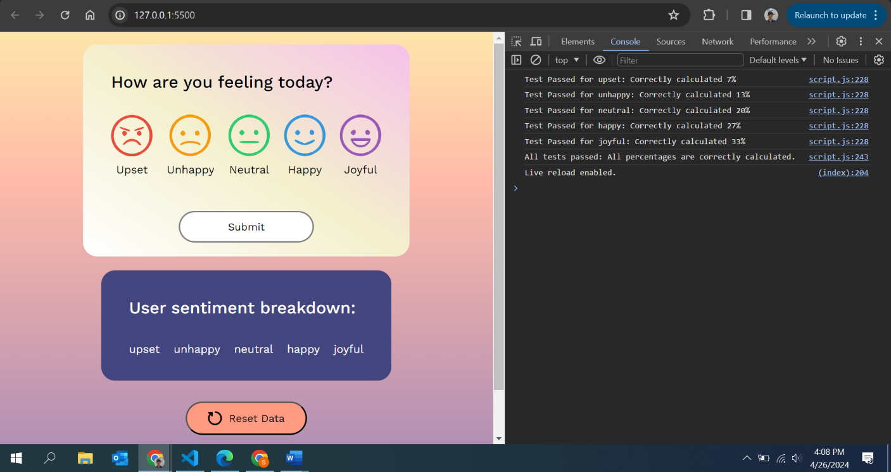**testUpdatePercentagesMath**

This function tests the updatePercentages method to ensure it correctly calculates and displays the percentage representation of each emotion based on their counts relative to the total count of all emotions. The tests passed.

**All tests run together:**

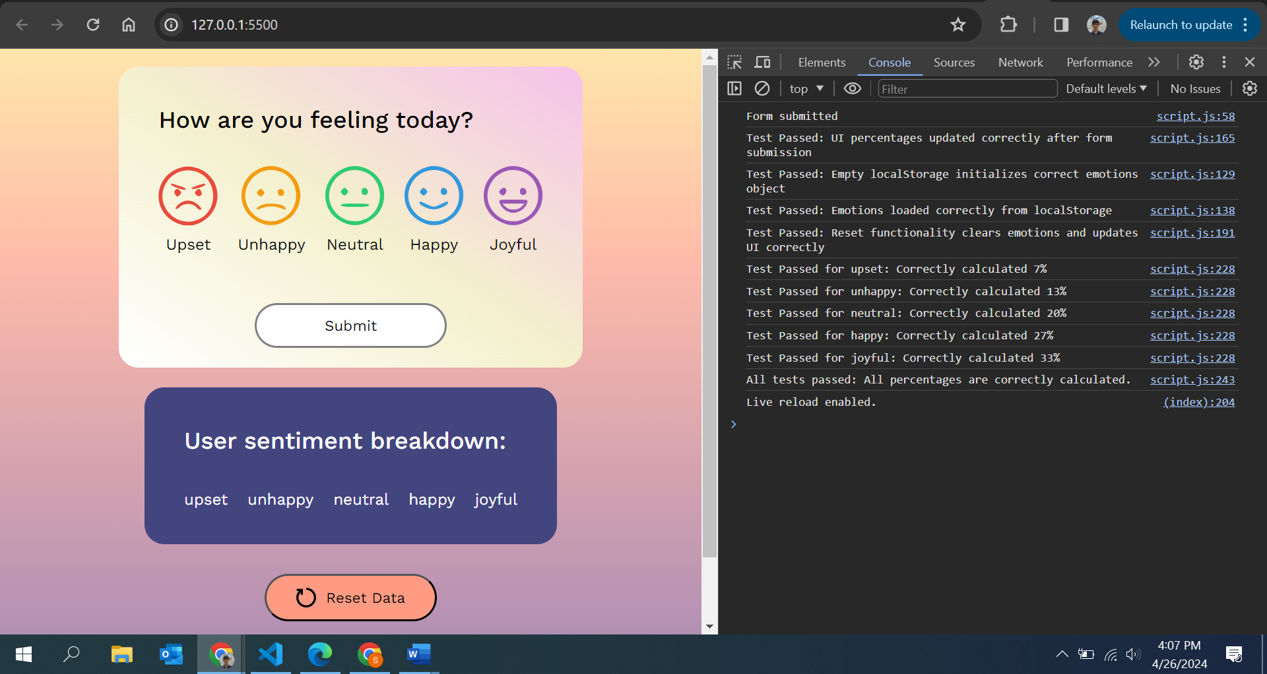

As seen above, when all the tests are run together, they pass. Hence, the application has been thoroughly tested and is ready for deployment.

**NOTE:** I used AI to give me a few ideas as to how to test the document and I also used chat GPT to give me an overview of how to implement the test. I think if guided correctly, AI can be very helpful in the testing stage of software engineering.