**5 March 2018 – Mayagüez**

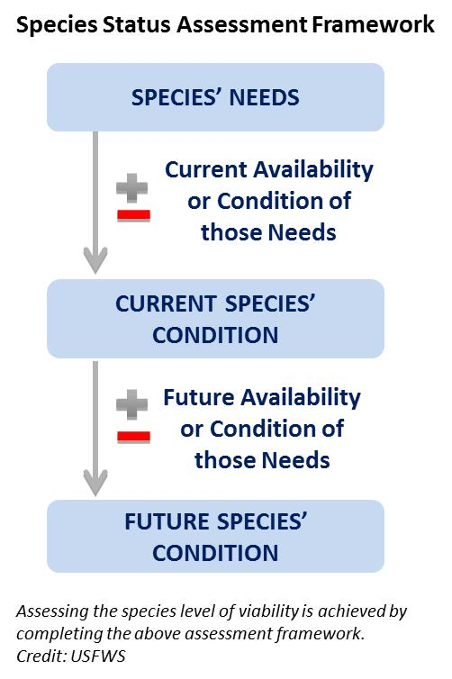Creating Puerto Rican Boa analysis units and the 3Rs

Species viability is a critical component of the SSA.Viability is not a specific state, but rather a continuous measure of the likelihood that a species will sustain populations over time (USFWS, 2016). Using the SSA framework (Figure 1-1), we consider what the subspecies needs to maintain viability by characterizing the status of the subspecies in terms of its **resiliency**, **representation**, and **redundancy** (Smith et al., 2017).

**Resiliency** describes the ability of a population to withstand stochastic disturbance. Stochastic events arise from random factors such as weather, flooding, or fire. Resiliency is positively related to population size, growth rate, and connectivity among populations. Resiliency can include population size, occupancy across suitable habitat, availability of suitable habitat, and source propagules to maintain population growth after disturbance. We measure resiliency for the Puerto Rican Boa …

Figure 1. Species Status Assessment Framework

**Redundancy** describes the ability of a species to withstand catastrophic events. A catastrophic event is defined here as a rare event rapidly and irreversibly affecting multiple or all populations. Redundancy is positively related to the dilution of risk factors across many resilient, representative populations. We measure redundancy for the Puerto Rican Boa ….

**Representation** describes the ability of a species adapt to changing environmental conditions over geologic timescales. Representation is often measured using genetic diversity among populations because it is very obvious. A second type of representation encompasses the totality of behavioral, reproductive, environmental variation based on climatic zones across a species’ range is also used. Theoretically, the more representation a species has, the higher its potential of adapting to natural and anthropogenic change. We measure representation for the Puerto Rican Boa …

Boa notes – life history

In our boa transition model, we have four states young (s1), juvenile (s2), sub-adult (s3), and breeding adults (s4). The arrows from each state to other states show the transitions

Every other years – captive and wild boa (females) are developing eggs and relying on fat rather than moving to gain resources. *Not known: food availability and prey base.*

Across the Caribbean, we find that females are taking every other year (implies long-life span? – captivity 40-50 years) ~~“Feasting in El Yunque” Is the food concentrated in the forest?~~

The birth litter was 3000g and after birth 600g lost – 32 maximum – 17 infertile, 13 live boas, rest dead (~6 lb) (Eneilis)

Infertile ova – can be produced and then perhaps produce a litter the next year. They are probably producing ova annually (Eneilis) Others in captivity can produce babies yearly.

5 recaptures - low recaptures juveniles 2.27 cm per year (male -1 record) 17.6 cm per year (female – 1 record) many rats in the area in Fort Buchanan (Eneilis)

3 recaptures for juveniles and two or three for adults. *The size information for the adults could be created as a demographic catch rate. (Eneilis – Piping plover catches)*

More than 20 years just 2 recaptures at the same cave (Alberto)

*Females: wild populations (e.g., 80%) can produce every year and (e.g., 20%) some every other year.

*Males and females are the same size statistically.*

Young of the year 🡪 food availability – but what about predation rates? 110 cm is the smallest snake that is a female with ova. 60 cm and earlier – the babies are red and they are in shrubs.

Annual cycles 🡪 Feb - March mostly inactive w/dry cold season

* Not known: growth rates – If we asked Chris Krufield. Bob Clark – JP Zegarra will ask. Can call Amyris for - international.
* Segregation of juveniles – Transmitters in juveniles – nothing.

Natural predation: lizard cuckoos; interspecific competition - a threat. Even when humans are super aware of the snake – they kill it accidentally by human disturbance.

More than five feet no longer at the cave (Alberto) Mata de Platano – Hurricane Maria bat population collapsed. Bat populations take up to 10 years to repopulate. At least 10 years to see how the bats come back.

*Analysis unit notes:*

**Intraspecific behavior:** El Yunque is aggressive (“have personalities” – Eneilis). Other populations do not do that. They spend most of their time in trees in that place.

**Thermoregulatory behavior** (adults – day, night) and predation (juvenile, adult) should vary by analysis unit. During the day, only adults are basking. (Enelis)

**Habitat use:** Juveniles are moving more often. Resource and prey items: Anolis pulchellus and cristaltellus are on the ground. The larger anoles cuvieri are in trees, and that’s where the adults are found. (Fernando, Alberto)

**Spatial** **breaks**: Karst spend more time on the ground – more hiding places in the ground

El Yunque more time in the forest and in the trees (Davila, Fernando)

**Disease**: meat production – ticks positively correlated with cows and impact on boas (Fernando)

Since moving of boas has already happened because of the humans. genetic diversity is in favor of the species (Alberto, Graham). The moving of the species has made the population homogenous. Introducing rare alleles could have happened but perhaps a cline in the population structure (Fernando).

* Take these notes later: The delineation of polymorphic, polytypic traits of boas showed many overlapping areas. The final decision was one analysis unit analyzed at a smaller spatial scale.

Semana Saba and other sites for PR boa–Peter Tolson data

Los cababas roosevelets feral boas from escababs to the lagoon. Icacos and talk to Richard Thomas surveys intensely in the last 50 years.

**6 March 2018 – Boqueron office**

**Joglar:** observations over 45 years. But not intense like M. Toño and A. Puente

Life history looks good to Toño and Joglar. The arrows indicate that multiple timesteps can occur within one life stage. The growth rate and time spent in each life stage. What age and for how long is the boa staying in each life stage. Unless we receive additional information from the literature and commercial breeders.

Do we have a list of the people breeding the boa in the States. Some of the breeders might have the species and they will not tell the information.

The upper boundary of what you could produce is highest in the zoos and other places. We talked about how females only breed every other year but more resources will have the species breeding more often (up to each year).

The smallest breeding adult is 110 cm (Alberto Puente).

What is the generation time is the age at which the female will have her median offspring. What is the age at which the female PR boa. The generation time of a PR boa –

Breeding adults at 5 years for most of them. The translocations are successful and where it could hide and its life history strategy and that’s the downside. When the mortality rates of VI boas can be astounding and the 13 juveniles they all survived 12/13 survived one year later. When there are not rats/cats/dogs, and the other rates from Puerto Rican racers but mongoose are not a large factor. An additional factor of mortality would be the effects of electrical wiring and as they get older the potential for threats fall out.

The big adults are more vulnerable to mortality for going out after chickens and

The road mortality is different than human killing and it is different than electrical wiring.

One of the biggest concerns is oil collection from boas. He used to think it was stories. The same kind of thing but in a different format. The notes will be in a

Peter Tolson: saw a Puerto Rican boa in Philadelphia that was most than 10 feet long in 1979. There are strong selective pressures on the species are acting in Puerto Rico. However, the litter size of 32 or 33 is a good upper bound.

Lipid reserves versus size classes: a 100 g VI boa that is 700 mm SVL will have the same number of offspring as a 200 g boa that is 700 mm SVL.

*Shift from young to juvenile:* 10 - 20% survival of neonates of Cuban boa (600 - 700 SVL and 150 - 200 g)

*Shift from juveniles to sub-adults:* Cuban boa – ontogenetic shift at 2 y/o to find new territories, but the little ones stick around 5 hectares. Then b/c set off to find at beginning of sub-adult stage (1.5 m ) there is increased movement of the dispersal (like turtles)

Karst versus rainforest (seems like two delineated areas) Peter Tolson has only worked in karst – ground, trees, across the structure

Catastrophic events:

The southwestern populations of Cabo Rojo, Salinas, Guayama etc (xxx). Consulting with FEMA and Army Corps of Engineers since communications were back up a month + after hurricane. *Catastrophic events; boas found and killed in large numbers after hurricane Maria. Increased detection after the catastrophic events and resource-mediated movements towards junk piles and moving of debris and habitat (direct (immediate) and indirect effects of catastrophic events up to a year or more by depressing survival rates of the boas)*