**Creating Puerto Rican Boa analysis units and the 3Rs**

Prepared by the Alabama Cooperative Fish and Wildlife Research Unit, School of Forestry and Wildlife Sciences, Auburn University, Auburn, Alabama 36849-5418, USA

Objective: Summary of the Puerto Rican Boa expert meeting held March 5 – 6, 2018 to inform the forthcoming Species Status Assessment

Meeting participants:

Fernando Bird (UPR)

Alberto Puente-Rolon (UPR)

Rafael Joglar (remote) (UPR)

Daniel Savila (UPR)

Eneilis Mulero (UPR)

Peter Tolson (remote) (Toledo Zoo)

Miguel To­ño Garcia (remote) (FWS)

Internal participants:

Jose Cruz-Burgos (FWS)

Jan Paul Zegarra (FWS)

Nicole Angeli (AL Coop)

Conor McGowan (AL Coop)

Background:

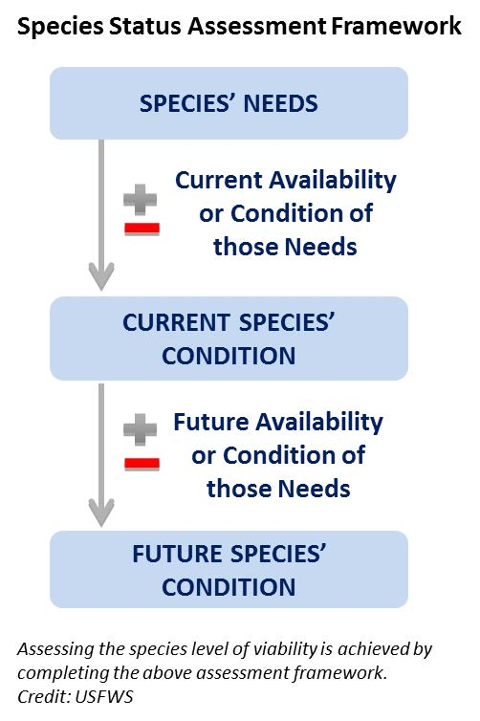Species viability is a critical component of the SSA.Viability is not a specific state, but rather a continuous measure of the likelihood that a species will sustain populations over time (USFWS, 2016). Using the SSA framework (Figure 1-1), we consider what the subspecies needs to maintain viability by characterizing the status of the subspecies in terms of its **resiliency**, **representation**, and **redundancy** (Smith et al., 2017).

**Resiliency** describes the ability of a population to withstand stochastic disturbance. Stochastic events arise from random factors such as weather, flooding, or fire. Resiliency is positively related to population size, growth rate, and connectivity among populations. Resiliency can include population size, occupancy across suitable habitat, availability of suitable habitat, and source propagules to maintain population growth after disturbance.

Figure 1. Species Status Assessment Framework

We measure resiliency for the Puerto Rican Boa … FWS has to create its own metrics.

**Redundancy** describes the ability of a species to withstand catastrophic events. A catastrophic event is defined here as a rare event rapidly and irreversibly affecting multiple or all populations. Redundancy is positively related to the dilution of risk factors across many resilient, representative populations.

We measure redundancy for the Puerto Rican Boa as.. FWS has to create its own metrics.

*Catastrophic events; boas found and killed in large numbers after hurricane Maria. Increased detection after the catastrophic events and resource-mediated movements towards junk piles and moving of debris and habitat (direct (immediate) and indirect effects of catastrophic events up to a year or more by depressing survival rates of the boas).*

**Representation** describes the ability of a species adapt to changing environmental conditions over geologic timescales. Representation is often measured using genetic diversity among populations because it is very obvious. A second type of representation encompasses the totality of behavioral, reproductive, environmental variation based on climatic zones across a species’ range is also used. Theoretically, the more representation a species has, the higher its potential of adapting to natural and anthropogenic change.

We measure representation for the Puerto Rican Boa … FWS has to create its own metrics.

Gaps in knowledge

* food available and prey base across sites and localities (feast in El Yunque?)
* size information related to transitions across life stages
* effect of breeders as a stressor (list of breeders in the States? Otherwise?)

Life history

Males and females are the same size statistically. Boas are not longer than five feet at the cave Mata de Platano (Alberto Puente). Puerto Rican boa in Philadelphia that was more than 10 feet long in 1979 (Peter Tolson). There are strong selective pressures acting on the species size in Puerto Rico.

*Young of the year:* 110 cm is the smallest snake that is a female with ova. If a boas is 60 cm and smaller than it is young, usually colored red, and in shrubs.

*Shift from young to juvenile:* 10 - 20% survival of neonates of Cuban boa (600 - 700 SVL and 150 - 200 g). The smallest breeding adult is 110 cm (Alberto Puente). 5 recaptures - low recaptures juveniles 2.27 cm per year (male -1 record)

*Shift from juveniles to sub-adults:* At the beginning of the sub-adult stage (1.5 m ), there is increased movement of the dispersal like turtles. In other species like the Cuban boa, an ontogenetic shift at 2 years old forces the boas to find new territories, but the smaller boas use an area of around 5 hectares. The growth of 17.6 cm per year (female – 1 record) is attributed to the many rats in the area of Fort Buchanan (Eneilis Mulero).

*Shift from sub-adults to breeding adults:* Most boas will transition to breeding adults at 5 years and live up to 32 years. During the day, only adults are basking (Enelis Mulero). The larger anoles cuvieri are in trees, and that’s where the adults are found (Fernando Bird, Alberto Puente).

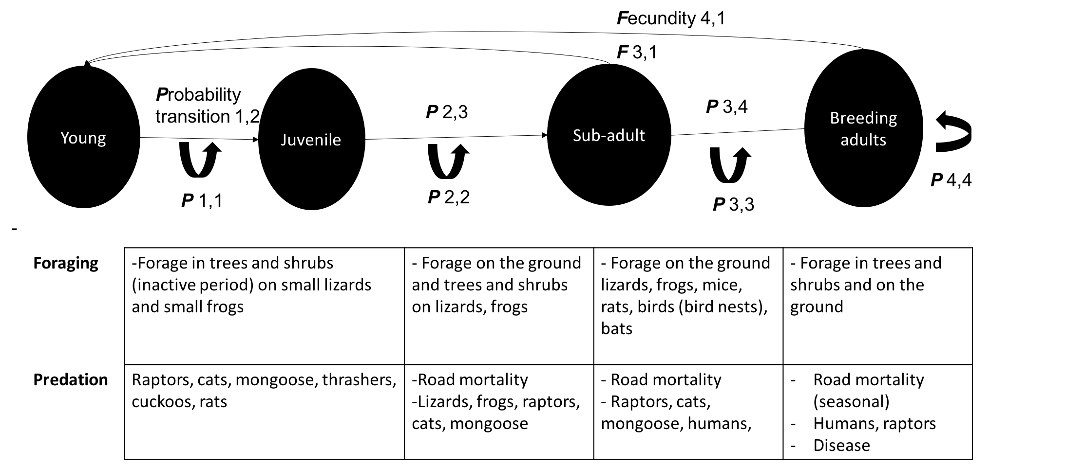

Fig. 1. The life history model for the stage (size) structured classes. The arrows indicate transitions from one state to another state and are represented by the probability of transitions (p). The fecundity (F) arrows at the top indicate the classes where females reproduce and contribute back to the population.

*Fertility*

*Females: wild populations (e.g., 80%) can produce every year and (e.g., 20%) some every other year (Eneilis). Only in captivity boas produce babies yearly. The generation time is the age at which the female will have her median offspring. The female PR boa will begin to reproduce during the sub-adult years.

The cost of fertility is high. Lipid reserves across the size classes indicate that a 100 g boa that is 700 mm SVL will have the same number of offspring as a 200 g boa that is 700 mm SVL. For Puerto Rican boas, the largest birth litter was 3000g and after birth the individual lost 600g mass. The egg clutch size was 32 with 17 infertile, 13 live boas, the rest dead (~6 lb) (Eneilis). The litter size of 32 or 33 is a good upper bound based on wild and captive animals (Peter Tolson).

Table 1. Stage-structured Lefkocitch Matrix.

|  |  | **Young** | **Juvenile** | **Subadult** | **Breeding Adult** | **Duration (years)** | **Size (cm)** |  |
| --- | --- | --- | --- | --- | --- | --- | --- | --- |
|  | Young | 0.1 | 0 | 5 | 33 | 1 | 34 - 60 |
|  | Juvenile | 0.2 | 0.92 | 0 | 0 | 2 | 60 - 90 |
|  | Subadult | 0 | 0.5 | 0.9 | 0 | 4 | 90 - 110 |
|  | Breeding Adult | 0 | 0 | 0.9 | 0.9 | 5+ | 110+ |

Analysis units

The consensus decision was to analyze Puerto Rican Boas needs and its resilience, redundancy, and representation as one analytical unit. Historic clines in the population structure (genetic, morphological, intraspecific behavior) that were present historically no longer exist (Fernando). The delineation of polymorphic, polytypic traits of boas showed many overlapping areas. The artificial movement of boas through intentional releases and as unintentional cargo has happened introducing rare and novel alleles across the populations. Today, the individuals are a homogenous population with high genetic diversity benefiting the species’ health (Alberto Puente, Graham Reynolds).

**Spatial** **breaks**: The karst versus rainforest seems like the only two delineated areas. In the karst, boas spend more time on the ground because there are more hiding places. In the rainforests like El Yunque more time in the forest and in the trees (Davila, Fernando). El Yunque boas are quite aggressive (“have personalities” – Eneilis).Peter Tolson has only worked in karst where the boas use the ground but also the trees and are generally found across the structure. The boas move across the karst forests and use the cave systems infrequently. For example, in more than 20 years, there were just 2 recaptures at the same cave (Alberto Puente).

**Stressors**

As boas age, the potential for threats diminishes. However, the following list of threats stress boas.

Additional factor of mortality

* electrical wiring
* vulnerable to humans if chasing domestics (chickens, pets)
* road mortality
* oil collection from boa
* vegetation structural change after catastrophic hurricanes
* food availability (i.e., after Hurricane Maria bat population collapsed)
* Disease – e.g., ticks positively correlated with meat production (Fernando)
* Breeders (international pet trade)

**Conservation**

Translocations are successful and where it could hide and its life history strategy and that’s the downside. In contrast to the mortality rates of VI boas which can be astounding, of 13 juveniles 12 survived one year later. When there are not rats/cats/dogs, and the other rates from Puerto Rican racers. Mongoose are not a factor due to their different activity periods.

When bat populations are lost, like after hurricanes, they will take up to 10 years to re-populate as a food source.