**Creating Puerto Rican Boa analysis units and the 3Rs**

Prepared by the Alabama Cooperative Fish and Wildlife Research Unit, School of Forestry and Wildlife Sciences, Auburn University, Auburn, Alabama 36849-5418, USA

Objective: Summary of the Puerto Rican Boa expert meeting held March 5 – 6, 2018 to inform the forthcoming Species Status Assessment

Meeting participants:

Fernando Bird (UPR)

Alberto Puente-Rolon (UPR)

Rafael Joglar (remote) (UPR)

Daniel Savila (UPR)

Eneilis Mulero (UPR)

Peter Tolson (remote) (Toledo Zoo)

Miguel To­ño Garcia (remote) (FWS)

Internal participants:

Jose Cruz-Burgos (FWS)

Jan Paul Zegarra (FWS)

Nicole Angeli (AL Coop)

Conor McGowan (AL Coop)

Background:

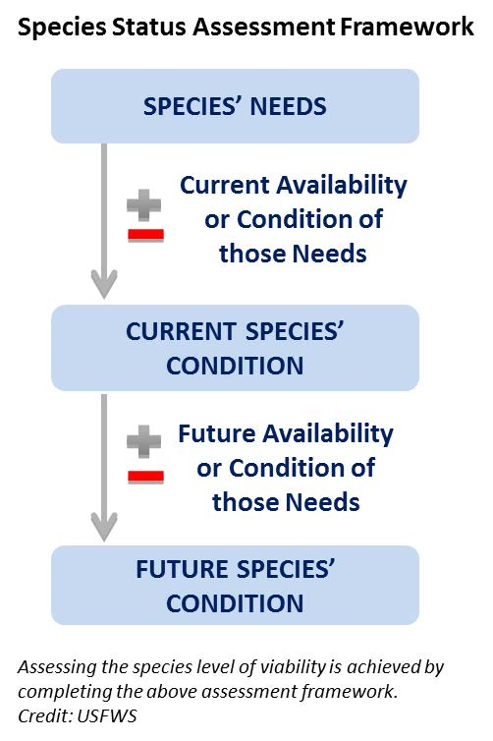Species viability is a critical component of the SSA.Viability is not a specific state, but rather a continuous measure of the likelihood that a species will sustain populations over time (USFWS, 2016). Using the SSA framework (Figure 1-1), we consider what the subspecies needs to maintain viability by characterizing the status of the subspecies in terms of its **resiliency**, **representation**, and **redundancy** (Smith et al., 2017).

**Resiliency** describes the ability of a population to withstand stochastic disturbance. Stochastic events arise from random factors such as weather, flooding, or fire. Resiliency is positively related to population size, growth rate, and connectivity among populations. Resiliency can include population size, occupancy across suitable habitat, availability of suitable habitat, and source propagules to maintain population growth after disturbance.

Figure 1. Species Status Assessment Framework

We measure resiliency for the Puerto Rican Boa … FWS has to create its own metrics.

**Redundancy** describes the ability of a species to withstand catastrophic events. A catastrophic event is defined here as a rare event rapidly and irreversibly affecting multiple or all populations. Redundancy is positively related to the dilution of risk factors across many resilient, representative populations.

We measure redundancy for the Puerto Rican Boa as.. FWS has to create its own metrics.

*Catastrophic events: boas found and killed in large numbers after hurricane Maria. Increased detection after the catastrophic events and resource-mediated movements towards junk piles and moving of debris and habitat (direct (immediate) and indirect effects of catastrophic events up to a year or more by depressing survival rates of the boas).*

**Representation** describes the ability of a species adapt to changing environmental conditions over geologic timescales. Representation is often measured using genetic diversity among populations because it is very obvious. A second type of representation encompasses the totality of behavioral, reproductive, environmental variation based on climatic zones across a species’ range is also used. Theoretically, the more representation a species has, the higher its potential of adapting to natural and anthropogenic change.

We measure representation for the Puerto Rican Boa … FWS has to create its own metrics.

Gaps in knowledge

* food available and prey base across sites and localities (feast in El Yunque?)
* size information related to transitions across life stages
* effect of breeders as a stressor (list of breeders in the States? Otherwise?)
* fecundity and survival of Puerto Rican boas

Life history

Males and females are the same size statistically. Boas are not longer than five feet at the cave Mata de Platano (Alberto Puente). A Puerto Rican Boa found in Philadelphia was more than 10 feet long in 1979 (Peter Tolson). There are strong selective pressures acting on the species size in Puerto Rico.

*Young of the year:* If a boas is smaller than 60 cm, colored red, and in shrubs it may be considered young of the year. The survival of juvenile Caribbean boas is known in other species for example, with 10 - 20% survival of Cuban Boa neonates (600 - 700 SVL, 150 - 200 g; Peter Tolson).

*Shift from young to juvenile:* Recaptures are low and little information exists related to juvenile boas. Based on just five recaptures of juveniles ever, growth of 2.27 cm per year for a single male was recorded (Alberto Puente, Eneilis Mulero).

*Shift from juveniles to sub-adults:* The smallest breeding adult is 110 cm (Alberto Puente). Increased movement and dispersal, like sea turtles, occurs at the beginning of the sub-adult stage. In species like the Cuban Boa, an ontogenetic shift at 2 years old forces the juveniles to find new territories, and they use an area of around 5 hectares. A fast growth rate observed for one female of 17.6 cm per year is attributed to the many rats in the area of Fort Buchanan (Eneilis Mulero).

*Shift from sub-adults to breeding adults:* Most boas will transition to breeding adults at 5 years and live up to 32 years. During the day, only adults are basking (Enelis Mulero). The larger anoles (*Anolis cuvieri*) are in trees where adults are found (Fernando Bird, Alberto Puente).

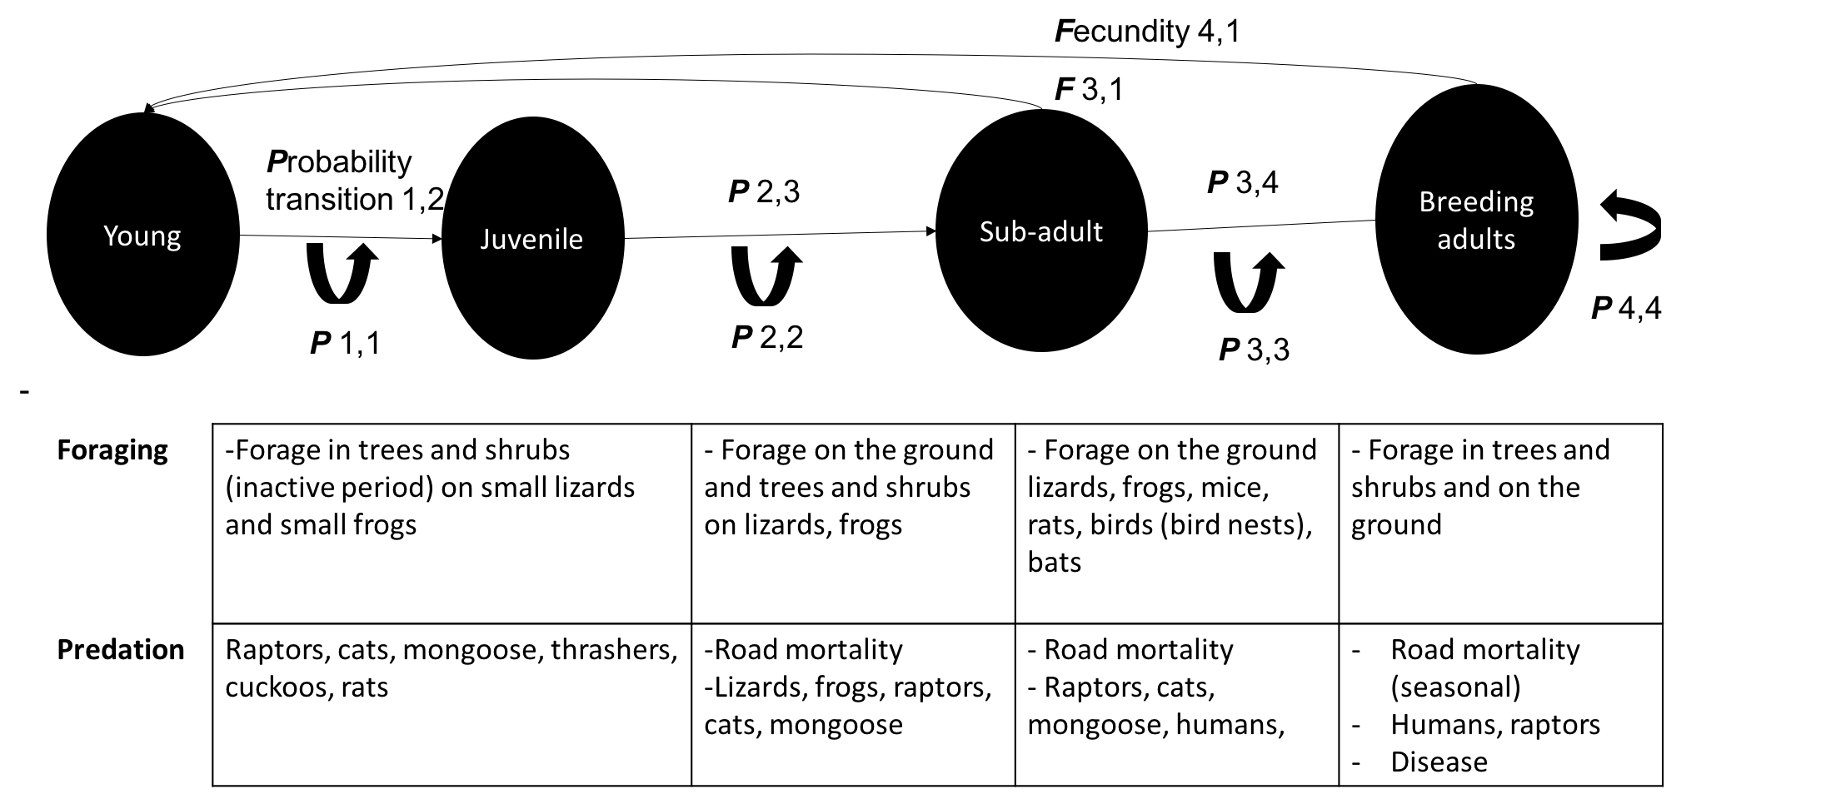

Fig. 1. The life history model for the stage (size) structured classes. The arrows indicate transitions from one state to another state and are represented by the probability of transitions (p). The fecundity (F) arrows at the top indicate the classes where females reproduce and contribute back to the population.

*Fertility*

*Females: in wild populations perhaps 80% of females can produce every year and about 20% reproduce every other year (Eneilis Mulero). In captivity all boas can produce offspring yearly. The generation time is the age at which the female will have her median offspring. The female Puerto Rican boa will begin to reproduce during the sub-adult years.

The cost of fertility is high. Lipid reserves across the size classes indicate that a 100 g boa that is 700 mm SVL will have the same number of offspring as a 200 g boa that is 700 mm SVL. For Puerto Rican boas, the largest birth litter recorded was approximately 3000g and after birth the individual female lost 600g mass. The egg clutch size was 32 with 17 infertile, 13 live boas, the rest dead (Eneilis Mulero). The litter size of 32 or 33 is a good upper bound based on both wild and captive animals (Peter Tolson).

Table 1. Stage-structured Lefkocitch Matrix covariates. Fecundity (***F)*** and the probability **(*P*)** that the boas will transition to each life stage are relevant covariates. The four life stages of young (y), juvenile (j), subadult (s), and breeding adults (a) were determined as distinct by the team assembled.

|  |  | **Young** | **Juvenile** | **Subadult** | **Breeding Adult** |  |  |
| --- | --- | --- | --- | --- | --- | --- | --- |
|  | Young | ***P***yy | 0 | ***Fsy*** | ***Fay*** |  |
|  | Juvenile | ***P***jy | ***P***jj | 0 | 0 |  |
|  | Subadult | 0 | ***P***sj | ***P***ss | 0 |  |
|  | Breeding Adult | 0 | 0 | ***P***as | ***P***aa |  |

Table 2. Stage-structured Lefkocitch Matrix with approximate values from the expert meeting.* The duration that boas remain in each life stage and the approximate size of the boas at each life stage was determined and based on expert opinion.

|  |  | **Young** | **Juvenile** | **Subadult** | **Breeding Adult** | **Duration (years)** | **Size (cm)** |  |
| --- | --- | --- | --- | --- | --- | --- | --- | --- |
|  | Young | 0.1 | 0 | 2 | 15 | 1 | 34 - 60 |
|  | Juvenile | 0.2 | 0.41 | 0 | 0 | 2 | 60 - 90 |
|  | Subadult | 0 | 0.5 | 0.36 | 0 | 4 | 90 - 110 |
|  | Breeding Adult | 0 | 0 | 0.36 | 0.9 | 5+ | 110+ |

*Data here is representative from the meeting and subject to change based on additional data inputs and literature.

Analysis units

The consensus decision was to analyze Puerto Rican boas’ needs, resilience, redundancy, and representation using one analytical unit. Historic clines in the population structure (genetic, morphological, intraspecific behavior) no longer exist (Fernando Bird). The artificial movement of boas through intentional releases and as unintentional cargo has happened introducing rare and novel alleles across the populations. The delineation of polymorphic, polytypic traits of boas indicates many overlapping areas. Today, the boas are a homogenous population with high genetic diversity benefiting the species’ health (Alberto Puente, Graham Reynolds).

**Geographic** **delineations**: The karst versus rainforest seems like the only two delineated areas. In the karst, boas spend more time on the ground because there are more hiding places (Peter Tolson). The boas move across the karst forests and are found across the habitat structure. Despite the unusual and notable feeding behavior of boas foraging for bats, individuals use the cave systems infrequently. For example, in more than 20 years, there were just 2 recaptures at the same cave (Alberto Puente). In the rainforests like El Yunque more time in the forest and in the trees (Daniel Savila, Fernando Bird). El Yunque boas are quite aggressive and “have personalities” (Eneilis Mulero).

**Stressors**

As boas age, the potential for threats diminishes. The following list of stressors may contribute to the mortality of boas:

* electrical wiring
* vulnerable to humans if chasing domestics (chickens, pets)
* road mortality
* oil collection from boa
* vegetation structural change after catastrophic hurricanes
* food availability (i.e., after Hurricane Maria bat population collapsed)
* disease – e.g., ticks positively correlated with meat production (Fernando Bird)
* breeders (international pet trade)

**Conservation**

Translocations are successful due to its secretive life history strategies. When rats/cats/dogs are absent, boas have high survival. Mongoose are not a factor due to their different activity periods. In contrast to the high mortality rates of closely related Virgin Island boas, twelve of thirteen radio-tracked juveniles survived one year later. A greater problem is resource availability. When bat populations are lost, for example after hurricanes, the bat population can take up to ten years to re-populate and reprise its role as a sought-after food source.