**A demographic projection model to support conservation decision making for an endangered snake with limited monitoring data**

Anna M. Tucker1*, Conor P. McGowan2, Eneilis Mulero3, Nicole F. Angeli4, Jan P. Zegarra5

1 School of Forestry and Wildlife Sciences, Auburn University, Alabama USA

2 U.S. Geological Survey, Alabama Cooperative Fish and Wildlife Research Unit, Auburn University, Alabama USA

3 University of Puerto Rico, Mayaguez Campus, Mayaguez, PR 00681

4 School of Forestry and Wildlife Sciences, Auburn University, Alabama USA

5 U.S. Fish and Wildlife Service, Caribbean Ecological Services Field Office, Boquerón, Puerto Rico.

* corresponding author: annamtucker@gmail.com

*This draft manuscript is distributed solely for purposes of scientific peer review. Its content is deliberative and predecisional, so it must not be disclosed or released by reviewers. Because the manuscript has not yet been approved for publication by the U.S. Geological Survey (USGS), it does not represent any official USGS finding or policy.*

**ABSTRACT**

Conservation planning for rare and threatened species is often made more difficult by a lack of research and monitoring data. In such cases, managers may rely on qualitative assessments of species risk that lack explicit acknowledgement of uncertainty. Snakes are a group of conservation concern that are also notoriously difficult to monitor. Here we demonstrate a quantitative population projection for a data-deficient species, the Puerto Rican boa (*Chilabothrus inornatus*) using expert knowledge and published information about species life history and threats to persistence. Using this model, we simulated population dynamics over 30 years under four scenarios of future urbanization and found that there was an increased probability of population decline as urbanization rates increased. We conduct a sensitivity analysis to evaluate the sensitivity of outcomes to model inputs, a practice that may also be useful in recovery planning. The sensitivity analyses also provide insight into how the future trajectories would change if the elicited demographic rates are incorrect. Even when data are sparse, quantitative methods can often be used to produce rigorous and reproducible estimates of future status with quantifiable uncertainty.

**INTRODUCTION**

For many rare and threatened species, little research or monitoring data exist to inform conservation decision-making (Karanth et al. 2003, Good et al. 2006, Brito 2010). Despite a lack of data, managers still need to make predictions about the effects of potential management actions in order to make decisions (Conroy and Peterson 2013). In such situations, decision makers often rely on qualitative assessments of species risk which may be subjective and lack explicit acknowledgement of uncertainty (McCarthy et al. 2004). Although qualitative methods are useful in some circumstances, there may be many cases where even some knowledge of the species’ life history and ecology can be used to develop demographic projection models that result in quantitative assessments of resiliency, extinction risk, and associated uncertainties. There are many sources of uncertainty in population projections (Williams et al. 2002), and failing to explicitly acknowledge them can lead to overly precise predictions and a misunderstandings about risks to species persistence (Gregory and Keeney 2002, McGowan et al. 2011). Quantitative projections allow for the explicit acknowledgement and incorporation of uncertainty and provide decision makers with more nuanced results upon which to base their decisions.

Snakes are notoriously persecuted by humans worldwide and are a group of conservation concern (Mullin and Seigel 2009, Böhm et al. 2013). A recent analysis of a randomly selected subset of reptile species showed that up to 33% of snake species worldwide may be threatened (Böhm et al. 2013). For many species there is data about species distribution only, and information about population trends is lacking. However, an analysis of 17 snake populations in Europe, Australia, and Nigeria found that 11 (65%) declined sharply over the ~20 year study period (Reading et al. 2010). Habitat loss due to urbanization and human development is one of the main threats facing snake populations (Gibbons et al. 2000, Böhm et al. 2013). Additionally, as humans move into previously natural areas snakes face increased threats as result of human interactions (Burghardt et al. 2009).

Snakes and many other reptiles are difficult to monitor, leading to data deficiency for many species (Böhm et al. 2013). Many snakes are cryptic and difficult to detect, exhibit low activity, and are not commonly captured using standardized sampling protocols (Winne et al. 2007, Steen 2010). As a result, quantitative assessments of perceived declines are lacking (Bland and Böhm 2016). Lack of monitoring data also makes it difficult to quantify relationships between environmental stressors and population dynamics (Gibbons et al. 2000). These factors present many challenges for conservation planning and assessment.

The Puerto Rican boa (*Chilabothrus inornatus*) is a terrestrial/arboreal boa endemic to the island of Puerto Rico. This species has been classified as Endangered in the United States since 1970 and listing under the Act requires periodic assessment of the species status to inform possible reclassification decisions and recovery planning. Despite widespread accounts of species occurrence, there are no estimates of historic or current population size and limited field studies on population status, trends or demographics. However, demographics and life history of captive populations are well understood. We used expert opinion and published studies to develop a demographic projection model, which was used to assess the predicted future status of the Puerto Rican boa (hereafter, PR boa) under several potential scenarios. This model allowed us to incorporate many sources of uncertainty to produce quantitative estimates of quasi-extinction risk and population growth. This type of model, despite lack of data, will still be useful for status assessment, reclassification decisions, recovery planning and prioritizing future research and monitoring.

**METHODS**

*Focal Species*

The Puerto Rican boa is a large boa that grows to an average size of ~1.5 m and live up to 32 years. Females reproduce biennially, producing 18-32 eggs per clutch (Huff 1978, Tolson 1992, Puente Rolon 2012). After hatching, young reach sexual maturity at around 5 years (Huff 1978). Diet and behavior vary across life stage, with smaller boas remaining in trees and shrubs to forage on small lizards and frogs, gradually moving to the ground as they grow and begin to also consume rodents, birds, and bats. Small boas may be predated by mongoose, cats, and some birds, but the main sources of larger boa mortality are road strikes, human persecution, and habitat loss.

*Expert Meeting*

On March 5-6, 2018, a team of species experts met to develop a modeling framework that could be used to inform an upcoming classification or recovery planning decisions. During that meeting the team developed a life cycle model (Figure 1), identified key threats, and estimated demographic rates by consensus. Experts agreed that the PR boa species should be considered a single population unit comprising the island of Puerto Rico, noting homogeneity in genetics, morphology, and behavior across the island.

*Demographic Matrix Model*

Based on the life history diagram, we developed a stage-based Lefkovitch matrix model (Caswell 2001) for this population that grouped individuals into stages based on size (Figure 1). We considered five life stages: young of the year, young (<60 cm), juveniles (60-90 cm), subadults (90-110 cm), and adults (>110 cm). We elicited the probabilities of annual survival, growth to the next size class, and fecundity (average number of offspring per individual) for each size class from the expert team or, where applicable, drew from the available literature (Table 1). The experts used personal information, unpublished data, and inference from captive zoo populations to determine average productivity, survival, and growth rates. The experts also directed us to graduate theses and dissertations that were completed but not widely available through literature searches.

We used the stage-specific estimates of survival and growth to calculate the transition rates in the diagram and matrix in Figure 1. These demographic rates are summarized in a matrix:

*Habitat Availability*

The Puerto Rico GAP Analysis (Gould et al. 2008) developed habitat suitability models for a suite of species. That analysis estimated a total of 414,379 ha of suitable habitat for the PR boa. However, per USFWS recommendation, there are no clear records of PR boa above 700 m, so we only considered areas below 700 m to be suitable habitat, resulting in 379,029 ha of habitat. We were also interested in determining the proportion of habitat that fell in developed, urban areas, as experts believed boas experience different pressures in those areas (see *Differences Between Natural and Urban Habitat*, below). We used a raster dataset developed by Martinuzzi et al. (2007) to determine the proportion of suitable habitat falling within developed areas (Figure 2). Martinuzzi et al. (2007) used remote sensing data and information from the U.S. Census Bureau to define three land use types across Puerto Rico: urban, densely-populated rural, and sparsely-populated rural. Human persecution is a key threat to this species, so we considered habitat within sparsely populated areas to be “natural”, i.e. minimally disturbed, and habitat within either urban or densely populated areas to be “developed”. Of the estimated 379,029 ha of suitable habitat, 43% falls within developed areas (Figure 2).

*Carrying Capacity*

We imposed density dependence on this population in the form of a simple population ceiling (Morris and Doak 2002). Published estimates of PR boa density range from 1-5.6 boas/ha (Tolson 1997, Rios-López and Aide 2007, Mulero-Oliveras 2019). If all available habitat was used (379,029 ha), this corresponds to a maximum population size ranging from 379,029 to 2,274,174 individuals. Although some studies have estimated higher boa densities in some areas (6 boas/ha, (Tolson 1997, Rios-López and Aide 2007), all available estimates are from the northern part of the range where the species is considered more abundant than in the dry southern region of the Island. To account for variation in density and habitat quality across the island, we chose to set the maximum island-wide density at 3 boas/ha, for a maximum carrying capacity of 1,137,087 boas. We compared model outputs for simulations with varying maximum densities and found that these input values had little to no effect on resulting probabilities of population growth or quasi-extinction (Appendix B).

For each model replication, we randomly drew a carrying capacity from a Uniform distribution bounded by this minimum and maximum (379, 029 – 1,137,087 boas). We assumed that reproduction would cease if the ceiling was reached, and therefore imposed a rule that set fecundity equal to zero if the total population size reached (or exceeded) the ceiling. It is likely that approaching and exceeding carrying capacity would affect multiple demographic processes, but we do not have data to estimate these effects and so implementing a simple fecundity reduction ceiling function allows us to limit population growth without speculating on the functional form of density dependence (Morris and Doak 2002, McGowan et al. 2017).

*Initial Population Size*

The current population size of PR boas is unknown, and little data exists to inform estimates of current abundance. Therefore, for each model replication, we randomly drew an initial population size from a predetermined range. The range for possible current abundance was estimated using published estimates of boa density and input from the expert team, and we assumed a range of 0.1 to 0.5 boas/ha across all available habitat as a starting density, which corresponds to a range of 37,903 to 189,515 boas in the current population. We chose a maximum current density lower than that estimated by published studies from the north (up to 6 boas/ha) to account for the fact that densities are likely lower in other parts of the range. We assumed that the population started at the stable stage distribution, calculated using the popbio package for R (Stubben and Milligan 2007, R Core Team 2016). The final population size depends in part on the initial population size, so we present projection results as the change in population size from the first year.

*Uncertainty in Demographic Rates*

At the expert meeting described above the team approximated the average value of each rate, but we did not conduct a formal elicitation to obtain estimates of uncertainty in those estimates (Burgman 2005). We followed the recommendations of McGowan et al. (2011) to introduce parametric uncertainty into the replicates of our model simulations. To incorporate uncertainty in our estimates of the average demographic rates, we assumed that the error in our mean estimate was 15% of the average value approximated by the team. We wanted to introduce parameter uncertainty and variability and chose a value between 10% and 20% following the guidance of Kremer (1983). For example, the team estimated average adult survival probability as 0.9, so we assumed a standard deviation of . For each transition probability, we randomly drew an average value for each iteration from a Beta distribution, using the method-of-moments method to convert the mean and standard deviation into beta distribution the shape parameters (Morris and Doak 2002). For the fecundity rates, we randomly drew an average value from a Log-normal distribution (Morris and Doak 2002).

*Temporal Variation in Demographic Rates*

Realized demographic rates often vary annually based on stochastic variation in environmental conditions. To allow for temporal variation in realized rates, we assumed the standard deviation in realized annual rates was 15% of the mean. We used these replication-specific mean and standard deviation to define the distributions from which annual rates were drawn. A conceptual diagram of this hierarchical process is provided in Appendix A. Survival and growth probabilities were drawn from a Beta distribution and fecundity rates were drawn from a Log-normal distribution.

*Differences Between Natural and Urban Habitat*

PR boas occur in many different habitats across the island and experience different conditions in each habitat type. For this projection, we assumed that boas could occupy either natural or urban (developed) habitat. Natural habitat was defined as all suitable habitat falling within sparsely populated areas and urban habitat was defined as all suitable habitat within densely populated or urban areas, as defined by Martinuzzi et al. (2007). Experts believed that in more developed areas boas experience higher mortality due to human persecution, road strikes, and the occurrence of feral cats. Therefore, we assumed that all realized demographic rates would be lower in urban habitats than in natural (undeveloped) conditions. There was some uncertainty in the magnitude of this effect, so we allowed it to vary among replications. For each replication we calculated average rates in urban habitats as the average baseline rate multiplied by a randomly drawn habitat effect with a minimum of 0.5 and a maximum of 1. This allowed the demographic rates in urban areas to be lower than those in natural settings by up to 50%.

*Sensitivity Analysis*

Most of the demographic rates used in this model have not been empirically estimated for this population, therefore we relied on elicited estimates by the expert team. To evaluate the sensitivity of model outputs to these input values, we ran simulations in which we randomly drew values for survival and fecundity from a wide range of possible values. For survival rates, we drew values between 0.01 and 0.99, and for fecundity we drew values between 1 and 20. For each demographic rate we randomly drew 1000 values, holding all other rates constant at the average values in Table 1. We simulated 1000 replications of the population projection at each value, keeping the initial population size and carrying capacity fixed at 113,709 and 758,058, respectively, which were the midpoints of the ranges used in the full population projection. For each projection we determined whether the population remained stable or grew by determining whether the population size in the final year was greater than or equal to the initial population size. We also calculated the probability of quasi-extinction at a threshold of 5000 individuals by finding the proportion of replicates in which the population size fell below 5000. Our purpose was to quantify the expected change in model outputs as each model input parameter changed and to identify thresholds for viability for each input demographic parameter.

We also evaluated the sensitivity of model outputs to the input ranges of possible current abundance and carrying capacity. We compared four different iterations of the simulation model that set the upper bound for current density at either 1 boa/ha or 0.5 boa/ha and set the upper bound for carrying capacity at either 6 boas/ha or 3 boas/ha. We projected the population for 1000 replicates per scenario, holding all demographic rates constant at their average values, and compared the probabilities of population growth, decline, and quasi-extinction.

*Future Scenarios*

Predicting the status of a species under different future conditions is a key part of building management plans for an endangered species. Current ecosystem dynamics may change and current threats to viability may worsen or abate in the future, so simulating multiple future scenarios can help inform management planning and decision-making. The expert team agreed that the key threats to the PR boa are habitat loss and human interactions, both of which are linked to increased development and conversion of natural areas into urban areas. PR boas can persist in islands of habitat within an urbanized matrix (Mulero-Oliveras 2019), but not in a purely developed landscape. We considered future scenarios that included changes in land cover such that developed areas would encroach upon natural areas, resulting in both an increased proximity of natural areas to development and loss of overall habitat area. Each scenario had a different urbanization rate, which was implemented as the rate at which both overall suitable habitat area declined and the rate at which the percent of available habitat falling within developed areas increased. By simulating simultaneous habitat loss and land cover change, these scenarios represent the most extreme way that urbanization could impact PR boa populations. A recent analysis of past rates of urbanization in proximity to protected natural areas in Puerto Rico (Castro-Prieto et al. 2017) found that urban growth increased at a rate of 16% over 2000-2010. For a best-case scenario, we assumed no future urban growth (0% per decade), and therefore that the percent of habitat within developed areas would remain the same as current conditions (43%) and that the total amount of habitat would remain constant (379,029 ha). We next considered a scenario in which the rate of urbanization was reduced by half to a rate of 8% per decade, and therefore that both the proportion of habitat falling in an urban matrix would increase by 8% every ten years and the total habitat area would decrease by 8% every ten years. For a status quo scenario, we assumed the rate of urbanization would continue at 16% per decade, and the total amount of available habitat would decrease by 16% every ten years. For the worst-case scenario, we assumed that the rate of urbanization would increase by half to rate of 24% per decade. To implement these changes in land cover in the model, we calculated the expected rate of development per year and used this to calculate the predicted total habitat availability and proportion in urban areas. This assumes that development occurs gradually each year.

*Population Projection*

We projected the population for 100,000 replications per scenario. For each replicate, we randomly drew the initial population size, carrying capacity, and average demographic rates. The initial population size in each habitat type was equal to the iteration initial population size multiplied by proportion of the available habitat in that type. We projected each population for 30 years, starting in the stable stage distribution as calculated from the replicate average matrix using the popbio package for R (Stubben and Milligan 2007, R Core Team 2016). The time horizon of 30 years was chosen by the team as a reasonable representation of the “foreseeable future” for this species (U.S. Department of the Interior 2009, Smith et al. 2018). For each year, we calculated annual realized demographic rates as described above and calculated the population size by multiplying the year-specific matrix by the population size in the previous time step. We summed the number of individuals in each stage to determine the total population size and calculated the change in population size from the first year by subtracting the initial population size from the projection population size. We calculated the average population growth rate (λ) for each replicate by finding the geometric mean of the year-specific growth rates . We calculated the probabilities of population growth and decline for each scenario as the proportion of replicates in which the average population growth rate was greater than or equal to 1 or less than 1, respectively.

*Quasi-extinction Threshold*

The quasi-extinction threshold is the population size below which either the population cannot recover because it enters an “extinction vortex” (Gilpin and Soulé 1986), or the plausible management alternatives would drastically change (e.g., switching from habitat management to captive breeding). Selecting an appropriate quasi-extinction threshold for a specific population is often challenging due to uncertainties about how demographic feedbacks and management actions influence realized population dynamics. Therefore, we assessed quasi-extinction risk at four thresholds: total population size of 50, 500, 1000, or 5000. For each scenario, we calculated the probability of the population falling below these thresholds as the proportion of replicates in which this occurred. A conceptual diagram of the simulation model is provided in Figure 4.

**RESULTS**

*Sensitivity Analysis*

Changes in adult survival probability had the strongest influence on both the probability of quasi-extinction and of population growth (Figure 3). Quasi-extinction probability was ~0 for all iterations in which adult survival was > 0.75. This analysis also indicated some thresholds at which we expect population dynamics to change. For example, the probability of population growth declined drastically as fecundity fell below ~4.5 young per adult per year (Figure 3). We note that this sensitivity analysis is conducted assuming that only one demographic rate changes independent of the others, while, in reality, threats likely influence more than one rate simultaneously.

Changing the input for maximum current density and maximum carrying capacity density had little effect on simulation model outcomes (Figure B2). Reducing the upper bound for initial population size (current density) resulted in slightly higher quasi-extinction probabilities, but probability of quasi-extinction was ~1% at the highest threshold and under the worst urbanization scenario. Reducing the upper bound for carrying capacity resulted in little to no change in probabilities of population growth and lower probabilities of population decline (Table B1).

*Population Projection*

Our projection model indicated that the population is most likely to decline over a 30-year period under the status quo scenario, i.e. if the current rate of urbanization were to continue (Table 2, Figure 5). Under the current rate of urbanization (16% per decade) the model predicted a 64.3% probability of decline and 35.7% probability of stability or growth. Lower rates of urbanization were associated with a greater probability of population stability or growth, but the probability of growth was only 50.2% under the best-case scenario (no further urbanization), which may be unlikely to occur. However, quasi-extinction probability was low, likely due to the possibility of a large current population size (initial population size range from 37,903 to 189,515 individuals, see *Initial Population Size* above), and was less than 5% for all scenarios and thresholds (Table 2, Figure 5).

**DISCUSSION**

We developed a demographic projection model for the PR boa that incorporated many sources of uncertainty regarding current population status and population vital rates, despite lack of monitoring data to inform past or current abundance. Using this model, we simulated population dynamics over 30 years under four scenarios of future urbanization and found that there was an increased probability of population decline as urbanization rates increased. The probability that the population would remain stable or grow was greater than 50% only when urbanization rates fell to 0%. Increasing rates of urbanization were also associated with an increased quasi-extinction probability, especially at the highest quasi-extinction threshold (5000 individuals). Quasi-extinction probabilities were low for most scenarios due to the possibility of a large initial population size, which buffers the population from falling below the quasi-extinction thresholds within 30 years. If the true current population size is lower than our projected minimum of 37,903 individuals, quasi-extinction probability may be greater.

This model is largely built based on the personal knowledge and opinion of species experts, with support from published studies. The sensitivity analyses serve to evaluate the effect of key model inputs on our estimates of the probability of quasi-extinction or population growth. These sensitivity analyses can help managers see how predictions would change if model inputs are correct, identify how incorrect model inputs would have to be before management decisions would change, and establish priorities for future research. Methods exist to formally elicit demographic parameter estimates and relationships from experts, but those are also time- consuming and can be expensive, or not feasible if few people are experts on the species biology, as was the case for the PR boa (Martin et al. 2012, Drescher et al. 2013, Burgman 2016). Such methods are especially useful for eliciting estimates of uncertainty in demographic rates, i.e. variance or 95% CI. Here, we applied a blanket uncertainty of 15% to all demographic rates because we did not have expert elicitation results, but our projection would be improved by including explicit estimates of uncertainty for each demographic rate. Our model structure incorporated parametric uncertainty such that each replicate of the simulation drew different mean values from the distribution set up using expert elicited means and the 15% C.V. With this added layer of prediction uncertainty, our simulations account for the possibility that the elicited average values are incorrect. With or without those expert-elicited estimates of parametric uncertainty, a sensitivity analysis like the one presented here can help identify which demographic rates contribute the most to realized population trajectories, and can provide decision makers with target thresholds (e.g., adult survival > 0.75) that may be useful in recovery planning.

Without demographic information, occupancy models can be useful for predicting species presence across its range. However, occupancy alone may not be sufficient to understand responses to future threats because animals often exist in suboptimal habitat (Schlaepfer et al. 2002, Battin 2004). For the PR boa, there are opportunistic sightings from across the range, most frequently in human-dominated areas. That alone might indicate that urbanized habitat is suitable for boas, but species experts agreed that those areas are likely population sinks in which boas experience increased mortality due to road strikes and direct human persecution. By modeling the proportion of habitat in urbanized areas and allowing for a large range in the negative effect of urbanization, we were able to capture this nuance that might be lost if we analyzed occurrence records alone.

Density dependence presents a challenge in developing demographic projections because the mechanisms and functional form of population responses to increased density are still poorly understood for many species. Especially for an island endemic, we thought it important to restrict population growth but had no data to inform carrying capacity or population responses to increased density. By using published estimates of boa density and home range size, we calculated a reasonable range of possible carrying capacities for the island of Puerto Rico. We imposed density dependence in the projection using a simple ceiling function, though in reality population response to density is likely more complex and nuanced. However, our sensitivity analysis indicated that, for our projections, changing this ceiling had little effect on population trajectories.

The sensitivity analyses were an important outcome of this modeling effort. Despite having limited information on demographic rates, we were still able to construct a model of population dynamics based on known features of the species life history. The sensitivity analyses of that model provide insight into how the future trajectories would change if the elicited demographic rates are incorrect. For example, we found that all simulations with adult survival >0.75 had no extinction risk, meaning that our experts would have to be wrong about the average adult survival rate by 0.15 in order to change the risk for this species. We can also conclude that mark recapture studies or other efforts to study the survival rates of adult boa would greatly improve confidence in our model predictions and utility for decision-making.

This analysis synthesized information from the published and grey literature with expert opinion to develop a quantitative projection model despite many uncertainties about current population status and demographic rates. Because we explicitly incorporated those uncertainties in the simulation model, the outputs reflect our best predictions given those uncertainties. Even when data are sparse, quantitative methods can often be used to produce rigorous and reproducible estimates of future status with quantifiable uncertainty.

**ACKNOWLEDGMENTS**

We thank the expert team for contributing their time and expertise to develop this model. We thank XX and reviewers for comments that improved the quality of this manuscript. The findings and conclusions in this article are those of the authors and do not necessarily represent the opinions of the U.S. Fish and Wildlife Service. Any use of trade, firm, or product names is for descriptive purposes only and does not imply endorsement by the U.S. Government.

*Authors’ contributions*

AMT, NAF, CPM, and JPZ conceived the ideas; NAF and AMT designed methodology and analyzed the data with input from CPM, JPZ, and EMO; AMT led the writing of the manuscript. All authors contributed critically to the drafts and gave final approval for publication.

*Code availability*

All code can be found at http://www.github.com/annamtucker/pr-boa.

**LITERATURE CITED**

Battin, J. 2004. When Good Animals Love Bad Habitats: Ecological Traps and the Conservation of Animal Populations. Conservation Biology 18:1482–1491.

Bland, L. M., and M. Böhm. 2016. Overcoming data deficiency in reptiles. Biological Conservation 204:16–22.

Böhm, M., B. Collen, J. E. M. Baillie, P. Bowles, J. Chanson, N. Cox, G. Hammerson, M. Hoffmann, S. R. Livingstone, M. Ram, A. G. J. Rhodin, S. N. Stuart, P. P. van Dijk, B. E. Young, L. E. Afuang, A. Aghasyan, A. García, C. Aguilar, R. Ajtic, F. Akarsu, L. R. V. Alencar, A. Allison, N. Ananjeva, S. Anderson, C. Andrén, D. Ariano-Sánchez, J. C. Arredondo, M. Auliya, C. C. Austin, A. Avci, P. J. Baker, A. F. Barreto-Lima, C. L. Barrio-Amorós, D. Basu, M. F. Bates, A. Batistella, A. Bauer, D. Bennett, W. Böhme, D. Broadley, R. Brown, J. Burgess, A. Captain, S. Carreira, M. del R. Castañeda, F. Castro, A. Catenazzi, J. R. Cedeño-Vázquez, D. G. Chapple, M. Cheylan, D. F. Cisneros-Heredia, D. Cogalniceanu, H. Cogger, C. Corti, G. C. Costa, P. J. Couper, T. Courtney, J. Crnobrnja-Isailovic, P. A. Crochet, B. Crother, F. Cruz, J. C. Daltry, R. J. R. Daniels, I. Das, A. de Silva, A. C. Diesmos, L. Dirksen, T. M. Doan, C. K. Dodd, J. S. Doody, M. E. Dorcas, J. Duarte de Barros Filho, V. T. Egan, E. H. El Mouden, D. Embert, R. E. Espinoza, A. Fallabrino, X. Feng, Z. J. Feng, L. Fitzgerald, O. Flores-Villela, F. G. R. França, D. Frost, H. Gadsden, T. Gamble, S. R. Ganesh, M. A. Garcia, J. E. García-Pérez, J. Gatus, M. Gaulke, P. Geniez, A. Georges, J. Gerlach, S. Goldberg, J. C. T. Gonzalez, D. J. Gower, T. Grant, E. Greenbaum, C. Grieco, P. Guo, A. M. Hamilton, K. Hare, S. B. Hedges, N. Heideman, C. Hilton-Taylor, R. Hitchmough, B. Hollingsworth, M. Hutchinson, I. Ineich, J. Iverson, F. M. Jaksic, R. Jenkins, U. Joger, R. Jose, Y. Kaska, U. Kaya, J. S. Keogh, G. Köhler, G. Kuchling, Y. Kumlutaş, A. Kwet, E. La Marca, W. Lamar, A. Lane, B. Lardner, C. Latta, G. Latta, M. Lau, P. Lavin, D. Lawson, M. LeBreton, E. Lehr, D. Limpus, N. Lipczynski, A. S. Lobo, M. A. López-Luna, L. Luiselli, V. Lukoschek, M. Lundberg, P. Lymberakis, R. Macey, W. E. Magnusson, D. L. Mahler, A. Malhotra, J. Mariaux, B. Maritz, O. A. V. Marques, R. Márquez, M. Martins, G. Masterson, J. A. Mateo, R. Mathew, N. Mathews, G. Mayer, J. R. McCranie, G. J. Measey, F. Mendoza-Quijano, M. Menegon, S. Métrailler, D. A. Milton, C. Montgomery, S. A. A. Morato, T. Mott, A. Muñoz-Alonso, J. Murphy, T. Q. Nguyen, G. Nilson, C. Nogueira, H. Núñez, N. Orlov, H. Ota, J. Ottenwalder, T. Papenfuss, S. Pasachnik, P. Passos, O. S. G. Pauwels, N. Pérez-Buitrago, V. Pérez-Mellado, E. R. Pianka, J. Pleguezuelos, C. Pollock, P. Ponce-Campos, R. Powell, F. Pupin, G. E. Quintero Díaz, R. Radder, J. Ramer, A. R. Rasmussen, C. Raxworthy, R. Reynolds, N. Richman, E. L. Rico, E. Riservato, G. Rivas, P. L. B. da Rocha, M. O. Rödel, L. Rodríguez Schettino, W. M. Roosenburg, J. P. Ross, R. Sadek, K. Sanders, G. Santos-Barrera, H. H. Schleich, B. R. Schmidt, A. Schmitz, M. Sharifi, G. Shea, H. T. Shi, R. Shine, R. Sindaco, T. Slimani, R. Somaweera, S. Spawls, P. Stafford, R. Stuebing, S. Sweet, E. Sy, H. J. Temple, M. F. Tognelli, K. Tolley, P. J. Tolson, B. Tuniyev, S. Tuniyev, N. üzüm, G. van Buurt, M. Van Sluys, A. Velasco, M. Vences, M. Veselý, S. Vinke, T. Vinke, G. Vogel, M. Vogrin, R. C. Vogt, O. R. Wearn, Y. L. Werner, M. J. Whiting, T. Wiewandt, J. Wilkinson, B. Wilson, S. Wren, T. Zamin, K. Zhou, and G. Zug. 2013. The conservation status of the world’s reptiles. Biological Conservation 157:372–385.

Brito, D. 2010. Overcoming the Linnean shortfall: Data deficiency and biological survey priorities. Basic and Applied Ecology 11:709–713.

Burghardt, G. M., J. B. Murphy, D. Chiszar, and M. Hutchins. 2009. Combating Ophiophobia: Origins, Treatment, Education, and Conservation Tools. Pages 262–280 *in* S. J. Mullin and R. A. Seigel, editors. Snakes: Ecology and Conservation. Cornell University Press, Ithaca, NY.

Burgman, M. A. 2005. Risks and Decisions for Conservation and Environmental Management. Cambridge University Press, Cambridge, UK.

Burgman, M. A. 2016. Trusting judgments: how to get the best out of experts. Cambridge University Press.

Castro-Prieto, J., S. Martinuzzi, V. C. Radeloff, D. P. Helmers, M. Quiñones, and W. A. Gould. 2017. Declining human population but increasing residential development around protected areas in Puerto Rico. Biological Conservation 209:473–481.

Caswell, H. 2001. Matrix population models: construction, analysis, and interpretation. 2nd edition. Sinauer Associates, Inc., Sunderland, MA, USA, MA, USA.

Conroy, M. J., and J. T. Peterson. 2013. Decision Making in Natural Resources Management. Wiley-Blackwell.

Drescher, M., A. H. Perera, C. J. Johnson, L. J. Buse, C. A. Drew, and M. A. Burgman. 2013. Toward rigorous use of expert knowledge in ecological research. Ecosphere 4:1–26.

Gibbons, J. W., D. E. Scott, T. J. Ryan, K. A. Buhlmann, T. D. Tuberville, B. S. Metts, J. L. Greene, T. Mills, Y. Leiden, S. Poppy, and C. T. Winne. 2000. The Global Decline of Reptiles, Déjà Vu Amphibians. BioScience 50:653.

Gilpin, M. E., and M. E. Soulé. 1986. Minimum viable populations: processes of species extinctions. Pages 19–34 *in* M. E. Soulé, editor. Conservation Biology: the Science of Scarcity and Diversity. Sinauer Associates, Inc., Sunderland, MA, USA.

Good, T. C., M. L. Zjhra, and C. Kremen. 2006. Addressing data deficiency in classifying extinction risk: A case study of a radiation of Bignoniaceae from Madagascar. Conservation Biology 20:1099–1110.

Gregory, R. S., and R. L. Keeney. 2002. Making smarter environmental management decisions. Journal of the American Water Resources Association 38:1601–1612.

Huff, T. A. 1978. Breeding the Puerto Rican boa at the Reptile Breeding Foundation. International Zoo Yearbook 16:81–82.

Interior, U. S. D. of the. 2009. The Meaning of “Foreseeable Future” in Section 3(20) of the Endangered Species Act. Solicitor memorandum M- 3702, Office of the Solicitor, Washington, D.C.

Karanth, K. U., J. D. Nichols, J. Seidensticker, E. Dinerstein, J. L. D. Smith, C. McDougal, A. J. T. Johnsingh, R. S. Chundawat, and V. Thapar. 2003. Science deficiency in conservation practice: The monitoring of tiger populations in India. Animal Conservation 6:141–146.

Martin, T. G., M. A. Burgman, F. Fidler, P. M. Kuhnert, S. Low-Choy, M. Mcbride, and K. Mengersen. 2012. Eliciting Expert Knowledge in Conservation Science. Conservation Biology 26:29–38.

McCarthy, M. A., D. Keith, J. Tietjen, M. A. Burgman, M. Maunder, L. Master, B. W. Brook, G. Mace, H. P. Possingham, R. Medellin, S. Andelman, H. Regan, T. Regan, and M. Ruckelshaus. 2004. Comparing predictions of extinction risk using models and subjective judgement. Acta Oecologica 26:67–74.

McGowan, C. P., N. Allan, J. Servoss, S. Hedwall, and B. Wooldridge. 2017. Incorporating population viability models into species status assessment and listing decisions under the U.S. Endangered Species Act. Global Ecology and Conservation 12:119–130.

McGowan, C. P., M. C. Runge, and M. a. Larson. 2011. Incorporating parametric uncertainty into population viability analysis models. Biological Conservation 144:1400–1408.

Morris, W. F., and D. F. Doak. 2002. Quantitative Conservation Biology. Sinauer Associates, Inc., Sunderland, MA, USA.

Mulero-Oliveras, E. S. 2019. Population and habitat utilization of the Puerto Rican boa (Chilabothrus inornatus) in an urban fragmented habitat. University of Puerto Rico.

Mullin, S. J., and R. A. Seigel, editors. 2009. Snakes: Ecology and Conservation. Cornell University Press, Ithaca, NY.

Puente Rolon, A. R. 2012. Reproductive ecology, fitness, and management of the Puerto Rican Boa (Epicrates inornatus, Boidae). University of Puerto Rico.

R Core Team. 2016. R: A language and environment for statistical computing. R Foundation for Statistical Computing, Vienna, Austria.

Reading, C. J., L. M. Luiselli, G. C. Akani, X. Bonnet, G. Amori, J. M. Ballouard, E. Filippi, G. Naulleau, D. Pearson, and L. Rugiero. 2010. Are snake populations in widespread decline? Biology Letters 6:777–780.

Rios-López, N., and T. M. Aide. 2007. Herpetofaunal Dynamics During Secondary Succession. Herpetologica 63:35–50.

Schlaepfer, M. A., M. C. Runge, P. W. Sherman, and P. W. Sherman. 2002. Ecological and evolutionary traps. Trends in Ecology & Evolution 17:474–480.

Smith, D. R., N. L. Allan, C. P. McGowan, J. A. Szymanski, S. R. Oetker, and H. M. Bell. 2018. Development of a Species Status Assessment Process for Decisions under the U.S. Endangered Species Act. Journal of Fish and Wildlife Management 9:302–320.

Steen, D. A. 2010. Snakes in the grass: Secretive natural histories defy both conventional and progressive statistics. Herpetological Conservation and Biology 5:183–188.

Stubben, C., and B. Milligan. 2007. Estimating and Analyzing Demographic Models Using the popbio package in R. Journal of Statistical Software 22.

Tolson, P. J. 1992. The Reproductive Biology of the Neotropical Boid Genus Epicrates (Serpentes:Boidae). Page *in* W. C. Hamlett, editor. Reproductive Biology of South American Vertebrates. Springer, New York, NY.

Tolson, P. J. 1997. Population census and habitat assessment for the Puerto Rican boa, Epicrates inornatus, at the U.S. Naval Security Group Activity, Sabana Seca, Puerto Rico. Final Report. Puerta de Tierra, Puerto Rico.

Williams, B., J. Nichols, and M. Conroy. 2002. Analysis and Management of Wildlife Populations. First edition. Academic Press, San Diego, California.

Winne, C. T., J. D. Willson, B. D. Todd, K. M. Andrews, and J. W. Gibbons. 2007. Enigmatic Decline of a Protected Population of Eastern Kingsnakes, Lampropeltis Getula, in South Carolina. Copeia 2007:507–519.

**TABLES AND FIGURES**

**Table 1**. Stage-specific demographic rates. Average values were determined by the expert team or drawn from available literature.

|  |  |  |  |
| --- | --- | --- | --- |
| **Demographic rate** | **Description** | **Average** | **Rationale** |
|  | Survival – Young of the year | 0.1 | Expert opinion, informed by studies of Cuban boaa |
|  | Survival – Young | 0.3 | Expert opinion, informed by studies of Cuban boaa |
|  | Survival – Juvenile | 0.9 | Expert opinion |
|  | Survival – Subadult | 0.72 | Expert opinion – survival of this stage is lower than the juvenile or adult stage because individuals begin dispersing widely and face more threats |
|  | Survival – Adult | 0.9 | Expert opinion and estimates from radio-tracked translocated snakesb |
|  | Growth – Young to Juvenile | 0.67 | Expert opinion – approximately 2/3 of the young of the year grow enough to become juveniles in the next year. |
|  | Growth – Juvenile to Subadult | 0.5 | Expert opinion – juvenile stage typically lasts two years |
|  | Growth – Subadult to Adult | 0.25 | Expert opinion – subadult stage typically lasts four years |
|  | Fecundity – Adult | 4.5 | Average clutch size is 18 (range = 12-32)b,c This clutch size is multiplied by 0.5 because only females produce young (assumes a 50:50 sex ratio) and multiplied by 0.5 again because females reproduce bienniallyc |
|  | Fecundity – Subadult | 2 | Expert opinion – some larger subadults may breed, but with a lower breeding probability |

aTolson 1992

bPuente-Rolon 2012

cHuff 1978

**Table 2.** The probabilities of quasi-extinction, population growth, and population decrease for each scenario. We evaluated quasi-extinction probability at four thresholds due to our uncertainties about how that threshold should be determined. The probability of population growth and decline are the proportion of replicates in which the average population growth rate (λ) was greater than 1 or less than 1, respectively. Average population growth rate and percent change in population size are presented as the median and 95% quantiles among all replicates.

|  |  |  |  |  |  |  |  |
| --- | --- | --- | --- | --- | --- | --- | --- |
| Urban growth | Quasi-extinction probability | | | | Probability of population stability or growth (λ ≥ 1) | Probability of population  decline (λ < 1) | Average population growth rate (λ) |
| 50 | 500 | 1000 | 5000 |
| 0% | 0 | 0 | 0 | 0.005 | 0.502 | 0.499 | 1.00  (0.933, 1.06) |
| 8% | 0 | 0 | 0 | 0.006 | 0.435 | 0.565 | 0.994  (0.927, 1.06) |
| 16% | 0 | 0 | 0.0001 | 0.011 | 0.357 | 0.643 | 0.987  (0.921, 1.05) |
| 24% | 0 | 0 | 0 | 0.015 | 0.285 | 0.715 | 0.981  (0.916, 1.04) |

**Figure 1**. Life cycle and stage-based matrix model for the Puerto Rican boa.

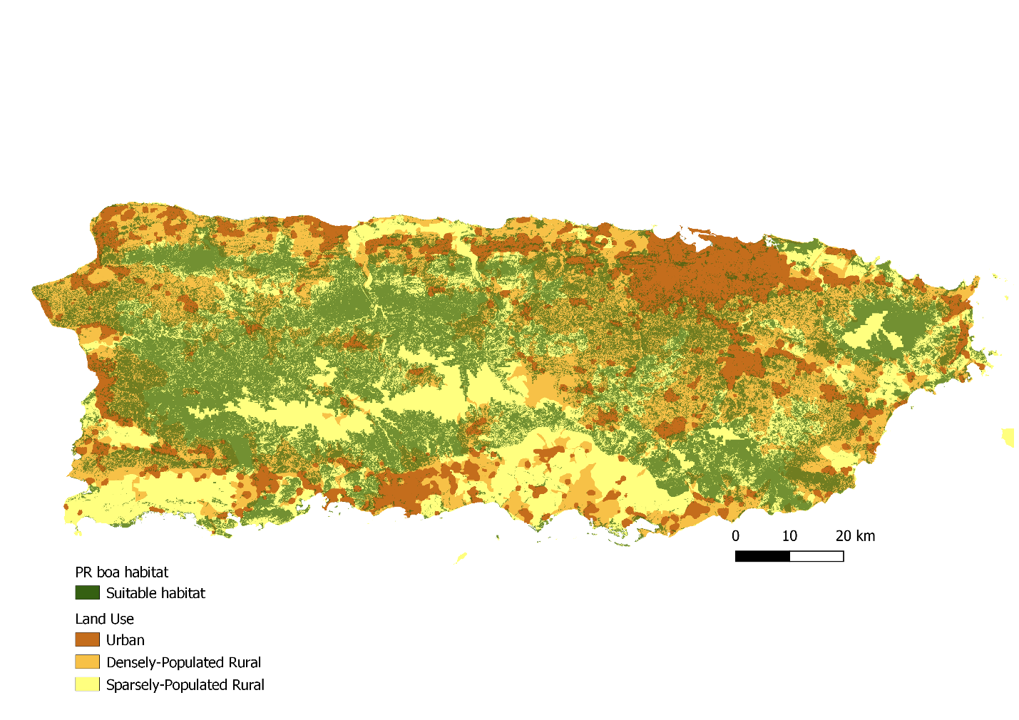

**Figure 2.** Habitat availability for Puerto Rican boas. Suitable habitat (green) was based on the PR Gap Analysis and only includes pixels at less than 700 m elevation. Land use raster based on remote sensing and U.S. Census Bureau data was used to determine the proportion of habitat falling within developed (urban and densely-populated rural) versus natural (sparsely-populated rural) areas.

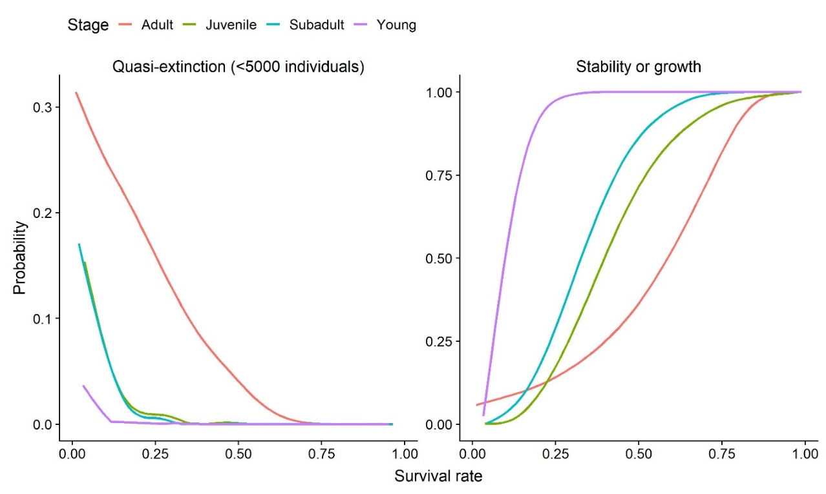

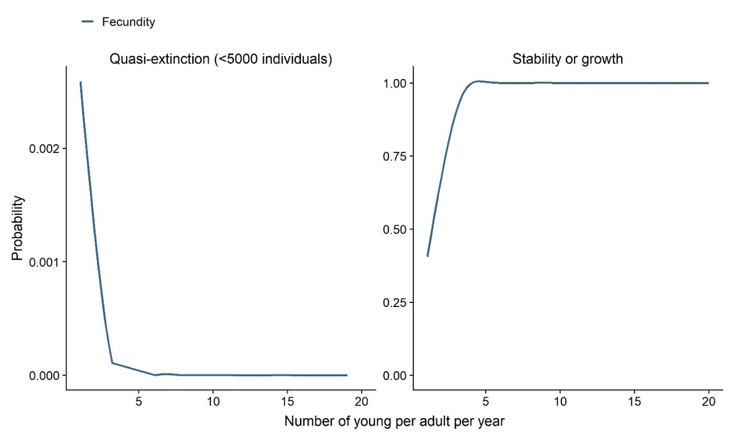

**Figure 3.** Simulated probabilities of quasi-extinction and of population growth over the range of possible survival rates (A) for each stage (adult – orange, subadult – blue, juvenile – green, young – purple) and fecundity (B).

**Figure 4.** Conceptual diagram of the stochastic simulation model used to assess the future condition of PR boas under different rates of urbanization. White hexagons on the left represent model inputs and gray hexagons on the right represent model outputs. Rectangles represent values calculated within each replication of the simulation.

**Figure 5.** Projected change in population size over 30 years for four potential scenarios of land cover change. Solid black lines show the medians among all replicates, and shaded gray regions show the 95% quantiles (95% of replications fell within this range). The dashed line is at 0, indicating no change in population size.