**A stochastic population projection for the Puerto Rican boa (*Chilabothrus inornatus*)**

Anna M. Tucker

*This draft manuscript is distributed solely for purposes of scientific peer review. Its content is deliberative and pre-decisional, so it must not be disclosed or released. This manuscript does not represent any official USGS finding or policy.*

**Introduction**

The Puerto Rican boa (*Chilabothrus inornatus*) is a terrestrial boa endemic to the island of Puerto Rico. This species has been classified as Endangered in the United States since 1970. Here we used expert opinion and published studies to develop a demographic projection model, which was used to assess the predicted future status of the Puerto Rican boa (hereafter, PR boa) under several potential scenarios.

**Methods**

*Expert Meeting*

On March 5-6, 2018, a team of species experts met to develop a modeling framework that would inform this SSA. During that meeting the team developed a life cycle model (Figure 1) and identified key threats; the discussions during that meeting provided the basis for the projection model described here. Meeting participants and affiliations are listed in Table 1.

At the meeting, participants discussed the current knowledge of PR boa life history and ecology and identified gaps in knowledge. Gaps included the status of food availability and prey across sites, size information related to transitions across life stages, the stress induced by breeding, and some demographic rates for wild populations.

Experts agreed that the PR boa status should be assessed as a single analysis unit comprising the island of Puerto Rico. Historic clines in population structure resulting in differences in genetics, morphology, and behavior no longer exist due to human-assisted movements of boas, both intentional and unintentional (F. Bird *pers. comm.*). Today the boas are a homogenous population with high genetic diversity (A. Puente, *pers. comm*.).

**Table 1**. Participants of the expert meeting held March 5-6, 2018 to inform the SSA for the Puerto Rican boa.

|  |  |
| --- | --- |
| Name | Affiliation |
| Fernando Bird | University of Puerto Rico |
| Alberto Puente-Rolon | University of Puerto Rico |
| Rafael Joglar | University of Puerto Rico |
| Daniel Savila | University of Puerto Rico |
| Eneilis Mulero | University of Puerto Rico |
| Peter Tolson | Toledo Zoo |
| Miguel Toño Garcia | USFWS |
| Jose Cruz-Burgos | USFWS Caribbean Ecological Services Field Office |
| Jan Paul Zegarra | USFWS Caribbean Ecological Services Field Office |
| Nicole Angeli | Auburn University, Alabama Fish and Wildlife Cooperative Research Unit |
| Conor McGowan | USGS, Alabama Fish and Wildlife Cooperative Research Unit |

*Demographic Matrix Model*

We developed a stage-based Lefkovitch matrix model (Caswell 2001) for this population that grouped individuals into stages based on size (Figure 1). This model was chosen to represent the growth and maturation process because it allows us to account for stage-specific differences in survival and reproductive output. We considered four life stages based on size: young (<60 cm), juveniles (60-90 cm), subadults (90-110 cm), and adults (>110 cm). We elicited the probabilities of annual survival, growth to the next size class, and fecundity (average number of offspring per individual) for each size class from the expert team or drew estimates from the available literature (Table 2). The experts used personal information, unpublished data and inference from captive zoo populations to determine productivity and survival rates. The experts also directed us to graduate theses and dissertations that were completed but not widely available through literature searches.

The probabilities of transitioning between size classes was determined by estimating the length of time spent in each age class. For example, experts believed that snakes remained in the juvenile age class for 2 years on average, so the mean transition rate from juvenile to sub-adult was 0.5. In other words, 50% of the animals in the juvenile age class transitioned to the subadult stage because each year half the animals would transition to the next stage.

**Figure 1**. Life cycle and stage-based matrix model for the Puerto Rican boa, based on an annual time step and pre-breeding census. In each time step, the probabilities of survival are denoted using the letter , probabilities of growth from one stage to the next is denoted , and the average fecundity (number of offspring produced per individual) is denoted .

**Table 2**. Stage-specific demographic rates. Average values were determined by the expert team or drawn from available literature. Standard deviations (SD) were calculated assuming that rates varied within 15% of the average.

|  |  |  |  |  |
| --- | --- | --- | --- | --- |
| **Demographic rate** | **Description** | **Average** | **SD**  **(Average*0.15)** | **Rationale** |
|  | Survival – young of the year | 0.3 | 0.05 | Expert opinion, informed by studies of Cuban boaa |
|  | Survival – Juvenile | 0.9 | 0.14 | Expert opinion |
|  | Survival – Subadult | 0.72 | 0.11 | Expert opinion – survival of this stage is lower than the juvenile or adult stage because individuals begin dispersing widely and face more threats |
|  | Survival – Adult | 0.9 | 0.14 | Expert opinion and estimates from radio-tracked translocated snakesc |
|  | Growth – Young to Juvenile | 0.67 | 0.1 | Expert opinion – approximately 2/3 of the young of the year grow enough to become juveniles in the next year. |
|  | Growth – Juvenile to Subadult | 0.5 | 0.08 | Expert opinion – juvenile stage typically lasts two years |
|  | Growth – Subadult to Adult | 0.25 | 0.38 | Expert opinion – subadult stage typically lasts four years |
|  | Fecundity – Adult | 4.5 | 1.4 | Average clutch size is 18 (range = 12-32)b,c This clutch size is multiplied by 0.5 because only females produce young (assumes a 50:50 sex ratio) and multiplied by 0.5 again because females reproduce bienniallyd |
|  | Fecundity – Subadult | 2 | 1.4 | Expert opinion – some larger subadults may breed, but with a lower breeding probability |

aP. Tolson pers. comm.

bTolson 1992

cPuente-Rolon 2012

dHuff 1978

We used the stage-specific estimates of survival and growth to calculate the transition rates in the diagram and matrix in Figure 1. For example, the probability that a young of the year in year *t* will become a juvenile in year *t+1* is equal to the probability of surviving the year () multiplied by the probability of growth from young to juvenile ().

The probability of a young of the year remaining in the young stage is equal to the probability of surviving the year () and *not* growing enough to reach the juvenile stage ().

The transition rates for each stage were calculated following this framework. The realized fertility rates ( and ) in the matrix model are calculated by multiplying the estimated reproductive output for each stage class by the survival rate of young, which was estimated as 0.3, i.e. new young of the year must survive one year before entering the population.

These demographic rates are summarized in a matrix:

For each projection we assumed that the population started at the stable stage distribution, calculated using the popbio package for R (Stubben and Milligan 2007, R Core Team 2016). The stage distribution is the proportion of the population in stage class, and most populations will converge on a stable stage distribution if demographic rates remain relatively constant for a sufficiently long time (Caswell 2001). Before reaching the stable stage distribution, the population may exhibit erratic growth patterns that are an artifact of the stage imbalance. By starting the population projection at the stable stage distribution, we sought to minimize these effects.

*Habitat Availability*

The Puerto Rico GAP Analysis (Gould et al. 2008) developed habitat suitability models for a suite of species, including the PR boa. We used the resulting raster dataset to assess the total area of available habitat, which was then used to estimate minimum and maximum bounds for the current and maximum population sizes. The PR GAP Analysis used occurrence records to map habitat across Puerto Rico and estimated 414,379 ha of habitat. However, per USFWS recommendation, there are no clear records of PR boa above 700 m, so we only considered areas below 700 m to be suitable habitat, totaling 379,029 ha. We were also interested in determining the proportion of habitat that fell in developed, urban areas, as experts believed boas experience different pressures in those areas (see *Differences Between Natural and Urban Habitat*, below). We used a raster dataset developed by Martinuzzi et al. (2007) to determine the proportion of suitable habitat falling within developed areas (Figure 2). Martinuzzi et al. (2007) used remote sensing data and information from the U.S. Census Bureau to define three land use types across Puerto Rico: urban, densely-populated rural, and sparsely-populated rural. Human persecution is a key threat to this species, so we considered habitat within sparsely populated areas to be “natural”, i.e. minimally disturbed, and habitat within either urban or densely populated areas to be “developed”. Of the estimated 379,029 ha of suitable habitat, 43% falls within developed areas.

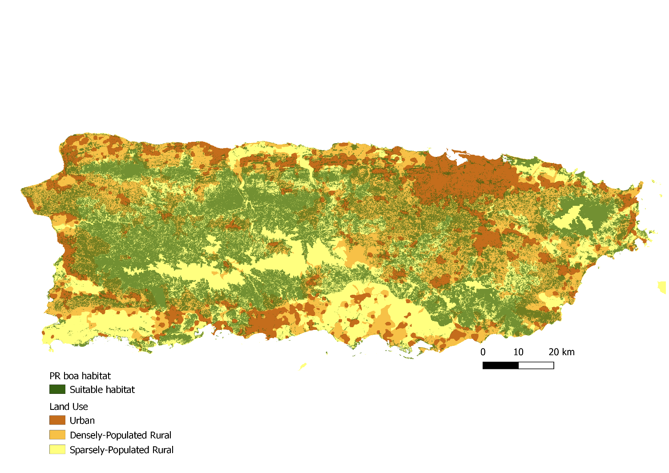

**Figure 2.** Habitat availability for Puerto Rican boas. Suitable habitat (green) was based on the PR Gap Analysis and only includes pixels at less than 700 m elevation. Land use raster based on remote sensing and U.S. Census Bureau data was used to determine the proportion of habitat falling within developed (urban and densely-population rural) versus natural (sparsely-populated rural) areas.

*Carrying Capacity*

Most wildlife populations face constraints on the maximum number of individuals that can be supported by local resources. We imposed density dependence on this population in the form of a simple population ceiling. Published estimates of PR boa density range from 1-3 (Mulero-Oliveras 2019). If all available habitat was used, this corresponds to a maximum population size ranging from 379,029 to 1,137,087 individuals. Although some studies have estimated higher boa densities in some areas, all available estimates are from the northern part of the range where habitat is higher quality and densities are greater (J.P. Zegarra *pers. comm.*). To account for variation in density and habitat quality across the island, we chose to set the maximum island-wide density at 3 boas/ha, which we feel is a more conservative approach. We compared model outputs for simulations with varying maximum densities and found that these input values had minimal effect on probabilities of population growth or quasi-extinction (Appendix B).

For each model replication, we randomly drew a carrying capacity from a Uniform distribution bounded by this minimum and maximum. We assumed that reproduction would cease if the ceiling was reached, and therefore imposed a rule that set fecundity equal to zero if the total population size reached the ceiling. This approach is a simplified model of how carrying capacity would affect population demographics. It likely that approaching and exceeding carrying capacity would affect multiple demographic processes, but we do not have data to estimate these effects and so implementing a simple fecundity reduction ceiling function allows us to limit population growth without speculating on the functional form of density dependence (Morris and Doak 2002, McGowan et al. 2017).

*Initial Population Size*

The current population size of PR boas is unknown, and little data exists to inform estimates of current abundance. Therefore, for each model replication, we randomly drew an initial population size from a predetermined range. The range for possible current abundance was estimated using published estimates of boa density and input from the expert team, and we assumed a range of 0.1 to 0.5 boas/ha across all available habitat as a starting density, which corresponds to a range of 37,903 to 189,515 boas in the current population. We chose a maximum current density lower than that estimated by published studies from the north (up to 7 boas/ha) to account for the fact that densities are likely lower in other parts of the range. The final population size depends in part on the initial population size, so we present projection results as the change in population size from the first year.

*Uncertainty in Demographic Rates*

At the expert meeting described above the team approximated the average value of each rate, but we did not conduct a formal elicitation to obtain estimates of uncertainty in those estimates (Burgman 2005). To incorporate uncertainty in our estimates of the average demographic rates, we assumed that the error in our mean estimate was 15% of the average value approximated by the team. For example, the team estimated average adult survival probability as 0.9, so we assumed a standard deviation of . For each transition probability, we randomly drew an average value for each iteration from a Beta distribution, using the method-of-moments method to calculate the shape parameters. For the fecundity rates, we randomly drew an average value from a Log-normal distribution.

*Temporal Variation in Demographic Rates*

Realized demographic rates often vary annually based on stochastic variation in environmental conditions. To allow for temporal variation in realized rates, we assumed the standard deviation in realized annual rates was 15% of the mean. We used these replication-specific mean and standard deviation to define the distributions from which annual rates were drawn. Transition probabilities were drawn from a Beta distribution and fecundity rates were drawn from a Log-normal distribution. A conceptual depiction of how both parametric uncertainty temporal variability were included in the projection model is provided in Appendix A.

*Differences Between Natural and Urban Habitat*

PR boas occur in many different habitats across the island and experience different conditions in each habitat type. For this projection, we assumed that boas could occupy either natural (undeveloped) or developed habitat. Natural habitat was defined as all suitable habitat that was not adjacent to development. Developed habitat was defined as all suitable habitat falling within either urban or densely populated rural areas, as defined by Martinuzzi et al (2007) (see *Habitat Availability*, above). Experts believed that in developed areas boas experience higher mortality due to human interactions, road strikes, and the occurrence of feral cats. Fecundity and growth may also be lower due to lower food availability and other stressors associated with living in an urbanized landscape. Therefore, we assumed that all realized demographic rates would be lower in urban habitats than in natural (baseline) conditions. To include this effect, for each replication we calculated average rates in urban habitats as the average baseline rate multiplied by a randomly drawn habitat effect with a minimum of 0.5 and a maximum of 1. This allowed the demographic rates in urban areas to be lower than those in natural settings by up to 50%.

*Future Scenarios*

The key threats to this species are habitat loss and human interactions, both of which are linked to increased development and conversion of natural areas into urban areas. PR boas can persist in islands of habitat within an urbanized matrix (Mulero-Oliveras 2019), but not in a purely developed landscape. We considered future scenarios that included changes in land cover such that developed areas would encroach upon natural areas, resulting in both an increased proximity of development to natural areas and loss of overall habitat area. We considered three potential future scenarios based on an analysis of past rates of urbanization in proximity to protected natural areas in Puerto Rico (Castro-Prieto et al. 2017), which found that urban growth increased at a rate of 16% over 2000-2010. For a best-case scenario, we assumed no future urban growth, and therefore that the proportion of habitat in natural and urban areas would remain the same as current conditions (0.43) and that the total amount of habitat would remain constant. We next considered a scenario in which the rate of urbanization was reduced by half to a rate of 8% per decade, and therefore that both the proportion of habitat falling in an urban matrix would increase by 8% every ten years and the total habitat area would decrease by 8% every ten years. For a status quo scenario, we assumed the rate of urbanization would continue at 16% per decade, and the total amount of available habitat would decrease by 16% every ten years. For the worst-case scenario, we assumed that the rate of urbanization would increase by half to rate of 24% per decade. To implement these changes in land cover in the model, we calculated the expected rate of development per year and used this to calculate the predicted total habitat availability and proportion in urban areas. This assumes that development occurs gradually each year (Table 3, Figure 3).

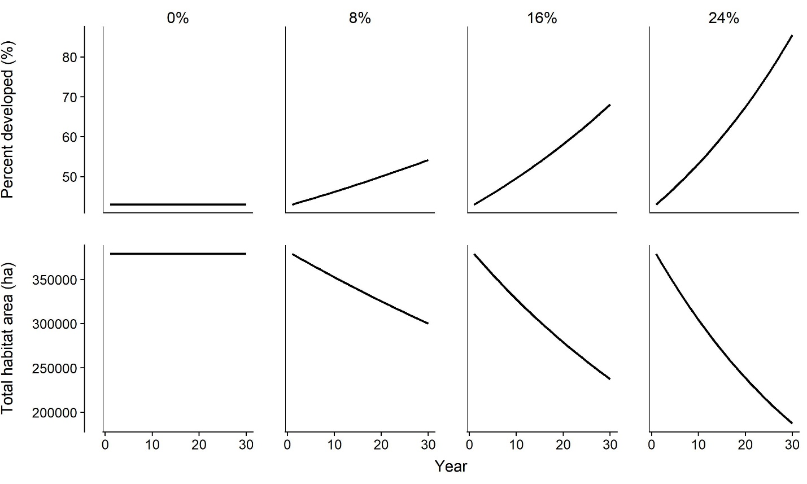

**Figure 3**. Change in the total habitat area and the proportion of habitat falling within an urban area under four future scenarios, each representing a different rate of urbanization (0% per decade, 8% per decade, 16% per decade, or 24% per decade). These scenarios are based on an analysis by Castro-Prieto et al (2017) and described in text.

**Table 3.** The total habitat area and proportion of habitat falling within an urban area in 30 years under four future scenarios with different rates of urban growth.

|  |  |  |  |  |  |
| --- | --- | --- | --- | --- | --- |
| Scenario | Urban growth per decade | Total habitat area in 30 years (ha) | Percent developed habitat in 30 years | Total natural habitat in 30 years (ha) | Total developed habitat in 30 years (ha) |
| No further urbanization | 0% | 379,029 | 43% | 215,046 | 163,983 |
| Reduced urbanization | 8% | 300,269 | 54% | 138,124 | 162,145 |
| Status quo | 16% | 237,427 | 58% | 99,719 | 137,708 |
| Increased urbanization | 24% | 187,377 | 86% | 25,233 | 162,144 |

*Population Projection*

We projected the population for 10,000 replications per scenario. For each replicate, we randomly drew the initial population size, carrying capacity, and average demographic rates. The initial population size in each habitat type was equal to the iteration initial population size multiplied by proportion of the available habitat in that type. We projected each population for 30 years, starting in the stable stage distribution. For each year, we calculated annual demographic rates as described above and calculated the population size by multiplying the year-specific matrix by the population size in the previous time step. We summed the number of individuals in each stage to determine the total population size and calculated the change in population size from the first year by subtracting the initial population size from the projection population size. We calculated the average population growth rate (λ) for each replicate by finding the geometric mean of the year-specific growth rates . When population growth rate (λ) is equal to 1, the population is stable. We calculated the probabilities of population growth and decline for each scenario as the proportion of replicates in which the average population growth rate was greater than 1 or less than 1, respectively.

*Quasi-extinction Threshold*

Many population viability analyses use a quasi-extinction threshold to assess extinction risk. The quasi-extinction threshold is the population size below which either the population cannot recover because it enters an “extinction vortex” (Gilpin and Soulé 1986), or the plausible management alternatives would drastically change (e.g. switching from habitat management to captive breeding). Selecting an appropriate quasi-extinction threshold for a specific population is often challenging due to uncertainties about both how demographic feedbacks and management actions influence realized population dynamics. Therefore, we assessed quasi-extinction risk at four thresholds, chosen to address four levels of risk tolerance: total population size of 50, 500, 1000, or 5000. For each scenario, we calculated the probability of the population falling below these thresholds as the proportion of replicates in which this occurred.

**Figure 4.** Conceptual diagram of the stochastic simulation model used to assess the future condition of PR boas under different rates of urbanization. White hexagons on the left represent model inputs and gray hexagons on the right represent model outputs. Rectangles represent values calculated within each replication of the simulation. Current habitat area and proportion urban were estimated based on suitable habitat analyses performed by the PR Gap Analysis (Gould et al. 2008) and land use analysis by Martinuzzi et al (2007). Rate of urbanization was based on estimates of urbanization rates in Puerto Rico by Castro-Prieto et al (2017). All other inputs (ranges for current and maximum density, average demographic rates, and effect of urbanization on demographics) were determined based on expert opinion.

**Results**

Our projection model indicated that the population is most likely to decline over a 30-year period under the status quo scenario, i.e. if the current rate of urbanization were to continue (Table 4, Figure 5). Under the current rate of urbanization (16% per decade) the model predicted a 54% probability of decline and 46% probability of stability or growth. Lower rates of urbanization were associated with a greater probability of population stability or growth, but the probability of growth was only 56% under the best case scenario (no further urbanization), which may be unlikely to occur. However, quasi-extinction probability was low due to the possibility of a large current population size (initial population size range from 37,903 to 189,515 individuals, see *Initial Population Size* above) and was less than 5% for all scenarios and thresholds (Table 5, Figure 6).

**Table 4.** The probabilities of quasi-extinction, population growth, and population decrease for each scenario. We evaluated quasi-extinction probability at four thresholds due to our uncertainties about how that threshold should be determined. The probability of population growth and decline are the proportion of replicates in which the average population growth rate (λ) was greater than 1 or less than 1, respectively.

|  |  |  |  |  |  |  |  |
| --- | --- | --- | --- | --- | --- | --- | --- |
| Scenario | Urban growth per decade | Quasi-extinction probability | | | | Probability of population stability or growth | Probability of population  decline |
| 50 | 500 | 1000 | 5000 |
| No further urbanization | 0% | 0 | 0 | 0.001 | 0.014 | 0.56 | 0.44 |
| Reduced urbanization | 8% | 0 | 0.001 | 0.001 | 0.022 | 0.51 | 0.49 |
| Status quo | 16% | 0 | 0.000 | 0.002 | 0.030 | 0.46 | 0.54 |
| Increased urbanization | 24% | 0 | 0.001 | 0.001 | 0.037 | 0.41 | 0.59 |

**Figure 5.** Projected change in population size over 30 years for four potential scenarios of land cover change. Solid black lines show the medians among all replicates, and shaded gray regions show the 95% quantiles (95% of replications fell within this range). The dashed line is at 0, indicating no change in population size.

**Figure 6.** Predicted quasi-extinction probability for the PR boa under four scenarios of future urbanization, evaluated at four different quasi-extinction thresholds (50, 500, 1000, and 5000).

**Discussion**

**Literature Cited**

Burgman, M. A. 2005. Risks and Decisions for Conservation and Environmental Management. Cambridge University Press, Cambridge, UK.

Castro-Prieto, J., S. Martinuzzi, V. C. Radeloff, D. P. Helmers, M. Quiñones, and W. A. Gould. 2017. Declining human population but increasing residential development around protected areas in Puerto Rico. Biological Conservation 209:473–481.

Caswell, H. 2001. Matrix population models: construction, analysis, and interpretation. 2nd edition. Sinauer Associates, Inc., Sunderland, MA, USA.

Gilpin, M. E., and M. E. Soulé. 1986. Minimum viable populations: processes of species extinctions. Pages 19–34 *in* M. E. Soulé, editor. Conservation Biology: the Science of Scarcity and Diversity. Sinauer Associates, Inc., Sunderland, MA, USA.

Gould, W. A., C. Alarcon, B. Fevold, M. E. Jimenez, S. Martinuzzi, G. Potts, M. Quinones, M. Solórzano, and E. Ventosa. 2008. The Puerto Rico Gap Analysis Project Volume 1: land cover, vertebrate species distributions, and land stewardship.

Huff, T. A. 1978. Breeding the Puerto Rican boa at the Reptile Breeding Foundation. International Zoo Yearbook 16:81–82.

Martinuzzi, S., W. A. Gould, and O. M. Ramos González. 2007. Land development, land use, and urban sprawl in Puerto Rico integrating remote sensing and population census data. Landscape and Urban Planning 79:288–297.

McGowan, C. P., N. Allan, J. Servoss, S. Hedwall, and B. Wooldridge. 2017. Incorporating population viability models into species status assessment and listing decisions under the U.S. Endangered Species Act. Global Ecology and Conservation 12:119–130.

Morris, W. F., and D. F. Doak. 2002. Quantitative Conservation Biology. Sinauer Associates, Inc., Sunderland, MA, USA.

Mulero-Oliveras, E. S. 2019. Population and habitat utilization of the Puerto Rican boa (Chilabothrus inornatus) in an urban fragmented habitat. University of Puerto Rico.

Puente Rolon, A. R. 2012. Reproductive ecology, fitness, and management of the Puerto Rican Boa (Epicrates inornatus, Boidae). University of Puerto Rico.

R Core Team. 2016. R: A language and environment for statistical computing. R Foundation for Statistical Computing, Vienna, Austria.

Stubben, C., and B. Milligan. 2007. Estimating and Analyzing Demographic Models Using the popbio package in R. Journal of Statistical Software 22.

Tolson, P. J. 1992. The Reproductive Biology of the Neotropical Boid Genus Epicrates (Serpentes:Boidae). Page *in* W. C. Hamlett, editor. Reproductive Biology of South American Vertebrates. Springer, New York, NY.

Appendix A: Simulation model diagram

Figure A1. Diagram depicting how annual demographic rates were simulated incorporating both parametric uncertainty in the true overall values and annual variation, using survival of the smallest age class () as an example. This process was used to simulate all demographic rates.

Appendix B: Sensitivity Analysis

*Demographic Rates*

Most of the demographic rates used in this model have not been empirically estimated for this population, therefore we relied on approximation by the expert team. To evaluate the sensitivity of model outputs to these input values, we ran simulations in which we randomly drew values for survival and fecundity from a wide range of possible values. For survival rates, we drew values between 0.01 and 0.99, and for fecundity we drew values between 1 and 20. For each demographic rate we randomly drew 1000 values, holding all other rates constant at the average values in Table 1. We randomly drew 100 values, and simulated 1000 replications of the population projection at each value. For these model sensitivity tests, we were interested in evaluating the sensitivity of model outcomes to changes in demographic rates, and therefore we kept the initial population size and carrying capacity fixed at 215,000 and 1,000,000, respectively, for all projections. For each projection we determined whether te population remained stable or grew by determining whether the population size in the final year was greater than or equal to the initial population size. We also calculated the probability of quasi-extinction at the most conservative threshold (5000 individuals) by finding the proportion of replicates in which the population size fell below 5000.

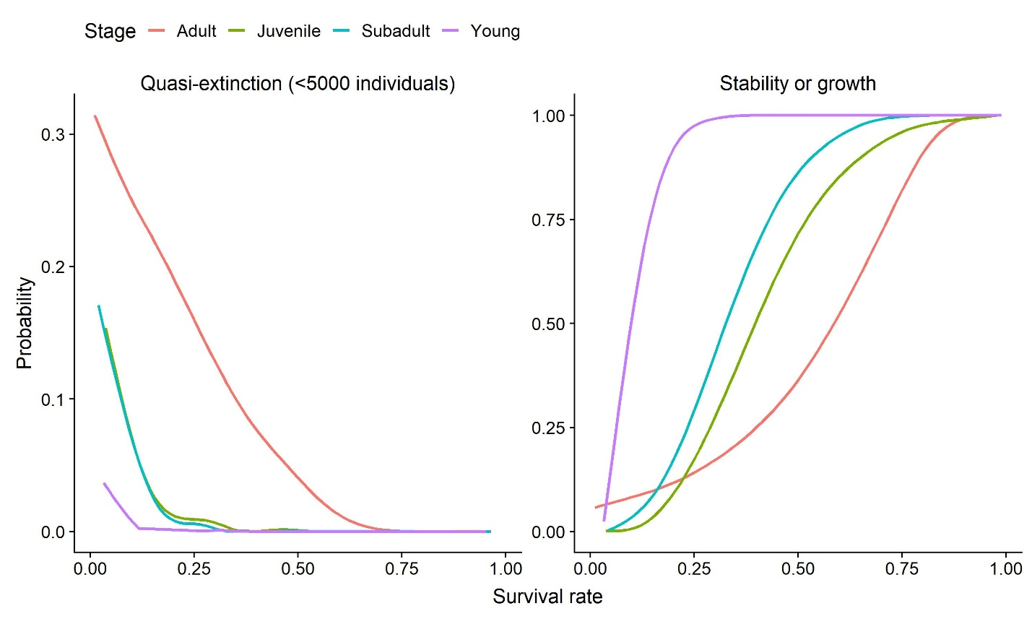

**Figure B1.** Simulated probabilities of quasi-extinction and of population growth over the range of possible survival rates for each stage (adult – orange, subadult – blue, juvenile – green, young – purple).

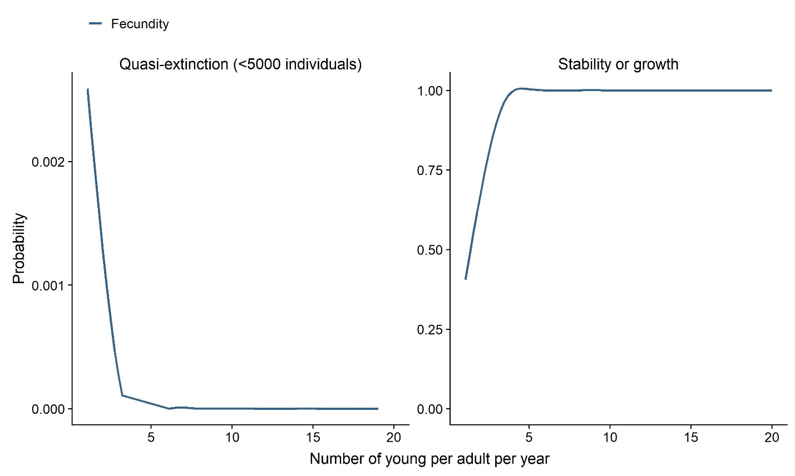

**Figure B2.** Simulated probabilities of quasi-extinction and population stability/growth over the range of possible fecundity values.

Changes in adult survival probability had the strongest influence on both the probability of quasi-extinction and of population growth (Figure A1). Quasi-extinction probability was ~0 for all iterations in which adult survival was > 0.75. This analysis also indicated some thresholds at which would expect population dynamics to change. For example, the probability of population growth declined drastically as fecundity fell below ~5 young per adult per year (Figure A2). We note that this sensitivity analysis is conducted assuming that only one demographic rate changes independent of the others, while in reality threats likely influence more than one rate simultaneously.

*Maximum Density*

Initially we defined the range of possible current population sizes by assuming that boa density across all suitable habitat ranged from 0.1-1 boas/ha. We defined the range of possible carrying capacities by assuming that the maximum density of boas we could find across all suitable habitat ranged from 1-6 boas/ha. Based on our habitat analysis, we estimated 379,029 ha of suitable habitat. This corresponds to a maximum current population size of 379,029 boas, and a maximum possible carrying capacity of 2,274,174 boas. There was some concern that these estimates might be too large and relying too heavily on information from the northern part of the range where habitat quality and boa density are known to be greater, and a more conservative approach would be to assume a lower upper bound for both current population size and carrying capacity. Here I compare four different iterations of the simulation model that reduce either the upper bound for current population size (from 1 boa/ha to 0.5 boa/ha), the upper bound for carrying capacity (from 6 boas/ha to 3 boas/ha), both, or neither.

**Table B1.** Scenarios used to evaluate the effect of assuming a lower maximum density on model outputs.

|  |  |  |  |  |
| --- | --- | --- | --- | --- |
| Scenario | Maximum density – current population size (boas/ha) | Maximum current population size (boas) | Maximum density – carry capacity  (boas/ha) | Maximum carrying capacity (boas) |
| Reduce both | 0.5 | 189,515 | 3 | 1,137,087 |
| Reduce maximum current N | 0.5 | 189,515 | 6 | 2,274,174 |
| Reduce maximum K | 1 | 379,029 | 3 | 1,137,087 |
| Reduce neither (original) | 1 | 379,029 | 6 | 2,274,174 |

We ran the simulation model described above for 10,000 replicates per scenario, under each of 4 different urbanization rates (0%, 8%, 16% or 24% urban growth per decade).

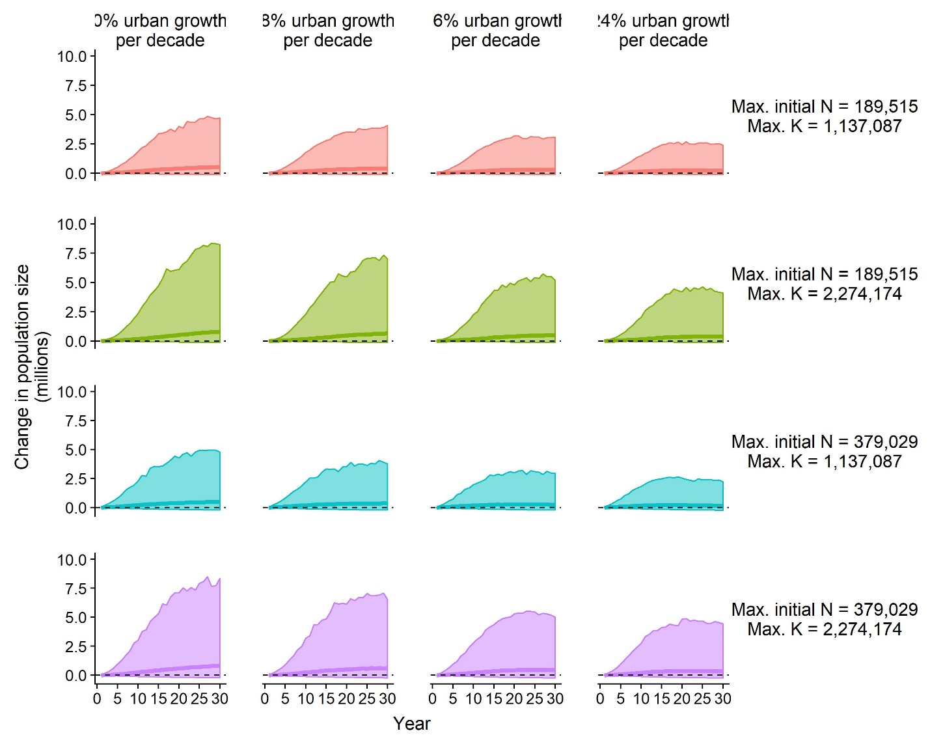

**Figure B3.** Projected change in population size under four rates of urbanization, with four different inputs for maximum current and carrying capacity density. Solid lines are the median and shaded regions represent the range in which 95% of the replications fell. The dashed horizontal line at 0 indicates no change in population size.

Changing the input for maximum current density and maximum carrying capacity density had little effect on simulation model outcomes (Figure A3). Reducing the upper bound for initial population size (current density) resulted in slightly higher quasi-extinction probabilities, but probability of quasi-extinction was ~1% at the highest threshold and under the worst urbanization scenario. Reducing the upper bound for carrying capacity resulted in slightly lower probabilities of population growth and lower probabilities of population decline.

**Table B2.** Probabilities of quasi-extinction, growth, and decline under four rates of urbanization and four potential density thresholds. For quasi-extinction probability and the probability of population decline, lower numbers are green and higher numbers are red. For the probability of population growth low numbers are red and high numbers are green.

|  |  |  |  |  |  |  |  |  |
| --- | --- | --- | --- | --- | --- | --- | --- | --- |
| **Percent urban growth per decade** | **Maximum current density (boas/ha)** | **Maximum carrying capacity density (boas/ha)** | **Quasi-extinction probability** | | | | **Probability of population growth** | **Probability of population decline** |
| **50** | **500** | **1000** | **5000** |
| 0% | 0.5 | 3 | 0.0000 | 0.0002 | 0.0002 | 0.0071 | 0.831 | 0.169 |
| 8% | 0.5 | 3 | 0.0000 | 0.0001 | 0.0006 | 0.0095 | 0.825 | 0.175 |
| 16% | 0.5 | 3 | 0.0000 | 0.0003 | 0.0006 | 0.0098 | 0.817 | 0.183 |
| 24% | 0.5 | 3 | 0.0000 | 0.0000 | 0.0005 | 0.0104 | 0.803 | 0.197 |
| 0% | 0.5 | 6 | 0.0000 | 0.0000 | 0.0003 | 0.0078 | 0.837 | 0.163 |
| 8% | 0.5 | 6 | 0.0000 | 0.0001 | 0.0005 | 0.0105 | 0.826 | 0.174 |
| 16% | 0.5 | 6 | 0.0000 | 0.0001 | 0.0002 | 0.0110 | 0.816 | 0.184 |
| 24% | 0.5 | 6 | 0.0000 | 0.0000 | 0.0006 | 0.0093 | 0.807 | 0.193 |
| 0% | 1 | 3 | 0.0000 | 0.0001 | 0.0001 | 0.0024 | 0.830 | 0.170 |
| 8% | 1 | 3 | 0.0000 | 0.0000 | 0.0002 | 0.0039 | 0.813 | 0.187 |
| 16% | 1 | 3 | 0.0000 | 0.0000 | 0.0001 | 0.0041 | 0.771 | 0.229 |
| 24% | 1 | 3 | 0.0000 | 0.0000 | 0.0004 | 0.0059 | 0.718 | 0.282 |
| 0% | 1 | 6 | 0.0000 | 0.0001 | 0.0002 | 0.0037 | 0.833 | 0.167 |
| 8% | 1 | 6 | 0.0000 | 0.0000 | 0.0002 | 0.0041 | 0.815 | 0.185 |
| 16% | 1 | 6 | 0.0000 | 0.0001 | 0.0004 | 0.0059 | 0.799 | 0.201 |
| 24% | 1 | 6 | 0.0000 | 0.0001 | 0.0002 | 0.0061 | 0.778 | 0.222 |