**A stochastic population projection for the Puerto Rican boa (*Chilabothrus inornatus*)**

Anna M. Tucker1 and Conor P. McGowan2

1School of Forestry and Wildlife Sciences, Auburn University, Auburn AL

2U.S. Geological Survey, Alabama Cooperative Fish and Wildlife Research Unit, Auburn University, Auburn AL

*This draft manuscript is distributed solely for purposes of scientific peer review. Its content is deliberative and pre-decisional, so it must not be disclosed or released. This manuscript does not represent any official USGS finding or policy.*

**Background**

The Puerto Rican boa (*Chilabothrus inornatus*) is a terrestrial boa endemic to the island of Puerto Rico. This species has been classified as Endangered in the United States since 1970. Here we used expert opinion and published studies to develop a demographic projection model, which was used to assess the predicted future status of the Puerto Rican boa (hereafter, PR boa) under several potential scenarios.

*Life History*

*Key Threats*

**Methods**

*Expert Meeting*

On March 5-6, 2018, a team of species experts met to develop a modeling framework that would inform this SSA.

*Demographic Matrix Model*

We developed a size-based Lefkovitch matrix model(Caswell 2001) that described the probabilities of survival, growth, and fecundity for each age class (Figure 1).

**Figure 1**. Life cycle and stage-based matrix model for the Puerto Rican boa.

We considered four life stages: young (<60 cm), juveniles (60-90 cm), subadults (90-110 cm), and adults (>110 cm). We elicited the probabilities of annual survival, growth, and fecundity for each size class from the expert team or drawn from the available literature (Table 1). The experts used personal information, unpublished data and inference from captive zoo populations to determine productivity and survival rates. The experts also directed us to graduate theses and dissertations that were completed but not widely available through literature searches. The probabilities of transitioning between size classes was determined by estimating the length of time spent in each age class. For example, experts believed that snakes remained in the juvenile age class for 2 years on average, so the mean transition rate from juvenile to sub-adult was 0.5. In other words, 50% of the animals in the juvenile age class transitioned to the subadult stage because each year half the animals would transition to the next stage.

**Table 1**. Stage-specific demographic rates.

|  |  |  |  |
| --- | --- | --- | --- |
| **Demographic rate** | **Stage** | **Model input** | **Rationale** |
| Survival | Young of the year | 0.3 | Expert opinion, informed by studies of Cuban boaa |
| Survival | Juvenile | 0.9 | Expert opinion |
| Survival | Subadult | 0.72 | Expert opinion – survival of this stage is lower than the juvenile or adult stage because individuals begin dispersing widely and face more threats |
| Survival | Adult | 0.9 | Expert opinion and estimates from radio-tracked translocated snakesc |
| Growth | Young to Juvenile | 0.67 | Expert opinion – approximately 2/3 of the young of the year grow enough to become juveniles in the next year. |
| Growth | Juvenile to Subadult | 0.5 | Expert opinion – juvenile stage typically lasts two years |
| Growth | Subadult to Adult | 0.25 | Expert opinion – subadult stage typically lasts four years |
| Fecundity | Adult | 9 | Average clutch size is 18 (range = 12-32)b,c This clutch size is multiplied by 0.5 because only females produce young (assumes a 50:50 sex ratio) |
| Fecundity | Subadult | 2 | Expert opinion – some larger subadults may breed, but with a much lower breeding probability |

a(P. Tolson pers. comm)

a(Tolson 1992)

b(Puente Rolon 2012)

We used the stage-specific estimates of survival and growth to calculate the transition rates () in the diagram and matrix in Figure 1. For example, is the probability of a young of the year in year *t* will become a juvenile in year *t+1*. This probability is equal to the probability of surviving the year () multiplied by the probability of growth from young to juvenile ().

The probability of a young of the year remaining in the young stage () is equal to the probability of surviving the year () and *not* growing enough to reach the juvenile stage ().

The transition rates for each stage were calculated following this framework. These demographic rates are summarized in a matrix model:

For each projection we assumed that the population started at the stable stage distribution, calculated using the popbio package for R (Stubben and Milligan 2007, R Core Team 2016).

*Habitat Availability*

The Puerto Rican GAP Analysis developed habitat suitability models for a suite of species, including the PR boa. We used the resulting raster dataset to assess the total area of available habitat, which was then used to estimate minimum and maximum bounds for the current and maximum population sizes. The PR GAP Analysis used occurrence records to map habitat across Puerto Rico and estimated 414,379 ha of habitat. However, per USFWS recommendation, there are no clear records of PR boa above 700 m , so we only considered areas below 750m to be suitable habitat. We were also interested in determining the proportion of habitat that fell in developed, urban areas, as experts believed boas experiences different pressures in those areas (see *Differences Among Natural and Urban Habitat*, below). We extracted urban areas from the full PR GAP landcover raster (high development, land cover class 63) and, for each cell of suitable habitat, we used the r.buffer tool in the GRASS plugin for QGIS to determine the proximity to development. For each cell of suitable habitat, we created a buffer of 160 m and determined the proportion of those buffers that contained development. This buffer radius corresponds to a total area of approximately 8 ha (80,424 m2) and was chosen based on published estimates of boa home range size, which average 8-8.5 ha (Wunderle et al. 2004, Puente Rolon 2012). Although home ranges may be smaller in urban areas (Mulero-Oliveras 2019), boas can move widely and we thought it reasonable that they might encounter developed areas if they existed within a 8 ha area. Based on this analysis, we estimated a total of 389,223 ha of habitat, with 95.1% in natural areas and 4.9% in urban areas (Figure X).

**Figure X.** Habitat availability for Puerto Rican boas.

*Uncertainty in Initial Population Size and Demographic Rates*

The current population size of PR boas is unknown, and little data exists to inform estimates of current abundance. Therefore, for each model replication, we randomly drew an initial population size from a predetermined range. The range of possible current abundance was estimated using published estimates of boa density and input from the expert team, and we assumed a range of 0.1 to 1 boas/ha across all available habitat as a starting density, which corresponds to a range of 38,922 to 389,223 boas in the current population. The final population size depends in part on the initial population size, so we present projection results as the change in population size from the first year.

At the expert meeting described above the team approximated the average value of each rate, but we did not conduct a formal elicitation to obtain estimates of uncertainty in those estimates. To incorporate uncertainty in our estimates of the average demographic rates, we assumed the average value of each parameter varied by ±15% for each iteration of the projection. For each transition probability, we randomly drew an average value for each iteration from a Beta distribution, using the method-of-moments method to calculate the shape parameters. For the fecundity rates, we randomly drew an average value from a Log-normal distribution.

*Sensitivity Analysis*

Most of the demographic rates used in this model have not been empirically estimated for this population, therefore we relied on approximation by the expert team. To evaluate the sensitivity of model outputs to these input values, we ran simulations in which we randomly drew values for survival and fecundity from a wide range of possible values (Table 3). We randomly drew 1000 values for each rate (iterations) and replicated the population projection for each combination of demographic rates 1000 times (replications). We set initial population size to 215,000 and carrying capacity to 1,000,000 for all projections. For each replicated projection we calculated the average population growth rate (λ) by calculating the year-specific population growth rates and finding the geometric mean. We used a linear regression model to estimate the effect of each demographic rate on average λ and found that all four survival probabilities had a stronger effect on population growth rate than fecundity (Table 3).

**Table 3**. Results of simulation-based sensitivity to demographic rates, including estimated effects and standard errors.

|  |  |  |
| --- | --- | --- |
| Demographic rate | Input range | Estimated effect on average λ |
| Fecundity | 1 – 20 | 0.014 ± 0.000018 |
| Young Survival | 0.01 – 0.99 | 0.342 ± 0.000352 |
| Juvenile Survival | 0.01 – 0.99 | 0.398 ± 0.000361 |
| Subadult Survival | 0.01 – 0.99 | 0.363 ± 0.000352 |
| Adult Survival | 0.01 – 0.99 | 0.347 ± 0.000364 |

For each iteration we also calculated the probability of population increase and decrease by finding the proportion of replicates in which the average population growth rate was greater than one and the proportion in which λ was less than one, respectively. We calculated the probability of quasi-extinction for each iteration by finding the proportion of replicates in which the population size in the final year was less than 50 individuals.

**Figure 2**. Relationships between average population growth rate and the value of each demographic rates. Points represent median average population growth rate (λ) for 1000 replications at each value and vertical lines represent the 95% quantiles. Vertical dashed lines are the average demographic rates estimated by the expert team.

**Figure 3**. Relationship between the probability that the population size will increase over a 30-year period and the value of each demographic rate. Points represent the proportion of 1000 replicates at each value in which the average population growth rate was greater than 1. Smoothed lines show the median probability over the range of input values. Vertical dashed lines are the average demographic rates estimated by the expert team.

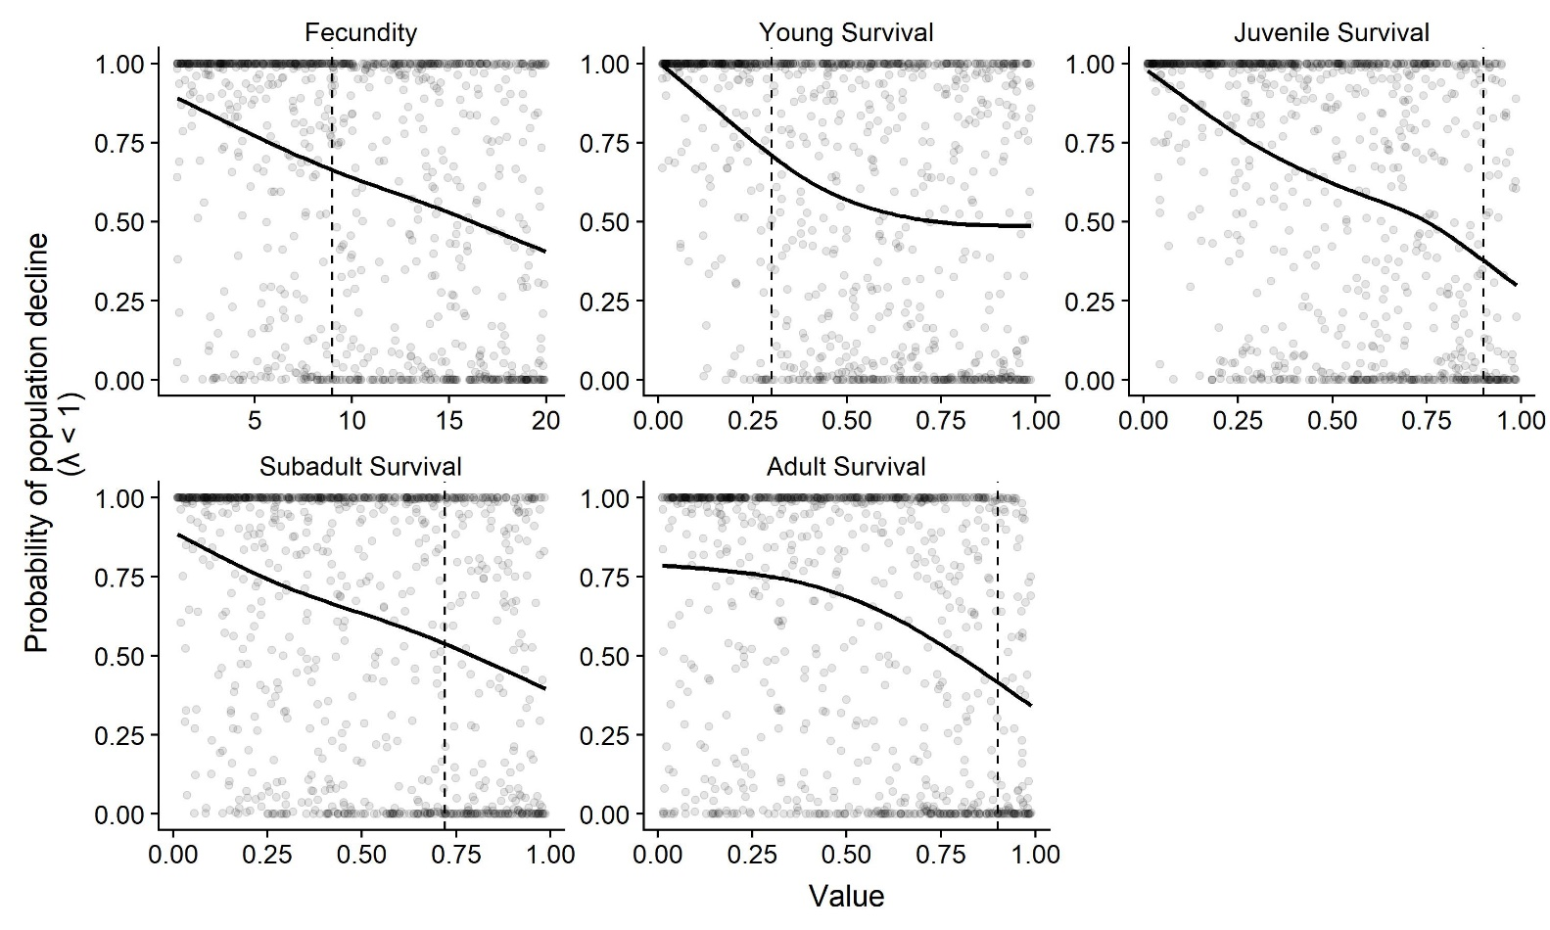

**Figure 4**. Relationship between the probability that the population size will decrease over a 30-year period and the value of each demographic rate. Points represent the proportion of 1000 replicates at each value in which the average population growth rate was less than 1. Smoothed lines show the median probability over the range of input values. Vertical dashed lines are the average demographic rates estimated by the expert team.

**Figure 5**. Relationship between the probability that the population will reach a quasi-extinction threshold of 50 individuals in 30 years and the value of each demographic rate. Points represent the proportion of 1000 replicates at each value in which population size in the final year was less than the quasi-extinction threshold. Smoothed lines show the median probability over the range of input values. Vertical dashed lines are the average demographic rates estimated by the expert team.

Quasi-extinction probability was strongly influenced by adult survival; the probability of quasi-extinction was less than 5% for all iterations in which adult survival was greater than 0.83. However, this result is also tied to the choice of a time horizon (here, 30 years). Even if the population is declining, when adult survival is very high there is a higher probability that at least some individuals will persist.

*Density Dependence*

Most wildlife populations face constraints on the maximum number of individuals that can be supported by local resources. We imposed density dependence on this population in the form of a simple population ceiling. Published estimates of PR boa density range from 1-6 (Mulero-Oliveras 2019). If all available habitat was used, this corresponds to a maximum population size ranging from 389,223 to 2,335,338 individuals. For each model replication, we randomly drew a population ceiling from a Uniform distribution bounded by this minimum and maximum. We assumed that reproduction would cease if the ceiling was reached, and therefore imposed a rule that set fecundity equal to zero if the total population size reached the ceiling. This approach is a simplified model of how carrying capacity would affect population demographics. It likely that approaching and exceeding carrying capacity would affect multiple demographic processes, but we do not have data to estimate these effects and so implementing a simple fecundity reduction ceiling function allows us to limit population growth without speculating on the functional form of density dependence (McGowan et al. 2017).

*Temporal Variation in Demographic Rates*

Realized demographic rates often vary annually based on stochastic variation in environmental conditions. To allow for temporal variation in realized rates, we assumed the standard deviation in realized annual rates was 15% of the mean. We used these iteration-specific mean and standard deviation to define the distributions from which annual rates were drawn. Transition probabilities were drawn from a Beta distribution and fecundity rates were drawn from a Log-normal distribution.

*Differences Between Natural and Urban Habitat*

PR boas occur in many different habitats across the island and experience different conditions in each habitat type. For this projection, we assumed that boas could occupy either natural or urban (developed) habitat. Natural habitat was defined as all undeveloped forested land. Urban habitat was defined as all medium- to high-development areas. The relative cover of each habitat type was assessed using landcover datasets compiled by the Puerto Rico Gap Analysis Project (Gould et al. 2008). Experts believed that in more developed areas, boas may experience higher mortality due to human interactions, road strikes, and the occurrence of feral cats. However, there is also a higher density of small prey (e.g. rats). Therefore, we assumed that realized demographic rates would be more variable in urban habitats than in natural (baseline) conditions. To include this additional variation, for each iteration we calculated realized rates in developed habitats as the average baseline rate multiplied by a randomly drawn habitat effect. For urban habitat, the effect had a minimum of 0.9 and a maximum of 1. This effectively allowed the urban rates to vary within 10% of the natural rates.

*Future Scenarios*

The key threats to this species are habitat loss and human interactions, both of which are linked to increased development and conversion of natural areas into urban areas. We considered future scenarios that included changes in land cover such that developed areas would encroach upon natural areas, resulting in either increased fragmentation of natural areas, loss of habitat area, or both. PR boas can persist in islands of habitat within an urbanized matrix, but For the baseline scenario, we assumed the proportion of habitat in natural and urban areas would remain the same as current conditions (0.05) and that the total amount of habitat would remain constant. To represent a moderate or severe increase in development, we also considered scenarios in which the proportion of habitat that fell within urban areas was 0.25 or 0.5, respectively. To represent habitat loss, we considered scenarios in which the total amount of habitat was reduced by 25% from current conditions. Reducing the total area of available habitat reduced This resulted in six total scenarios (Table 4).

*Population Projection*

For each iteration, we drew the initial population size and average demographic rates. The initial population size in each habitat type was equal to the iteration initial population size multiplied by the relative cover of that type (i.e. the proportion of the available habitat in that type). We projected each population for 30 years, starting in the stable stage distribution. For each year, we calculated realized demographic rates as described above and calculated the population size by multiplying the year-specific matrix by the population size in the previous time step. We summed the number of individuals in each stage to determine the total population size and calculated the change in population size from the first year by subtracting the initial population size from the projection population size. We calculated the average population growth rate (λ) for each replicate by finding the geometric mean of the year-specific growth rates . We also tracked whether the population fell below a quasi-extinction threshold of 50 individuals in each time step. The quasi-extinction probability was calculated as the proportion of replicates in which the population fell below this threshold. The probabilities of population growth and decline were calculated as the proportion of replicates in which the average population growth rate was greater than 1 or less than 1, respectively.

**Results**

In our projections the population was most likely to increase over a 30-year period (Figure X), with the probability of population decline under baseline conditions 3.4% (Table X). Increasing the proportion of habitat surrounded by urban areas resulted in a small increase in the probability of decline (5% when the proportion of urban habitat was 0.5). Reducing the total area of habitat by 25% had a stronger influence on population growth, with a 17% probability of decline if the proportion of urbanized habitat remains low. In the most severe scenario, with 25% reduction in habitat and 50% of habitat occurring in urban areas, the probability of population decline is 25%. The probability of reaching the quasi-extinction threshold of 50 individuals was 0 for all scenarios.

**Table 4.** The probabilities of quasi-extinction, population increase, and population decrease for each scenario.

|  |  |  |  |  |  |
| --- | --- | --- | --- | --- | --- |
| Scenario | Proportion of habitat in urban areas | Percent reduction in total habitat area | Quasi-extinction | Population  increase | Population  decline |
| A | 0.05 | 0% | 0 | 0.966 | 0.034 |
| B | 0.25 | 0% | 0 | 0.949 | 0.051 |
| C | 0.5 | 0% | 0 | 0.953 | 0.047 |
| D | 0.05 | 25% | 0 | 0.832 | 0.168 |
| E | 0.25 | 25% | 0 | 0.821 | 0.179 |
| F | 0.5 | 25% | 0 | 0.753 | 0.247 |

**Figure X.** Results of population projection under three potential scenarios of land cover change with no reduction in total habitat area, showing the change in population size from the first year (A) and population growth rate (B) over time. Solid black lines show the medians among all replicates, and shaded gray regions show the 95% quantiles. The dashed line is at 0 in panel A and at 1 in panel B, both indicating no change in population size.

**Figure X.** Results of population projection under three potential scenarios of land cover change with a 25% reduction in total habitat area, showing the change in population size from the first year (A) and population growth rate (B) over time. Solid black lines show the medians among all replicates, and shaded gray regions show the 95% quantiles. The dashed line is at 0 in panel A and at 1 in panel B, both indicating no change in population size.

**Literature Cited**

Caswell, H. 2001. Matrix population models: construction, analysis, and interpretation. 2nd edition. Sinauer Associates, Inc., Sunderland, MA, USA.

Gould, W. A., C. Alarcon, B. Fevold, M. E. Jimenez, S. Martinuzzi, G. Potts, M. Quinones, M. Solórzano, and E. Ventosa. 2008. The Puerto Rico Gap Analysis Project Volume 1: land cover, vertebrate species distributions, and land stewardship.

McGowan, C. P., N. Allan, J. Servoss, S. Hedwall, and B. Wooldridge. 2017. Incorporating population viability models into species status assessment and listing decisions under the U.S. Endangered Species Act. Global Ecology and Conservation 12:119–130.

Mulero-Oliveras, E. S. 2019. Population and habitat utilization of the Puerto Rican boa (Chilabothrus inornatus) in an urban fragmented habitat. University of Puerto Rico.

Puente Rolon, A. R. 2012. Reproductive ecology, fitness, and management of the Puerto Rican Boa (Epicrates inornatus, Boidae). University of Puerto Rico.

R Core Team. 2016. R: A language and environment for statistical computing. R Foundation for Statistical Computing, Vienna, Austria.

Stubben, C., and B. Milligan. 2007. Estimating and Analyzing Demographic Models Using the popbio package in R. Journal of Statistical Software 22.

Tolson, P. J. 1992. The Reproductive Biology of the Neotropical Boid Genus Epicrates (Serpentes:Boidae). Page *in* W. C. Hamlett, editor. Reproductive Biology of South American Vertebrates. Springer, New York, NY.

Wunderle, J. M., J. E. Mercado, B. Parresol, and E. Terranova. 2004. Spatial Ecology of Puerto Rican Boas (Epicrates inornatus) in a Hurricane Impacted Forest. Biotropica 36:555.