PR boa simulation model results with reduced densities

In the original version of the model, we defined the range of possible current population sizes by assuming that boa density across all suitable habitat ranged from 0.1-1 boas/ha. We defined the range of possible carrying capacities by assuming that the maximum density of boas we could find across all suitable habitat ranged from 1-6 boas/ha. Based on our habitat analysis, we estimated 379,029 ha of suitable habitat. This corresponds to a maximum current population size of 379,029 boas, and a maximum possible carrying capacity of 2,274,174 boas. There was some concern that these estimates might be too large, and a more conservative approach would be to assume a lower upper bound for both current population size and carrying capacity. Here I compare four different iterations of the simulation model that reduce either the upper bound for current population size (from 1 boa/ha to 0.5 boa/ha), the upper bound for carrying capacity (from 6 boas/ha to 3 boas/ha), both, or neither.

|  |  |  |  |  |
| --- | --- | --- | --- | --- |
| Scenario | Maximum density – current population size (boas/ha) | Maximum current population size (boas) | Maximum density – carry capacity  (boas/ha) | Maximum carrying capacity (boas) |
| Reduce both | 0.5 | 189,515 | 3 | 1,137,087 |
| Reduce maximum current N | 0.5 | 189,515 | 6 | 2,274,174 |
| Reduce maximum K | 1 | 379,029 | 3 | 1,137,087 |
| Reduce neither (original) | 1 | 379,029 | 6 | 2,274,174 |

I ran the simulation model for 10,000 replicates per scenario, under each of 4 different urbanization rates (0%, 8%, 16% or 24% urban growth per decade). Below are the projected median population sizes and 95% quantiles.

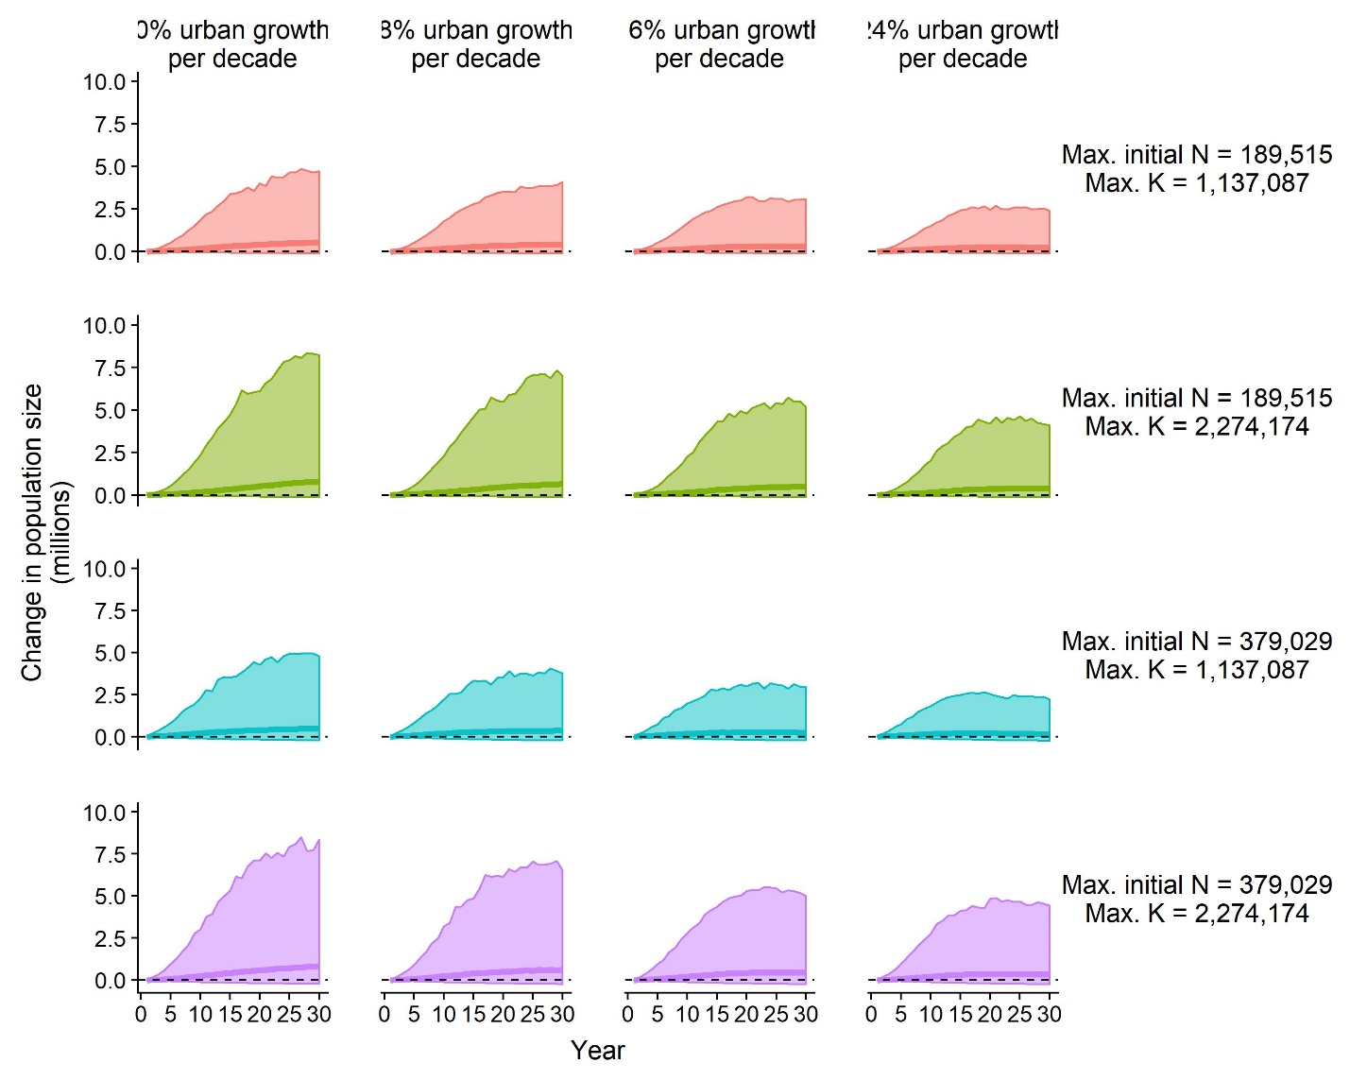

There is not a lot of difference among the scenarios in projected population size under different future urbanization rates. I also plotted just the median projected population size to better visualize some differences.

The scenario in which only the upper bound for current population size was reduced was nearly identical to the original version of the simulation. Reducing the upper bound for the carrying capacity resulted in less overall population growth and an earlier plateau.

This table has a lot of information, so I color coded the cells to aid in distinguishing the scenarios. For quasi-extinction probability and the probability of population decline, lower numbers are green and higher numbers are red. For the probability of population growth low numbers are red and high numbers are green.

|  |  |  |  |  |  |  |  |  |
| --- | --- | --- | --- | --- | --- | --- | --- | --- |
| **Percent urban growth per decade** | **Maximum current density (boas/ha)** | **Maximum carrying capacity density (boas/ha)** | **Quasi-extinction probability** | | | | **Probability of population growth** | **Probability of population decline** |
| **50** | **500** | **1000** | **5000** |
| 0% | 0.5 | 3 | 0.0000 | 0.0002 | 0.0002 | 0.0071 | 0.831 | 0.169 |
| 8% | 0.5 | 3 | 0.0000 | 0.0001 | 0.0006 | 0.0095 | 0.825 | 0.175 |
| 16% | 0.5 | 3 | 0.0000 | 0.0003 | 0.0006 | 0.0098 | 0.817 | 0.183 |
| 24% | 0.5 | 3 | 0.0000 | 0.0000 | 0.0005 | 0.0104 | 0.803 | 0.197 |
| 0% | 0.5 | 6 | 0.0000 | 0.0000 | 0.0003 | 0.0078 | 0.837 | 0.163 |
| 8% | 0.5 | 6 | 0.0000 | 0.0001 | 0.0005 | 0.0105 | 0.826 | 0.174 |
| 16% | 0.5 | 6 | 0.0000 | 0.0001 | 0.0002 | 0.0110 | 0.816 | 0.184 |
| 24% | 0.5 | 6 | 0.0000 | 0.0000 | 0.0006 | 0.0093 | 0.807 | 0.193 |
| 0% | 1 | 3 | 0.0000 | 0.0001 | 0.0001 | 0.0024 | 0.830 | 0.170 |
| 8% | 1 | 3 | 0.0000 | 0.0000 | 0.0002 | 0.0039 | 0.813 | 0.187 |
| 16% | 1 | 3 | 0.0000 | 0.0000 | 0.0001 | 0.0041 | 0.771 | 0.229 |
| 24% | 1 | 3 | 0.0000 | 0.0000 | 0.0004 | 0.0059 | 0.718 | 0.282 |
| 0% | 1 | 6 | 0.0000 | 0.0001 | 0.0002 | 0.0037 | 0.833 | 0.167 |
| 8% | 1 | 6 | 0.0000 | 0.0000 | 0.0002 | 0.0041 | 0.815 | 0.185 |
| 16% | 1 | 6 | 0.0000 | 0.0001 | 0.0004 | 0.0059 | 0.799 | 0.201 |
| 24% | 1 | 6 | 0.0000 | 0.0001 | 0.0002 | 0.0061 | 0.778 | 0.222 |

Reducing the upper bound for initial population size (current density) resulted in slightly higher quasi-extinction probabilities, but still only ~1% at the highest threshold and under the worst urbanization scenario. Reducing the upper bound for carrying capacity resulted in slightly lower probabilities of population growth and lower probabilities of population decline.