**SSA 200: Strategic Use of Data**

**Activity 1 – Developing Model Sets**

**Objectives:**

* Understand the link between conceptual diagrams and statistical models
* Develop ecological hypotheses about species needs and translate hypotheses into biologically-meaningful models
* Choose appropriate ecological variables from available data sources to include in models

**Background:**

The Island mouse (*Zapus islandsonious*) is a species that lives on Darlost's Island. There are 10 current populations, although historically they occurred at 11 sites across the island. As you covered in SSA 100, the mice are adapted to the unique ecology of Darlost’s Island. Their primary food source is dune beetles, which are found across the small island. They also rely on beach grass that grows along the coasts to build their nests and create shelter from the sun and cold winters. They require warm spring temperatures for successful breeding. They are also very sensitive to noise, and loud noises can lead to depressed breeding activity and, in extreme cases, death from cardiac arrest. There are also several stressors on the island that influence their population dynamics. The two main predators of Island mice are Jack’s sparrow, which are found across the island, and the pirate rat, which are only found along the coasts. Darlost’s fire is a disease that causes mange and can be fatal, and toxic gas plumes from the island’s volcanoes can also be deadly. This conceptual diagram summarizes the key species needs (green boxes) and threats (red boxes) and how they influence breeding and survival.

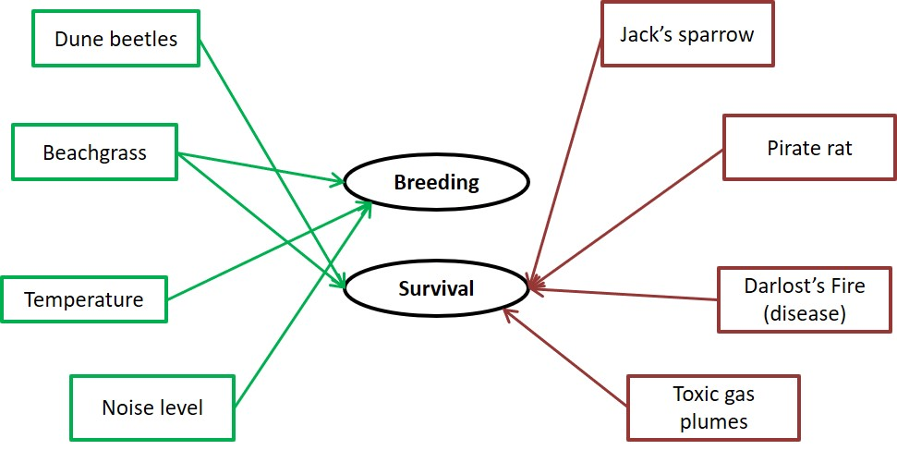

Using this conceptual model and what you know about the ecology of the mice, you are tasked with developing models that will inform how these factors influence Island mouse occurrence, abundance, and survival probability across their range.

The goal of model selection is to find the model that best explains the data using the fewest number of parameters, which will hopefully identify the most important ecological drivers of species success. It is standard practice to always include a **null model** in your model set, which is a model that does not include any covariates. Sometimes none of the data we have are good predictors of the response variable of interest. Does that mean the models are useless? This result still tells us about the system, in that in can tell us that the things we thought were important drivers of species success maybe aren’t as important, and there could be other factors that we should consider.

When lots of different data sources are available, it can be tempting to fit “all subsets”, or all possible combinations of available covariates. This kitchen sink approach is not good practice for a few reasons. First, it can be time consuming and computationally intensive to fit all possible combinations. Second, and more importantly, it can result in the selection of models that might not make a lot of sense ecologically or be hard to use in future predictions. Finally, it’s just not good science because it usually results in trying to come up with theory to explain observations *post hoc*, instead of conducting meaningful tests of biological hypotheses.

It’s also important to carefully consider the combinations of covariates to include. We want to avoid **collinearity** in model sets, which happens when one or more covariates are correlated with each other. This can be an issue for estimation because it leads to overly precise estimates, basically because we are including the same information twice. For example, if we are interested in predicting grizzly bear occurrence, we may want to test a model that includes the presence of a water source or the presence of fish at a given site. Since the presence of fish is highly correlated with the presence of water, those covariates are collinear, and we would not include both in the same model. The presence of fish implies the presence of water, and may be closer to the real ecological reason why bears occur near water. However, if data about fish presence isn’t available, including water in the model can be a good proxy.

For each of the following scenarios, don’t worry about the mechanics or details of fitting the models, but focus instead on the combinations of covariates that can best explain the response variable of interest. Write your models both as a formula that lists all covariates (feel free to use your own abbreviations) and as a sentence that describes the ecological hypothesis that the model represents. We’ve included space for six models, but feel free to include fewer or more candidate models in your list. For example, consider the following set of models to predict grizzly bear occurrence:

|  |  |  |
| --- | --- | --- |
|  | Model (formula) | Hypothesis (sentence) |
| 1 | water + trees + rocks | Bear occurrence is dependent on the presence of water source, forest cover, and rocky substrate. |
| 2 | water + trees | Bear occurrence is dependent on the presence of a water source and forest cover. |
| 3 | water | Bear occurrence depends primarily on the presence of a water source. |
| 4 | null model | Bear occurrence is not strongly associated with water source, forest cover, or rocky substrate. |

**Part 1: Occupancy**

The Island mouse Recovery Team is interested in mapping the drivers of occurrence across Darlost’s island in order to assess the suitability of other nearby islands for possible translocations. They have collected occurrence data from a variety of sources and want to use species distribution modeling to find the environmental covariates that best predict occurrence. Using the following data sources, develop a set of candidate models to predict occurrence of Island mice.

*Response variable = Probability of island mouse presence*

|  |  |  |
| --- | --- | --- |
| **Source** | **Data Type** | **Variables Measured** |
| National Land Cover Database (NLCD) | Land cover/land use in 30km grid | *Each cell is classified as one of:*  Open water  Perennial Ice/Snow  Developed, Open  Developed, Low  Developed, Medium  Developed, High  Rock/sand/clay  Deciduous forest  Evergreen forest  Mixed forest  Dwarf scrub  Shrub/scrub  Grassland  Sedge  Lichens  Moss  Pasture/Hay  Cultivated crops  Woody wetlands  Emergent wetlands |
| WorldClim Bioclimatic variables | Climate data in 30km grid | Annual Mean Temperature  Max Temperature of Warmest Month  Min Temperature of Coldest Month  Temperature Annual Range (BIO5-BIO6)  Mean Temperature of Wettest Quarter  Mean Temperature of Driest Quarter  Mean Temperature of Warmest Quarter  Mean Temperature of Coldest Quarter  Annual Precipitation  Precipitation of Wettest Month  Precipitation of Driest Month  Precipitation of Wettest Quarter  Precipitation of Driest Quarter  Precipitation of Warmest Quarter  Precipitation of Coldest Quarter |
| NOAA Weather Station | Daily local weather data from 3 weather stations across island and 1 weather buoy offshore | Maximum air temperature  Minimum air temperature  Average air temperature  Maximum wind speed  Minimum wind speed  Average wind speed  Total precipitation  Maximum water temperature  Minimum water temperature  Average water temperature |

**Occupancy candidate model set**

|  |  |  |
| --- | --- | --- |
|  | **Model (formula)** | **Hypothesis (sentence)** |
| 1 |  |  |
| 2 |  |  |
| 3 |  |  |
| 4 |  |  |
| 5 |  |  |
| 6 |  |  |

**Part 2: Abundance**

A graduate student has developed a project to estimate Island mouse abundance and map the drivers of abundance across its range. His field crew conducted transect surveys at randomly-selected points across Darlost’s island to estimate the abundance of Island mice while accounting for detection probability. He and his crew conducted vegetation surveys at each transect point and also recorded the presence or absence of Jack’s sparrows and pirate rats each survey. Use the following data to construct a set of models to predict mouse abundance.

*Response variable = Site abundance*

|  |  |  |
| --- | --- | --- |
| **Source** | **Data Type** | **Variables Measured** |
| Vegetation surveys | Vegetation data collected at each transect | Percent canopy cover  Percent shrub cover  Percent herbaceous cover  Substrate: rock, soil, sand, other  Soil type: clay, silt, loam, NA  Beachgrass density  Average DBH  Ambient noise level (decibels)  Toxic gas level |
| Predator surveys | Presence/absence of predators during each survey | Jack’s sparrow presence/absence  Pirate rat presence/absence |
| Other transect info | Measured via GIS | Distance to nearest coast  Distance to nearest volcano  Ecotype: coastal, palms, mountains |
| NOAA Weather Station | Daily local weather data from 3 weather stations across island and 1 weather buoy offshore | Maximum air temperature  Minimum air temperature  Average air temperature  Maximum wind speed  Minimum wind speed  Average wind speed  Total precipitation  Maximum water temperature  Minimum water temperature  Average water temperature |
| NLCD | Land cover/land use in 30km grid | *Each cell is classified as one of:*  Open water  Perennial Ice/Snow  Developed, Open  Developed, Low  Developed, Medium  Developed, High  Rock/sand/clay  Deciduous forest  Evergreen forest  Mixed forest  Dwarf scrub  Shrub/scrub  Grassland  Sedge  Lichens  Moss  Pasture/Hay  Cultivated crops  Woody wetlands  Emergent wetlands |

**Abundance candidate model set**

|  |  |  |
| --- | --- | --- |
|  | **Model (formula)** | **Hypothesis (sentence)** |
| 1 |  |  |
| 2 |  |  |
| 3 |  |  |
| 4 |  |  |
| 5 |  |  |
| 6 |  |  |

**Part 3: Breeding success**

A study is conducted to measure breeding success in the Beach Bums, Dead Man’s Dunes, and Misty Mountain populations. Over the course of five years, mouse nests are surveyed throughout breeding to estimate the number of offspring produced per female. Pitfall traps are also placed at each study population to estimate invertebrate abundance. Use the following data sources to develop models to determine factors associated with the number of offspring per female.

*Response variable = Number off offspring per female*

|  |  |  |
| --- | --- | --- |
| **Source** | **Data Type** | **Variables Measured** |
| Nest surveys | Data collected at each nest | Ecotype: coastal, palms, mountains  Toxic gas level at nest  Nest substrate: beachgrass, sand, shrub, other  Female age  Female disease status (test positive/negative) |
| Pitfall traps | Index of invertebrate diversity and abundance collected for each site in each year | Dune beetle abundance  Total insect abundance  Number of species detected |
| WorldClim Bioclimatic variables | Climate data in 30km grid | Annual Mean Temperature  Max Temperature of Warmest Month  Min Temperature of Coldest Month  Temperature Annual Range (BIO5-BIO6)  Mean Temperature of Wettest Quarter  Mean Temperature of Driest Quarter  Mean Temperature of Warmest Quarter  Mean Temperature of Coldest Quarter  Annual Precipitation  Precipitation of Wettest Month  Precipitation of Driest Month  Precipitation of Wettest Quarter  Precipitation of Driest Quarter  Precipitation of Warmest Quarter  Precipitation of Coldest Quarter |
| NOAA Weather Station | Daily local weather data from 3 weather stations across island and 1 weather buoy offshore | Maximum air temperature  Minimum air temperature  Average air temperature  Maximum wind speed  Minimum wind speed  Average wind speed  Total precipitation  Maximum water temperature  Minimum water temperature  Average water temperature |
| NLCD | Land cover/land use in 30km grid | *Each cell is classified as one of:*  Open water  Perennial Ice/Snow  Developed, Open  Developed, Low  Developed, Medium  Developed, High  Rock/sand/clay  Deciduous forest  Evergreen forest  Mixed forest  Dwarf scrub  Shrub/scrub  Grassland  Sedge  Lichens  Moss  Pasture/Hay  Cultivated crops  Woody wetlands  Emergent wetlands |

**Breeding success candidate model set**

|  |  |  |
| --- | --- | --- |
|  | **Model (formula)** | **Hypothesis (sentence)** |
| 1 |  |  |
| 2 |  |  |
| 3 |  |  |
| 4 |  |  |
| 5 |  |  |
| 6 |  |  |