**SSA 200: Strategic Use of Data**

**Activity 3 – Model-based Predictions**

**Objectives:**

* Understand the link between data analysis and stochastic projections
* Use projection outputs to quantify the 3 R’s and make predictions about future conditions for a species
* Implement different future scenarios to describe the range of likely outcomes for a species

**Background Information:**

The first two activities focused on using available data to better understand the historic and current conditions of a species and to identify the key species needs and stressors that influence their ability to persist. Now we will use the results of those analyses to develop a stochastic population projection that we can use to estimate the probability that the species will persist until some arbitrary time horizon in the future.

We have some information about Island Mouse abundance, but transect surveys were only conducted across part of the range. We also have some anecdotal reports and information from recent satellite images that can tell us something about abundance across the island. We can pull all sources of information together using a **multistate occupancy** model. Under this framework, we will assign each population to one of three categories:

* Low abundance: mice are present but at low numbers, declining or unstable population
* High abundance: mice are consistently present, stable or increasing population
* Locally extirpated: no mice present

Populations can transition between these states with some **transition probability**, which we’ll denote using ***T***. The probability is the probability of transitioning from the low abundance state (L) to the high abundance state (H). The probability is the probability of transitioning from the low abundance state (L) to the locally extirpated state (E). The time step of each transition can be any length of time that is biologically reasonable. Here we will use a one-year time step, so we are talking about the probability of transitioning between states in one year. We can visualize these transitions using a conceptual diagram:

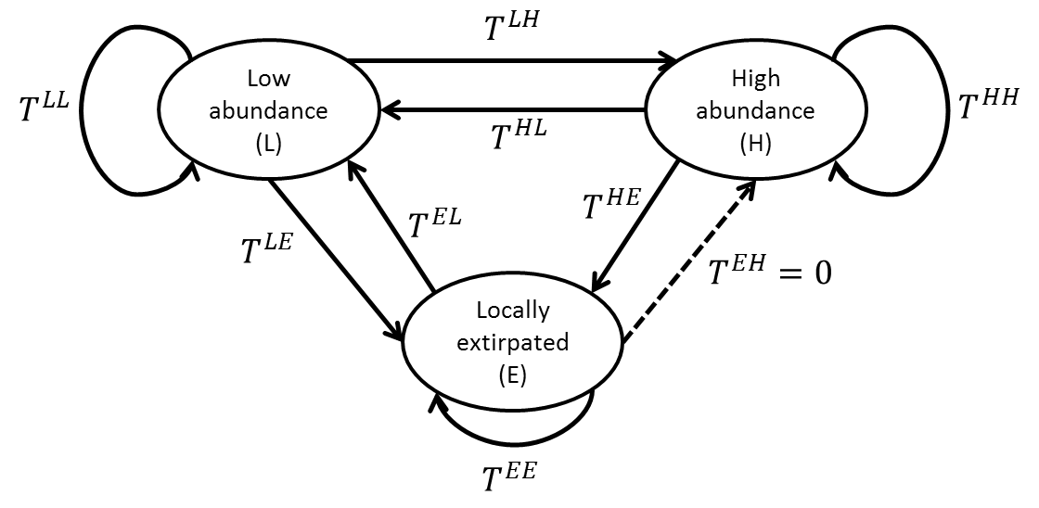

Each arrow represents a transition probability. Note that the arrow from locally extirpated to high abundance is dashed, because here we will assume that this transition probability is equal to 0, in other words it’s not possible for a population to go from locally extirpated to high abundance in one year. The arrows that loop back on each state are the probabilities of remaining in the current state.

We can also visualize the same relationships using a matrix.

In a transition matrix, each cell represents the probability of going *from* the column number/state *to* the row number/state. In this matrix, the columns and rows (in order) represent the extirpated, low abundance, and high abundance states.

Based on all available information, the Island Mouse Recovery Team determined the state of each population over the past 10 years. We used a multistate model to estimate each transition probability, in an analysis similar to a site-occupancy analysis.

These are the estimated transition probabilities with their corresponding standard errors:

1. **What is the probability of a population that is currently low abundance remaining low abundance in the next year?**
2. **What is the probability of a high abundance population becoming extirpated in one year?**
3. **What is the probability of transitioning from locally extirpated to low abundance?**
4. **Here these transition probabilities were estimated directly using a statistical model. If the data to fit such a model were not available, what are some other potential ways to determine what those values should be?**

**Part 1: Projecting Future Conditions**

We would like to determine the probability of Island Mice persisting 15 years in the future. We have defined three analysis units based on ecotype (coastal, paradise palms, mountain). The ecotype and current state of each population is listed below:

|  |  |  |
| --- | --- | --- |
| **Population** | **Ecotype** | **Current state** |
| Beach Bums | Coastal | H |
| Cannibal Cove | Coastal | H |
| Castaways | Coastal | L |
| Message in a Bottle | Coastal | H |
| Darlost’s Dome | Mountain | L |
| Misty Mountain | Mountain | L |
| Skull Mountain | Mountain | E |
| Dead Man Dunes | Paradise palms | L |
| Realm of Spirits | Paradise palms | H |
| Snowmelt Thicket | Paradise palms | L |
| Treasure Grove | Paradise palms | L |

Using the estimated transition probabilities above, we will project the population 15 years into the future, replicating that projection 1000 times. Our estimates of the standard error for each parameter represent our uncertainty about the true value of that parameter. To account for this **parametric uncertainty** in the projection, we can use the estimated standard error to define a Beta distribution for each transition probability. For example, the distribution of possible values for the probability of transitioning from low abundance to high abundance ():

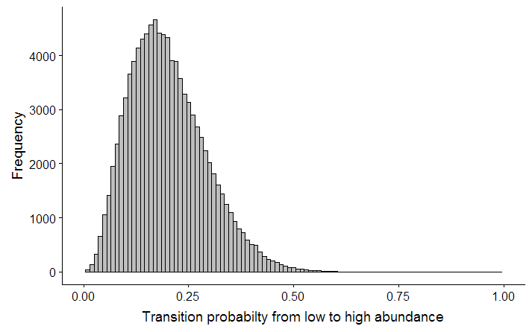

For each replicated projection, we will randomly draw a value from this distribution for the transition probability from low to high. Each transition probability will have its own distribution.

If we run that projection, we can look at the number of populations in each state over time:

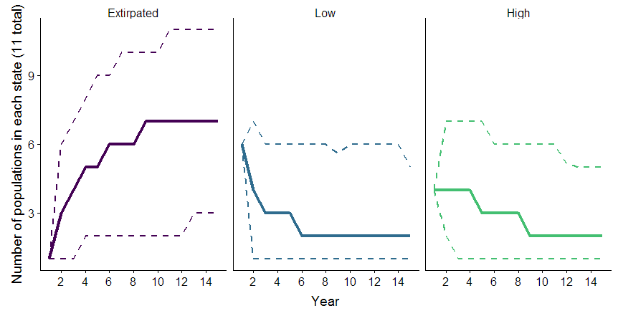

Here the solid lines are the medians from 1000 replications and the dashed lines are the 95% confidence intervals. If we want to break it up by ecotype, we can look at the number of populations in each state in the final year:

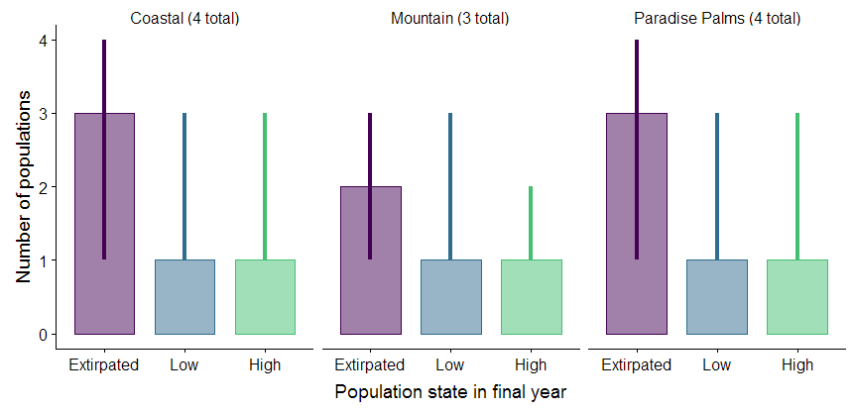

Here the height of the bars show the median number of populations that ended in each state and the error bars show the 95% confidence intervals.

That same information can also be represented in table form. Here the medians are given in each cell with the 95% confidence intervals in parentheses.

|  |  |  |  |
| --- | --- | --- | --- |
| **Ecotype** | **Number of populations in each state** | | |
| **Extirpated** | **Low** | **High** |
| Coastal | 3 (1, 4) | 1 (1, 3) | 1 (1, 3) |
| Mountain | 2 (1, 3) | 1 (1, 3) | 1 (1, 2) |
| Paradise Palms | 3 (1, 4) | 1 (1, 3) | 1 (1, 3) |

We can also use simulation outputs to estimate the probability that certain events will occur. We do that by calculating the proportion of replications in which that event occurred. For example, if we wanted to know the probability that at least one population from each ecotype ended in the “high abundance” state, we would count the number of replications in which all three ecotypes had at least one population in “high” and divide that by the total number of replications. Under these baseline conditions, that probability is 0.122, or 12.2%. We could also estimate the probability of extinction for the species by calculating the proportion of replications in which all populations ended in the “extirpated” state, and the probability of extinction for each ecotype.

|  |  |
| --- | --- |
| **Group** | **Extinction probability** |
| Coastal | 0.21 |
| Mountain | 0.37 |
| Paradise Palms | 0.24 |
| Overall | 0.05 |

1. **What is the most likely outcome for Island Mice in 15 years? What is the most likely outcome for each ecoregion?**
2. **Why is there uncertainty about the number of populations that will end in each state?**
3. **How would you characterize the expected resiliency, redundancy, and representation of this species? Use the above figures and tables to support your statements.**

**Part 2: Alternate Scenarios**

In the above projection, we assumed that baseline conditions would stay the same in the future. However, it is often useful to explore how species are expected to respond to potential changes that could occur in the future.

The first step to developing those projections is quantifying the relationships between ecological needs and/or stressors and parameters in the projection model. In this case, the parameters in the model are the transition probabilities among different states. Using the multistate model framework described above, we can include ecological covariates and determine whether they have a strong effect on transition probabilities.

We fit several models and ranked them using AIC to determine the ecological covariates that were most strongly associated with each transition probability. Three transition probabilities were found to be strongly associated with ambient noise level. , , and all increased as ambient noise level increased (β = 1.5 ± 0.03, p = 0.001).

1. **Write your interpretation of this result in a sentence.**

Two transition probabilities were found to be strongly associated with annual temperature range. and both decreased as temperature range increased (β = -1.8 ± 0.41, p = 0.0023).

1. **Write your interpretation of this result in a sentence.**

We can build these relationships into the projection model, and then see how the extinction probability and likely outcomes change if one or both of these covariates change.

1. **Under what future conditions would you expect ambient noise level to change on Darlost’s Island? Would it increase or decrease?**
2. **Under what future conditions would you expect the annual temperature range to change on Darlost’s Island? Would it increase or decrease?**

Use this information to develop three potential future scenarios below. Try to consider a “worst case”, “best case” and “most likely” set of future conditions. Write a few sentences about why you chose that scenario, and assign expected changes in ambient noise level and temperature range (this can be positive, negative, or zero).

|  |  |  |  |
| --- | --- | --- | --- |
| **Scenario** | **Description** | **Change in ambient noise level (db)** | **Change in annual temperature range (°C)** |
|  |  |  |  |
|  |  |  |  |
|  |  |  |  |

Next you will implement your scenarios and describe the 3 R’s under each. Follow this link (<http://ssa200.shinyapps.io/mouse-multistate>) to a web application where you can input the parameters for each scenario and see the results. Leave the number of years and number of replications on the default values for this activity.

Fill in the following table to summarize the results of your scenarios.

|  |  |  |  |  |
| --- | --- | --- | --- | --- |
| **Scenario** | **Overall extinction probability** | **Number of populations in each state in the final year** | | |
| **Extirpated** | **Low** | **High** |
|  |  |  |  |  |
|  |  |  |  |  |
|  |  |  |  |  |

**Part 3: Interpretation and Communication**

Depending on the scenarios you chose to run, you may have seen drastically varying predicted population outcomes. In addition to the baseline “status quo” scenario, we ran two additional scenarios that represented potential future climate change and management actions.

Scenario 1 – Status quo: No change in ambient noise level or annual temperature range

Scenario 2 – Noise reduction: Climate change leads to an increase in average annual temperature range of 0.5 °C, but management efforts to restrict development leads to a decrease in ambient noise level of 2 decibels.

Scenario 3 – Noise increase: Climate change leads to an increase in average annual temperature range of 0.5 °C, and further development leads to an increase in ambient noise level of 2 decibels.

The results of all three scenarios are below:

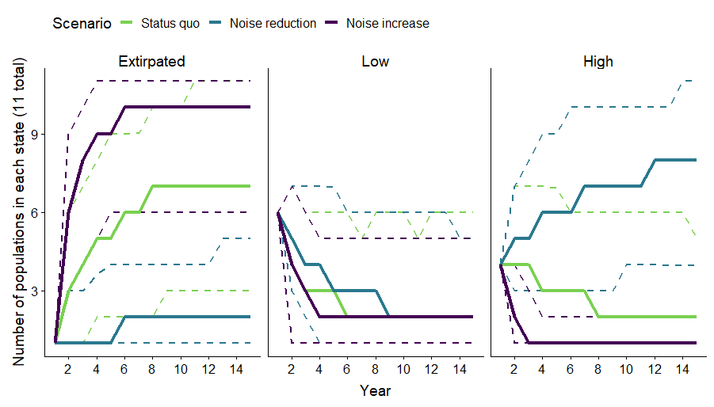

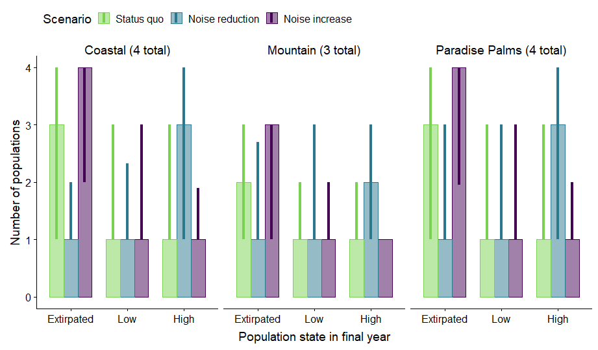

|  |  |  |  |
| --- | --- | --- | --- |
| **Group** | **Extinction probability** | | |
| **Status quo** | **Noise reduction** | **Noise increase** |
| Coastal | 0.21 | 0.00 | 0.57 |
| Mountain | 0.37 | 0.014 | 0.67 |
| Paradise Palms | 0.24 | 0.001 | 0.58 |
| Overall | 0.05 | 0.00 | 0.29 |

1. **Considering all three of these scenarios together, how would you characterize the expected resiliency, redundancy, and representation of Island Mice? Use the above figures and tables to support your statements.**
2. **Do you think all three of these scenarios are equally likely? Is one more likely to occur than others? How would you incorporate your uncertainty about which scenario is most likely to occur in your presentation of these results?**
3. **Which metrics and/or figures do you think are most helpful in communicating the results of this projection to decision makers? Why?**