**SSA 200: Strategic Use of Data**

**Activity 4 – Developing an Analysis Plan**

**Objectives:**

* Critically assess data sets to determine data types and identify appropriate analysis options
* Use all available information to develop a comprehensive analysis plan to quantitatively assess current and future conditions in the context of the 3 R’s

**Scenario:**

The Service has been petitioned to list a small, highly range-limited butterfly species that occurs in various habitats in the Prairie Pothole region. The petition is focus on small population sizes and growing threats from habitat disturbance due to oil and gas development. The service has issued data call to management partners in the region requesting any data on the species, i.e., its habitats, its life history, population monitoring, or any other available information and data.

The service received three data sets from partners. All of the locations with survey information are mapped below:

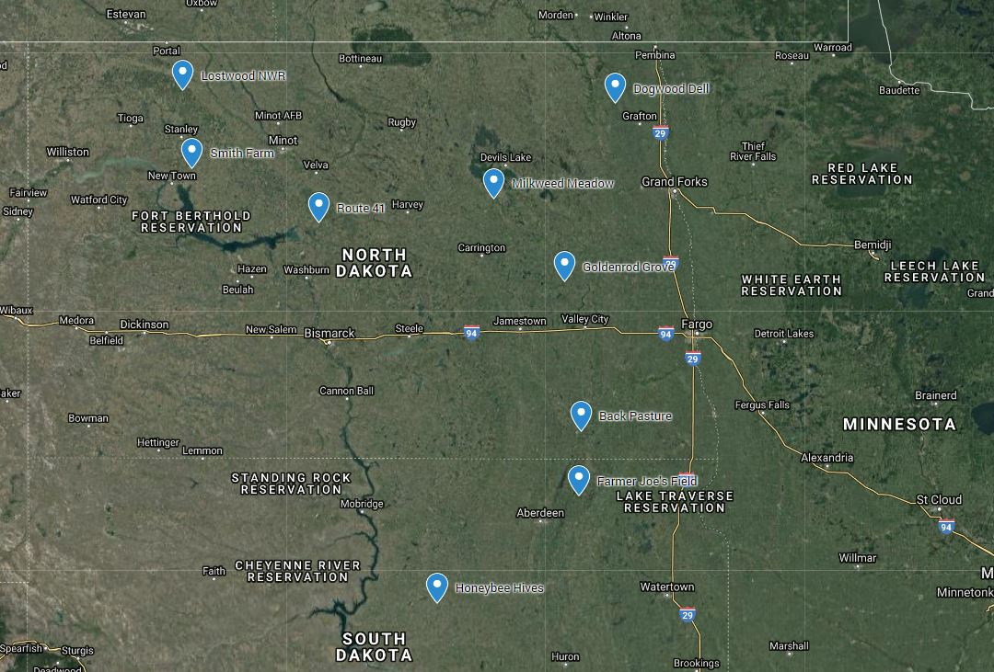

One dataset from the Lostwood National Wildlife Refuge in North Dakota recorded presence/absence data at a number sites over 6 years and also recorded some information on habitat features and weather at the time of surveys. A second data set from the Nature Conservancy, repeatedly counted (three times per season) individuals observed on several transects at three different properties from 1999 until 2009. They did not provide information about the habitat or other covariates but that information may be available from National Land Cover Data Base or NOAA weather data archives. A third data set from the BLM spanned 2 decades in the 1980s and 90s from several sites throughout the range, but the “data” were descriptive or qualitative in nature. The observer recorded the place, time, date and whether the butterflies were “not observed”, “scarce”, “not many” and “many”. No other covariate information was provided, but again useful information may be available from the NLCD or NOAA.

Following the data call, the service conducts their own literature search and review to find any academic or other publications available on the species and, as luck would have it, the was a now retired professor at North Dakota State that had 3 graduate students finish research thesis on this species. The students conducted field surveys and experiments and published some of their work in peer review scientific journals. The labs work concluded that the butterflies, typically have a single generation per year and the populations survive the winter as dormant eggs and that over winter survival of eggs is quite high (>90%) in the absence of early spring fires. They learned that females can lay up to 200 eggs in a single season, but that many caterpillars (>80%) die before pupating into adults.

**Instructions:**

The three data sets described above are available in the Excel workbook called “04_data-sets.xlsx”, available from the course website. Given the available data and published literature, your task is to devise an analysis and modeling plan to conduct an SSA for this butterfly that will support the listing decision. Write up your plan as a few paragraphs or bulleted list. We will regroup to present and discuss our plans as a group.

You are encouraged to use the Data Analysis Roadmap (in your course handout and available on the course website) to guide your process of assessing the data and deciding on an analysis plan.

Some things to consider:

* Think about not only the data type (counts, presence/absence, etc) but also the methodology behind how it was collected. Be sure the data at hand meet the assumptions of your proposed analysis
* What is the response variable for each analysis? What are you trying to estimate (e.g. abundance, occupancy probability, survival, fecundity, etc.)?
* Consider how all pieces of the analysis will fit together, especially how you will use the data analysis to build a projection model
* You do not have to use all data sets or all information available in your planned analysis
* How will you define and quantify the 3 R’s?

**Analysis Plan:**