**SSA 200 – Strategic Use of Data**

**Post-class assessment**

*Please choose the single most correct answer for each question.*

1. **What is a model?**
   1. Someone who walks in fashion shows and is photographed a lot.
   2. A mathematical equation.
   3. A simplified representation of reality.
   4. A computer program used to predict future events.
2. **What information does a regression coefficient tell you?**
   1. It quantifies the relationship between a predictor variable and a response variable.
   2. It describes the correlation between two predictor variables in the model.
   3. It tells you the probability that a covariate is an important predictor of the response variable.
   4. It tells you how close the observed value is to the mean.
3. **What types of uncertainty can we resolve using statistical models?**
   1. Demographic stochasticity and observational uncertainty
   2. Observational uncertainty and ecological uncertainty
   3. Partial controllability and environmental stochasticity
   4. Environmental stochasticity and demographic stochasticity
4. **Which of the following statements is a correct interpretation of the population projection below?**

*The solid line is the median and the dashed lines are the 95% confidence intervals*

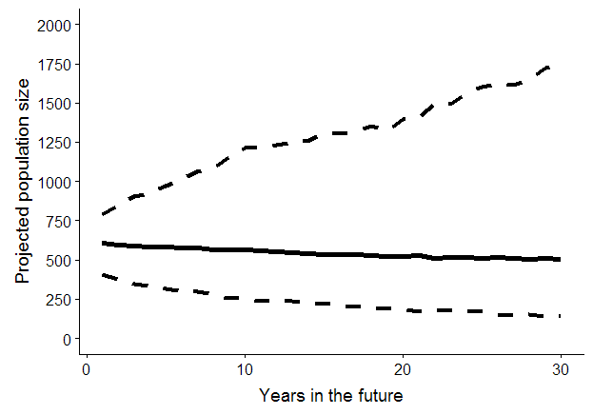

* 1. This population has high resiliency.
  2. This population will most likely be extinct in 30 years.
  3. This population will most likely remain stable for the next 30 years.
  4. It is more likely than not that there will be at least 1000 individuals in the population in 30 years.

**SSA 200 – Strategic Use of Data**

**Post-class assessment**

*Please choose the single most correct answer for each question.*

1. **What is a model?**
   1. Someone who walks in fashion shows and is photographed a lot.
   2. A mathematical equation.
   3. A simplified representation of reality.
   4. A computer program used to predict future events.
2. **What information does a regression coefficient tell you?**
   1. It quantifies the relationship between a predictor variable and a response variable.
   2. It describes the correlation between two predictor variables in the model.
   3. It tells you the probability that a covariate is an important predictor of the response variable.
   4. It tells you how close the observed value is to the mean.
3. **What types of uncertainty can we resolve using statistical models?**
   1. Demographic stochasticity and observational uncertainty
   2. Observational uncertainty and ecological uncertainty
   3. Partial controllability and environmental stochasticity
   4. Environmental stochasticity and demographic stochasticity
4. **Which of the following statements is a correct interpretation of the population projection below?**

*The solid line is the median and the dashed lines are the 95% confidence intervals*



* 1. This population has high resiliency.
  2. This population will most likely be extinct in 30 years.
  3. This population will most likely remain stable for the next 30 years.
  4. It is more likely than not that there will be at least 1000 individuals in the population in 30 years.