**Low-Cost Multipath Routing Protocol by Adapting Opportunistic Routing in Wireless Sensor Networks**

RAMAIAH INSTITUTE OF TECHNOLOGY

(Autonomous Institute, Affiliated to VTU)

Bengaluru – 560054



DEPARTMENT OF COMPUTER SCIENCE AND ENGINEERING

RAMAIAH INSTITUTE OF TECHNOLOGY

Aug - Dec 2018

***Submitted By -***

|  |  |  |  |
| --- | --- | --- | --- |
| **Name** | **USN** | **Phone Number** | **E-Mail ID** |
| Rushali Mohbe | 1MS16CS082 | 9731366364 | rushali17mohbe@gmail.com |
| Mohammed Annan | 1MS16CS057 | 9632033738 | annankandlur@gmail.com |

As part of the Course **Computer Networks - CS53**

SUPERVISED BY

Faculty

**Dr Shilpa Choudhary**

Table Contents Page no

1. Abstract 2
2. Introduction 3
3. Method 4
4. Performance Evaluation 9
5. Advantages 13
6. Limitations 13
7. Conclusion 14
8. References 15

**Abstract:**

Wireless Sensor Networks (WSN) are networks which are responsible for gathering information in certain area. In order to transfer information to the destination, the reliability is a very important factor. Reliability is substantially reduced in a multi-hop system because of several factors such as limited communication range, faulty node, network congestion. Traditional multipath routing protocols consumes large amounts of energy for the construction and maintenance of these multiple paths. This reduces the lifetime of the network and is still unable to guarantee the required reliability. Hence, a Low-Cost Multipath Routing Protocol by Adapting Opportunistic Routing is proposed. This protocol utilizes opportunistic routing in order to improve reliability, reduces the number of multipaths required and consequently reduces the energy consumption as well.

**Introduction:**

WSN comprises of a large number of sensor nodes and a sink node which are responsible for gathering information in certain area. In order to transfer information, reliability is an important factor [1-2]. Reliability is substantially reduced in a such a system because of several factors such as limited communication range, faulty node, network congestion, limited battery, etc.

In order to ensure a high reliability, a multipath routing protocol is used. This protocol constructs a multipath from the source to the sink node. The source node calculates the required number of paths in the multipath using the required reliability and the calculated single path reliability. The source node then bifurcates the network accordingly in order to create the multipaths through which the data will be transmitted. However, in such a system, the energy consumption is is very high as multiple paths have to be created and exploited. Also, if the network isn’t large enough, then the protocol cannot provide the required reliability as it will not to able to construct the necessary multipaths.

Hence, in order to overcome the aforementioned problems, a multipath routing protocol utilizing opportunistic routing is proposed. This approach takes advantage of the broadcast abilities of a wireless network. Using opportunistic routing, multiple candidate nodes are selected and the data is broadcasted to them. These candidate nodes in turn utilize the same approach to transmit the data forward until it reaches the destination node. Since this technique finds multiple regions to transmit the data instead of finding the next node to forwards the data, the opportunistic routing is made to result in disjoint multipaths. The opportunistic routing also results in fewer number of multipaths necessary to achieve the required reliability.

**Opportunistic Multipath Routing Protocol:**

Assumptions made:

1. Every node in the network knows the location of the sink node.
2. Every node in the network knows its own location. [3]
3. Every node in the network knows the location of all of its one-hop neighbours. [4]

**Multipath Construction Process:**

The protocol constructs multipaths in such a way that they are completely disjointed so as to prevent collision and congestion. Based on the required reliability, the total number of multipaths is determined. Opportunistic routing provides equal opportunity for each of the neighbour nodes in the predetermined multipaths to transmit the data.

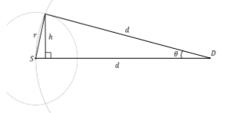

**Fig 1. A calculation of path width**

This protocol constructs a path via opportunistic routing. The width of such a path is w, which can be calculated using trigonometry. Refer Fig 1.

w = Width of path

d = Distance from source to destination node

w = 2 * h

h = d * sinΘ

sinΘ = √(1-cos^2Θ)

cosΘ = 

Therefore, w = 2 * d *

After calculating the width of the multipath, the protocol calculated the number of paths required to guarantee the required transmission success ratio. The protocol also sets the starting point and end point of each path to transmit the data. Finally, the source node allocates the path from the source node to the destination node. Algorithm 1 is the pseudo-code of the multipath construction process.

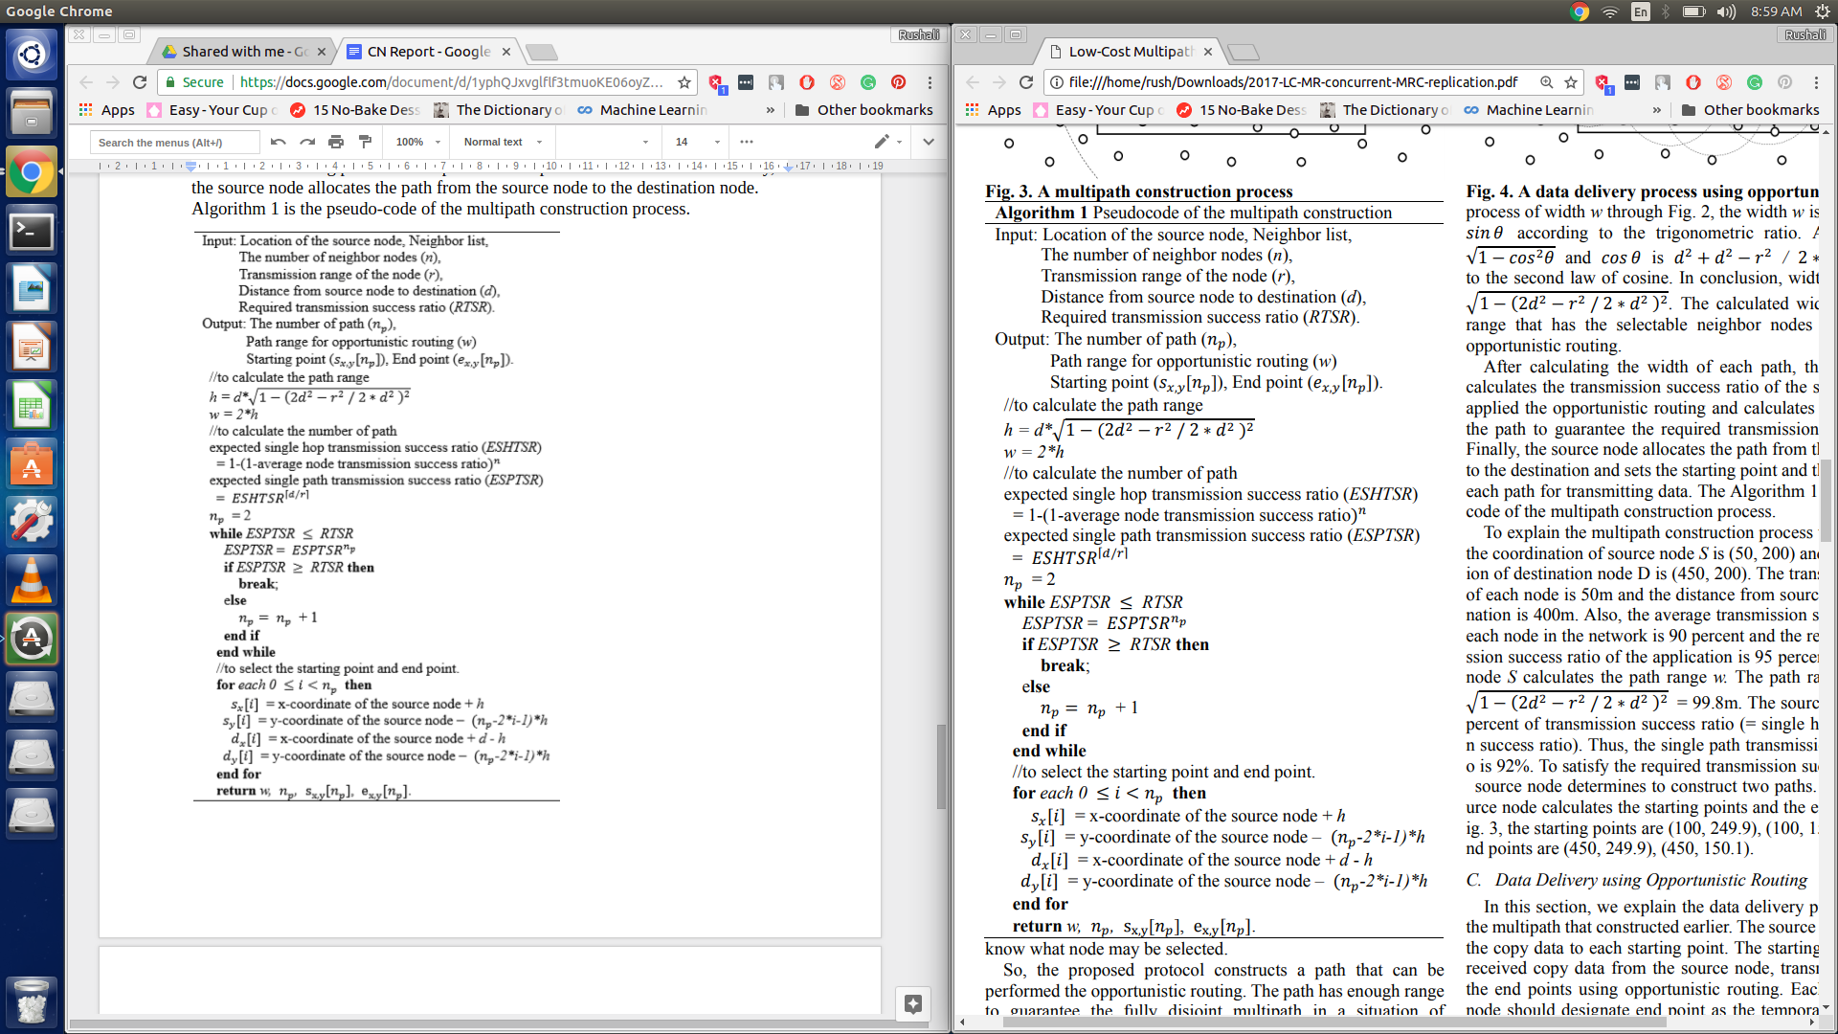

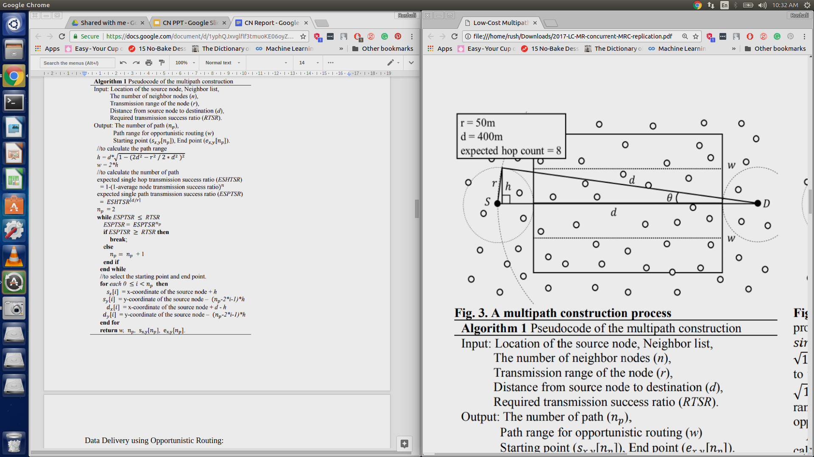

For example, Fig2 the coordination of source node S is (50, 200) and the coordination of destination node D is (450, 200). The transmission range of each node is 50m and the distance from source node to destination is 400m.   
The width w is therefore calculated to be equal to 99.8m.

**Data Delivery using Opportunistic Routing:**

A copy of the data is sent to each of the starting points by the source node. This data is then transmitted by the starting points using opportunistic routing. Each transmission node is required to assign a temporary end point as its destination. When one of the end points receives the data successfully, it forwards this data to the destination node .This kind of transmission process prevents collisions, congestion of the network and it ensures that the path is disjoint.

Algorithm 2 is the pseudo-code for the data delivery process of every transmission node in the path.

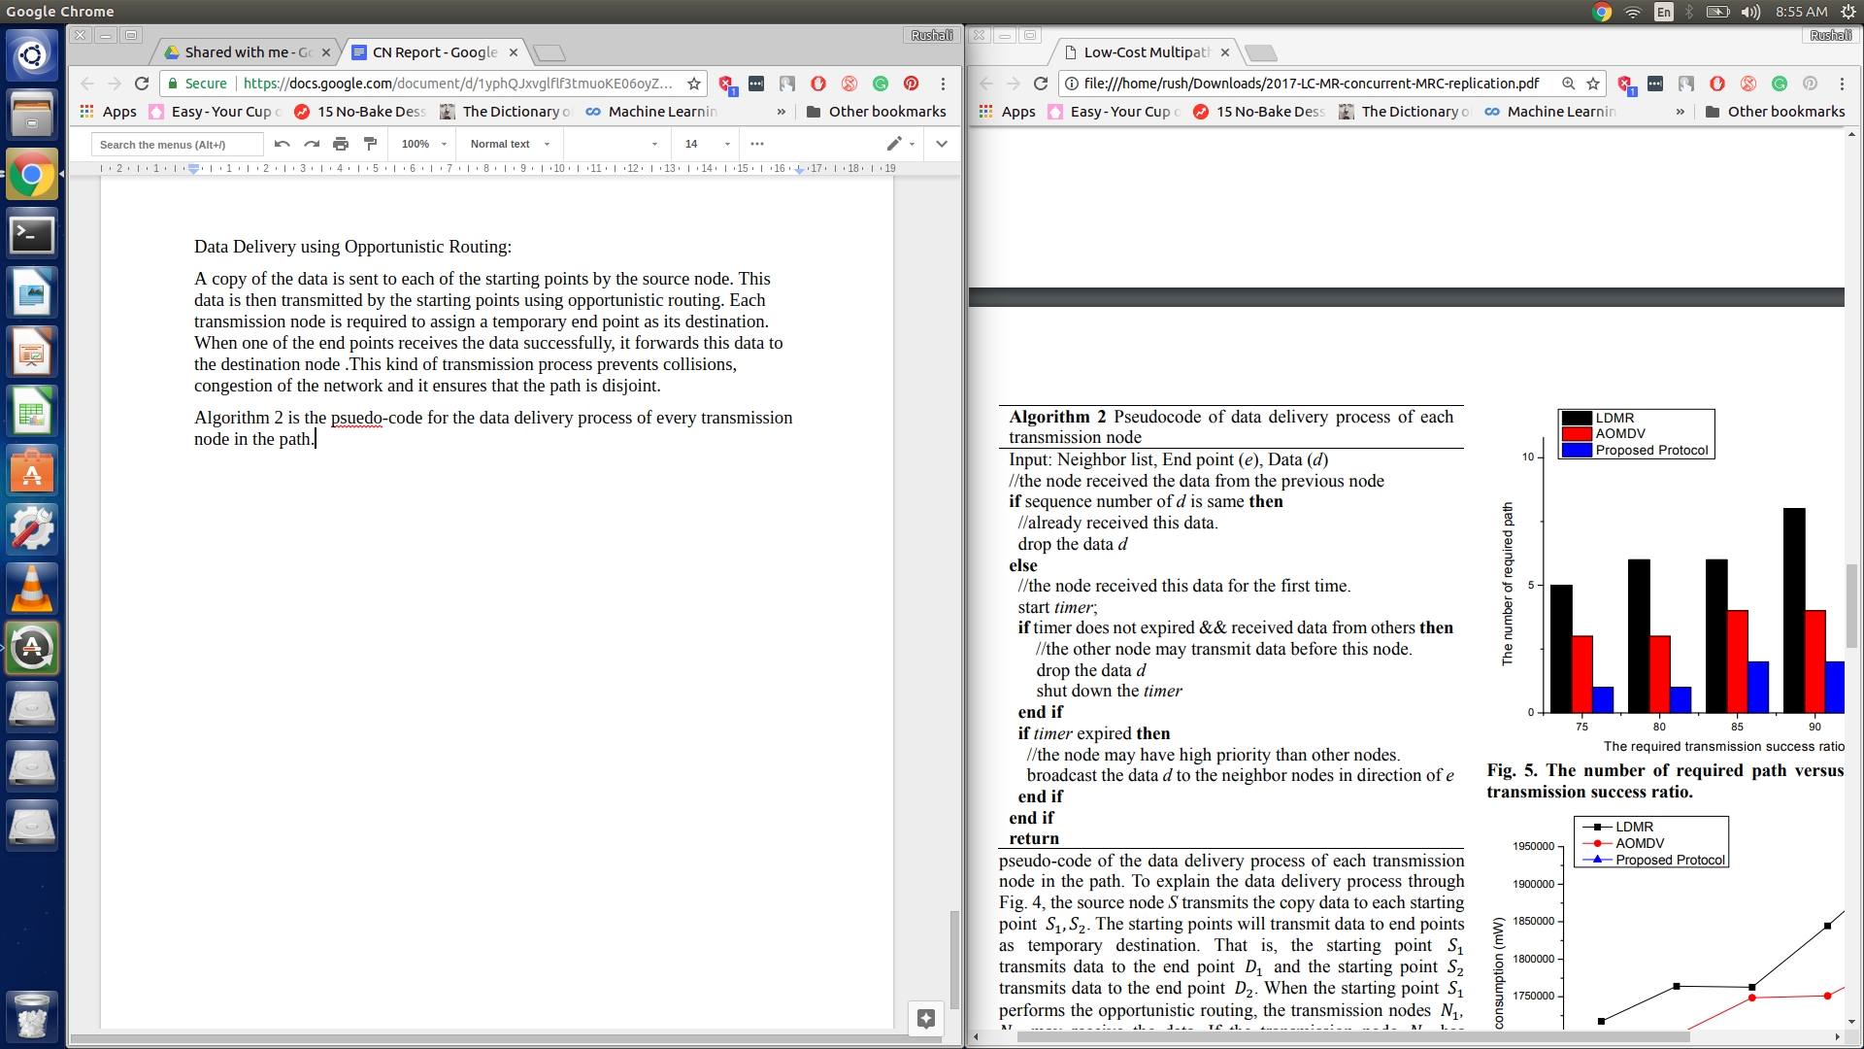

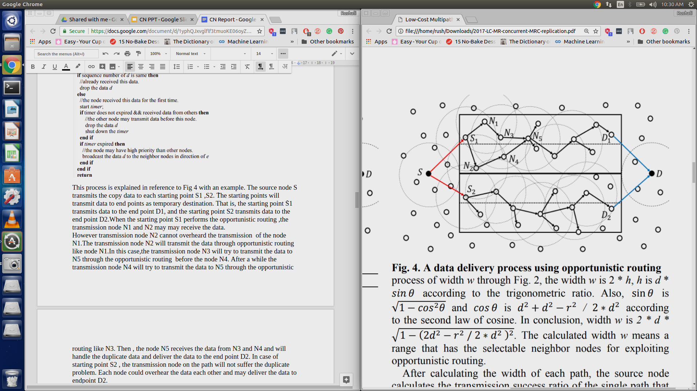

This process is explained in reference to Fig 4 with an example. The source node S transmits the copy data to each starting point S1 ,S2. ܵThe starting points will transmit data to end points as temporary destination. That is, the starting point ܵS1 transmits data to the end point D1, and the starting point S2 transmits data to the end point D2.When the starting point S1 performs the opportunistic routing ,the transmission node N1 and N2 may may receive the data.  
However transmission node N2 cannot overheard the transmission of the node N1.The transmission node N2 will transmit the data through opportunistic routing like node N1.In this case,the transmission node N3 will try to transmit the data to N5 through the opportunistic routing before the node N4. After a while the transmission node N4 will try to transmit the data to N5 through the opportunistic routing like N3. Then , the node N5 receives the data from N3 and N4 and will handle the duplicate data and deliver the data to the end point D2. In case of starting point S2 , the transmission node on the path will not suffer the duplicate problem. Each node could overhear the data each other and may deliver the data to endpoint D2.

**Performance Evaluation:**

**Simulation Model:**

The proposed protocol and the other protocols were simulated on NS-3.23 simulator. [5]

* Simulation field is 1000m x 1000m.
* Thousands of sensor nodes are randomly distributed in the sensor field.
* The transmission range of each sensor node is 100m.
* The average transmission success ratio is 85 percent
* The required transmission success ratio is 80 percent.
* Transmitting, receiving, and idling power consumption of sensor node rates are 33, 25, and 3mW respectively.
* The device parameters are chosen in reference the MICA2 specification. [6]
* Each simulation lasts for 1000 seconds
* The source generates the data 50 times each simulation.
* The simulation value is the means of repeat 10 times.

**Simulation Results:**

* **Impact of the required success ratio**

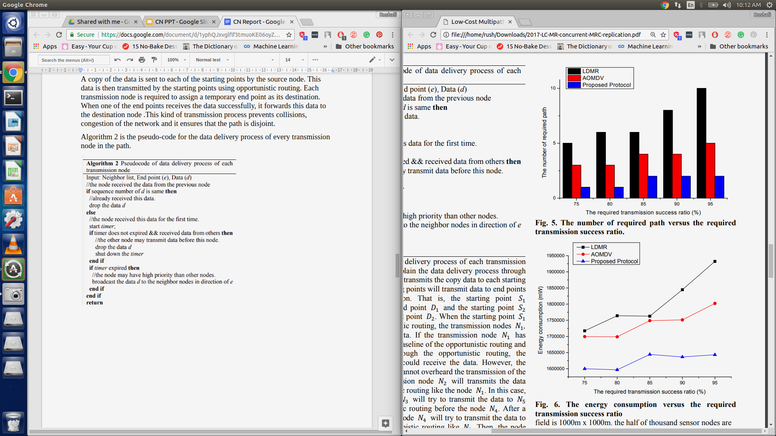

Fig. 5. show the number of required paths versus the required transmission success ratio. As the required transmission success ratio increased, the number of required paths also increased. Increasing the number of paths is the only way to increase the transmission success ratio in LDMR as it uses designated nodes in the path. Even though both the proposed solution and AOMDV use broadcasting so as the reduce the number of paths required. The proposed solution is more effective as the paths required is even lower that AOMDV as it utilizes opportunistic routing.

Fig. 6 shows the energy consumption versus the required transmission success ratio. As the required transmission success ratio increased, the energy consumption also increased. The energy consumption is related to the number of the path.Hence, LDMR consumes the most energy. Although lesser than LDMR, AOMDV consumes more energy that the proposed solution because it uses broadcasting to construct multipath in the network. However, the proposed protocol does not perform the broadcasting to construct multipath like the AOMDV and does not need many paths to guarantee the transmission success ratio like the LDMR.

* **Impact of Network Size:**

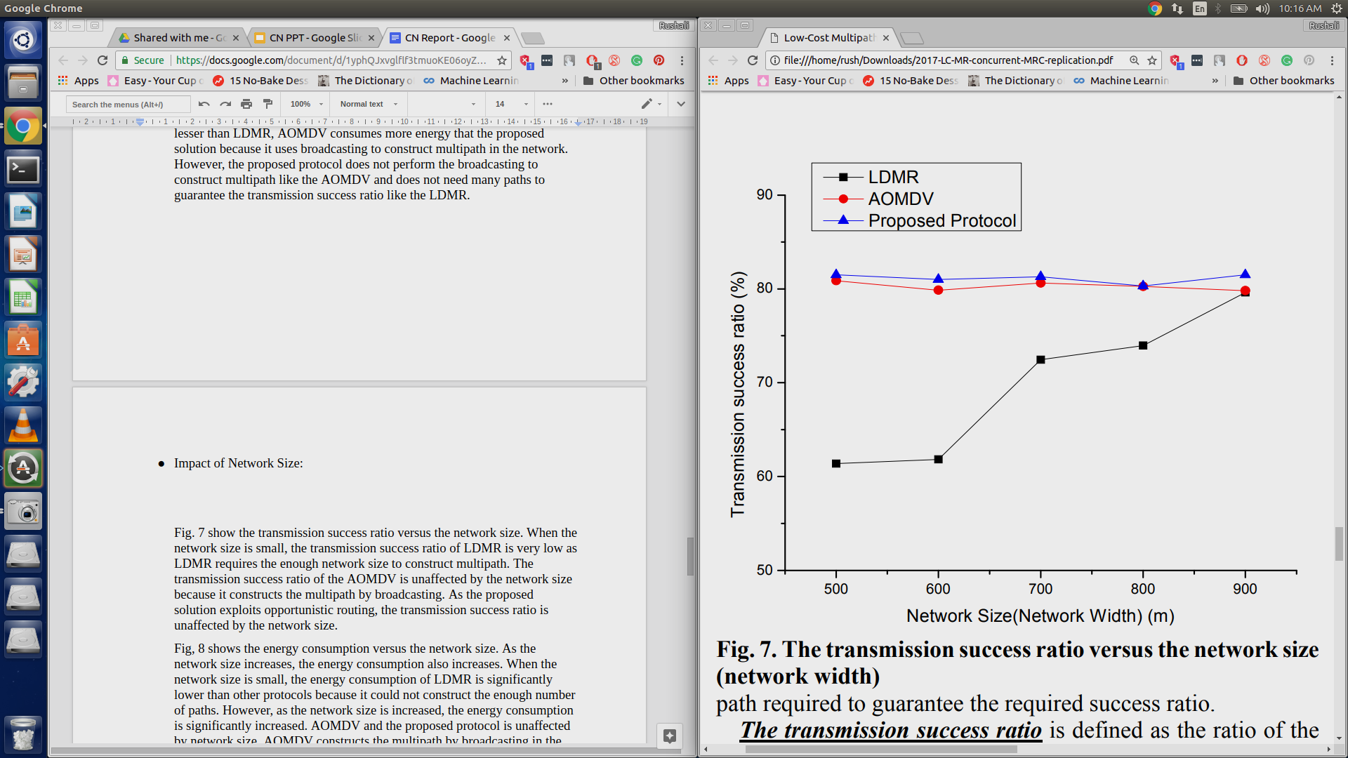

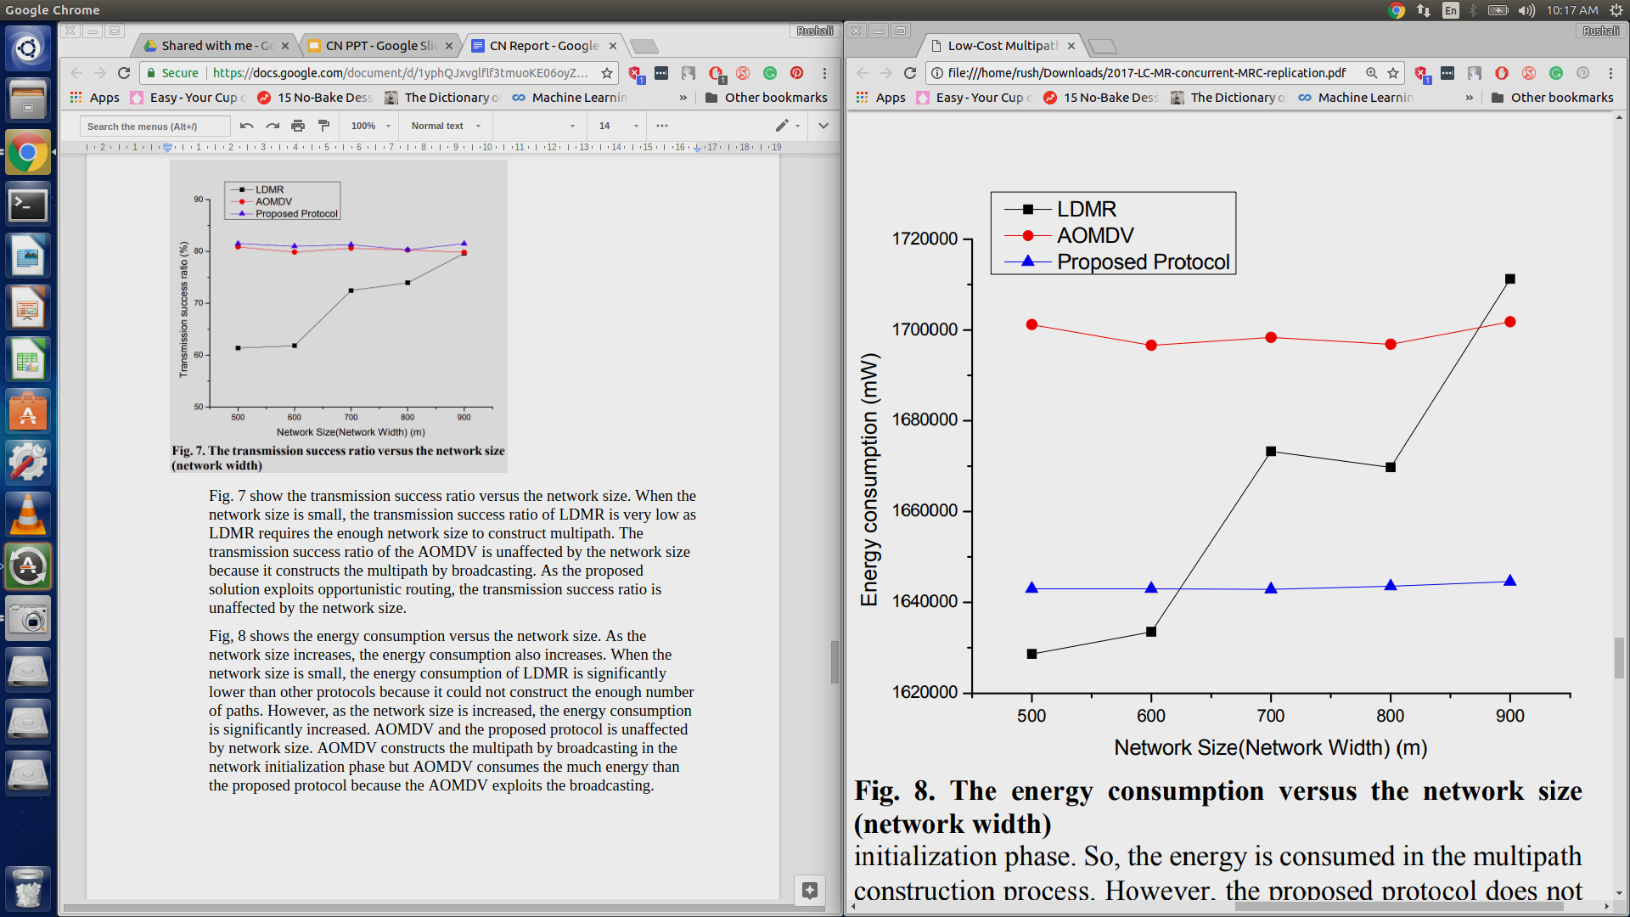

Fig. 7 show the transmission success ratio versus the network size. When the network size is small, the transmission success ratio of LDMR is very low as LDMR requires the enough network size to construct multipath. The transmission success ratio of the AOMDV is unaffected by the network size because it constructs the multipath by broadcasting. As the proposed solution exploits opportunistic routing, the transmission success ratio is unaffected by the network size.

Fig, 8 shows the energy consumption versus the network size. As the network size increases, the energy consumption also increases. When the network size is small, the energy consumption of LDMR is significantly lower than other protocols because it could not construct the enough number of paths. However, as the network size is increased, the energy consumption is significantly increased. AOMDV and the proposed protocol is unaffected by network size. AOMDV constructs the multipath by broadcasting in the network initialization phase but AOMDV consumes the much energy than the proposed protocol because the AOMDV exploits the broadcasting.

**Advantages:**

This proposed routing protocol may obtain the following advantages:

1) The whole network lifetime is increased by decreasing the energy consumption for multipath construction/maintenance.

2) The lower number of the path means less effect of network size than the existing multipath routing protocols.

3) If some nodes on the path damaged, the proposed routing protocol does not need the path recovery process because the proposed routing protocol does not predetermine the next forwarding node.

**Limitations:**

1. Some applications may be slower in offering traffic to the transport layer, thus starving paths assigned to them, causing under-utilization.
2. Moving to the alternative path will incur a potentially disruptive period during which the connection is re-established.
3. When the wireless signals are transferred they are blocked by the certain obstacles as walls, gates and human beings. The strength of wireless signals depends upon the location; if you’re closer to infrastructure you receive signals.
4. Wireless signals can be hindered by other electronic devices, the rate of frequency and the height from the ground
5. Though wireless technology is very common but still it is an expensive way of remain connected. Wireless network is relatively less stable and efficient than a wired connection
6. Initial setup is complicated.
7. One of the biggest disadvantages of large scale wireless sensor networks lies on the complexity of logistics involving selective replacement of sensors that have ran out of energy.
8. The lower speed compared to wired network.
9. WSN is less secure because hacker's may access with their system which actually can act as Access Point.

**Conclusions:**

As reliability is an important factor in WSN, the multipath routing protocol which exploits the opportunistic routing was proposed for energy efficiency and eliminating the network scale restriction. The proposed protocol constructs the large enough path to exploit the opportunistic routing and calculates the number of path to guarantee the required transmission success ratio. The simulation results show the proposed protocol has better energy efficiency with similar transmission success ratio in comparison with existing multipath routing.

**References:**

[1] I. F. Akyildiz et al., “A survey on sensor networks,” IEEE  
Communications, Vol. 40, No. 8, pp. 102-114, Aug. 2002  
[2] E. B. Hamida, and G. Chelius, “Strategies for data dissemination to mobile  
sinks in wireless sensor networks,” IEEE Wireless Communications,  
Vol.15, No. 6, pp.31-37, Dec. 2008  
[3] F. Yu, E. Lee, et al. "Circle Path Based Sink Location Service for  
Geographic Routing Scheme," IEEE Wireless Communications and  
Networking Conference, pp. 1-6, Apr. 2009  
[4] N. Bulusu, J. Heidemann, et al. "Gps-less low cost outdoor localization for  
very small devices." IEEE Personal Communications Magazine, Vol.7,  
No. 5, pp.28-34, Oct. 2000.  
[5] NS-3. Ns-3. http://www.nsnam.org/  
[6] J. Polastre, R. Szewczyk, et al. "Telos: Enabling Ultra-Low Power  
Wireless Research." IEEE IPSN 2005, pp. 364-369, Apr. 2005.