Attribute Origination Portal
The Complete Guide
How it was built · Who can do what · How to use it · How it works inside
Every explanation comes twice: a clear version, and an “explain it like I’m five” (ELI5) retelling. They say the same thing — read whichever suits you.

Part I — How the portal was built

1.1 The blueprint
CLEAR
The portal was built from two documents. The Build Guide & Sprint Backlog specified a 13-sprint system that turns solar electricity readings into saleable certificates: I-RECs (issued via a registry API) and VCUs (carbon credits, verified by a human auditor). Revision R1 (utility-data first) then replaced the plan to install our own meters with a capital-light approach: obtain each site’s official export figure from ENA (the Armenian electricity network) billing records, with the owner’s consent, and treat that as the record of account. Roughly $68,000 of hardware disappeared from the plan, and one new dependency appeared: ENA’s cooperation.
ELI5 — EXPLAIN IT LIKE I’M FIVE
Imagine planning to give every bakery its own official scale, then realising the post office already weighs every parcel with a certified scale — and will tell you the number if the bakery signs a permission slip. That is R1: use the measurement that already exists, keep your own scale as a backup plan.

1.2 Three principles that shaped everything
CLEAR
First: the data is evidence. Readings are written once and never updated; an auditor can reconstruct the system exactly as it stood on any past date. Second: double-issuance is fraud, not a bug. One megawatt-hour becomes exactly one certificate, enforced by a database constraint — not by application code that could have a bug. Third: the users are not technical. Bakery owners and installers use this to make decisions with legal consequences, so every strange word carries a plain-language explanation in Armenian and English, at the point where it appears.
ELI5 — EXPLAIN IT LIKE I’M FIVE
The portal is built like a bank vault with a friendly receptionist: the vault door physically cannot be left open (the database refuses), every visit is written in the guest book (the audit log), and the receptionist explains every scary word in whichever language you prefer (the ⓘ icons).

1.3 The stack
Concern | Choice | Why
Framework | Next.js 15 + TypeScript strict | One deployable; server actions give safe form handling
Database | PostgreSQL 16 (+TimescaleDB) | The integrity rules live in the database itself
Data access | Drizzle ORM, SQL-first | The critical constraints are hand-written SQL, readable
Auth | Database sessions, role-based | Revocable per-session; auditor accounts auto-expire
Jobs | pg-boss (Postgres-backed) | Nightly integrity checks; one less service to run
Styling | Tailwind + design tokens (CSS vars) | The pastel system is data, not code; WCAG AA tested
Validation | Zod schemas | Same rules on the form and on the server
Languages | next-intl — English default, full Armenian | Every UI string, glossary entry and contract in both
Testing | Vitest (193 tests) + pgTAP + CI | Constraints are proven at the database level
Hosting | Railway (web + jobs + Postgres) | Config-as-code committed in the repo

1.4 What was built, area by area
Area | What exists
Foundations | Auth with revocable sessions and expiring auditor accounts; pastel design system with automated contrast tests; audit log on every mutation; CI pipeline
ELI5 subsystem | ⓘ icons everywhere, hover tooltip + side panel, searchable /glossary, admin editor (no deploy needed), ~35 terms in Armenian and English
Sites & people | Mobile site wizard (GPS, offline draft, ENA account number), owner/vendor records with encrypted bank details, site lifecycle state machine
ENA acquisition (R1) | Data-release consent with revocation; bill parser with confidence scoring; mandatory human confirmation queue; coverage dashboard; overdue chasing
Manual fallback | Typed-in export/generation figures, loudly badged MANUAL; all-or-nothing CSV import; scenario seeder with deliberately broken test sites
Integrity ledger | Append-only readings (database REVOKE), per-device sha256 hash chain, nightly + on-demand verification, transparent adjustment records
Reconciliation (R1) | Quantity-aware: export vs generation with self-consumption modelled; hard rules dispute, soft rules flag; learned per-site bands; expected-yield model
Attribute ledger | The UNIQUE constraint (double-counting firewall, pgTAP-proven), full state machine with four allocation guards, track assignment with written rationale
Carbon & issuance | Versioned emission factors (lookup by vintage), traceable calculations, Issuer registration, issue request builder, the sandbox gate, certificate lifecycle
Portals | Owner (generation, earnings, claim rules, provisional vs confirmed), vendor (fleet, commissions), auditor (asOf time machine, self-service verification)

1.5 What is deliberately NOT finished
CLEAR
The registry client and e-signature provider ship as working mock implementations behind real interfaces — the sandbox gate and all guards are fully real — because the actual counterparties (Armenia’s I-REC Issuer, ENA, an e-sign vendor) are not yet contracted. Revision R1’s blocking dependency is recorded in docs/DISCOVERY_SPIKE.md: confirm the Issuer exists, pilot ENA data on three sites, and ask whether certificates are issued on generation or export. The code is built so any answer is cheap to absorb.
ELI5 — EXPLAIN IT LIKE I’M FIVE
The car is built and the engine runs; the two missing pieces are the licence plate office (the Issuer) and the fuel supplier (ENA) actually answering the phone. The garage door is designed so that whichever fuel arrives, it plugs in without rebuilding the car.

Part II — Who can do what
Nine roles exist. Internal staff share the operations console (their duties differ by procedure and everything is audit-logged); external people get their own separate, smaller portals; the auditor gets a read-only console. Unauthorised URLs return a hard 403 — pages a role cannot use do not merely hide, they refuse.
Role | Sees | Can do | Cannot do
Admin | Everything | All operator actions, plus: flip sandbox flags (with written reason), override track assignments, revoke any login session instantly, manual entry on production sites, edit glossary | Escape the audit log — every admin action is recorded like everyone else’s
Ops | Operations console | Create/manage sites, run the ENA queue, enter manual readings (sandbox), run reconciliation, build issue requests, edit glossary | Admin screens; manual entry on production sites
MRV analyst | Operations console | Confirm/correct/reject bill extractions, run reconciliation, resolve disputed and flagged periods with reasons | Change sandbox flags or tracks
Carbon manager | Operations console | Assign tracks (I-REC vs carbon) with named assessor + rationale, manage emission factors, run carbon calculations | Override an existing track (admin only)
Commercial | Operations console | Inventory by vintage/track, exports, offtake and payout records | Touch readings or reconciliation
Field tech | Operations console | Create sites from a phone (wizard), register devices | Issuance, admin, financial screens
Site owner | “My solar” only | See their generation (provisional vs confirmed), earnings, payout statements, what they may legally claim; download claim statement | See any other site or any internal screen
Installer (vendor) | “Fleet” only | Monitor every site they installed, see commission statements | See owner finances or internal screens
Auditor (VVB) | Auditor console only | Reconstruct the system as of any past date, run hash-chain verification themselves, inspect traceable calculations | Change ANYTHING — the account is read-only, time-limited, and every view they open is itself logged

ELI5 — EXPLAIN IT LIKE I’M FIVE
Think of a building with one front door and many rooms. Your keycard opens only your rooms. The bakery owner’s card opens a cosy room with their own numbers. The auditor’s card opens a glass observation deck: they can see everything, touch nothing, and the deck writes down where they looked. The admin’s card opens every room — but the corridor cameras record the admin too.

Part III — How to use the portal

1. What is this portal?
CLEAR
The portal collects each site’s official export figures from ENA billing records (with the owner’s consent), cross-checks them against inverter data, converts verified megawatt-hours into certified environmental attributes (I-RECs and carbon credits), sells them, and pays site owners — keeping a tamper-evident audit trail an external auditor can verify years later.

ELI5 — EXPLAIN IT LIKE I’M FIVE
Your solar panels make two things: electricity, and bragging rights that the electricity was clean. Companies pay real money for those bragging rights. This portal is the machine that collects the proof, gets the bragging rights officially certified, sells them, and sends you your share — and it keeps receipts for everything, forever, so nobody can ever accuse anyone of cheating.

2. Signing in
CLEAR
Enter your email and password. The interface is in English by default; Armenian is one click away (Հայերեն on the login page) and is fully translated. Your role decides what you see: operators land on the console, owners on “My solar”, installers on “Fleet”, auditors on the auditor console. Every unusual word has a small ⓘ icon — hover for one line, click for a plain-language panel with an example. The full dictionary lives at /glossary.

ELI5 — EXPLAIN IT LIKE I’M FIVE
One door, different rooms depending on who you are. A bakery owner sees their earnings; an auditor sees the evidence room; the operations team sees the engine room. You can’t wander into a room that isn’t yours — the doors are actually locked, not just hidden. And whenever a word looks scary, click the little ⓘ and it explains itself like a patient friend.

3. The coloured strip and the sandbox
CLEAR
A strip at the top always shows the environment: LOCAL (grey), SANDBOX (yellow), PRODUCTION (green). Sandbox sites additionally show a yellow 🧪 banner on every screen. Sandbox data behaves identically to real data but is blocked, in the deepest code layer, from ever reaching a real registry.

ELI5 — EXPLAIN IT LIKE I’M FIVE
Yellow means practice mode — a flight simulator wired into the real cockpit. All the buttons work, but the plane cannot take off. Practice fearlessly when you see yellow: nothing you do there can create a real certificate.

4. Creating a site (field technicians)
CLEAR
Sites → + New site. Four steps on a phone: identity (site, owner, tax ID, ENA account number from the electricity bill) → technical (capacity, inverter, modules, tilt) → location (GPS capture) → review. The draft survives lost signal. Sites then move through a fixed lifecycle (LEAD → … → PRODUCING); every move is recorded and illegal jumps are refused with an explanation.

ELI5 — EXPLAIN IT LIKE I’M FIVE
It’s a passport application for the solar plant, filled in while standing next to it. The phone remembers everything even if the mountain eats your signal, and the GPS button writes down exactly where the plant lives. The ENA account number from the electricity bill is the plant’s ID card at the electric company.

5. ENA data — the official numbers
CLEAR
ENA data → paste or upload bill data (or it arrives by feed/request). The parser extracts account, period, export and import with a confidence score; every record then waits in a confirmation queue where an analyst confirms, corrects (with a recorded reason) or rejects it. Only confirmed figures become readings. A consent must be recorded per site first, and the coverage dashboard shows every site-month as received, awaiting or overdue. ENA data lags 30–45 days — periods show AWAITING_SOURCE meanwhile, and that is normal.

ELI5 — EXPLAIN IT LIKE I’M FIVE
The electric company already measures your roof with a certified meter (they pay you for the power, so they have to). With your signed permission slip, their monthly letter becomes our official number. A human reads every letter before it counts — the computer’s guess is never trusted alone. The letter takes about a month, so meanwhile you see your inverter’s estimate with a big “not official yet” sticker.

6. Manual entry — the fallback
CLEAR
Readings → Manual entry (sandbox sites, or admin on production). Type the export figure (what the ENA bill will confirm) and the generation figure (the inverter). Both land as append-only readings badged MANUAL with your name attached. Bulk import takes a whole year as CSV; every row validates first and either all commit or none do.

ELI5 — EXPLAIN IT LIKE I’M FIVE
When the official letter is late or you are practising, you write the numbers in by hand. Everything you type wears a loud yellow ✎ MANUAL badge forever — a typed number is never allowed to disguise itself as a measured one — and the system never forgets who held the pen.

7. Reconciliation — making the numbers make sense
CLEAR
The engine compares WHAT each source measures: ENA reports export (what reached the grid); the inverter reports generation (everything produced); the difference is self-consumption. Hard rules — export exceeding generation — always DISPUTE the period. Soft rules — self-consumption outside the site’s learned band, generation ±15% from the modelled seasonal yield, an export-ratio jump — FLAG it for review without blocking. Disputes go to a queue sorted by severity; resolving one requires a reason from a fixed list plus a note, both audit-logged.

ELI5 — EXPLAIN IT LIKE I’M FIVE
The inverter says “I made 8”; the electric company says “I received 3.2”. That is not a fight — your ovens ate the other 4.8, which is normal and the portal knows it. But if the electric company ever claims it received MORE than the panels made, someone is wrong, and a human detective must sort it out before any certificate is printed. Numbers that merely look odd (a December pretending to be a June) get a yellow flag and a second look, without stopping the line.

8. The attribute ledger — where double-selling is impossible
CLEAR
Each reconciled month becomes exactly one attribute row per site — a database UNIQUE constraint makes a second one impossible. Attributes move MEASURED → RECONCILED → ELIGIBLE → ALLOCATED → ISSUED → TRANSFERRED → REDEEMED. Reaching ALLOCATED requires four guards: period reconciled; contract valid across the period; the evidence basis (a data-release consent, or meter calibration where our own meter is the record of account) covering the whole period; and a track assigned — a one-time, recorded decision (I-REC vs carbon) with a named assessor and written rationale. REDEEMED is terminal.

ELI5 — EXPLAIN IT LIKE I’M FIVE
Each month of sunshine is a golden coin that can only be minted once — the vault physically cannot mint a second. Before any coin leaves, four locks must open: the numbers checked out, the paperwork was signed, we had the right to the data, and someone decided what kind of coin it is. And a coin that has been spent (redeemed) is stamped forever — it can never be spent again.

9. Issuance — turning attributes into certificates
CLEAR
Issuance → register the site with the I-REC Issuer, then build an issue request from ALLOCATED attributes on the I-REC track. The volume comes from the ledger and cannot be edited. A checklist shows every guard that passed. The sandbox gate runs inside the registry client itself: a batch containing any sandbox attribute throws before any network call, no matter what the screen believed. Issued serial numbers bind permanently to their attribute rows.

ELI5 — EXPLAIN IT LIKE I’M FIVE
This is where coins go to the official mint and come back with serial numbers engraved. You can’t tell the mint how many coins you have — the vault counts them itself. If a practice coin sneaks into the bag, the mint door slams shut automatically.

10. For site owners — “My solar”
CLEAR
Monthly generation with provisional figures clearly separated from confirmed ones, certificate status, payout statements (MWh, rate, gross, deductions, net in dram), and exactly what you may and may not claim after selling — including your retained share and its downloadable claim statement.

ELI5 — EXPLAIN IT LIKE I’M FIVE
Your page answers three questions: how much did my roof make, when do I get paid, and what am I allowed to say about it? Once you sell March’s bragging rights, the buyer owns them — claiming them too would be selling the same thing twice, the one unforgivable sin here. The share you kept stays yours to brag about, with a paper that proves it.

11. For installers — “Fleet”
CLEAR
Every site you installed on one screen (contracted or not), its status and health, and commission statements accrued from certificate sales of your referred sites.

ELI5 — EXPLAIN IT LIKE I’M FIVE
One screen with every roof you’ve ever installed, whether it’s healthy, and how much pocket money each one sends you for having made the introduction.

12. For auditors — the console
CLEAR
A read-only, time-limited account where every view is itself logged. Point-in-time reconstruction renders contracts, emission factors and readings exactly as they stood on any chosen date. Chain verification can be run on demand — the auditor does not have to take our word. Every calculated figure lists the raw readings and factor version behind it, down to the scanned ENA bill.

ELI5 — EXPLAIN IT LIKE I’M FIVE
The auditor gets a time machine and a lie detector. The time machine shows the actual filing cabinet as it was on any past day. The lie detector checks that no page was quietly rewritten: every page is glued to the previous one with mathematics, and editing one leaves visible scars. The auditor presses the “check the glue” button themselves — which is exactly why every audit gets cheaper.

13. Everyday how-do-I…
CLEAR
Look up a word → any ⓘ or /glossary. Feed in a bill → ENA data → paste → confirm in the queue. Enter figures by hand → Readings → Manual entry. See why a month is stuck → Reconciliation queue. Sell certificates → get them ALLOCATED (Attributes), then Issuance. Add a dictionary word → Admin → Glossary (both languages, always). Kick a user out → Admin → Sessions → Revoke. Prove nothing was tampered with → Audit → Run verification now.

ELI5 — EXPLAIN IT LIKE I’M FIVE
Every button that matters is at most two clicks from the left-hand menu, and every dangerous button asks for a written reason it will remember forever.

Part IV — Technical architecture: how the pieces talk
The diagram below shows every layer. Read it top to bottom: people at the top, the application in the middle, the pure business rules and connectors beneath it, and the database — where the unbreakable rules live — at the bottom. The outside world sits on the right.
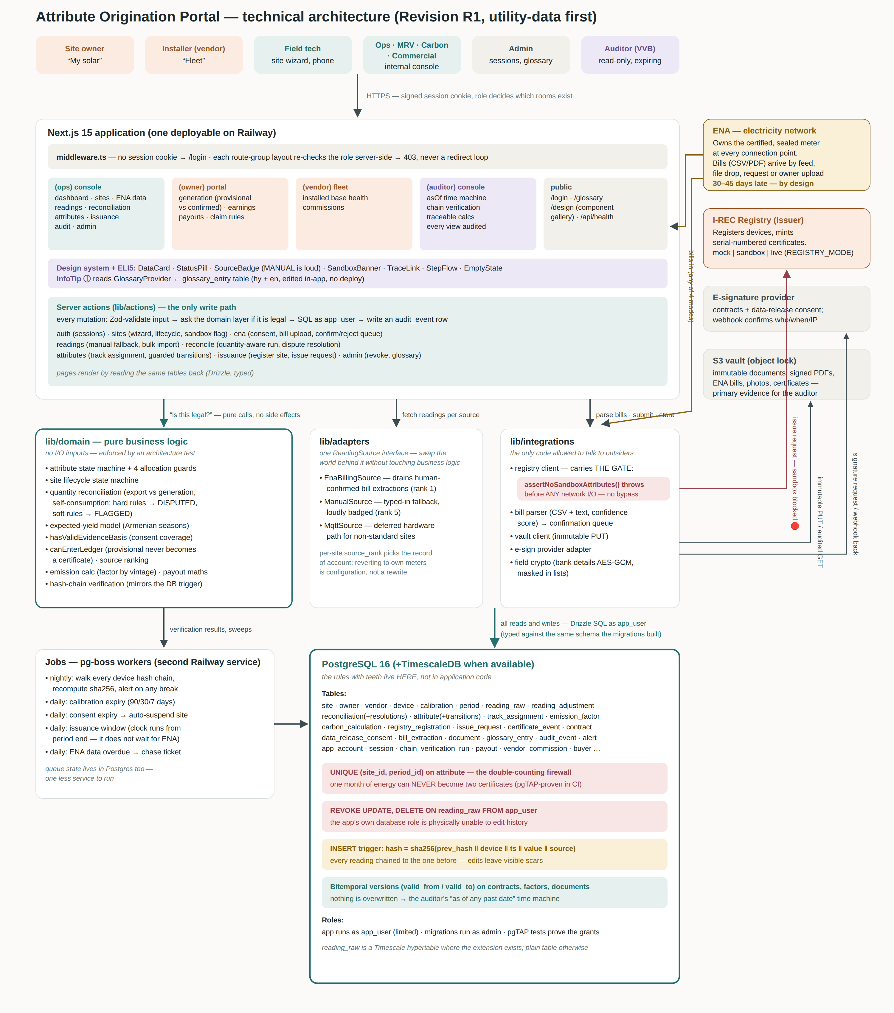
A full-resolution version ships alongside this document (architecture.svg / architecture.png) and in the repository under docs/.

The journey of a number — how each piece talks to the next
Step | What happens | Which pieces talk
1 | A person signs in. The middleware checks the session cookie; the route-group layout checks the role in the database and either renders their portal or returns 403. | Browser → middleware → layout → session table
2 | An ENA bill arrives (feed, file drop, request, or owner upload — all four modes converge). The parser extracts account, period, export/import and scores its own confidence. | ENA → bill parser (lib/integrations)
3 | The parsed record waits in the confirmation queue. An analyst confirms, corrects (reason recorded) or rejects. Nothing is ever auto-accepted. | Parser → bill_extraction table → (ops) ENA page → analyst
4 | On confirmation, the figure becomes a reading: source ENA_BILLING, quantity EXPORT. The database trigger seals it into the site’s hash chain as it lands. The app’s database role could not edit it afterwards even if it tried. | Server action → reading_raw table → hash trigger
5 | Reconciliation runs. The action gathers the period’s readings, asks the PURE domain engine to compare export vs generation (self-consumption modelled, learned bands, seasonal yield), and stores the verdict: RECONCILED, FLAGGED or DISPUTED. | Action → lib/domain/reconcile → reconciliation + period tables
6 | A clean period mints its attribute row — unless one already exists, which the UNIQUE constraint makes impossible. Provisional (inverter-only) figures are refused here by the canEnterLedger guard. | Action → attribute table (the firewall)
7 | Allocation asks four guard questions of the domain layer: period reconciled? contract valid? evidence basis (consent) covering the whole month? track assigned? Any “no” blocks with a plain-language reason. | Action → lib/domain guards → consent/contract/calibration tables
8 | An issue request goes to the registry through the ONE client allowed to talk to it. The client’s first act is the sandbox gate: any sandbox attribute in the batch throws before a single byte leaves the building. Returned serials bind permanently to their attribute rows. | Action → registry client → I-REC Registry → attribute table
9 | Money flows back: payout maths honour fixed-rate or revenue-share terms and the owner’s retained share; the owner and vendor portals read the same tables everyone else wrote. | Payout tables → owner/vendor portals
10 | Every night the jobs service walks every hash chain, sweeps calibration and consent expiries, checks issuance windows (counting from period end — the clock does not wait for ENA), and chases overdue ENA data. Findings land as alerts on the dashboard. | pg-boss jobs → all tables → alert table → dashboard

What each piece is for
Piece | What it is for | Who it talks to
Next.js app | Everything a person sees: four role portals, public glossary, design gallery. Server-rendered; no separate API server to maintain. | Browsers above it; lib layers below it
middleware + layouts | The two-stage lock: cookie present? (edge) then role allowed? (server, against the DB). Wrong role = 403, never a redirect loop. | Session and account tables
Server actions | The only write path. Every mutation: validate (Zod) → check legality (domain) → write (as the limited app_user role) → record (audit_event). | Domain, adapters, integrations, database
lib/domain | The brains, kept pure: state machines, the quantity reconciliation engine, yield model, allocation guards, payout maths, hash verification. No network, no database — an architecture test fails the build if anyone adds an I/O import. This is why the rules are unit-testable and auditable. | Called by actions and jobs; talks to nothing
lib/adapters | One ReadingSource interface with three implementations (ENA bills, manual, MQTT-deferred). The per-site source ranking chooses the record of account — so reverting to our own meters someday is configuration, not a rewrite. | Actions above; database below
lib/integrations | The only code allowed to talk to outsiders: registry client (carrying the sandbox gate), bill parser, document vault, e-sign, field encryption. Quarantining the outside world here means the rest of the codebase cannot accidentally leak sandbox data or bypass a gate. | I-REC registry, ENA bills, S3, e-sign provider
PostgreSQL | Not just storage — the enforcement layer. The UNIQUE firewall, the REVOKE that makes history read-only, the hash-chain trigger, and the bitemporal versions that power the auditor’s time machine all live here, where no application bug can reach them. | Everything; pgTAP tests prove the teeth are real
Jobs (pg-boss) | The night shift: chain verification, expiry sweeps, window monitors, ENA chasing. Runs as a second Railway service against the same database. | Database, alert table
Glossary subsystem | The ELI5 layer: glossary_entry rows (hy+en) flow through the GlossaryProvider into every ⓘ icon. Editable in-app by non-engineers — the vocabulary never requires a deploy. | Admin editor → database → every page
The vault (S3) | Immutable evidence: signed contracts, ENA bills, photos. Object-lock means even we cannot alter a stored document; every retrieval is audit-logged. | Integrations layer; auditor evidence packs

The five enforcement points (memorise these)
CLEAR
1) The firewall — UNIQUE (site, period) on the attribute table: one month, one certificate, ever. 2) Append-only history — the application’s database role has no UPDATE/DELETE on readings. 3) The hash chain — every reading is cryptographically glued to the previous one; a nightly job (and any auditor, on demand) re-checks every link. 4) The sandbox gate — the registry client throws on any sandbox attribute before any network I/O. 5) The allocation guards — no certificate without a reconciled period, a valid contract, a covering consent, and a deliberate track decision. Each lives at the deepest layer it can, below the reach of UI bugs.
ELI5 — EXPLAIN IT LIKE I’M FIVE
Five locks, each on a different door, each built so that forgetting is impossible: the mint that can’t strike a coin twice, the diary written in pen not pencil, the wax seals that crack if anyone re-opens an old page, the practice-coin detector at the mint door, and the four-key ceremony before any coin leaves the vault. The portal doesn’t ask people to be careful — it makes carelessness physically ineffective.

