

|  |
| --- |
| Business Template  **Subject areas** |
| **Logo / Image** |

Contents

1 Business Description 3

1.1 Business background 3

1.2 Problems. Current Situation 3

1.3 The benefits of implementing a database. Project Vision 3

2 Model description 3

2.1 Definitions & Acronyms 3

2.2 Logical Scheme 3

2.3 Objects 3

# 

# Business Description

## Business background

A museum is a cultural institution dedicated to collecting, preserving, researching, and showcasing artifacts of historical, cultural, scientific, or artistic value. Its mission is to educate the public and promote cultural heritage. The museum organizes both on-site and online exhibitions to engage a diverse audience.

## Problems. Current Situation

The museum currently lacks a centralized database, resulting in inefficiencies such as disorganized item tracking, scattered exhibition management, and limited visitor engagement data. This hinders effective decision-making, resource allocation, and operational growth.

## the Benefits of implementing a database. Project Vision

Implementing a robust database system will streamline inventory management, enhance exhibition planning, and improve visitor experience. A centralized system will enable efficient tracking of items, staff roles, and visitor interactions, ensuring operational efficiency and better data-driven decision-making.

# Model description

General description:

Database keeps track of items in museum which can be either artwork, artifact specimen or historical object which is defined in attribute item_type.

Inventory keeps track of each item and in which room is the item

Employee entity has recursive relationship (hierarchal) each employee has 1 manager but managers do not have other manager. Database keeps track of who’s working on certain exhibition. Guides can work online.

Database also keeps track of visitors and which exhibition they visited

The exhibition can be online and we keep track of which item is displayed on exhibition

## Definitions & Acronyms

* **Item Type:** A classification of museum items as artwork, artifact, specimen, or historical object.
* **Inventory:** The system that tracks museum items and their respective locations.
* **Exhibition:** A curated event, either on-site or online, showcasing selected museum items.
* **Employee Role:** Defines roles such as guide, curator, or manager, along with their responsibilities and participation in exhibitions.
* **Visitor:** Individuals attending museum exhibitions, either on-site or virtually.
* **Recursive Relationship:** A hierarchical connection where each employee reports to one manager, except for top-level managers.
* **Room:** A physical location within the museum where items are stored or displayed.
* **Item-on-Exhibition:** Tracks which items are included in specific exhibitions.
* **Shift-on-Exhibition:** Records which employees are assigned to specific exhibitions.
* **Is_Online:** A Boolean attribute indicating whether an exhibition or employee activity is virtual.
* **Manager:** A senior employee overseeing subordinates in a hierarchical structure.
* **Historical Period:** A field specifying the time period associated with a museum item.

## Logical Scheme

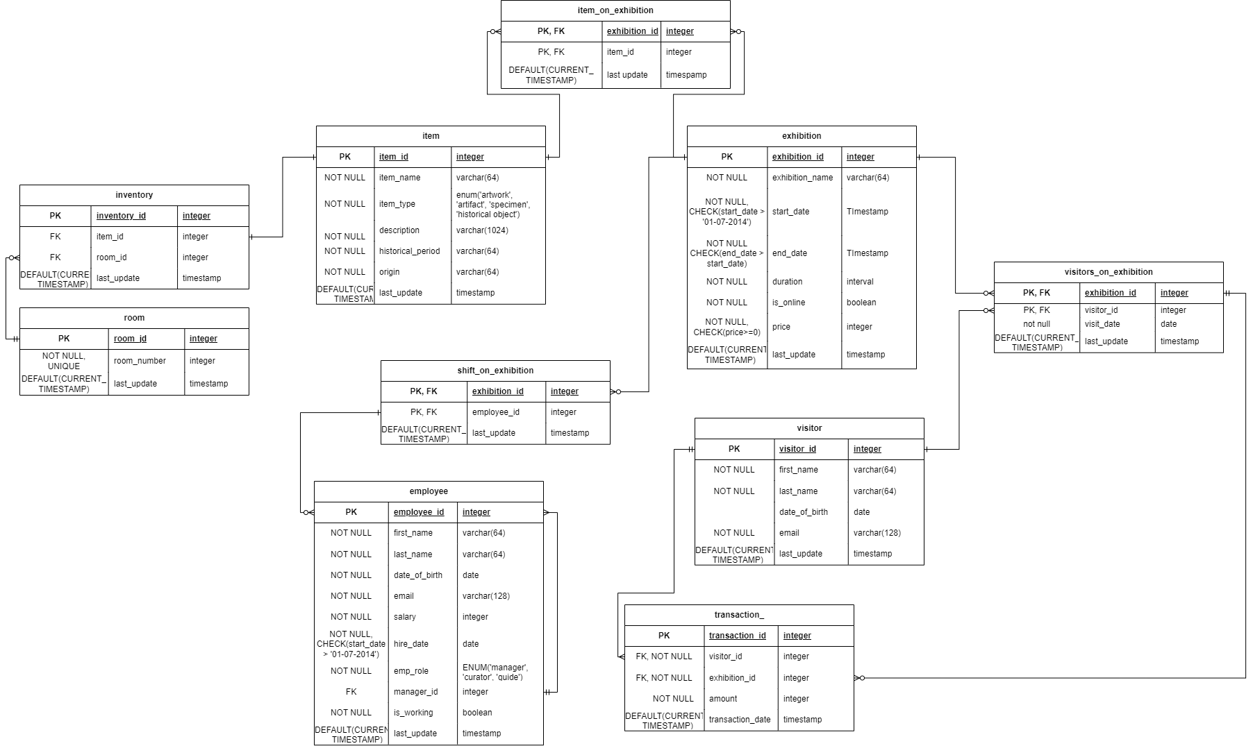

## Objects

1. item

Tracks museum items with attributes like name, type (artwork, artifact, specimen, historical object), description, and historical period.

|  |  |  |  |
| --- | --- | --- | --- |
| Table Name | Field name | Field Description | Data Type |
| item | Item_id | Id of item, PK | Integer |
| Item_name | NOT NULL | Varchar(64) |
|  | Item_type | NOT NULL | Varchar(64) |
|  | description | NOT NULL | Varchar(1024) |
|  | Historical_period | NOT NULL | Varchar(64) |
|  | origin | NOT NULL | Varchar(64) |
|  | Last_update | DEFAULT(CURRENT_TIMESTAMP) | timestamp |

|  |  |  |  |  |  |  |
| --- | --- | --- | --- | --- | --- | --- |
| Item_id | Item_name | Item_type | description | Historical_period | origin | Last_update |
| 1 | mona lisa | artwork | ‘fkjsfk’ | renaissance | florence | (Current_timestamp) |

1. Inventory

Links items to specific rooms in the museum to track their physical location.

|  |  |  |  |
| --- | --- | --- | --- |
| Table Name | Field name | Field Description | Data Type |
| inventory | inventory_id | PK | Integer |
| Item_id | FK | integer |
|  | Room_id | FK | integer |
|  | Last_update | DEFAULT(CURRENT_TIMESTAMP) | timestamp |

|  |  |  |  |
| --- | --- | --- | --- |
| Inventory_id | Item_id | Room_id | Last_update |
| 1 | 1 | 1 | (Current_timestamp) |

1. Room

Represents rooms in the museum where items are stored or displayed.

|  |  |  |  |
| --- | --- | --- | --- |
| Table Name | Field name | Field Description | Data Type |
| room | room_id | PK | Integer |
| Room_number | NOT NULL, UNIQUE | integer |
|  | Last_update | DEFAULT(CURRENT_TIMESTAMP) | timestamp |

|  |  |  |
| --- | --- | --- |
| room_id | Room_number | Last_update |
| 1 | 101 | (Current_timestamp) |

1. Visitor

Stores visitor details like name, email, date of birth, and tracks which exhibitions they attended.

|  |  |  |  |
| --- | --- | --- | --- |
| Table Name | Field name | Field Description | Data Type |
| visitor | visitor_id | PK | Integer |
| First_name | Not null | varchar(64) |
|  | Last_name | Not null | varchar(64) |
|  | Date_of_birth |  | Date |
|  | email | Not null | varchar(128) |
|  | Last_update | DEFAULT(CURRENT_TIMESTAMP) | timestamp |

|  |  |  |  |  |  |
| --- | --- | --- | --- | --- | --- |
| visitor_id | First_name | Last_name | Date_of_birth | email | Last_update |
| 1 | nini | kilasonia | 20-09-2004 | Ninkilasonia@gmail.com | (Current_timestamp) |

1. Exhibition

Manages exhibitions, including name, start and end dates, whether they are online, duration, and price.

Duration is calculated using start and end date

|  |  |  |  |
| --- | --- | --- | --- |
| Table Name | Field name | Field Description | Data Type |
| exhibition | exhibition_id | PK | Integer |
| exhibition_name | Not null | varchar(64) |
|  | Start_date | Not null, CHECK(start_date > '01-07-2014') | timestamp |
|  | End_date | Not null,  CHECK(end_date > start_date) | timestamp |
|  | duration | Not null | interval |
|  | Is_online | Not null | boolean |
|  | price | NOT NULL,  CHECK(price>=0) | tinyint |
|  | Last_update | DEFAULT(CURRENT_TIMESTAMP) | timestamp |

|  |  |  |  |  |  |  |  |
| --- | --- | --- | --- | --- | --- | --- | --- |
| exhibition_id | exhibition_name | Start_date | End_date | duration | Is_online | price | Last_update |
| 1 | asdads | 28-11-2024 00:00:00 | 02-12-2024 00:00:00 | 4 days | false | 100 | (Current_timestamp) |

1. Employee

Captures employee details, roles, salaries, and hierarchical relationships (managers and subordinates).

|  |  |  |  |
| --- | --- | --- | --- |
| Table Name | Field name | Field Description | Data Type |
| employee | employee_id | PK | Integer |
| First_name | Not null | varchar(64) |
|  | Last_name | Not null | varchar(64) |
|  | Date_of_birth | Not null | Date |
|  | email | Not null | varchar(128) |
|  | salary | Not null | integer |
|  | Hire_date | Not null, CHECK(start_date > '01-07-2014') | date |
|  | Emp_role | Not null | ENUM('manager', 'curator', 'guide') |
|  | Manager_id | FK | integer |
|  | Is_working | Not null | boolean |
|  | Last_update | DEFAULT(CURRENT_TIMESTAMP) | timestamp |

|  |  |  |  |  |  |  |  |  |  |  |
| --- | --- | --- | --- | --- | --- | --- | --- | --- | --- | --- |
| employee_id | First_name | Last_name | Date_of_birth | email | salary | Hire_date | Emp_role | Manager_id | Is_working | Last_update |
| 1 | nini | kilasonia | 20-09-2004 | Ninkilasonia@gmail.com | 1200 | 24-03-2024 | manager | null | true | (Current_timestamp) |

1. Items_on_exhibition

Tracks which items are displayed in specific exhibitions.

|  |  |  |  |
| --- | --- | --- | --- |
| Table Name | Field name | Field Description | Data Type |
| Items_on_exhibition | Exhibition_id | PK, FK | Integer |
| Item_id | PK, FK | integer |
|  | Last_update | DEFAULT(CURRENT_TIMESTAMP) | timestamp |

|  |  |  |
| --- | --- | --- |
| Exhibition_id | Item_id | Last_update |
| 1 | 1 | (Current_timestamp) |

1. Shift_on_exhibition

Links employees to exhibitions they are working on.

|  |  |  |  |
| --- | --- | --- | --- |
| Table Name | Field name | Field Description | Data Type |
| shift_on_exhibition | Exhibition_id | PK, FK | Integer |
| employee_id | PK, FK | integer |
|  | Last_update | DEFAULT(CURRENT_TIMESTAMP) | timestamp |

|  |  |  |
| --- | --- | --- |
| Exhibition_id | employee_id | Last_update |
| 1 | 1 | (Current_timestamp) |

1. Visitors_on_exhibitions

Tracks the relationship between visitors and the exhibitions they attended.

|  |  |  |  |
| --- | --- | --- | --- |
| Table Name | Field name | Field Description | Data Type |
| shift_on_exhibition | Exhibition_id | PK, FK | Integer |
| visitor_id | PK, FK | integer |
|  | Last_update | DEFAULT(CURRENT_TIMESTAMP) | timestamp |

|  |  |  |
| --- | --- | --- |
| Exhibition_id | visitor_id | Last_update |
| 1 | 1 | (Current_timestamp) |

1. transaction_

|  |  |  |  |
| --- | --- | --- | --- |
| Table Name | Field name | Field Description | Data Type |
| Transaction_ | transaction_id | PK | Integer |
| Visitor_id | FK, NOT NULL | integer |
|  | Exhibition_id | FK, NOT NULL | INTEGER |
|  | amount | NOT NULL | INTEGER |
|  | Last_update | DEFAULT(CURRENT_TIMESTAMP) | timestamp |

|  |  |  |  |  |
| --- | --- | --- | --- | --- |
| Transaction_id | Exhibition_id | visitor_id | amount | Last_update |
| 1 | 1 | 1 | 10 | (Current_timestamp) |