**CODE OUTPUTS**

Part A Output:

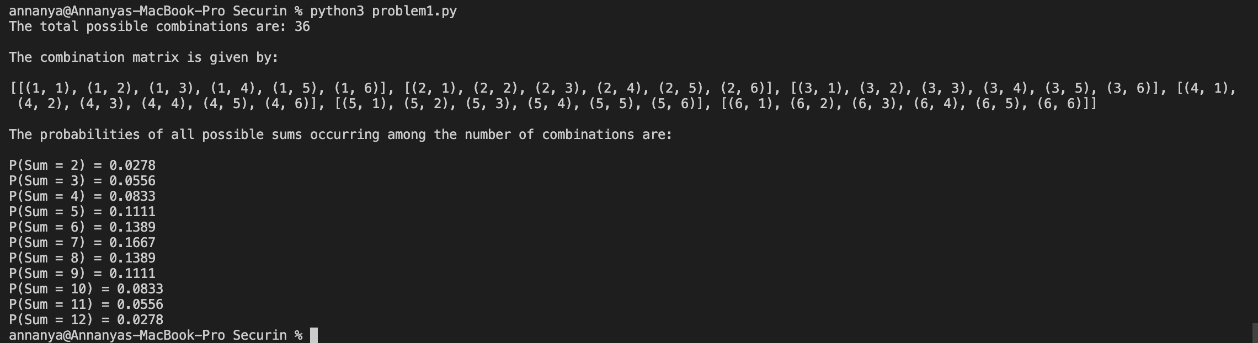

Part B Output:

