Task 1: Data Quality Assessment
Assessment of data quality and completeness in preparation for analysis. The client provided KPMG with 3 datasets:
- Customer Demographic
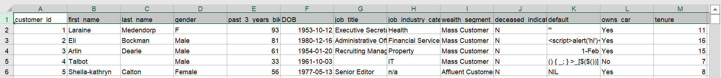
- Customer Addresses
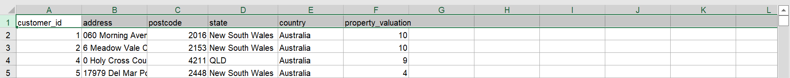
- Transactions data in the past 3 months
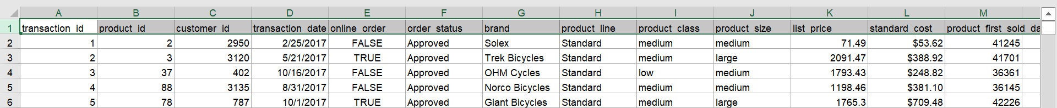

The task was to draft an email to the client identifying the data quality issues and strategies to mitigate the issues. Below are the main points of the letter:
- In the table Transactions:
- Missing Data: There are blank spaces at the following columns: online_order, order_status, brand, product_line, product_class, product_size, standart_cost and product_first_sold_date.
When not possible to rescue the missing data, these will be deleted. They represent less than 1% of the data and will not affect the results of our training model.
- Inconsistency issues: The data was cleaned
transaction_date is a object not a date
standard_cost is a object not a float (number)
product_first_sold_date is a float (number) not a date
- In the table CustomerDemographic:
- There are blank spaces at the following columns: last_name, DOB, job_industry_category, job_title and tenure. If possible, rescue the values.
-Validity issues: DOB is an object not a date. The data was cleaned.
-Gender column has different values for Male and Female (M, U, Femal…). The data will be cleaned. We recommend applying a single character option (‘F’, ‘M’, ‘U’ for others) or a drop-down list.
- The Default column was excluded, because it does not have any important value.
- In the table CustomerAdress:
- Standardize the name of the states in the column state: VIC or Victoria, NSW or New South Wales. The data will be cleaned to avoid multiple representations of the same value. We recommend an input message with the rule or a drop-down list with ‘Other’ to states out of Australia.

