**Task 1 - Accounting**

Business need:

The accounting department at Galactic Delivery Services would like to get a report that shows Customer contact information for all invoices paid during a given period. The report should only display invoices in the amount of over $300.00. Sort the data by the name of the customer.

Solution:

Solution Explorer

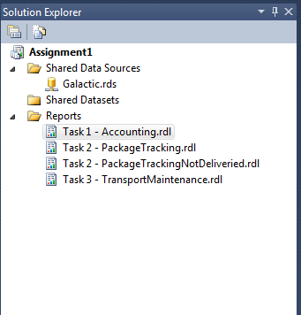

Report Data

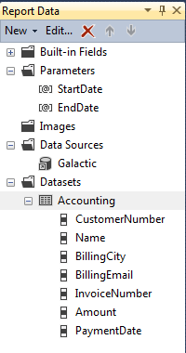

Query Designer

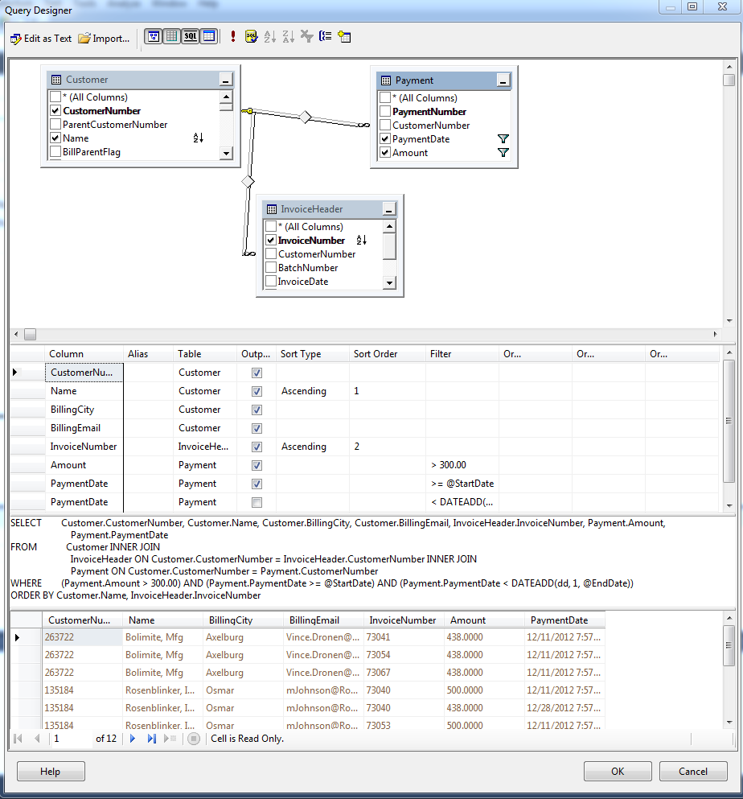

Query

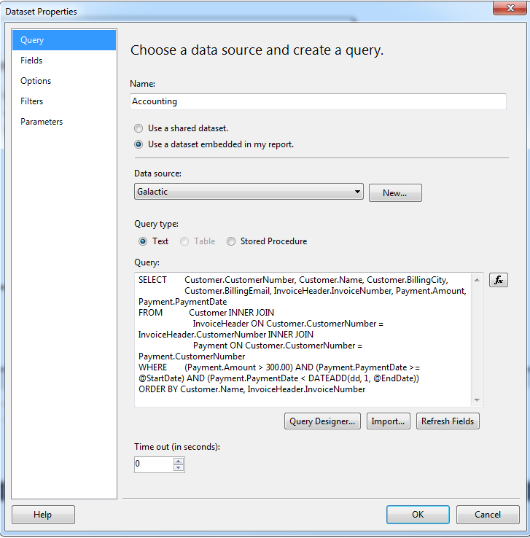

Design Surface

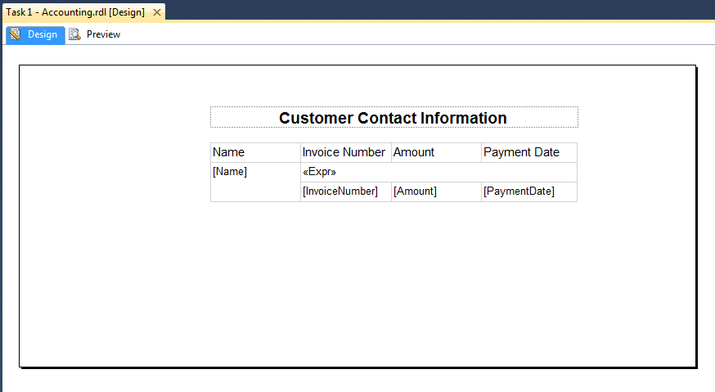

Group Pane

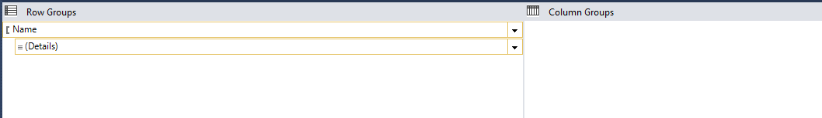

Preview

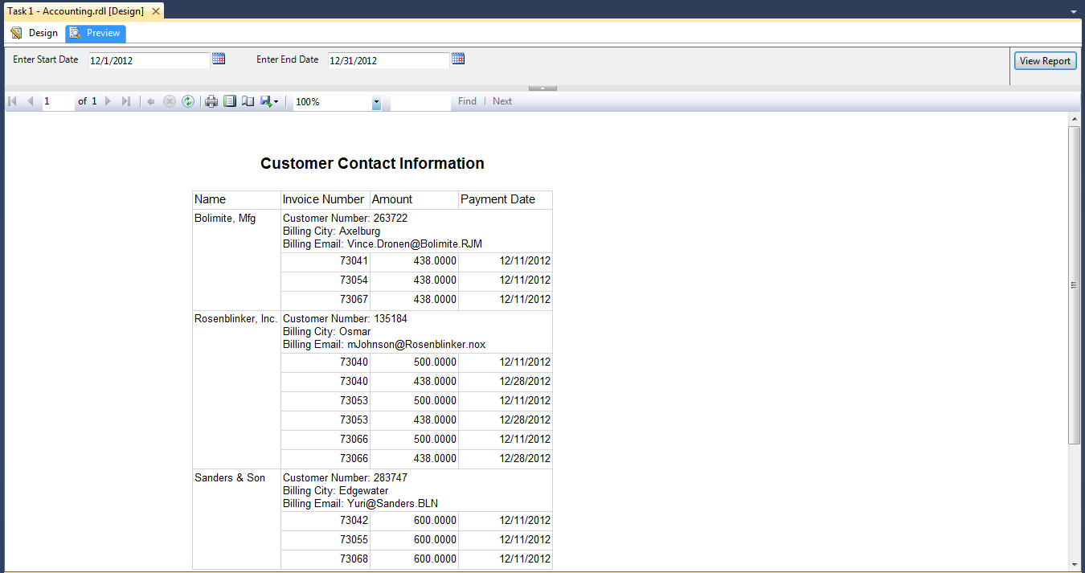

**Task 2 - PackageTracking**

Business need:

Management would like to see a report prepared from you that shows information about the following categories of deliveries:

* Packages that have been delivered one day after the pickup (less than 24hours)
* Packages that have been delivered on the same day as the day of pickup
* Packages that have been delivered one day before the pickup (within 24 hours)

This report should provide capabilities to show more detailed information for the managers if they want to see it.

Solution:

Solution Explorer

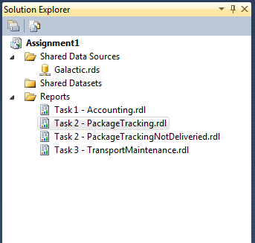

Report Data

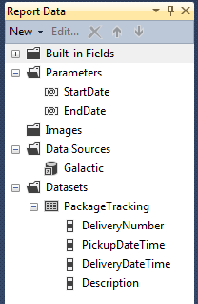

Query Designer

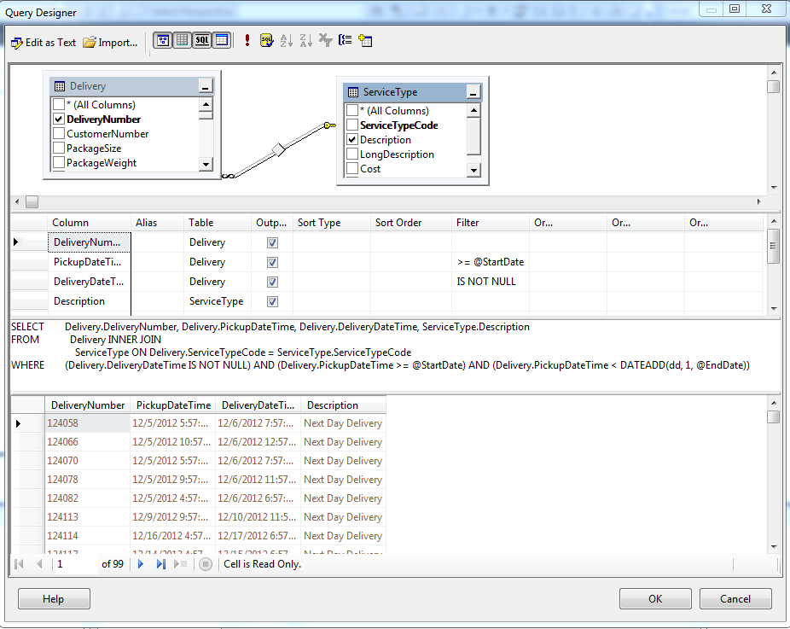

Query

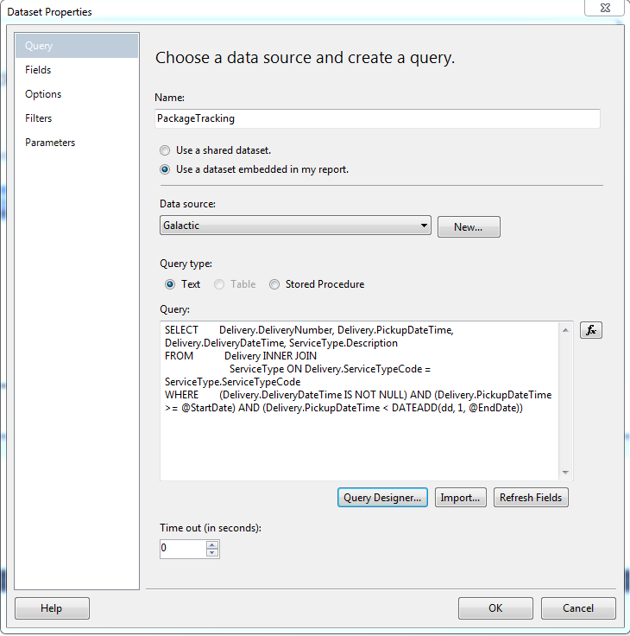

Design Surface

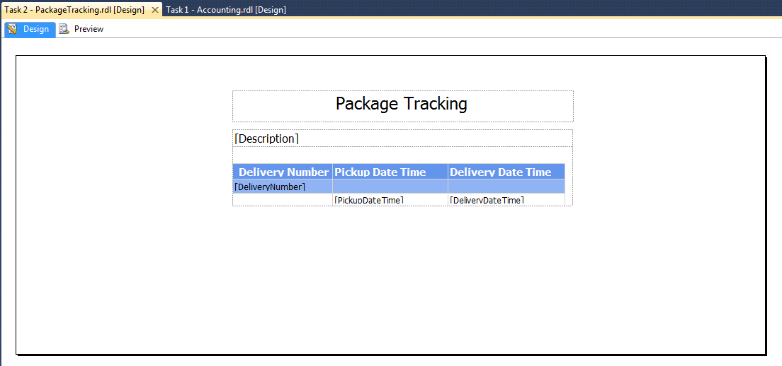

Group Pane

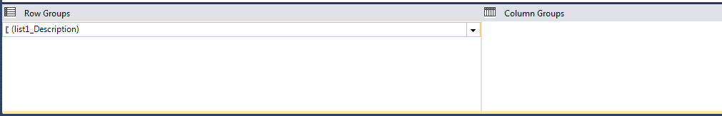

Preview

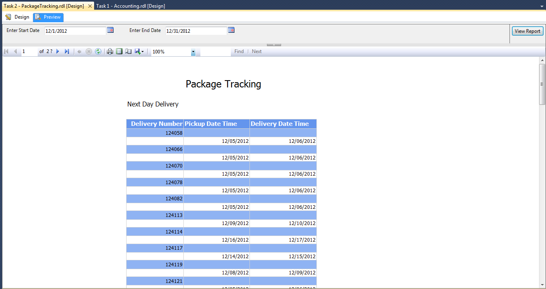

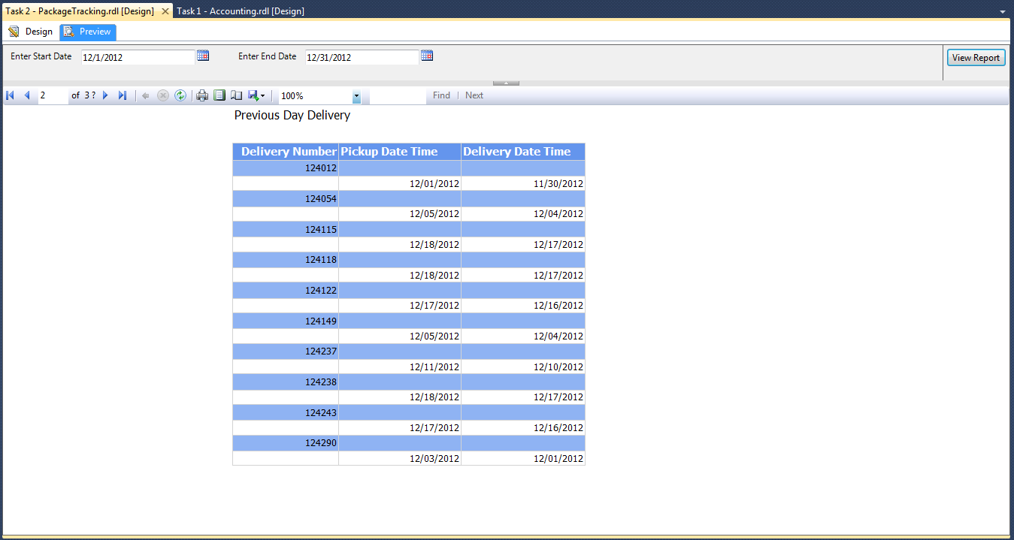

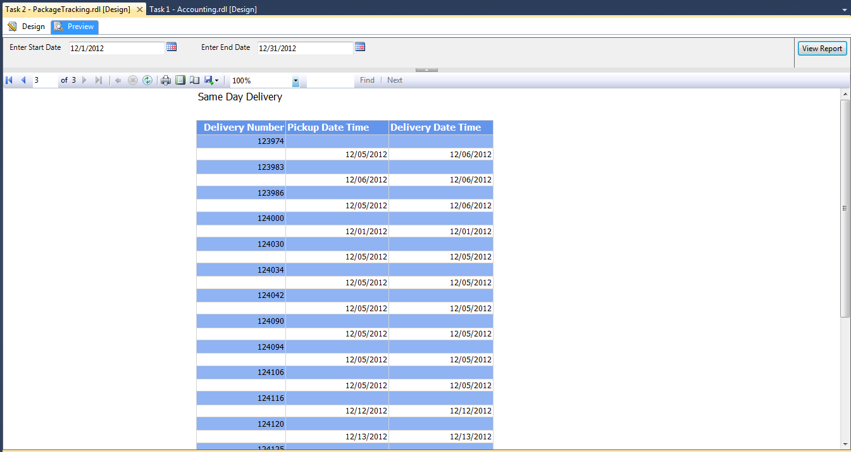

**Task 2 - PackageTrackingNotDeliveried**

Business need:

Management would like to see a report prepared from you that shows information about the following categories of deliveries:

* Packages that have been picked up for delivery but not delivered yet

This report should provide capabilities to show more detailed information for the managers if they want to see it.

Solution:

Solution Explorer

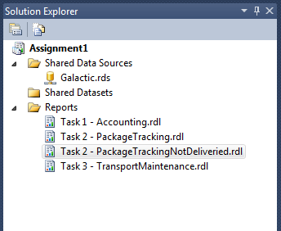

Report Data

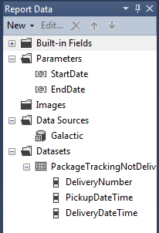

Query Designer

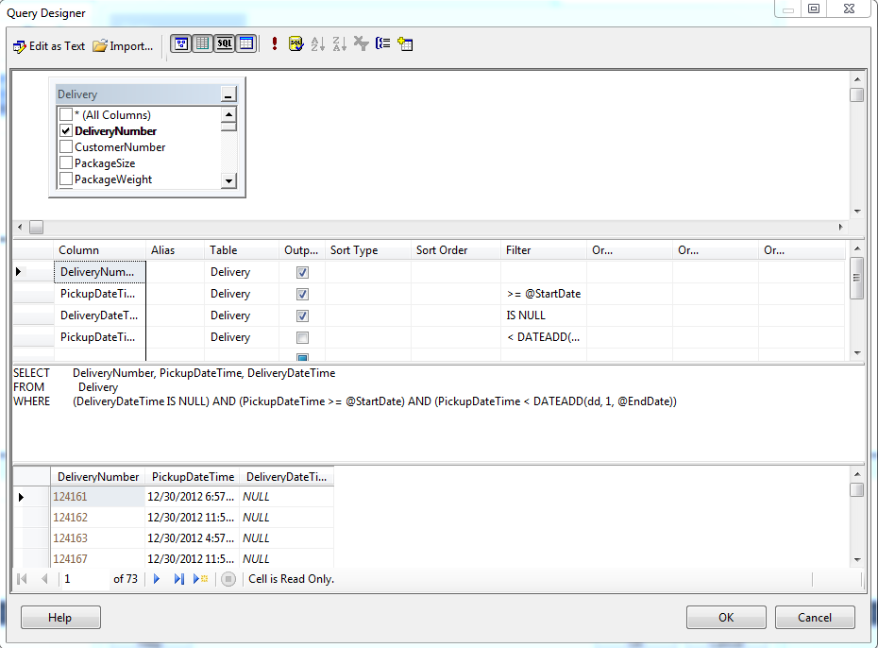

Query

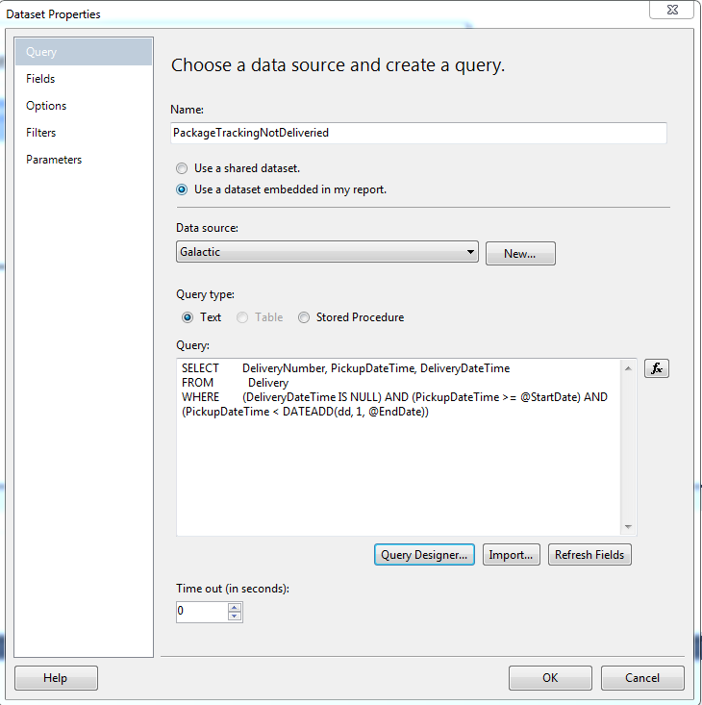

Design Surface

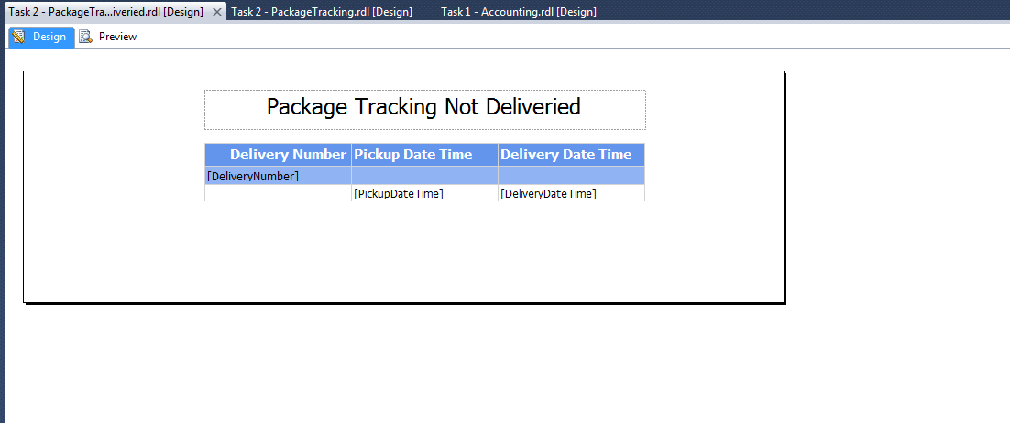

Group Pane

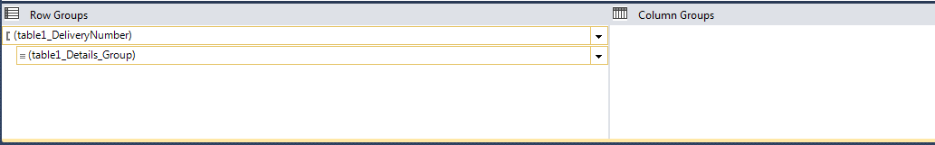

Preview

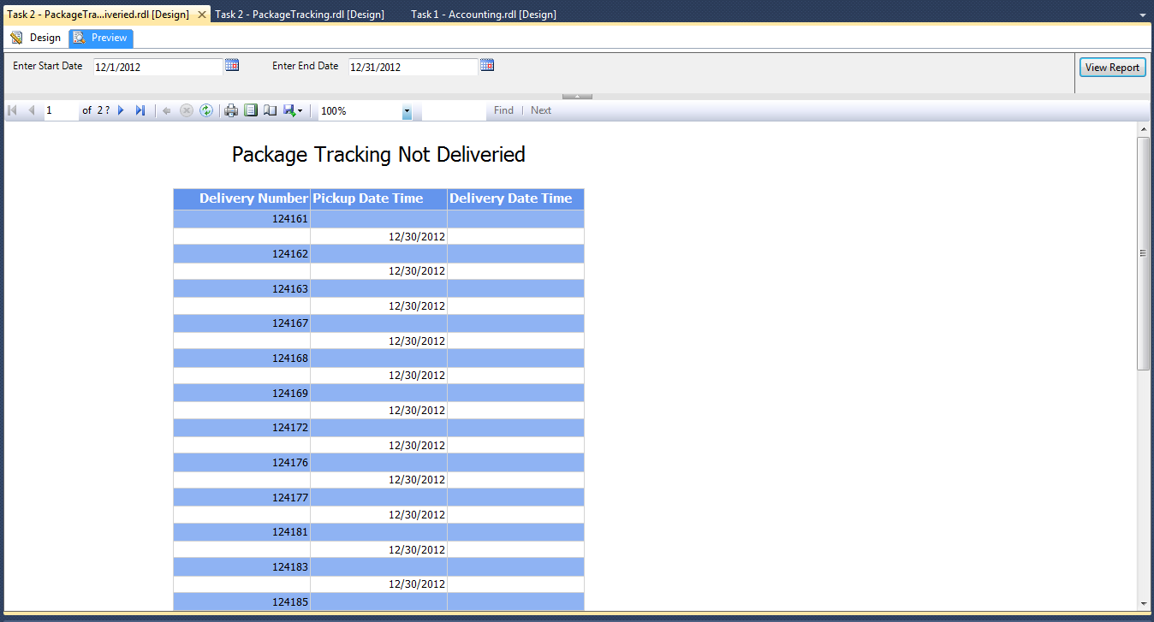

**Task 3 - TransportMaintenance**

Business need:

Management at GDS wants to see a detailed report outlining all the maintenance done to any Transport (by transport number and description). The report should group separately the scheduled maintenance work performed, and repair done because of malfunction of the transport. The report should show the cause of repair as well as the work done.

Solution:

Solution Explorer

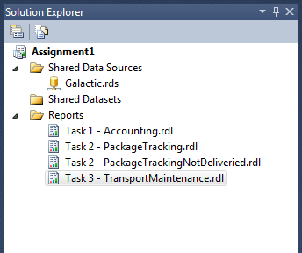

Report Data

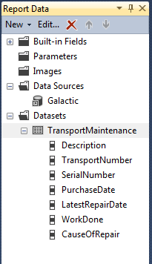

Query Designer

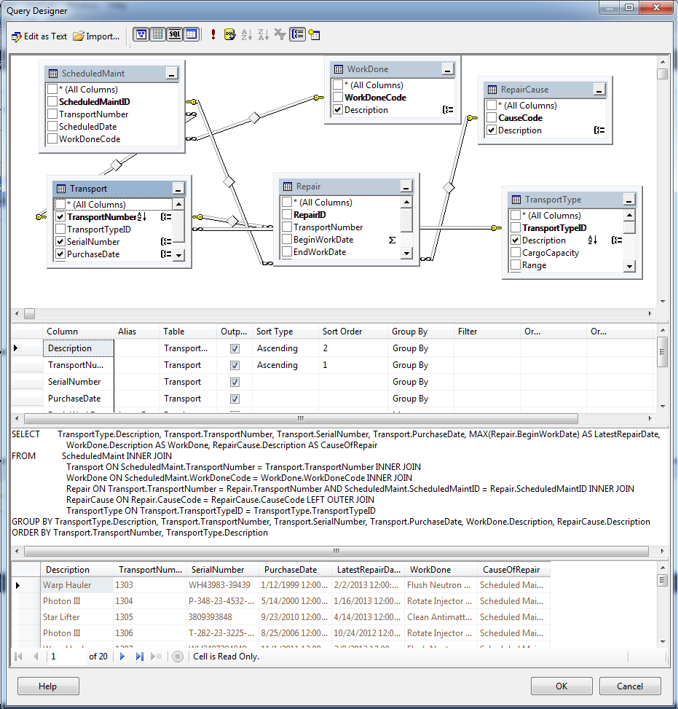

Query

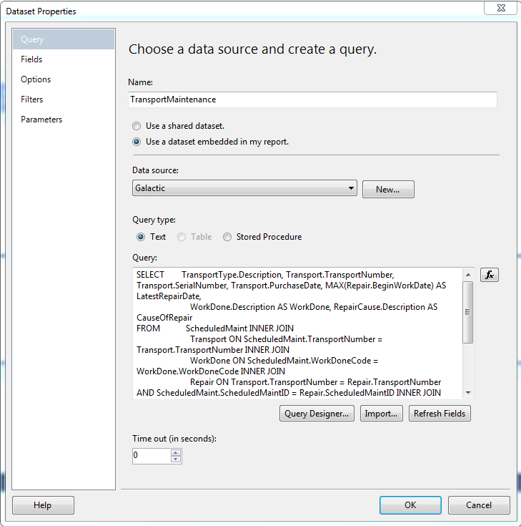

Design Surface

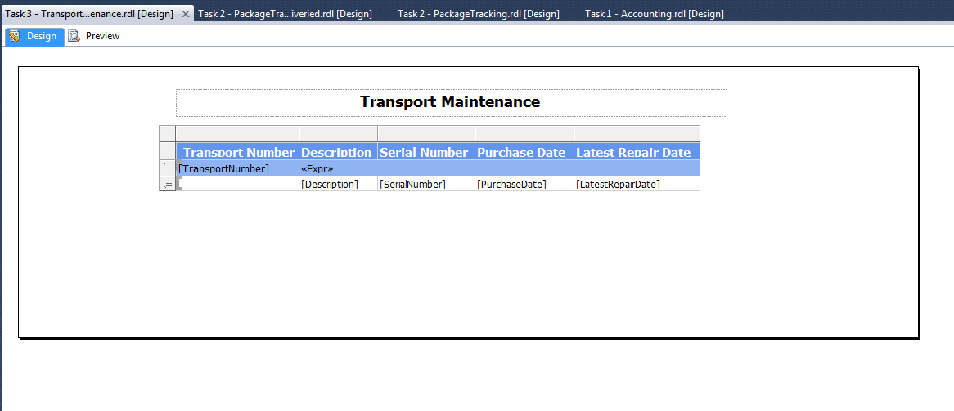

Group Pane

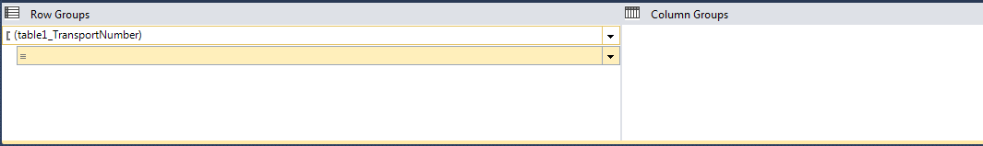

Preview

