Anna

Natallia Isayenka 100744884, ANNA POLUEKTOVA 100786356

System Design

Assignment 1

Nardin cOMPANY as a healthcare provider

**Table of content**

1.Case Study Summary of Nardin Company………………………………..……………………pg.2

2. Use-Cases……………………………………………………………………………….……………………pg.3

3. System Sequence Diagram………………………………….………………………………………...pg.4

3.1. Add Patient to waiting list SSD…………………..……………………………………pg.4

3.2. Create Prescription SSD………………………….……………………………………...pg.5

3.3. Create Specialist Appointment………………….…………………………………….pg.6

4.Three Layered Sequence Diagram………………………….…………………………………….pg.7

4.1. Add Patient to waiting list……………………….……………………………………..pg.7

4.2. Create Prescription ……………………………….………………………………………pg.8

4.3. Create Specialist Appointment…………………….………………………………….pg.9

5. Class diagram………………………………………………………..…………………………………...pg.10

…………5.1. Main Class Diagram…………………………...……...…………………………………...pg10

…………5.2. Add Patient to waiting list Class Diagram…………………….…………………pg.11

5.3. Create Prescription Class Diagram……………………………..………………….pg.12

5.4. Create Specialist Appointment Class Diagram…………..……..……………..pg.13

6. Method Contract…………………………………………………….…………………………………….p.14

7. Method Specification………………………………………………………………………………p.15-17

1. **Case Study Summary of Nardin Company**

Nardin Company expands its capabilities as a healthcare provider and establishes number of walk-in clinics in the area. Currently, walk-in clinic personnel use paper-based medical records and paper-based billing submission. They need solid cost effective solution for small and medium size health clinic and their major Electronic Health Record (EHR) System too expensive to be implemented. The system must provide a number of capabilities that Hospital EHR provides as well as integrated communication and billing modules.

The walk-in clinic Electronic Medical Record (EMR) system must contain health care information with full billing capabilities, chronic disease management tools, prescription module, scheduling and many other features. It can run locally in an office setting or be accessed over the Internet. The system must be a comprehensive Clinical Management system with high levels of security, flexible, intuitive to use and cost effective.

Key features of the walk-in clinic Electronic Medical Record (EMR) system must include:

* Add patient to waiting list
* Create Prescription module with drug-drug interaction, allergy alerts, prescription favorites, renal dosage adjustments
* Create Specialist Appointment

The walk-in clinic Electronic Medical Record (EMR) System must increase productivity, decrease billing errors and overall gain more profit. The walk-in clinic staff typically including medical doctors, nurses and receptionists will need to adapt to this new technology and slightly adjust their current internal processes where switching to the paperless but the system will pay for itself within first five to six months of implementation.

The project will include the design, testing, and ready to use walk-in clinic Electronic Medical Record (EMR) System. The project team will manage all personnel, hardware, and software resources. All project work will be independent of daily and ongoing operations and all required testing would be done in the project team. Project manager will manage project funding up to and including the allocated amounts identified in the project chart document. Any additional funding requires approval from the project sponsor.

The project deliverables must include:

* Robust multi-tired fully deployed, implemented and ready for production use walk-in clinic Electronic Medical Record (EMR) System;
* Technical documentation including user guidelines, configuration and deployment guide, and user training materials;

**2. Use-Cases**

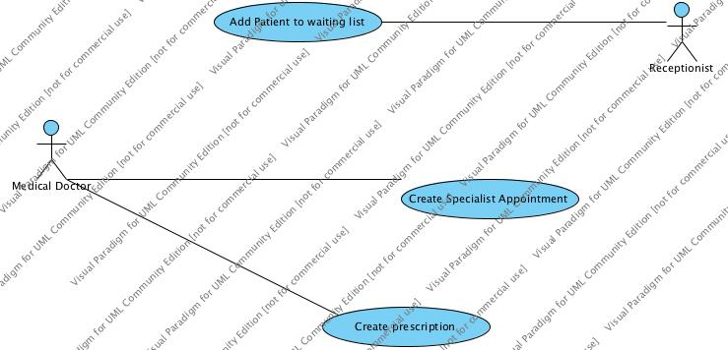

**3. System Sequence Diagram**

3.1. Add Patient to waiting list SSD

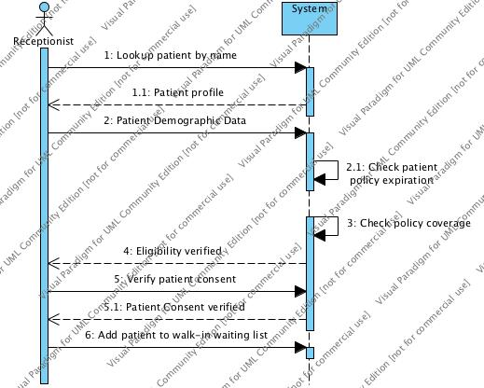

3.2. Create Prescription SSD

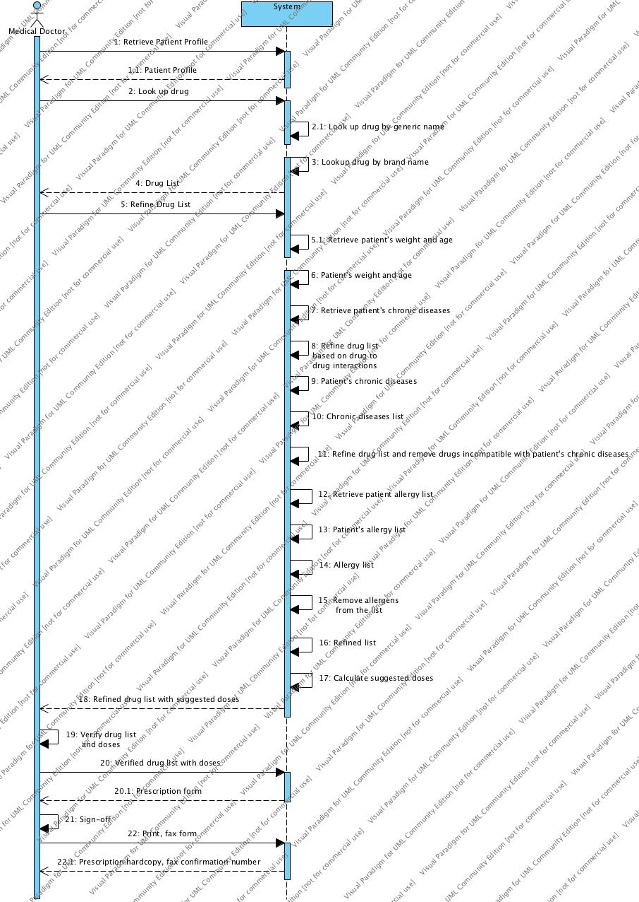

3.3. Create Specialist Appointment SSD

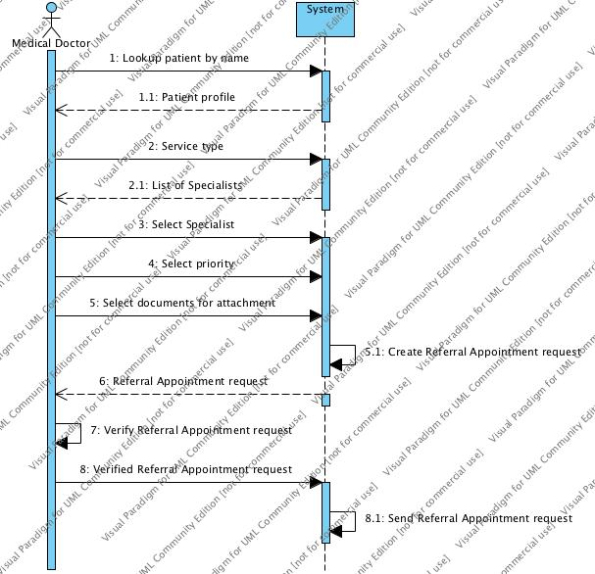

1. **Three Layered Sequence Diagram**
   1. Add Patient To Waiting List

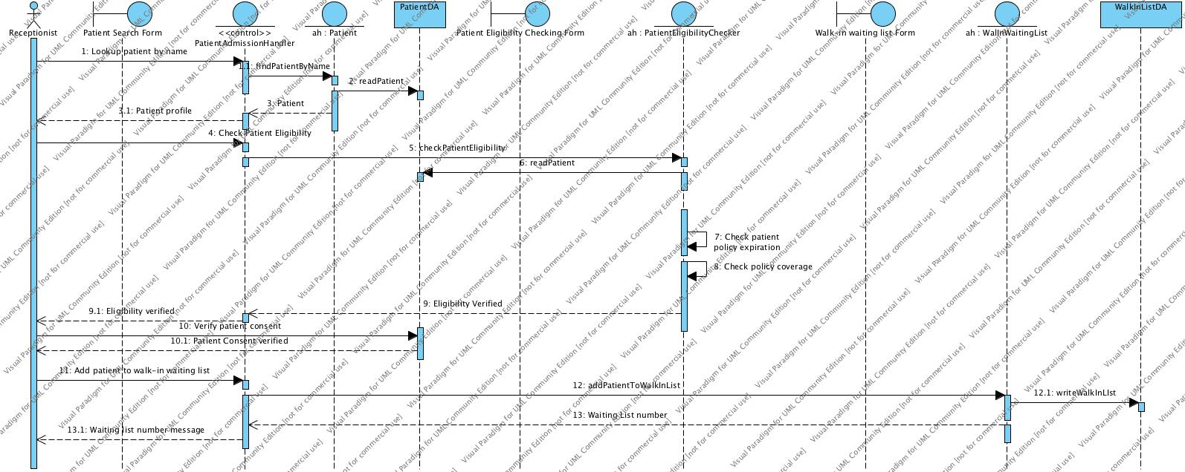

4.2. Create Prescription

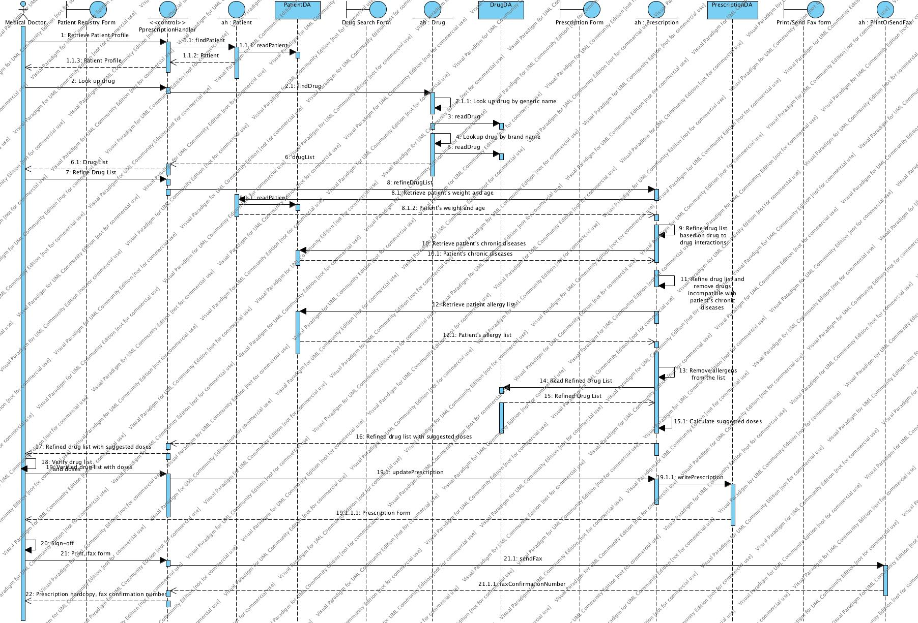

4.3. Create Specialist Appointment

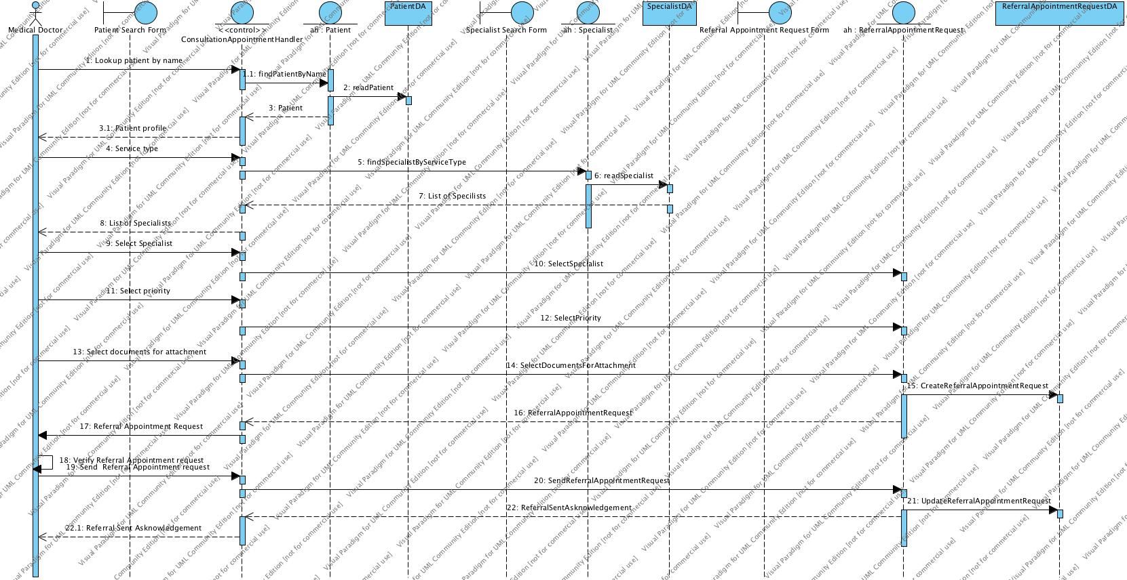

1. **Class Diagram**

5.1. Main Class Diagram

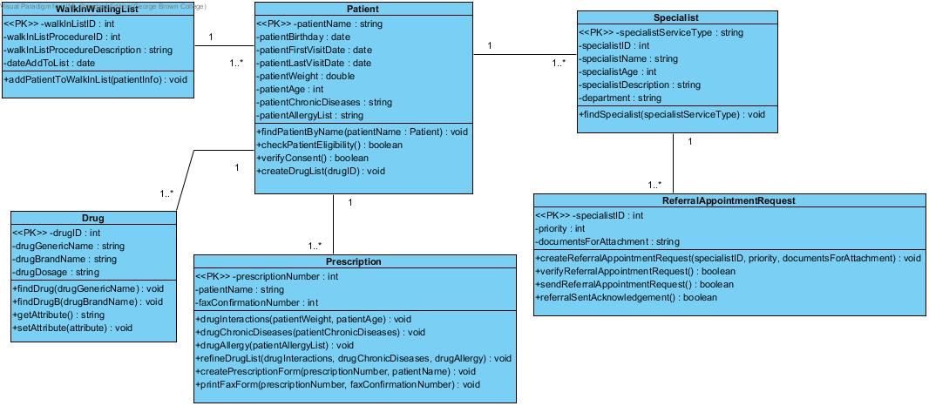

5.2. Add Patient to Waiting List Class Diagram

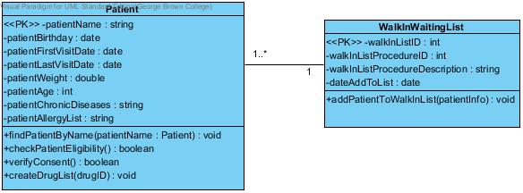

5.3. Create Prescription Class Diagram

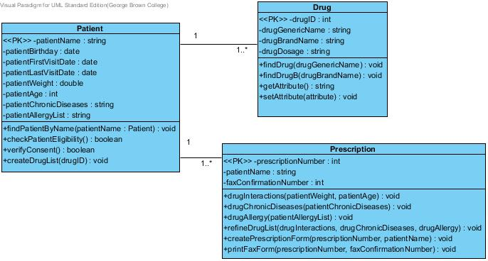

* 1. Create Specialist Appointment Class Diagram

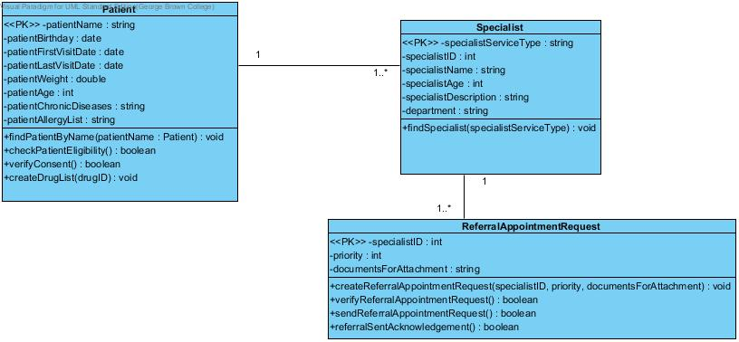

1. **Method Contract**

|  |  |  |
| --- | --- | --- |
| **Method Name:** findPatientByName | **Class Name:** Patient | **ID:** 10 |
| **Clients(consumers):** Patient | | |
| **Associated Use Cases:** Patient Admission Use Case | | |
| **Description of Responsibilities:** Look up patient by name to retrieve/update patient profile | | |
| **Arguments Received:** patientName: Patient | | |
| **Type of Value Returned:** void | | |
| **Pre-Conditions:** None | | |
| **Post-Conditions:** None | | |

|  |  |  |
| --- | --- | --- |
| **Method Name:** drugInteraction | **Class Name:** Prescription | **ID:** 62 |
| **Clients(consumers):** Patient | | |
| **Associated Use Cases:** Prescription Use Case | | |
| **Description of Responsibilities:** Refine drug list based on drug to drug interaction | | |
| **Arguments Received:** patientWeight: Patient, patientAge: Patient | | |
| **Type of Value Returned:** void | | |
| **Pre-Conditions:** None | | |
| **Post-Conditions:** None | | |

|  |  |  |
| --- | --- | --- |
| **Method Name:** createReferralAppointmentRequest | **Class Name:** ReferralAppointmentRequest | **ID:** 55 |
| **Clients(consumers):** Specialist, ReferralAppointmentRequest | | |
| **Associated Use Cases:** Requesting Consultation Appointment Use Case | | |
| **Description of Responsibilities:** Creation referral appointment request | | |
| **Arguments Received:** specialistID: Specialist, priority: ReferralAppointmentRequest,  documentsForAttachment: ReferralAppointmentRequest | | |
| **Type of Value Returned:** void | | |
| **Pre-Conditions:** None | | |
| **Post-Conditions:** None | | |

1. **Method Specifications**

|  |  |  |  |
| --- | --- | --- | --- |
| **Method Name:** findPatientByName | **Class Name:** Patient | | **ID:** 10 |
| **Contract ID:** 121 | **Programmer:** J. Doe | | **Date Due:** 1/4/14 |
| **Programming Language:**  **Visual Basic SmallTalk C++ Java** | | | |
| **Triggers/Events:** Receptionist is looking up for a patient | | | |
| **Arguments Received:**  **Data Type:** | | **Notes:** | |
| patientName | | Find a patient. | |
|  | |  | |
| **Messages Sent & Arguments Passed:**  **ClassName.MethodName:** | | **Data Type:** | **Notes:** |
| patientName.getPatientInfo() | | Patient |  |
|  | |  |  |
| **Arguments Returned:**  **Data Type:** | | **Notes:** | |
| void | |  | |
| **Misc. Notes:** None | | | |

|  |  |  |  |
| --- | --- | --- | --- |
| **Method Name:** drugInteraction | **Class Name:** Prescription | | **ID:** 62 |
| **Contract ID:** 122 | **Programmer:** J. Doe | | **Date Due:** 1/4/14 |
| **Programming Language:**  **Visual Basic SmallTalk C++ Java** | | | |
| **Triggers/Events:** Medical doctor is refining a drug list based on drug to drug interaction | | | |
| **Arguments Received:**  **Data Type:** | | **Notes:** | |
| patientWeight | | Retrieve patient weight. | |
| patientAge | | Retrieve patient age. | |
| **Messages Sent & Arguments Passed:**  **ClassName.MethodName:** | | **Data Type:** | **Notes:** |
| patientWeight.getPatientWeightInfo() | | Patient |  |
| patientWeight.getPatientAgeInfo() | | Patient |  |
| drugInteractions.refineDrugList() | | Prescription |  |
| **Arguments Returned:**  **Data Type:** | | **Notes:** | |
| void | |  | |
| **Misc. Notes:** None | | | |

|  |  |  |  |
| --- | --- | --- | --- |
| **Method Name:** createReferralAppointmentRequest | | **Class Name:** ReferralAppointmentRequest | **ID:** 55 |
| **Contract ID:** 123 | | **Programmer:** J. Doe | **Date Due:** 1/4/14 |
| **Programming Language:**  **Visual Basic SmallTalk C++ Java** | | | |
| **Triggers/Events:** Specialist creates a referral appointment request | | | |
| **Arguments Received:**  **Data Type:** | **Notes:** | | |
| specialistID | Retrieve specialist information (ID). | | |
| priority | Select priority. | | |
| documentsForAttachment | Select documents for attachment. | | |
| **Messages Sent & Arguments Passed:**  **ClassName.MethodName:** | **Data Type:** | | **Notes:** |
| specialistID.findSpecialistBySpecialistID() | Specialist | |  |
| priority.selectPriority() | ReferralAppointmentRequest | |  |
| documentsForAttachment.selectDocumentsForAttachment() | ReferralAppointmentRequest | |  |
| **Arguments Returned:**  **Data Type:** | **Notes:** | | |
| void |  | | |
| **Misc. Notes:** None | | | |