Anna

Natallia Isayenka 100744884, ANNA POLUEKTOVA 100786356

System Design

Assignment 2

Nardin cOMPANY as a healthcare provider

**Table of content**

1. ER Diagram………………………………..…………………………………………………………...……pg.2

2. Data Access Speed Optimization strategies…...………………………….……………………pg.3

3. Use Scenarios…………………………………………………….………………………………………...pg.4

3.1. Add Patient to waiting list…….…………………..……………………………………pg.4

3.2. Create Prescription……..………………………….……………………………………...pg.5

3.3. Create Specialist Appointment………………….…………………………………….pg.6

4.Windows Navigation Diagram…….………………………….…………………………………….pg.7

5. Interface Design Prototype…...………………………………..……………………………………..pg.8

5.1. Add Patient to waiting list…………………….…...……………….…………….......…pg.8

5.2. Create Prescription…………………….……………………………..………………….pg.10

5.3. Create Specialist Appointment…………………….…………..……..……………..pg.13

6. Deployment Diagram of (Low Level) Network Model…………………………………….p.16

7. Deployment Diagram of layers………………………………………………………………...……p.17

1. **ER Diagram**

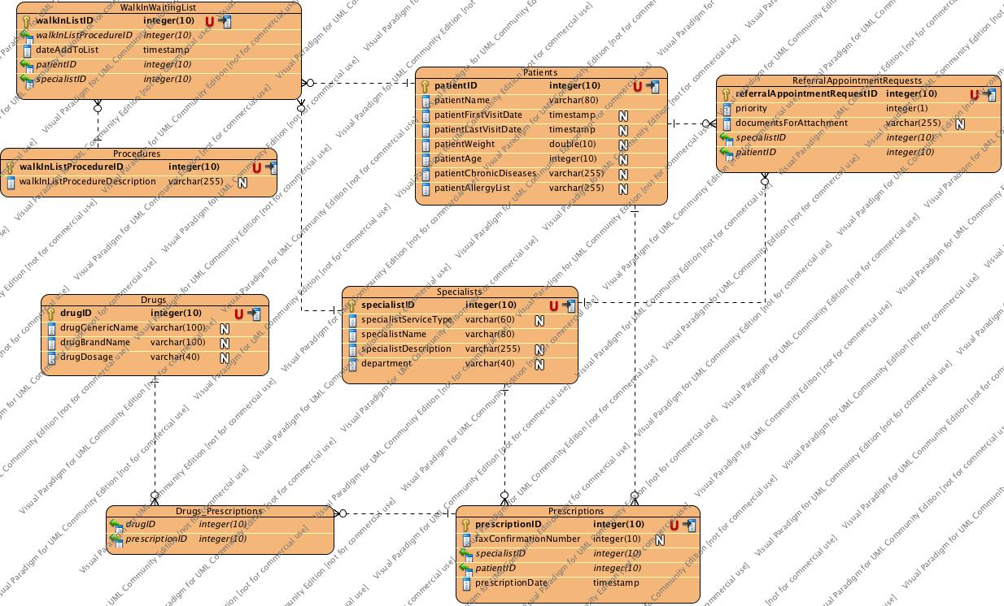

1. **Data Access Speed Optimization strategies**

|  |  |  |
| --- | --- | --- |
| Target | Comments | Suggestions to Improve Data Access Speed |
| All tables | Basic table manipulation | * Investigate if records should be clustered physically by primary key * Create indexes for primary keys * Create indexes for foreign keys |
| All tables | Sorts and Grouping | * Create indexes for fields that are frequently sorted or grouped |
| Drugs | User will need to search drugs information by generic drug name and brand name | * Create indexes for generic drug name and brand name |
| Patients | User will need to search patients by name, visit dates and age | * Create indexes for patient name, date of first visit, date of last visit and patient age |
| Specialists | User will need to search specialist by service type and name | * Create indexes for specialist service type and specialist name |
| Entire Physical Model | Investigate denormalization opportunities for all fields that are not updated very often | * Investigate one to one relationships * Investigate look-up tables * Investigate one-to-many relationships |

1. **Use Scenarios**
   1. Add Patient to waiting list

|  |
| --- |
| Use scenario: Existing Patient Requests refill |
| 1. Patient requests refill of prescribed medication. 2. Doctor looks up the patient profile and retrieves previously prescribed medications. 3. Doctor verifies is there any changes in patient condition that may affect medication dosage such as allergy list, body weight, age, chronic diseases, pregnancy and so forth. 4. Doctor updates patient profile if necessary 5. Doctor prescribes medication with dosage based on adjusted patient information. 6. Doctor prints prescription and gives to the patient or sends fax directly to preferred pharmacy. |

|  |
| --- |
| +Use scenario: Existing patient requests refill of discontinued medication |
| 1. Patient requests refill of prescribed medication that is currently sold out or discontinued. 2. Doctor looks up the patient profile and retrieves previously prescribed medications. 3. Doctor verifies is there any changes in patient condition that may affect medication dosage such as allergy list, body weight, age, chronic diseases, pregnancy and so forth. 4. Doctor updates patient profile if necessary. 5. Doctor searches medication by generic name and retrieves the list of similar drugs. 6. Doctor picks one of currently available analog and prescribes this medication with dosage based on adjusted patient information. 7. Doctor prints prescription and gives to the patient or sends fax directly to preferred pharmacy. |

* 1. Create Prescription

|  |
| --- |
| Use scenario: Existing Patient Makes New Appointment |
| 1. Patient requests appointment and gives the receptionist his name, address and insurance information. 2. Receptionist looks up patient and verifies if patient changes any information. 3. Receptionist verifies insurance information and clarifies paying options with patient. 4. Receptionists asks patient about preferable dates and times 5. Receptionists look up specialists   with required specialty and match the potential appointment times with available times and schedule appointment.   1. The receptionist informs patient of his appointment date and time. |

|  |
| --- |
| Use scenario: Existing Patient Reschedule Appointment |
| 1. Patient requests appointment and gives the receptionist his name, address and insurance information. 2. Receptionist looks up patient and verifies if patient changes any information. 3. Receptionists asks patient about preferable dates and times for new appointment. 4. Receptionists asks patient about date of existing appointment to be rescheduled. 5. Receptionist finds and reschedules appointment. 6. The receptionist informs patient of his new appointment date and time. |

* 1. Create Specialist Appointment

|  |
| --- |
| Use scenario: Existing Patient Discharges From Waiting List By Request |
| 1. Patient decides to leave walk-in clinic and requests to remove him from waiting list. He gives the receptionist his name, address and insurance information. 2. Receptionist looks up patient and verifies if patient changes any information. 3. Receptionist finds waiting list record and deletes it. 4. The receptionist informs patient that his waiting list record has been deleted. |

|  |
| --- |
| Use scenario: Awaiting Patient Reports Adverse Event |
| 1. Patient reports serious adverse event such as vomiting or acute headache 2. He gives the receptionist his name, address. 3. Receptionist looks up patient and verifies if patient changes any information. 4. Receptionist finds waiting list record and moves that on the top. 5. The receptionist informs patient that he will visit next available doctor. |

1. **Windows Navigation Diagram**

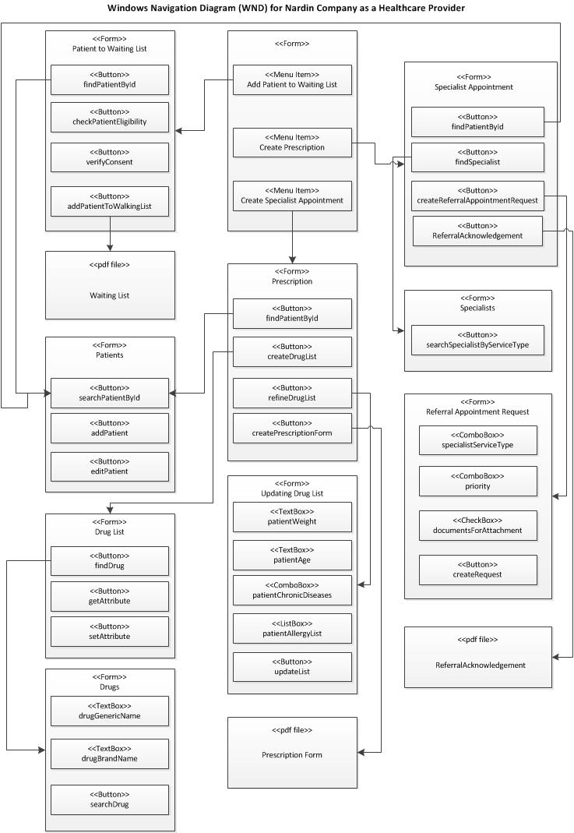

1. **Interface Design Prototype**

5.1 Add Patient to Waiting List

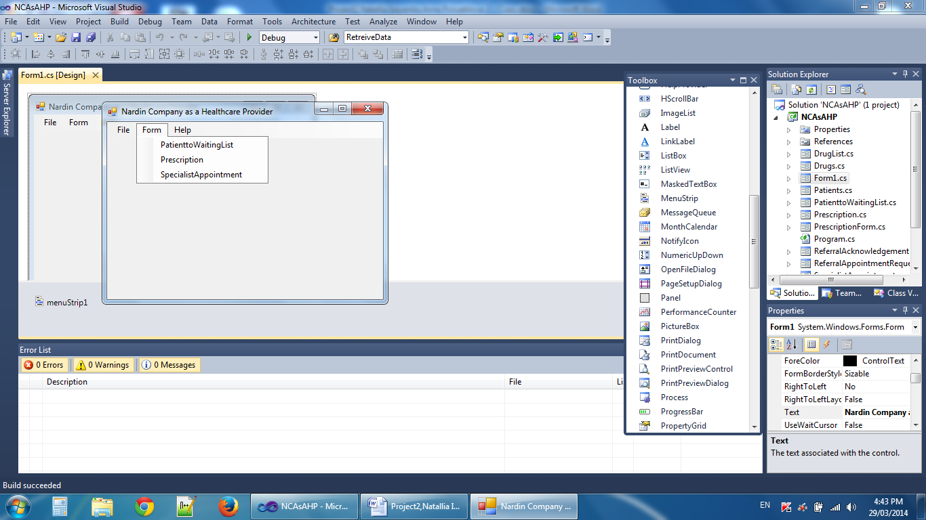

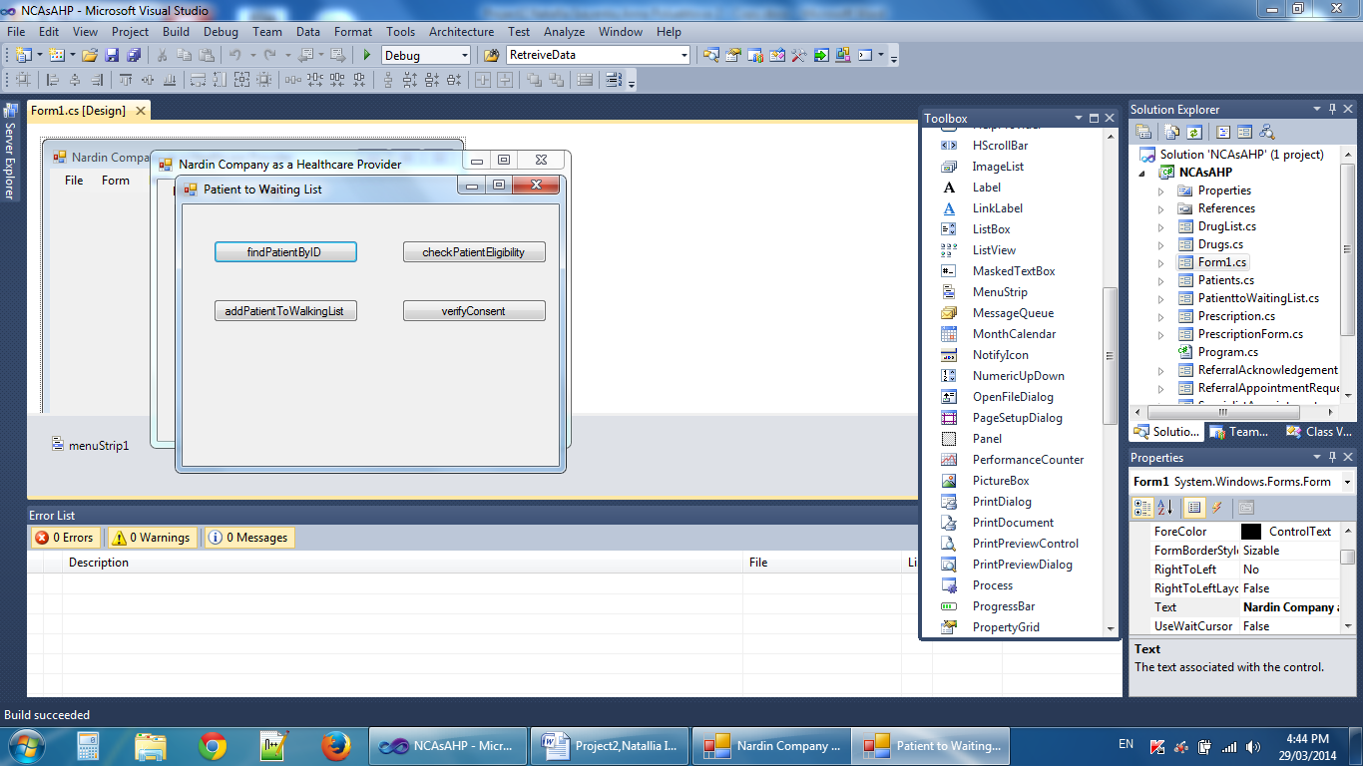

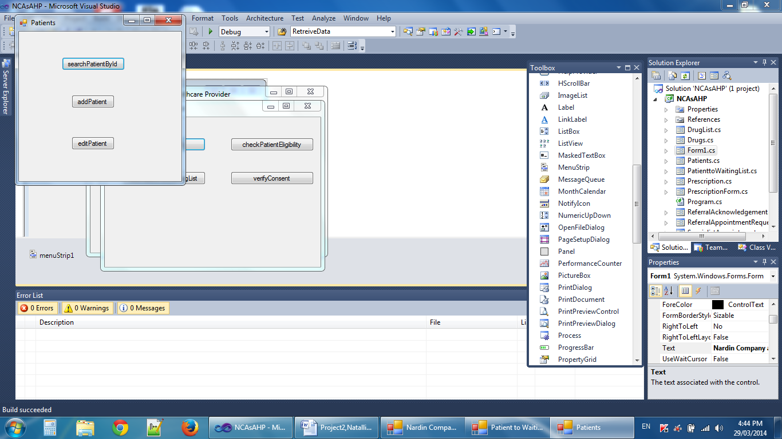

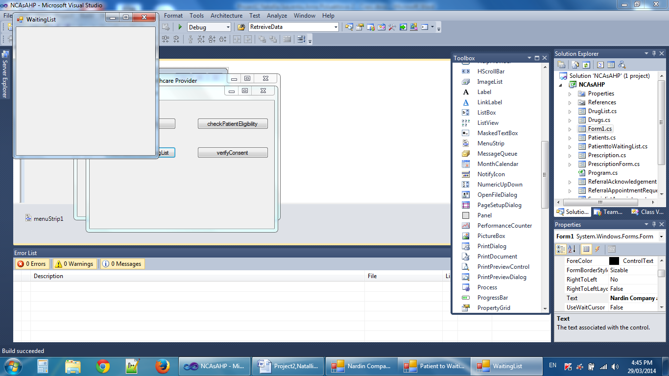

5.2 Create Prescription

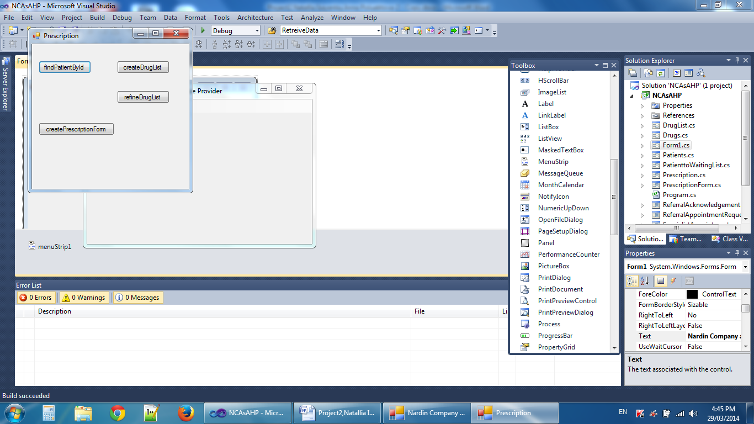

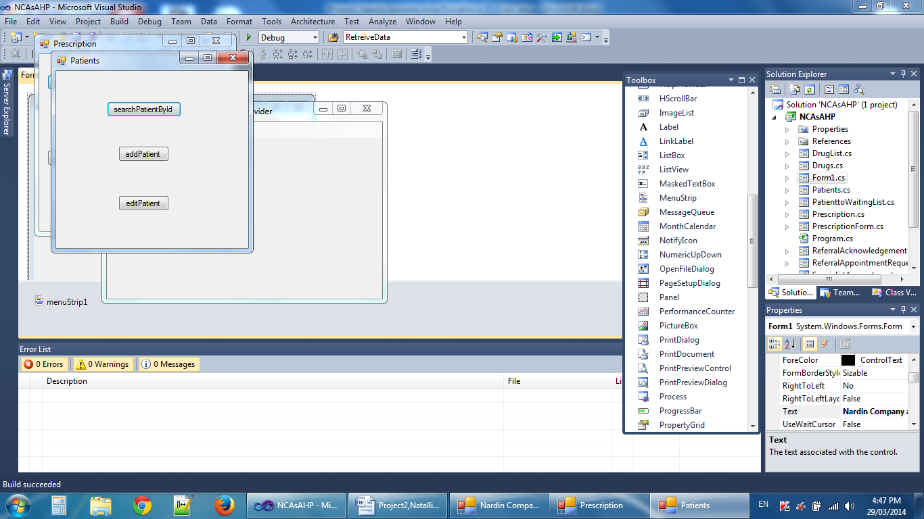

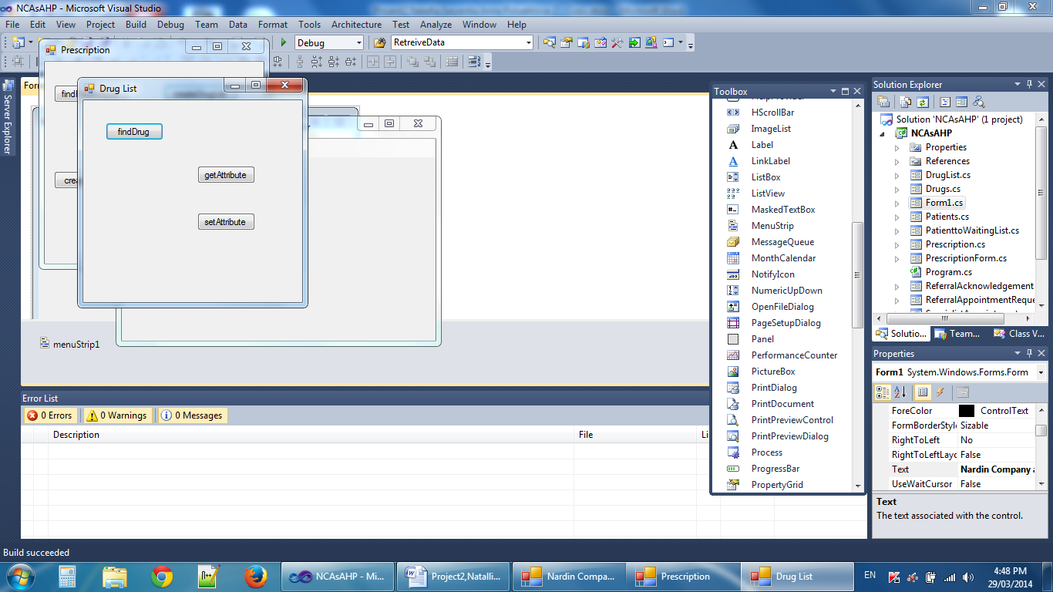 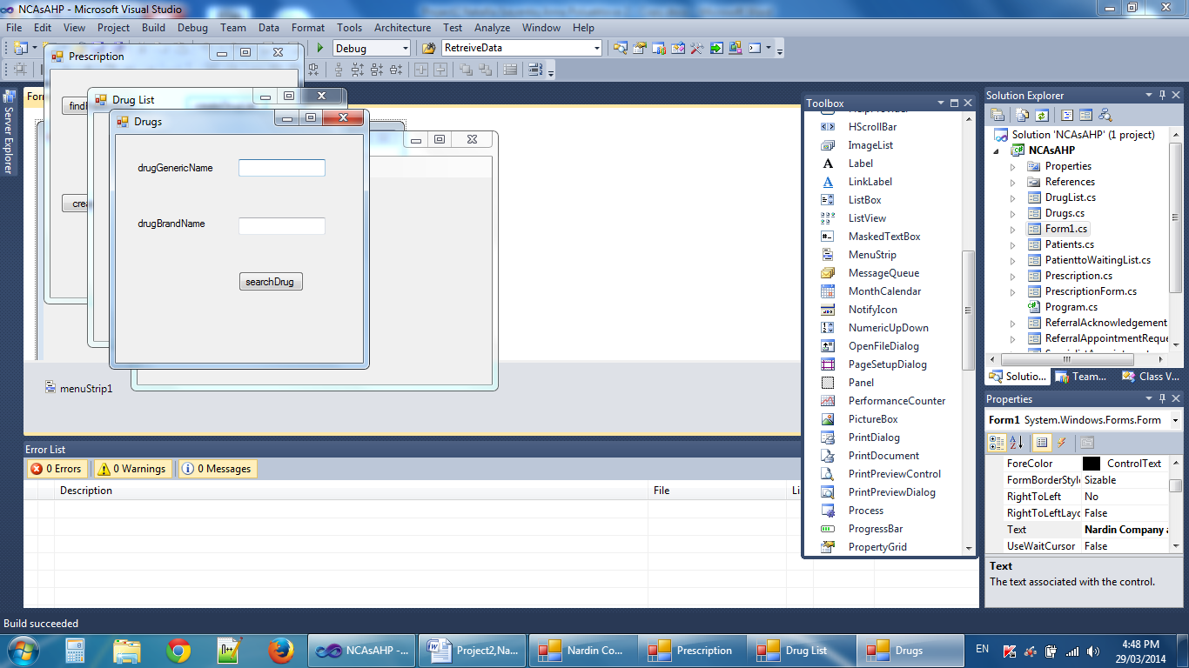 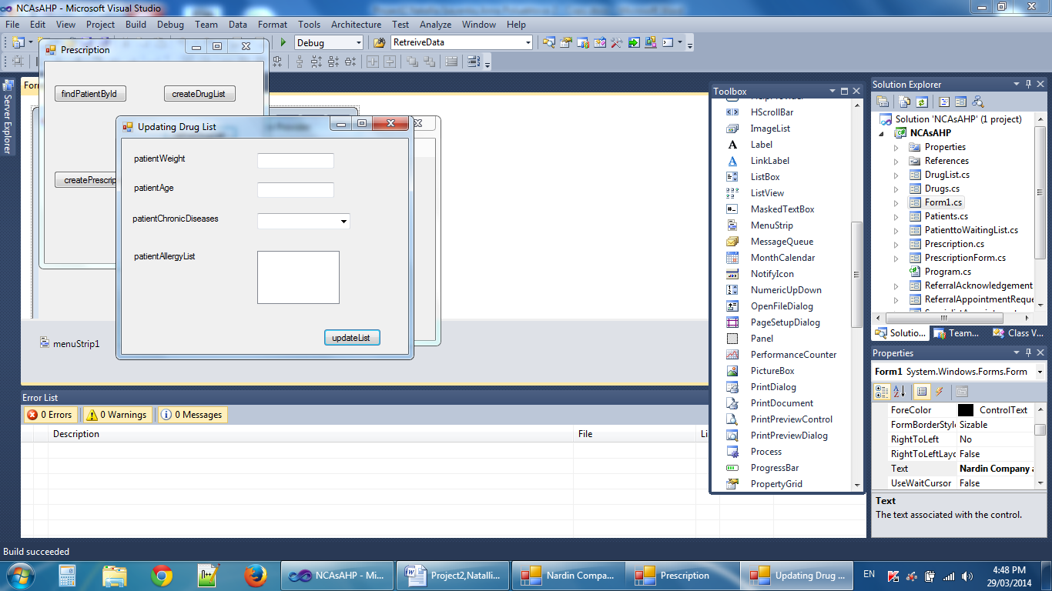 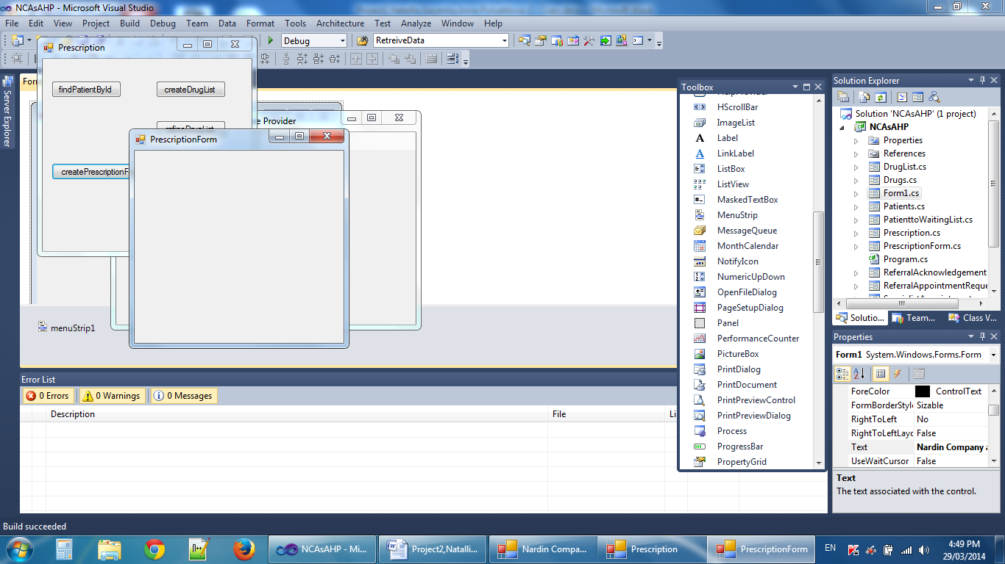

5.3 Create Specialist Appointment

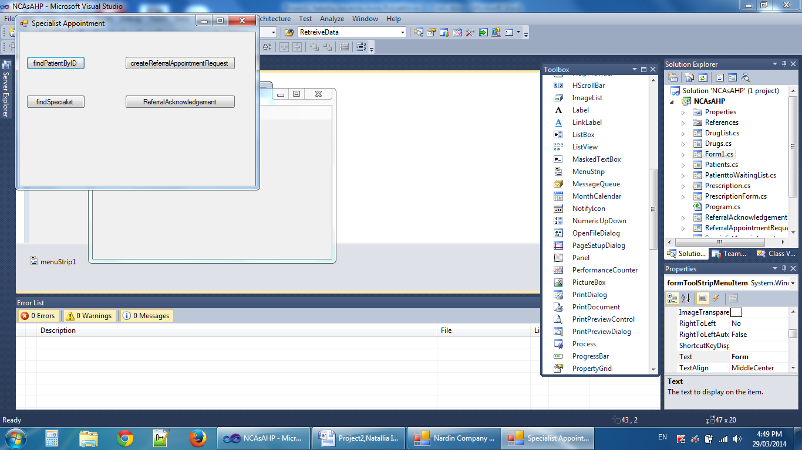 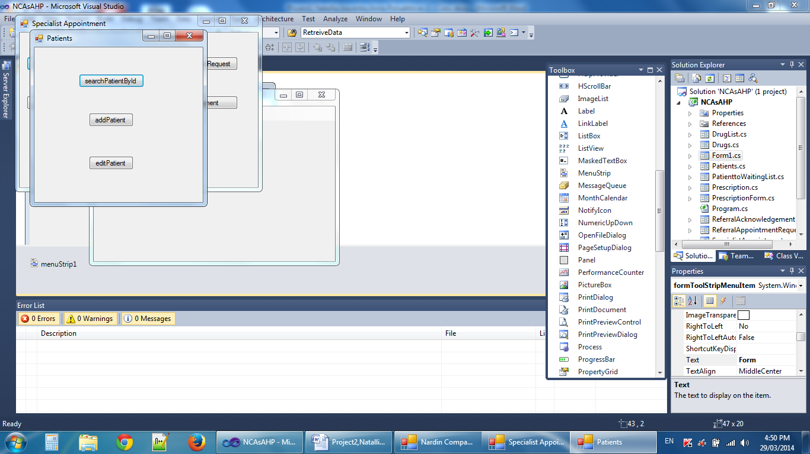 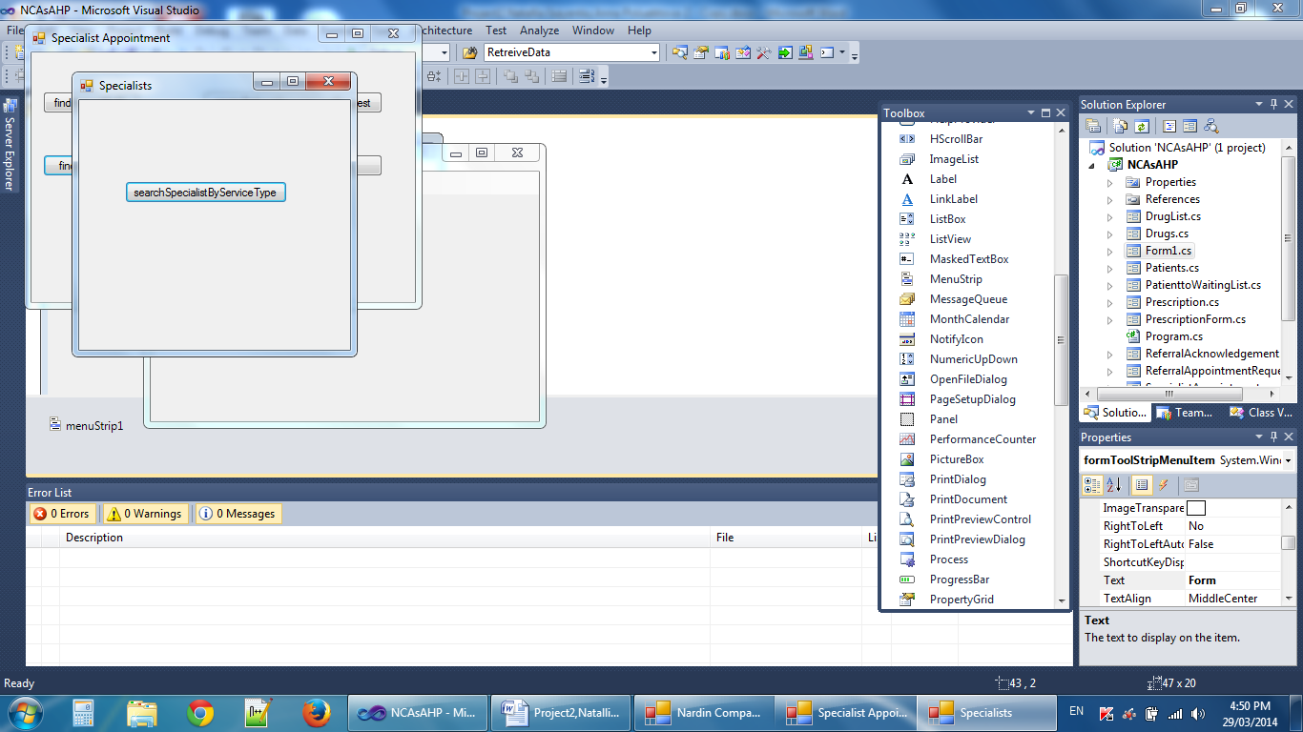 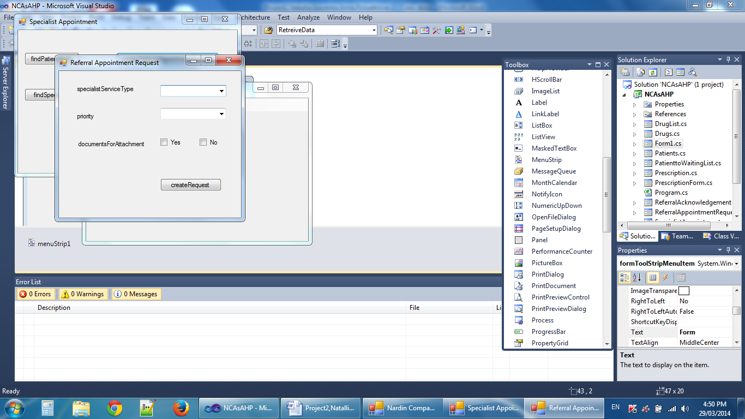

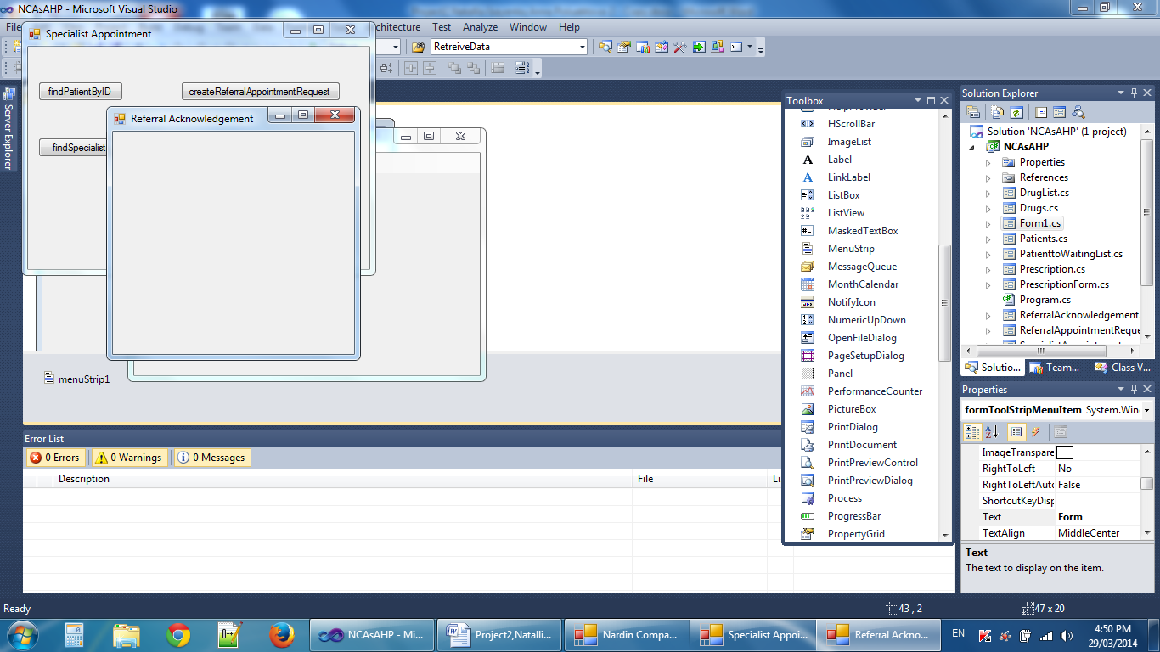

1. **Deployment Diagram of (Low Level) Network Model**

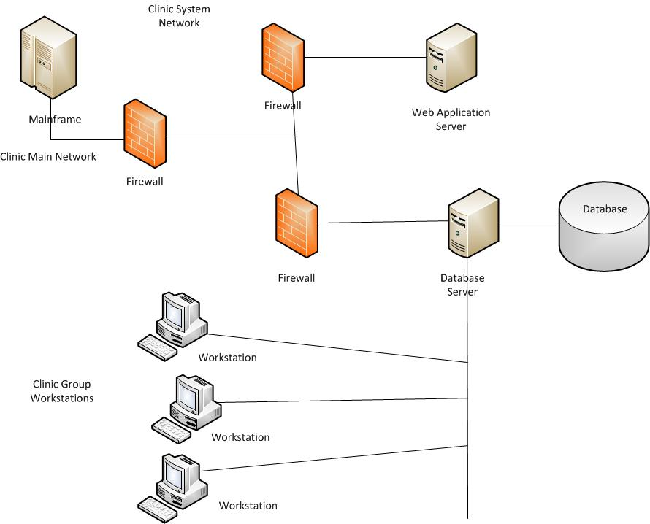

1. **Deployment Diagram of layers**

