1.

CREATE DATABASE loans;

2.

USE loans;

3.

CREATE TABLE loan_accounts (

accno INT AUTO_INCREMENT,

cust_name VARCHAR(20),

loan_amount INT(8),

instalments INT(2),

int_rate FLOAT(5,2),

start_date DATE,

interest FLOAT(15,2),

PRIMARY KEY (accno)

);

3.1.

INSERT INTO `loan_accounts` (`cust_name`, `loan_amount`, `instalments`,

`int_rate`, `start_date`, `interest`)

VALUES ('R.K. Gupta', '300000', '36', '12.00', '2009-07-19', 'NULL');

INSERT INTO `loan_accounts` (`cust_name`, `loan_amount`, `instalments`,

`int_rate`, `start_date`, `interest`)

VALUES ('S.P. Sharma', '500000', '48', '10.00', '2008-03-22', 'NULL');

INSERT INTO `loan_accounts` (`cust_name`, `loan_amount`, `instalments`,

`int_rate`, `start_date`, `interest`)

VALUES ('K.P. Jain', '300000', '36', 'NULL', '2007-03-08', 'NULL');

INSERT INTO `loan_accounts` (`cust_name`, `loan_amount`, `instalments`,

`int_rate`, `start_date`, `interest`)

VALUES ('M.P. Yadav', '800000', '60', '10.00', '2008-12-06', 'NULL');

INSERT INTO `loan_accounts` (`cust_name`, `loan_amount`, `instalments`,

`int_rate`, `start_date`, `interest`)

VALUES ('S.P. Sinha', '200000', '36', '12.50', '2010-01-03', 'NULL');

INSERT INTO `loan_accounts` (`cust_name`, `loan_amount`, `instalments`,

`int_rate`, `start_date`, `interest`)

VALUES ('P. Sharma', '700000', '60', '12.50', '2008-06-05', 'NULL');

INSERT INTO `loan_accounts` (`cust_name`, `loan_amount`, `instalments`,

`int_rate`, `start_date`, `interest`)

VALUES ('K.S. Dhall', '500000', '48', 'NULL', '2008-03-05', 'NULL');

4.

SELECT *

FROM `loan_accounts`;

5.

SELECT `accno`, `cust_name`, `loan_amount`

FROM `loan_accounts`;

6.

SELECT *

FROM `loan_accounts`

WHERE `instalments` < 40;

7.

SELECT `accno`, `loan_amount`

FROM `loan_accounts`

WHERE `start_date` < '2009-04-01';

8.

SELECT `int_rate`

FROM `loan_accounts`

WHERE `start_date` > '2009-04-01';

9.

SELECT *

FROM `loan_accounts`

WHERE `int_rate` = 0;

10.

SELECT *

FROM `loan_accounts`

WHERE NOT `int_rate` = 0;

11.

SELECT `loan_amount`

FROM `loan_accounts`

GROUP BY `loan_amount`;

SELECT DISTINCT `loan_amount`

FROM `loan_accounts`;

12.

SELECT `instalments`

FROM `loan_accounts`

GROUP BY `instalments`;

SELECT DISTINCT `instalments`

FROM `instalments`;

13.

SELECT *

FROM `loan_accounts`

WHERE `start_date` > '2008-12-31' AND `instalments` > 36;

14.

SELECT `cust_name`, `loan_amount`

FROM `loan_accounts`

WHERE NOT `instalments` = 36;

15.

SELECT `cust_name`, `loan_amount`

FROM `loan_accounts`

WHERE `loan_amount` < 500000 OR `int_rate` > 12;

16.

SELECT *

FROM `loan_accounts`

WHERE year(`start_date`) >= '2009';

17.

SELECT *

FROM `loan_accounts`

WHERE `loan_amount` BETWEEN '400000' AND '500000';

18.

SELECT *

FROM `loan_accounts`

WHERE `int_rate` BETWEEN 11.00 AND 12.00;

19.

SELECT `cust_name`, `loan_amount`

FROM `loan_accounts`

WHERE `instalments` IN (24, 36, 48);

20.

SELECT *

FROM `loan_accounts`

WHERE `loan_amount` BETWEEN 400000 AND 500000;

21.

SELECT *

FROM `loan_accounts`

WHERE `int_rate` BETWEEN 11.00 AND 12.00;

22.

SELECT `accno`, `cust_name`, `loan_amount`

FROM `loan_accounts`

WHERE `cust_name` LIKE '%Sharma';

23.

SELECT `accno`, `cust_name`, `loan_amount`

FROM `loan_accounts`

WHERE `cust_name` LIKE '%a';

24.

SELECT `accno`, `cust_name`, `loan_amount`

FROM `loan_accounts`

WHERE `cust_name` LIKE '%a%';

25.

SELECT `accno`, `cust_name`, `loan_amount`

FROM `loan_accounts`

WHERE NOT `cust_name` LIKE '%P%';

26.

SELECT `accno`, `cust_name`, `loan_amount`

FROM `loan_accounts`

WHERE `cust_name` LIKE '_a%';

27.

SELECT *

FROM `loan_accounts`

ORDER BY `loan_amount` ASC;

28.

SELECT *

FROM `loan_accounts`

ORDER BY `start_date` DESC;

29.

SELECT *

FROM `loan_accounts`

ORDER BY `loan_amount` ASC, `start_date` DESC;

30.

UPDATE `loan_accounts`

SET `int_rate` = '11.50'

WHERE `int_rate` = 0;

31.

UPDATE `loan_accounts`

SET `int_rate` = `int_rate` + '0.50'

WHERE `loan_amount` > 400000;

32.

UPDATE `loan_accounts`

SET `interest` = ((`loan_amount` * `int_rate` * `instalments`) / 12 * 100);

33.

DELETE FROM `loan_accounts`

WHERE year(`start_date`) < '2007';

34.

DELETE FROM `loan_accounts`

WHERE `cust_name` = 'K.P. Jain';

35.

ALTER TABLE `loan_accounts`

ADD `category` CHAR(1);

36.

SELECT `cust_name`, LENGTH(`cust_name`),

LCASE(`cust_name`), UCASE(`cust_name`)

FROM `loan_accounts`

WHERE `int_rate` < 11.00;

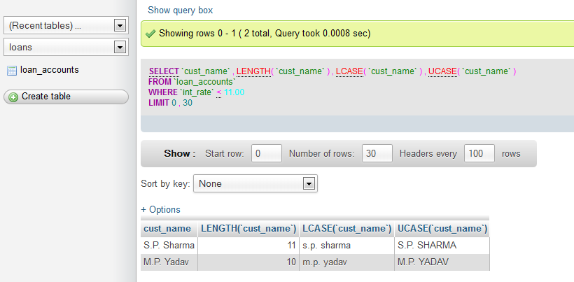

37.

SELECT LEFT(`cust_name`, 3), RIGHT(`cust_name`, 3),

SUBSTR(`cust_name`, 1, 3)

FROM `loan_accounts`

WHERE `int_rate` > 10.00;

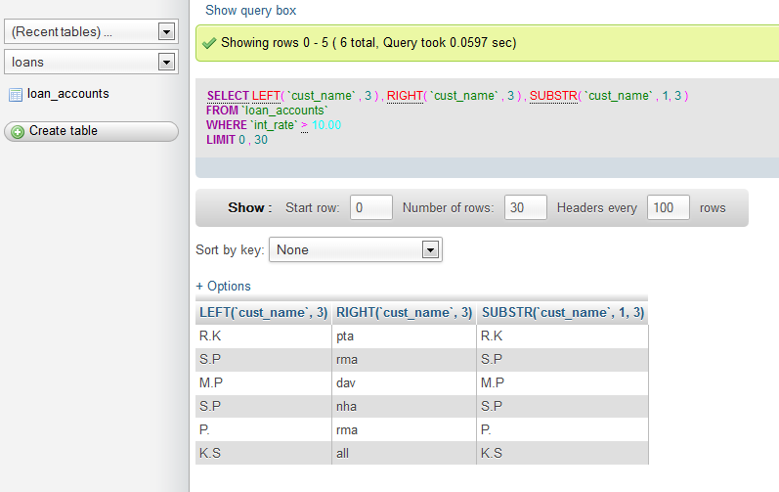

39.

SELECT DAYNAME(`start_date`)

FROM `loan_accounts`;

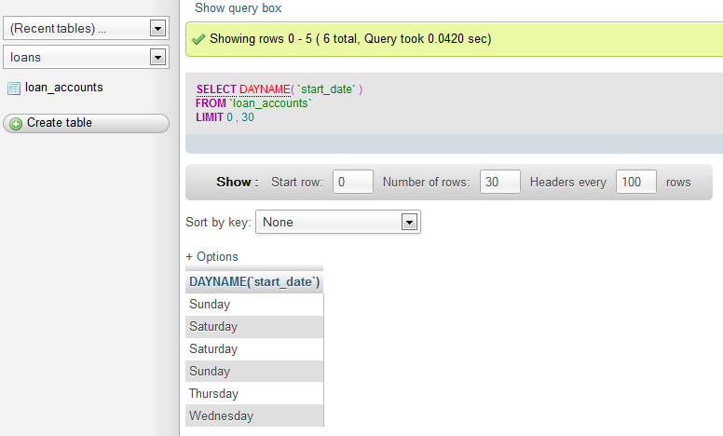

40.

SELECT ROUND(`int_rate` * 110 / 100, 2)

FROM `loan_accounts`

where `int_rate` > 10;

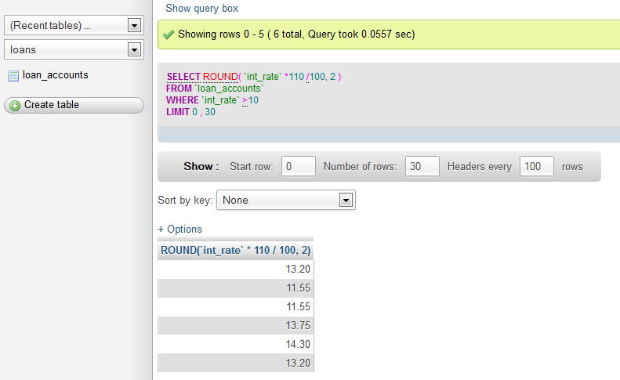

41.

SELECT POW(4,3), POW(3,4);

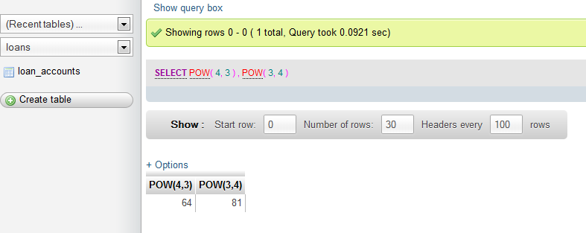

42.

SELECT ROUND(543.5694, 2), ROUND(543.5694), ROUND(543.5694, -1);

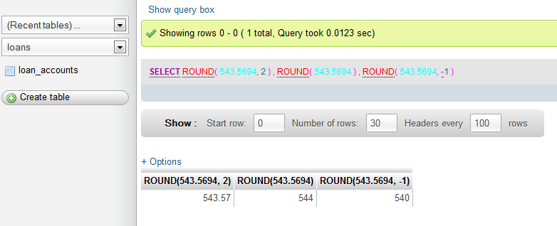

43.

SELECT TRUNCATE(543.5694, 2), TRUNCATE(543.5694, -1);

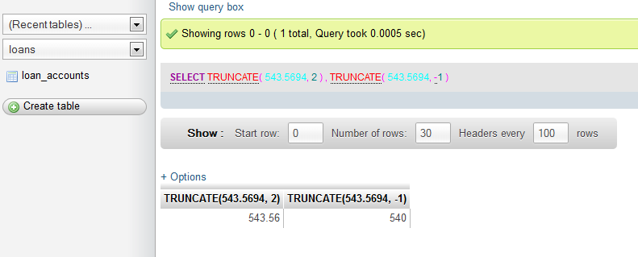

44.

SELECT LENGTH ("Prof. M.L. Sharma");

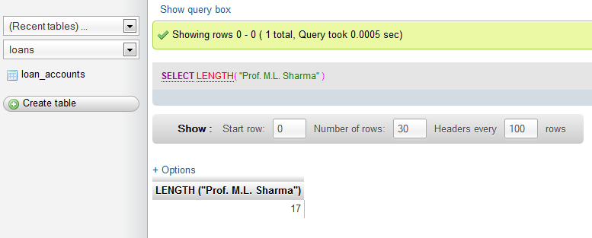

45.

SELECT CONCAT("SHEIKH", "HAROON")"FULL NAME";

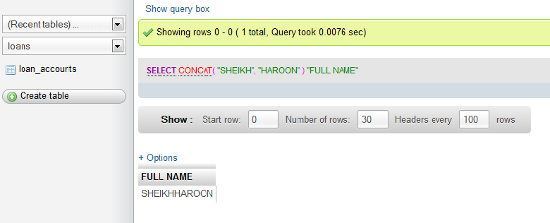

46.

SELECT YEAR(CURDATE()), MONTH(CURDATE()), DAY(CURDATE());

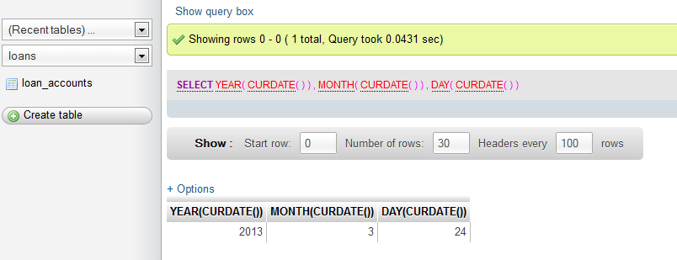

47.

SELECT DAYOFYEAR(CURDATE()), DAYOFMONTH(CURDATE()), DAYNAME(CURDATE());

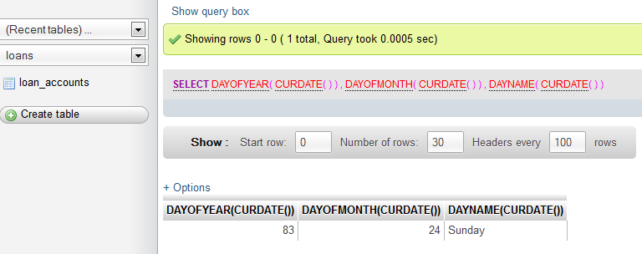

48.

SELECT LEFT("Unicode", 3), RIGHT("Unicode", 4);

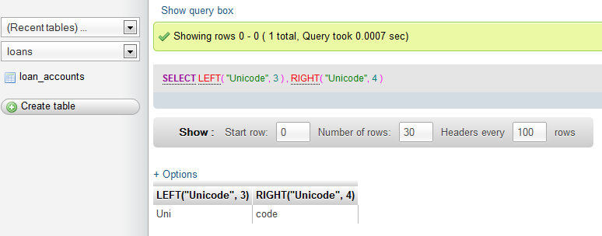

49.

SELECT INSTR("UNICODE", "CO"), INSTR("UNICODE","CD");

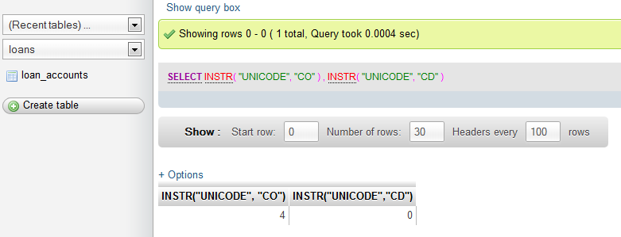

50.

SELECT MID("Informatics", 3, 4), SUBSTR("Practices", 3);

