▲ ATPLCRM
MANUAL END-TO-END
TESTING HANDBOOK
Administrator and non-administrator acceptance guide
for every function implemented through v0.7
LOCAL DOCKER · VERSION 0.7
CLARITY. CONNECTION. GROWTH.

Contents
- 1. Product and workflow map
- 2. Scope boundary
- 3. Roles and seeded accounts
- 4. Test environment preparation
- 5. Authentication, session and navigation
- 6. Overview, My Work, attention and notifications
- 7. Companies, contacts and activities
- 8. Lead lifecycle and independent validation
- 9. Opportunity, action and lifecycle testing
- 10. Pre-sales and evidence
- 11. Search, imports, duplicates and data quality
- 12. Reports and export
- 13. Administrator testing
- 14. Cross-role authorization and audit acceptance
- 15. Final regression route
- 16. Coverage checklist
- 17. Defect record template

Document purpose: manually validate every function implemented through ATPLCRM v0.7 before starting another feature.
Audience: business testers, administrators, sales users, pre-sales users and release reviewers.
Execution date: ____________________ Tester: ____________________ Build/commit: ____________________
Environment: ☐ International ☐ US Result: ☐ Pass ☐ Pass with observations ☐ Fail
Use synthetic data only. Run this handbook against a disposable local Docker environment because many scenarios create and change records. Record the actual result and evidence for every case; do not mark a case passed only because the control is visible.

1. Product and workflow map

ATPLCRM login
ATPLCRM v0.7 is a local CRM workspace built with React, FastAPI, PostgreSQL, Redis/Celery and Docker. The tested business flow is:
Company & contact | Lead | Independent validation | Opportunity | Pre-sales & evidence | Proposal & negotiation | Won / Lost / Hold
→ Actions, interactions, blockers and scheduled checks feed My Work, Needs Attention and notifications throughout the lifecycle.
Every pursuit has one commercial owner, one Ball in Court holder, one next action and due date, optional blockers, client interactions, team members, stakeholders, documents, a timeline and seven lifecycle milestones. A converted lead remains traceable and its pursuit context continues into the opportunity.

2. Scope boundary
This handbook tests what exists in v0.7. The following items are planned or partial and must not be reported as v0.7 defects merely because the complete future workflow is absent:
Area | Current v0.7 boundary
Identity | Local password sign-in only; Microsoft Entra/OIDC is planned.
Authorization | Current owner/team/management rules are testable; a fine-grained policy editor is planned.
Imports | CSV up to 5,000 rows; Excel, background jobs, fuzzy matching and field-by-field merge choice are planned.
Documents | Secure HTTPS links only; file upload, Outlook/email linking, sharing register and version supersession are planned.
Commercial | Stored currency/rate and value history work; rate refresh, re-baseline, full partner UI and complete close/handoff fields are pending.
Pre-sales | Assignment, status, effort and approval-to-share gate work; contributor capacity, full review evidence and costing are pending.
Reports | Current overview, pipeline, lead distribution, lifecycle report and forecast CSV work; historical funnels and advanced reports are pending.
AI | No AI provider or simulated AI feature exists in v0.7.
Notifications | Durable in-app alerts and scheduled tasks are included; email and mobile delivery are outside v0.7.
If a current control fails inside these boundaries, record a defect. If a planned control is absent, record it as Not in v0.7 scope.

3. Roles and seeded accounts
All seeded accounts use the DEMO_PASSWORD value from the selected environment file. Never copy that value into this document or a defect report.
Account | Access level | Business role | Main acceptance responsibility
maya@atplcrm.local | Standard | Account Executive | Company/contact work, leads, owned/team pursuits, actions and interactions
omar@atplcrm.local | Standard | Technical Lead | Assigned opportunity work and pre-sales deliverables
alex@atplcrm.local | Manager | Head of Sales | Independent lead validation, pipeline control, bulk assignment, imports and commercial controls
james@atplcrm.local | Manager | Head of Pre-Sales | Pre-sales assignment, approval and escalations
sarah@atplcrm.local | Executive | Chief Executive | Management access, reporting, validation and restricted values
admin@atplcrm.local | Administrator | Workspace Administrator | Users, references, rates and manual notification automation

Role rule summary
Capability | Standard | Manager | Executive | Administrator
View tenant records and use personal views | ✓ | ✓ | ✓ | ✓
Create company, contact and lead | ✓ | ✓ | ✓ | ✓
Edit a company/contact owned by someone else | — | ✓ | ✓ | ✓
Change an assigned pursuit | Team/owner/holder | ✓ | ✓ | ✓
Independently validate, convert or disqualify a lead | — | ✓ | ✓ | —*
Bulk assignment, CSV import and duplicate merge | — | ✓ | ✓ | ✓
Change value visibility or probability | — | ✓ | ✓ | —*
Approve pre-sales work to share | — | ✓ | ✓ | ✓
Maintain users, reference data and rates | — | — | — | ✓
Run notification scan manually | — | — | — | ✓
* Current domain routes for independent validation, value visibility and probability explicitly accept Manager or Executive. Test the Administrator account according to the actual control visibility; do not assume Administrator automatically has every commercial approval permission.

4. Test environment preparation

ENV-01 — Create a disposable International manual-test deployment
Role: Local operator
Precondition: Docker Desktop is running and port 8084 is free.
- Open Terminal and run:
```sh
cd /Users/n22/Desktop/ATPLCRM
cp .env .env.manual
sed -i '' 's/^COMPOSE_PROJECT_NAME=.*/COMPOSE_PROJECT_NAME=atplcrm-manual/' .env.manual
sed -i '' 's/^PORT=.*/PORT=8084/' .env.manual
docker compose --env-file .env.manual up -d --build --wait
```
- Run docker compose --env-file .env.manual ps.
- Open http://localhost:8084/api/health/.
- Open http://localhost:8084.
Expected: database, Redis, API, worker, scheduler and web are running; the migrate service completed successfully; health returns status: ok; the branded login page loads.
Actual/result: ______________________________________________________________________

ENV-02 — Verify schema and application version
- Run docker compose --env-file .env.manual exec -T api alembic current.
- Run docker compose --env-file .env.manual exec -T api python -c "from atplcrm.main import app; print(app.version)".
Expected: migration is 0006_notifications (head) and application version is 0.7.0.
Actual/result: ______________________________________________________________________

ENV-03 — Verify persistence across restart
- Complete a harmless record creation case, such as creating a company.
- Run docker compose --env-file .env.manual stop and then docker compose --env-file .env.manual start.
- Sign in and search for the created record.
Expected: the record remains because PostgreSQL uses a named volume.
Actual/result: ______________________________________________________________________

ENV-04 — Verify International and US isolation
- Create a uniquely named company in the manual International instance.
- Open the US deployment at http://localhost:8083 in a private browser and sign in.
- Search for the unique company.
- Start a lead conversion in each deployment and inspect currency choices.
Expected: the International record is absent from US; sessions do not cross between deployments; International offers configured currencies; US enforces USD and does not show a currency selector.
Actual/result: ______________________________________________________________________

ENV-05 — Record browser evidence
For every failed case, capture the full page, the visible error, role/account, record name, time and case ID. Also save the API response from browser developer tools when the visible message is unclear. Never include passwords or session cookies.

ENV-06 — Preserve or remove the test environment
- Preserve data for defect investigation: docker compose --env-file .env.manual down
- Permanently delete disposable data only after evidence is accepted: docker compose --env-file .env.manual down -v

5. Authentication, session and navigation

AUTH-01 — Valid sign-in for every role
For each of the six accounts, enter the email and the password from .env.manual, select Sign in, and record the displayed name, title and access level.
Expected: the Overview page opens; the profile shows the correct identity; no CSRF error appears.
Actual/result: ______________________________________________________________________

AUTH-02 — Invalid credentials
Enter a valid email with an incorrect password, then an unknown email with any password.
Expected: access is refused with a generic credential error; no user data or password detail is exposed.
Actual/result: ______________________________________________________________________

AUTH-03 — Sign out and protected navigation
- Sign in, select the header Sign out icon, and use the browser Back button.
- Directly request http://localhost:8084/#pipeline.
Expected: the login form is shown and protected workspace data is unavailable.
Actual/result: ______________________________________________________________________

AUTH-04 — Disabled account
- As admin, create a temporary Standard user and sign in once in a private window.
- As admin, change the account status to Inactive.
- Retry sign-in and refresh the previously authenticated private window.
Expected: active sessions are removed; the inactive account cannot enter the workspace.
Actual/result: ______________________________________________________________________

AUTH-05 — Password reset invalidates sessions
- Sign in as the temporary user in a private window.
- As admin, set a new password of at least 12 characters.
- Refresh the private window, try the old password, then try the new password.
Expected: the old session and old password fail; the new password succeeds.
Actual/result: ______________________________________________________________________

AUTH-06 — CSRF recovery across browser tabs
- Open the login form in Tab A and enter valid credentials without submitting.
- Open the same login page in Tab B, wait for it to load, then close it.
- Submit Tab A.
Expected: sign-in succeeds after the automatic one-time CSRF refresh; “CSRF validation failed” is not shown. Repeat around one authenticated save if desired.
Actual/result: ______________________________________________________________________

AUTH-07 — Session lifetime
Confirm the configured inactivity timeout is 12 hours. For practical manual acceptance, remove the workspace session cookie in browser developer tools and perform an authenticated action.
Expected: the user is returned to sign-in with an authentication/session message. A full 12-hour time-based soak may be recorded separately.
Actual/result: ______________________________________________________________________

NAV-01 — Main navigation and context header
Select every navigation item: Overview, My work, Needs attention, Leads, Opportunities, Companies, Contacts, Pre-sales, Reports, Data tools and Administration.
Expected: the correct title and content load without a full-page error; the header breadcrumb, instance label, profile, notifications and sign-out controls remain available.
Actual/result: ______________________________________________________________________

NAV-02 — Search this view
On Leads and Opportunities, enter part of a record, company, owner or next action in Search this view, clear it, and repeat with a non-matching term.
Expected: visible board cards update immediately; clearing restores records; no-match state is understandable.
Actual/result: ______________________________________________________________________

NAV-03 — Mobile navigation and layout
At widths 390 × 844 and 768 × 1024, open the navigation drawer, visit Contacts and an opportunity detail, then close the drawer.
Expected: no horizontal page overflow, controls remain reachable, tables can scroll inside their containers, and the backdrop/menu controls work by keyboard.
Actual/result: ______________________________________________________________________

6. Overview, My Work, attention and notifications
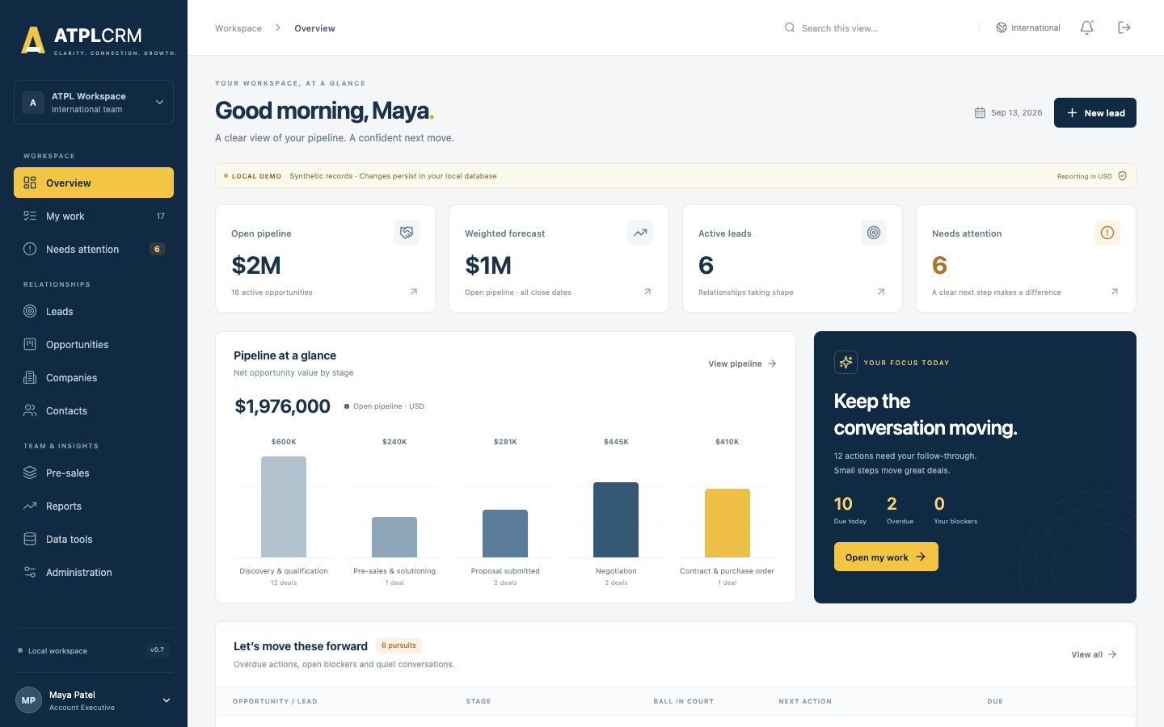
Standard user overview

WORK-01 — Overview metrics and drill-through
As Maya, compare active pipeline, weighted forecast, leads and needs-attention counts with their corresponding pages. Select each metric, View pipeline, Open my work, View all, and View queue.
Expected: totals include only applicable visible records; restricted values do not leak into totals; every control opens the correct page. Recent interactions and pre-sales items show current records.
Actual/result: ______________________________________________________________________
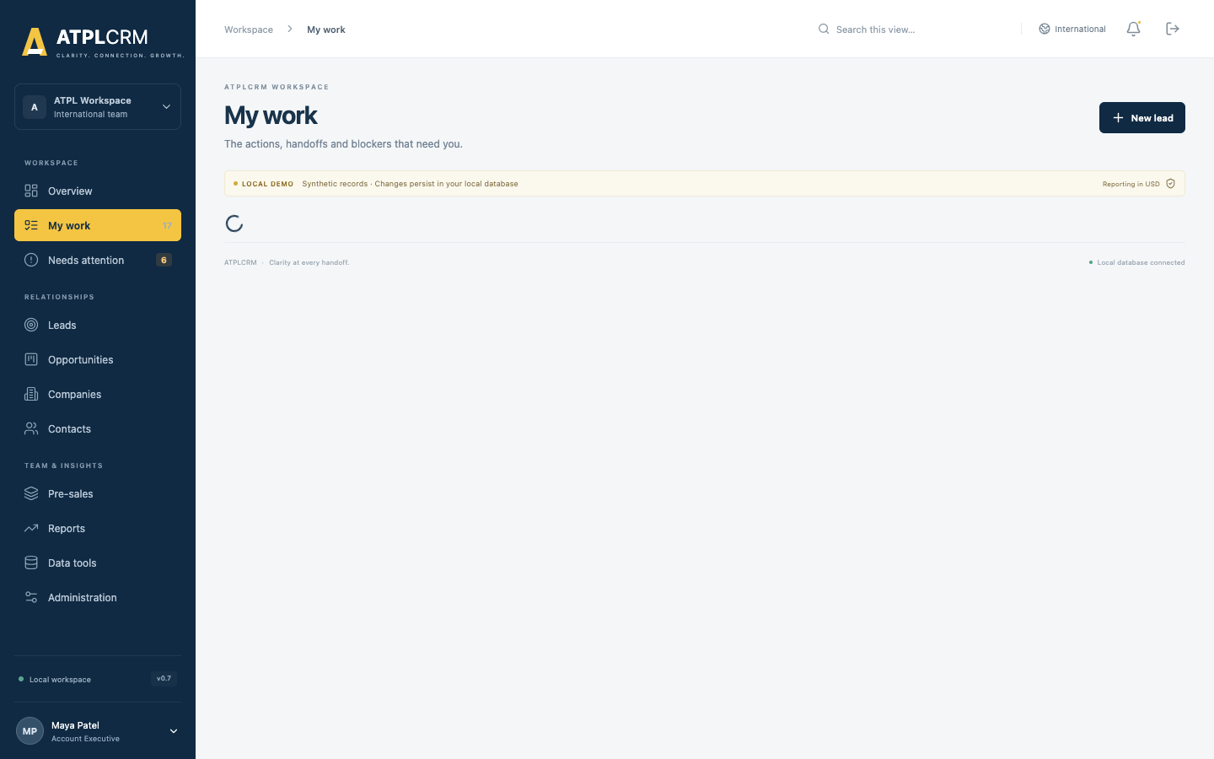
My Work queues

WORK-02 — Personal action queues
As each non-admin role, open My work and inspect Overdue actions, Due today and Upcoming actions.
Expected: only pursuits where the signed-in user is Ball in Court appear in those three sections, divided by due date; each row opens the correct record.
Actual/result: ______________________________________________________________________

WORK-03 — Owned blockers and assigned deliverables
Assign a blocker to Omar and a pre-sales request to Omar. Sign in as Omar and open My work.
Expected: the blocker appears under Blockers you own and the open request under Your deliverables. Delivered or Cancelled requests do not appear.
Actual/result: ______________________________________________________________________

WORK-04 — Needs Attention exception coverage
Prepare or identify records for each condition and open Needs attention:
- overdue next action;
- missing next action/action type;
- Ball in Court held over 14 days;
- blocker unresolved over 10 days;
- no client interaction for 21 days;
- expected close date passed;
- lead awaiting validation over 5 working days;
- overdue pre-sales deliverable.
Expected: every condition is a separate issue with severity, explanation and correct drill-through. Correcting the underlying record removes the issue after refresh.
Actual/result: ______________________________________________________________________

WORK-05 — Set the next move
As an assigned user, select Update on a pursuit. Change Ball in Court, full next action, action type, future due date, blocker, blocker owner, resolution action, next meeting and reason.
Expected: all values persist; a handoff resets days-held; setting a blocker requires owner and resolution; clearing the blocker clears its owner/resolution; changing a next action or holder requires the complete action and a future date.
Actual/result: ______________________________________________________________________

WORK-06 — Complete action and create the next action atomically
Open an assigned pursuit, select Complete action, enter outcome, note, new holder, new action/type and a future date.
Expected: the current action is stored in Timeline as Completed action, the new action becomes current, and both changes appear together. A past/today next date is rejected without partially completing the old action.
Actual/result: ______________________________________________________________________

WORK-07 — Concurrent work update protection
Open the same pursuit in two independent browser sessions. Save a work change in Session A, then submit a different change from Session B without refreshing.
Expected: Session B receives a conflict telling the tester to refresh; Session A’s values remain intact.
Actual/result: ______________________________________________________________________
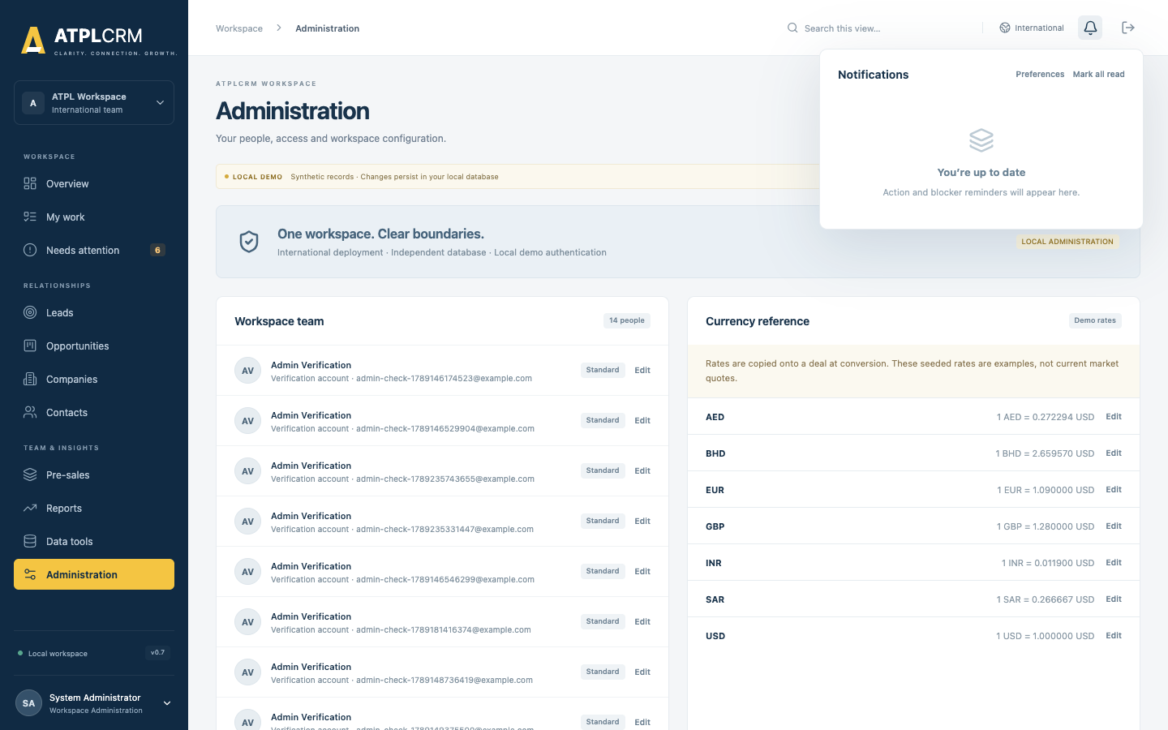
Durable notification inbox

NOTIF-01 — Personal inbox, drill-through and read state
Open the bell panel. Open an unread pursuit notification, mark one item read, then select Mark all read.
Expected: unread count decreases, read time is retained, the target record opens when present, and state remains after refresh/sign-out/sign-in.
Actual/result: ______________________________________________________________________

NOTIF-02 — Personal preferences
Select Preferences from the inbox or Manage preferences in Administration. Enable/mute each category and update:
- client inactivity: 7–120 days;
- proposal follow-up: 1–60 days;
- close notice: 1–60 days.
Expected: settings persist only for the signed-in user; values outside the ranges are rejected; muted categories stop future deliveries but issues remain visible in My Work/Needs Attention.
Actual/result: ______________________________________________________________________

NOTIF-03 — Administrator manual scan and automation status
As admin, select Run exception scan. Refresh Administration.
Expected: a success message reports newly created notifications; status shows task name, result, count and completion time. Running again without changed source conditions creates no duplicates. Non-admin roles do not have this control and an unauthorized request is refused.
Actual/result: ______________________________________________________________________

NOTIF-04 — Scheduled task health
Run:
docker compose --env-file .env.manual logs --tail=100 worker scheduler
Expected: worker is ready and registers atplcrm.refresh_notifications and atplcrm.weekly_pipeline_summary; scheduler is running. Exception scans are scheduled every 15 minutes and leadership summaries at 07:00 UTC each Monday.
Actual/result: ______________________________________________________________________

NOTIF-05 — Recipient and escalation rules
Using aged synthetic records, run the scan and verify each rule:
Trigger | Expected recipient
Due today / overdue action | Ball in Court holder
Missing next action | Ball in Court holder and commercial owner
Ball in Court over 14 days | Holder and relevant function head
Blocker over 10 days | Blocker owner and commercial owner
Client inactivity threshold | Commercial owner
Proposal without follow-up threshold | Commercial owner and Head of Sales
Validation over 5 working days | Head of Sales
Pre-sales due within 2 days or overdue | Assignee and Head of Pre-Sales
Close approaching/passed | Commercial owner
Lead nurture/opportunity hold revisit reached | Record owner
Automation failure | Administrators who enabled system failures
Weekly summary | Manager and Executive users who enabled weekly summary
Expected: delivery follows the table, severity is high for overdue/critical items, and the same source event is deduplicated.
Actual/result: ______________________________________________________________________

7. Companies, contacts and activities

REL-01 — Create a company
As Maya, select Companies → Create company and enter a unique name, domain, type, industry, country, owner, global account and region.
Expected: the company appears in the list and detail; the creator is recorded; a duplicate name is rejected with guidance to use the existing company.
Actual/result: ______________________________________________________________________

REL-02 — Edit company ownership rule
As Maya, edit her company. Create a company owned by Omar and try to edit it as Maya, then as Alex.
Expected: owner edits succeed; unrelated Standard user is refused; Manager succeeds. Changes appear in the company detail.
Actual/result: ______________________________________________________________________

REL-03 — Company detail
Open a company and verify Contacts, All pursuits and Company interactions. Open a contact and pursuit from the detail.
Expected: only records belonging to the company appear and navigation opens the selected record.
Actual/result: ______________________________________________________________________

REL-04 — Create and edit a contact
Create a contact with company, name, title, email, phone, country, owner, source, consent basis and outbound-contact choice. Edit the same contact.
Expected: values persist, company association is correct, and duplicate email is rejected. Owner/management edit rules match REL-02.
Actual/result: ______________________________________________________________________

REL-05 — Contact detail and engagement counters
Open a contact and compare email, owner, source, outbound touches, associated pursuits and interaction history. Log an outbound activity and refresh.
Expected: completed outbound client-facing activity increases touch count and appears in history; linked pursuits are accurate.
Actual/result: ______________________________________________________________________

REL-06 — Log client interaction
From a pursuit or contact, select Log interaction. Test Call, Email, Meeting and Internal note, inbound/outbound, outcomes and optional notes.
Expected: client-facing activity requires a contact; company/contact/pursuit must match; future activity time is rejected; client-facing activity updates last-client-interaction; Internal note does not.
Actual/result: ______________________________________________________________________

REL-07 — Do-not-contact control
Mark a contact Do not contact. Try an outbound client interaction without and then with an override reason.
Expected: the first save is blocked; a recorded reason allows the second; inbound and Internal note behavior remains appropriate.
Actual/result: ______________________________________________________________________

REL-08 — Contact collision notification
As Maya, log outbound contact against a contact owned by Omar.
Expected: Maya sees a warning naming the owner; Omar receives a durable notification.
Actual/result: ______________________________________________________________________

REL-09 — Company/contact lists
For both lists, test free-text search, owner, country, sort direction, next/previous page and row opening.
Expected: results are server-paginated and match every active filter; totals/pages update; controls do not lose state unexpectedly.
Actual/result: ______________________________________________________________________

REL-10 — Personal saved views
Save a filtered Company view and Contact view, apply each, sign out/in, then delete it. Try the same name twice for one entity and use the same name for another entity.
Expected: views are private to the current user, persist across sessions, restore filters and can be deleted; duplicate name is rejected only within the same user/entity.
Actual/result: ______________________________________________________________________

8. Lead lifecycle and independent validation

LEAD-01 — Create a lead
As Maya, select New lead and enter a unique lead name, company, commercial owner, Ball in Court holder, source/detail, area of interest, action/type and future due date.
Expected: the lead appears only on the Lead board/list in New status; source, owner, holder and next action match the form; today/past due date is rejected.
Actual/result: ______________________________________________________________________

LEAD-02 — Lead board, list, filters and saved view
Test Board/List, owner filter, text search, list status, priority, country, sort, pagination and a saved view.
Expected: counts and results agree; opening a result shows the same record; the saved view is personal and persistent.
Actual/result: ______________________________________________________________________

LEAD-03 — Status progression
As an assigned user, move New → Working → Engaged → Ready for validation using the detail status selector.
Expected: status persists and each change appears in Timeline; entering Ready records the Ready for validation milestone.
Actual/result: ______________________________________________________________________

LEAD-04 — Nurture
Select Nurture, choose a future revisit date, and save.
Expected: the lead closes with Nurture outcome and revisit date; the date eventually produces an owner notification when reached; a non-future date is rejected.
Actual/result: ______________________________________________________________________

LEAD-05 — Independent disqualification
Create a lead sourced/owned by Maya and make it Ready. Try disqualification as Maya, as Alex when Alex is made owner, and as an independent Manager/Executive.
Expected: Standard/self-review attempts are refused; independent Manager/Executive can choose a configured reason; lead closes as Disqualified and remains traceable.
Actual/result: ______________________________________________________________________

LEAD-06 — Independent validation and conversion
As independent Alex or Sarah, open a Ready lead and provide customer need, scope, primary contact from the same company, initial estimate, currency where applicable, service line and expected signature date.
Expected: conversion succeeds once; the original lead closes as Converted; a Discovery opportunity appears; company, source, contacts, team, history and pursuit identity are preserved; initial value history is created using the stored rate.
Actual/result: ______________________________________________________________________

LEAD-07 — Conversion gates and idempotency
Attempt conversion while the lead is not Ready, by a Standard user, by its owner/source Manager, with another company’s contact, invalid currency/service, or missing required data. Submit the same valid conversion twice.
Expected: invalid attempts explain the gate and create no opportunity; repeated valid submission returns the same opportunity and never duplicates it.
Actual/result: ______________________________________________________________________

LEAD-08 — Converted lead protection
Open the converted lead and try to change its status.
Expected: the UI points work to the linked opportunity and does not reopen/change the converted lead.
Actual/result: ______________________________________________________________________

9. Opportunity, action and lifecycle testing
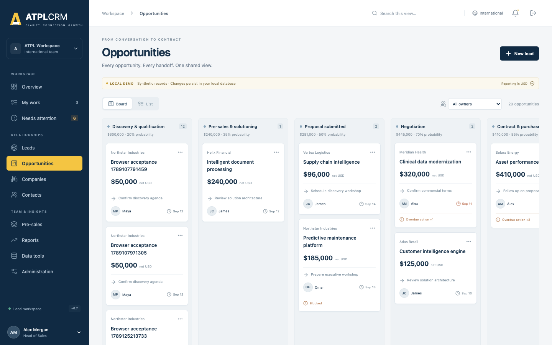
Opportunity board

OPP-01 — Board and list
Test Board/List, owner filter, text search, status/stage, priority, country, sort, pagination, personal saved views and result opening.
Expected: board columns use configured stage labels/probabilities; hold is excluded; visible net USD totals are correct; list behavior matches the Lead list.
Actual/result: ______________________________________________________________________

OPP-02 — Bulk assignment
In List view, as Alex select one or multiple opportunities/leads, set a commercial owner and/or Ball in Court holder, enter a reason and apply. Repeat as Maya.
Expected: Manager succeeds, row versions and audit history update, holder handoff resets held time, and Standard user cannot bulk assign. A stale selected record causes a conflict rather than overwriting.
Actual/result: ______________________________________________________________________

OPP-03 — Drag-and-drop stage movement
As an assigned user, drag an opportunity to another valid stage and enter stage-change evidence.
Expected: evidence is required, card moves only after save, configured probability applies, version increments and Timeline records old/new stage and reason. Cancelling leaves the card unchanged.
Actual/result: ______________________________________________________________________

OPP-04 — Accessible stage selector
Open the opportunity and use Opportunity stage without drag-and-drop.
Expected: it opens the same evidence workflow and produces the same result as OPP-03. Keyboard users can reach and operate the selector.
Actual/result: ______________________________________________________________________

OPP-05 — Team gate for advanced stages
On an opportunity without both roles, attempt Pre-sales, Proposal, Negotiation, Contract and Won. Assign a Pre-sales owner and Tech lead, then retry.
Expected: movement is blocked until both roles exist; after assignment it succeeds. Pre-sales assignment records its milestone once.
Actual/result: ______________________________________________________________________

OPP-06 — Hold and revisit
Move an opportunity to Hold without a revisit date, with today’s date, and then with a future date.
Expected: missing/non-future dates are rejected; valid hold stores the revisit and excludes the record from active forecast; a reached revisit creates an owner alert.
Actual/result: ______________________________________________________________________

OPP-07 — Close Lost
Move to Lost with and without a configured loss reason; optionally record a competitor.
Expected: loss reason is mandatory and must use an active configured value; valid save sets stage probability to 0, records Closed milestone and removes active-work alerts.
Actual/result: ______________________________________________________________________

OPP-08 — Close Won evidence gate
- Attempt Won with no final Contract, Purchase order or SOW link.
- Register the evidence link.
- Retry with contract/PO number, contract date and final value.
Expected: first attempt is blocked; missing close fields are rejected; valid attempt sets Won/100%, records final value history and Closed milestone. A user without value access cannot close Won.
Actual/result: ______________________________________________________________________

OPP-09 — Stage concurrency
Open the same opportunity in two independent sessions. Move it in Session A, then submit a different stage from Session B.
Expected: Session B gets a refresh conflict and cannot overwrite Session A. No duplicate milestone is created.
Actual/result: ______________________________________________________________________

OPP-10 — Assign pursuit team
As commercial owner/management, assign Pre-sales owner, Tech lead and multiple Supporting contributors. Repeat as an unrelated Standard user.
Expected: authorized changes persist and appear under Team & contacts; unique functional roles are replaced rather than duplicated; unrelated Standard user is refused.
Actual/result: ______________________________________________________________________

OPP-11 — Stakeholders
Add a contact from the opportunity company, change its relationship role, and remove it. Try another company’s contact and try to remove the active primary contact.
Expected: valid add/edit/remove works and is audited; cross-company contact is unavailable/refused; primary contact cannot be removed.
Actual/result: ______________________________________________________________________

OPP-12 — Record commercial value
As owner or management with value access, record Initial estimate, Proposal value, Revised proposal, Negotiated value and Final contract value with notes.
Expected: current value and USD equivalent update; every entry remains in reverse-chronological Value history with original currency/fixed FX rate; invalid type/negative amount is refused.
Actual/result: ______________________________________________________________________

OPP-13 — Probability override
As Manager/Executive, enter 0, 55 and 100 with reasons. Try as Standard.
Expected: management values persist with reason; stage remains unchanged; next stage change restores configured stage probability; Standard user is refused.
Actual/result: ______________________________________________________________________

OPP-14 — Restricted commercial values
As Manager/Executive, set restricted visibility with a reason. Inspect the record as management, an assigned team member and an unrelated Standard user.
Expected: management/team retain allowed access; unrelated Standard user sees no commercial amount, value history, activity narrative, completed actions or internal evidence. Restricted values do not leak through overview, reports, search or API-driven lists. Restore visibility and verify it returns.
Actual/result: ______________________________________________________________________

OPP-15 — Timeline and immutable action history
Complete actions, log interactions, move stages, assign roles, add stakeholders, record value and add evidence. Inspect Timeline.
Expected: entries show author/date/type and correct details in descending order. Completed actions and audit/value history have no UI edit/delete control and remain after later changes.
Actual/result: ______________________________________________________________________
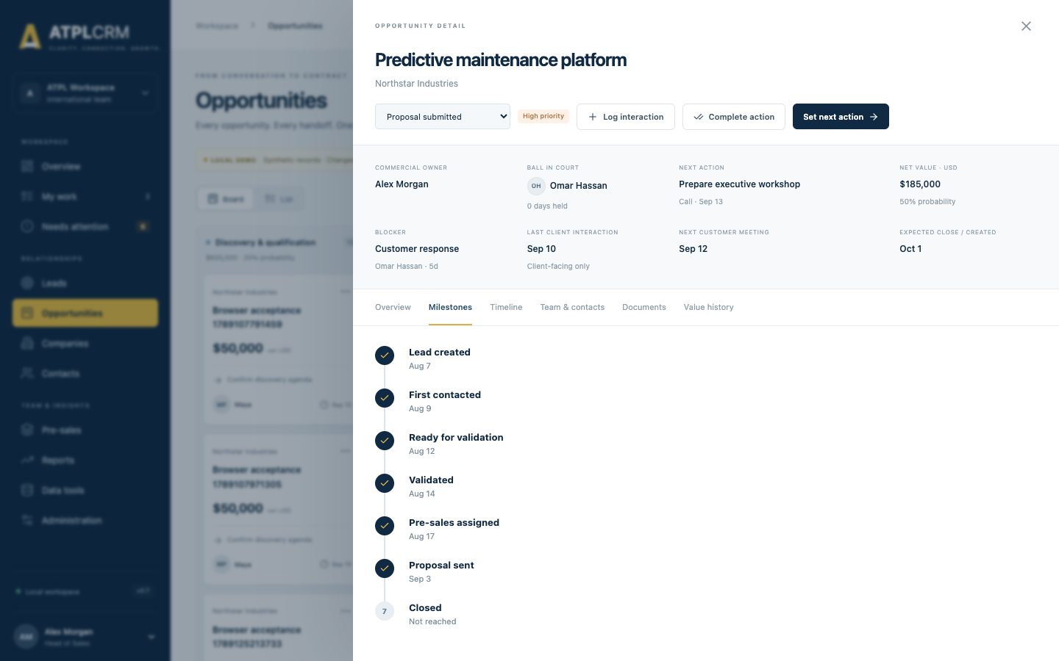
Seven milestone detail

OPP-16 — Seven milestones
Follow one record through lead creation, first outbound contact, Ready, validation, pre-sales assignment, Proposal and Won/Lost.
Expected: exactly seven milestones appear in order—Lead created, First contacted, Ready for validation, Validated, Pre-sales assigned, Proposal sent and Closed. Each timestamp is set once and remains after backward stage movement.
Actual/result: ______________________________________________________________________

10. Pre-sales and evidence

PRE-01 — Create request
As management or assigned Pre-sales owner, create a request with opportunity, title, type, assignee, needed-by date, meeting date, estimate and notes. Try as unrelated Standard user.
Expected: authorized request appears in the queue and assignee’s My Work; assignee is added as Supporting contributor; unrelated Standard user is refused.
Actual/result: ______________________________________________________________________

PRE-02 — Request queue
Verify Open requests, Ready for review and Past due metrics; search using the page header and open a row.
Expected: status/date metrics and visible rows agree; title, opportunity, assignee, status, needed-by and estimate are correct.
Actual/result: ______________________________________________________________________

PRE-03 — Status updates and ownership
As assignee, move through Requested, Clarification required, Accepted, In progress, Ready for review, Blocked and Cancelled. Try updating another assignee’s request as Standard.
Expected: assignee/management can update; unrelated Standard user is refused; Blocked requires a reason. Every change appears in the pursuit Timeline.
Actual/result: ______________________________________________________________________

PRE-04 — Approval and delivery gate
As Standard assignee, attempt Approved to share and Delivered. As Manager, approve; then deliver with and without actual effort.
Expected: management approval is required; Delivered is allowed only from Approved to share and requires actual days; delivered work leaves My Work.
Actual/result: ______________________________________________________________________

DOC-01 — Evidence link register
As an assigned pursuit user, add an HTTPS document link with title, type, version and visibility.
Expected: invalid URL is rejected; valid item appears in Documents and opens in a new tab; document type/version/visibility display correctly.
Actual/result: ______________________________________________________________________

DOC-02 — Internal evidence visibility
Add one Pursuit document and one Internal team-only document. View as assigned and unrelated users.
Expected: assigned users see both; unrelated users see only the pursuit document, subject to restricted-value behavior.
Actual/result: ______________________________________________________________________

11. Search, imports, duplicates and data quality
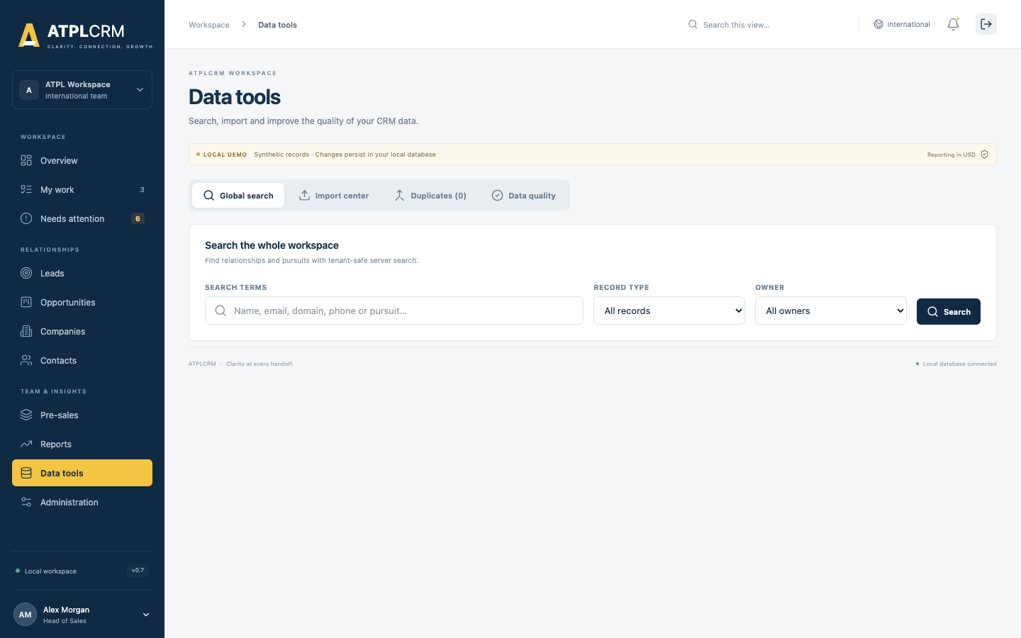
Data tools

DATA-01 — Universal search
Search by company, contact, lead and opportunity text. Filter by record type and owner; test next/previous pages and clear filters.
Expected: results are tenant-scoped, filters combine correctly, type/detail/route are accurate and selecting a result opens its destination. Restricted values are not exposed.
Actual/result: ______________________________________________________________________

DATA-02 — Download templates
As Manager/Executive/Administrator, download Company, Contact and Lead CSV templates.
Expected: each file downloads with documented headers and opens as CSV. Standard users cannot perform imports/merges.
Actual/result: ______________________________________________________________________

DATA-03 — Column mapping and dry-run validation
Upload a CSV whose headings differ from the template. Map columns and select Validate file.
Expected: mapping controls accept the source columns; preview reports total, valid and invalid rows without creating records.
Actual/result: ______________________________________________________________________

DATA-04 — Company CSV import
Import valid and invalid company rows including missing name/country, unknown owner and duplicate company.
Expected: valid rows import; invalid rows are skipped with row/field errors; no duplicate is silently created; completion totals match.
Actual/result: ______________________________________________________________________

DATA-05 — Contact CSV import
Import rows with valid/unknown company, valid/invalid/duplicate email, owner and source.
Expected: relationships resolve within the tenant; invalid rows are reported; valid rows preserve consent/contact fields supported by the importer.
Actual/result: ______________________________________________________________________

DATA-06 — Lead CSV import
Import rows with company/owner/holder/source/action values and future/invalid due dates.
Expected: valid leads create complete pursuits; invalid references/dates are rejected row by row; successful rows appear in Leads.
Actual/result: ______________________________________________________________________

DATA-07 — Partial import and error report
Use a file containing both valid and invalid rows. Download the validation/error report and import valid rows.
Expected: only valid rows are created; error download identifies original rows and reasons; imported/skipped totals are exact.
Actual/result: ______________________________________________________________________

DATA-08 — Import history and limits
Refresh the Import center and inspect filename, entity, status, row counts and errors. Try an unsupported type/empty file and a file over 5,000 rows.
Expected: completed imports remain in history; invalid format/size is rejected clearly; no partial data is created before confirmation.
Actual/result: ______________________________________________________________________

DATA-09 — Exact duplicate review and merge
Create two companies with matching normalized domain/name or two contacts with matching email/phone as permitted by the fixture, open Possible duplicates, select a primary and merge.
Expected: exact groups appear; Manager/Executive/Administrator can merge; linked contacts, pursuits, activities, primary-contact links and stakeholder links move safely; duplicate is archived and no longer appears. Same-record or cross-tenant IDs are rejected.
Actual/result: ______________________________________________________________________

DATA-10 — Data quality dashboard
Create records missing domain, industry, email, phone or with overdue/missing action. Open Data quality.
Expected: score, records checked, issue/duplicate totals and metrics reconcile; issue severity/reason are correct; selecting an issue opens the relevant area.
Actual/result: ______________________________________________________________________

12. Reports and export

RPT-01 — Pipeline metrics
Compare Net pipeline and Weighted pipeline against visible open opportunities. Include Won, Lost, Hold and a restricted opportunity.
Expected: open visible net values are counted; weighted amount uses the current probability; Won/Lost/Hold are excluded; hidden values do not leak.
Actual/result: ______________________________________________________________________

RPT-02 — Pipeline by stage
Compare every stage bar/count/value to the Opportunity board and select the stage.
Expected: labels use current reference configuration; counts and visible values match; drill-through opens Opportunities.
Actual/result: ______________________________________________________________________

RPT-03 — Lead distribution
Compare lead status counts to the Lead board and select a status.
Expected: counts match the current status distribution and drill-through opens Leads. Treat it as a distribution, not historical conversion analysis.
Actual/result: ______________________________________________________________________

RPT-04 — Lifecycle bottleneck report
For each of seven milestone tiles, verify record count, median working days, target and health indicator; select a tile.
Expected: exactly seven tiles display; values reflect stored timestamps and weekday calculations; drill-through lists matching records.
Actual/result: ______________________________________________________________________

RPT-05 — Forecast detail
Compare record, company, stage, owner, close, probability and net USD with opportunity details. Test value restrictions with different roles.
Expected: data is consistent and restricted rows/values remain protected.
Actual/result: ______________________________________________________________________

RPT-06 — Forecast CSV export
Select Export CSV, open the file in a text editor and spreadsheet, and compare rows/totals. Include a test record beginning with =, +, - or @ if possible.
Expected: visible forecast rows export; spreadsheet-formula prefixes are escaped; restricted data is absent; no HTML/error file is downloaded.
Actual/result: ______________________________________________________________________

13. Administrator testing
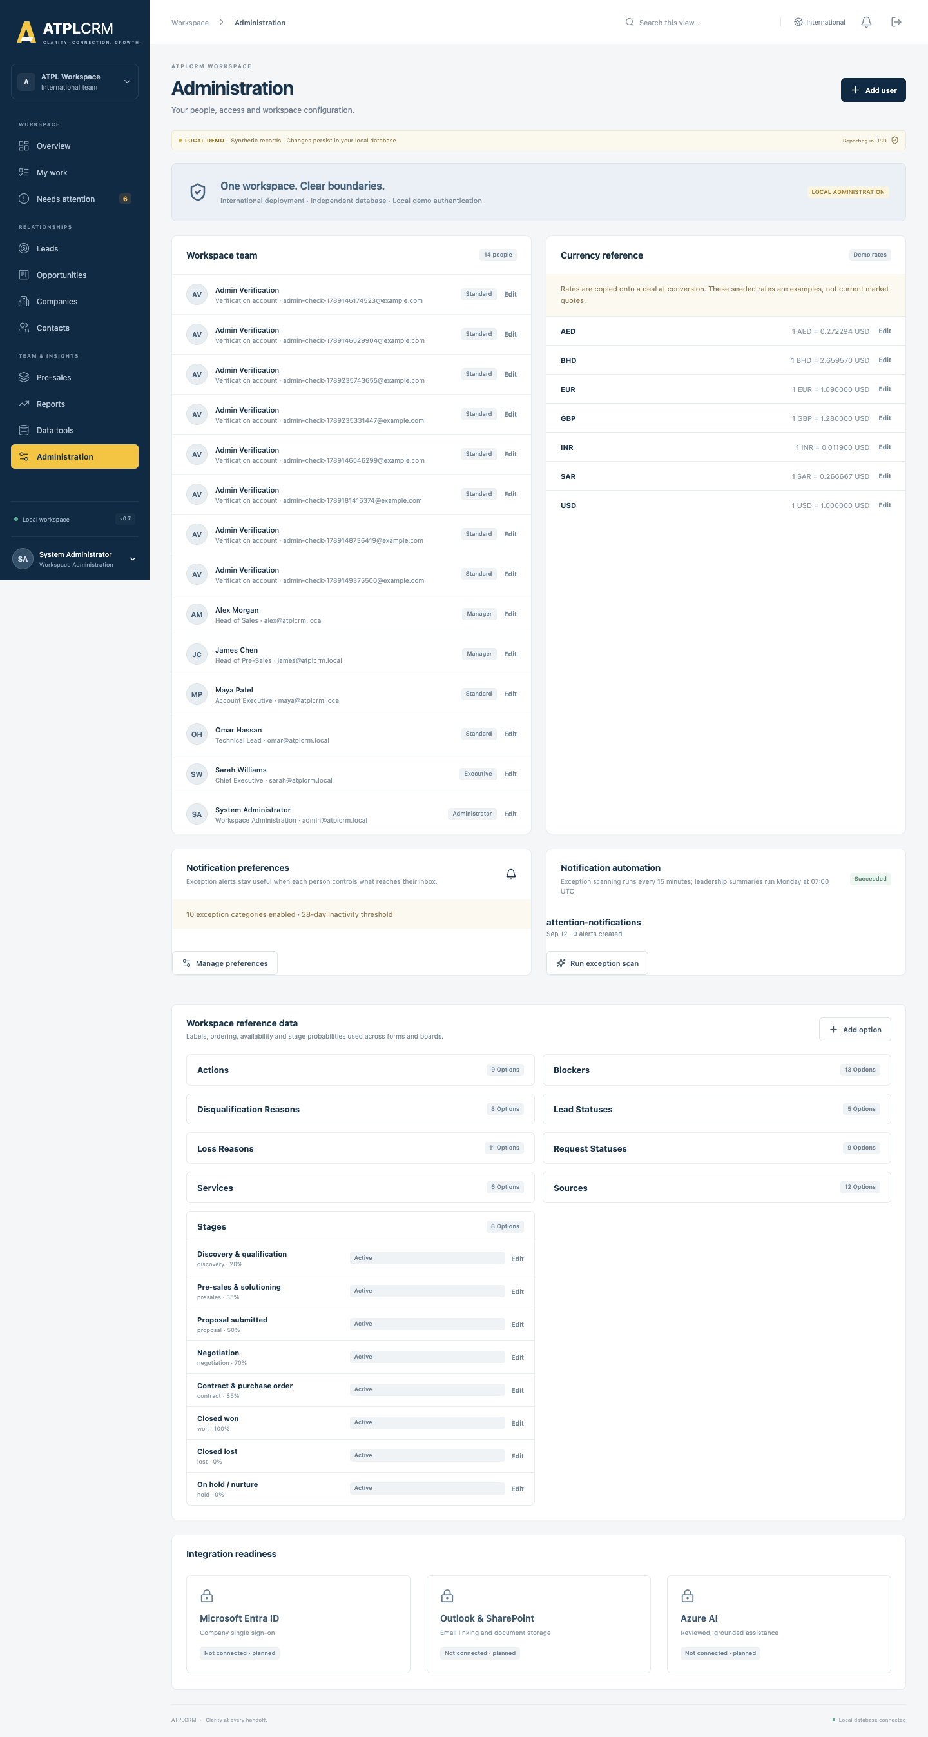
Administration workspace

ADMIN-01 — Administration visibility
Open Administration as admin and each non-admin role.
Expected: all users see their own profile, currency reference, notification preferences and integration-readiness information; only admin sees editable Workspace team, rates/reference controls and manual automation controls. Server authorization rejects direct non-admin admin requests.
Actual/result: ______________________________________________________________________

ADMIN-02 — Create user
Create Standard, Manager, Executive and Administrator test users using unique emails and passwords of at least 12 characters.
Expected: each active user appears with correct identity/title/level and can sign in. Duplicate email, invalid email and short password are rejected.
Actual/result: ______________________________________________________________________

ADMIN-03 — Edit user and access level
Change name, email, title and access level, then sign in as that user.
Expected: profile and permissions reflect the change. Email stays unique and normalized.
Actual/result: ______________________________________________________________________

ADMIN-04 — Account activation and password
Repeat AUTH-04 and AUTH-05; reactivate the account and confirm only the current password works.
Expected: activation and session invalidation are immediate and tenant-scoped.
Actual/result: ______________________________________________________________________

ADMIN-05 — Protect current administrator
As admin, try to deactivate the signed-in account or remove its Administrator access.
Expected: both changes are refused so the current administrator cannot lock itself out.
Actual/result: ______________________________________________________________________

ADMIN-06 — Add reference option
Add options to Sources, Service lines, Action types, Blocker types, Loss reasons and Disqualification reasons. Try adding a duplicate code and a new workflow stage/status code.
Expected: supported additions appear in corresponding forms after refresh; duplicate code is rejected; stage, lead-status and request-status codes cannot be added because their stable workflow codes are locked.
Actual/result: ______________________________________________________________________

ADMIN-07 — Edit reference option
Edit label, sort order and availability; edit a stage probability. Deactivate an option and inspect new forms while opening old records that already use it.
Expected: labels/order/probabilities update; inactive options cannot be selected for new changes while historical records remain understandable; stable code does not change. The default None blocker cannot be disabled and stage probability cannot be blank.
Actual/result: ______________________________________________________________________

ADMIN-08 — Exchange rates
Update a non-USD rate and source, convert a new lead in that currency, then change the rate again.
Expected: future conversion uses the latest rate; the existing opportunity/value history retains its original fixed rate. USD remains exactly 1 and cannot be changed. US deployment exposes USD only.
Actual/result: ______________________________________________________________________

ADMIN-09 — Integration readiness
Inspect Microsoft identity, email/document integration and other readiness cards.
Expected: planned integrations are described honestly and no unavailable integration can be enabled or mistaken for connected functionality.
Actual/result: ______________________________________________________________________

14. Cross-role authorization and audit acceptance

SEC-01 — Assigned-team authorization
Use one opportunity with Maya as owner, Alex as holder, James as Pre-sales owner and Omar as Tech lead. Try work updates as each and as an unrelated Standard user.
Expected: owner, source, holder, explicit team and management can work according to current rules; unrelated Standard user can view tenant data but cannot change that pursuit.
Actual/result: ______________________________________________________________________

SEC-02 — Management-only operations
As Standard, attempt independent conversion/disqualification, bulk assignment, import, merge, restricted-value change, probability override and pre-sales approval. Repeat with the appropriate Manager/Executive.
Expected: Standard is refused and no data changes; the eligible management role succeeds when business gates are met.
Actual/result: ______________________________________________________________________

SEC-03 — Administrator-only operations
As a non-admin, attempt user/reference/rate maintenance and manual notification scan, including a direct API call captured from developer tools.
Expected: UI control is absent and server returns forbidden; no data changes.
Actual/result: ______________________________________________________________________

SEC-04 — Tenant isolation
Copy a record identifier from International and request it while authenticated to US, then reverse the test.
Expected: record is not found/available; no name, value, contact, timeline, notification or import information crosses tenant boundaries.
Actual/result: ______________________________________________________________________

SEC-05 — Audit timeline completeness
For a single pursuit, complete at least one change from every implemented workflow and inspect Timeline after each save.
Expected: user, time, action and useful detail are present for status, work/handoff, stage, value, restriction, probability, team, stakeholder, activity, request, document and completed-action changes.
Actual/result: ______________________________________________________________________

SEC-06 — Database immutability guards
On the disposable database only, identify one row in crm_auditevent, crm_valuehistory and crm_pursuitaction, then attempt an ordinary UPDATE and DELETE inside a transaction using the application database role.
Expected: PostgreSQL rejects mutation of protected historical rows. Roll back the transaction and retain the error as evidence. Do not perform this case on a shared or production database.
Actual/result: ______________________________________________________________________

SEC-07 — Error quality and atomicity
For key forms, deliberately omit mandatory fields, use invalid dates/URLs/numbers and violate a permission or workflow gate.
Expected: a specific message identifies the correction; modal data is not silently lost; no partial company/contact/lead conversion/action completion/stage close/request delivery is committed.
Actual/result: ______________________________________________________________________

SEC-08 — Keyboard and basic accessibility
Use Tab/Shift+Tab, Enter, Space and Escape through login, navigation, board/list switch, forms, detail tabs, notifications and dialogs. Check visible focus and labels using browser accessibility inspection.
Expected: focus is visible and logical, controls have names, dialogs can be completed/closed, stage selection works without drag, and color is not the sole meaning. Record any screen-reader or contrast issue as an accessibility defect; a full formal audit remains pending.
Actual/result: ______________________________________________________________________

15. Final regression route
Execute this sequence on one named synthetic pursuit to prove the full handoff:
- Admin creates/reactivates all required test users and validates reference options/rates.
- Maya creates a company and contact, sets consent and logs the first interaction.
- Maya creates a lead, changes status through Ready and assigns a future action.
- Independent Alex validates and converts it; confirm preserved source/contact/history and initial value.
- Alex assigns James as Pre-sales owner and Omar as Tech lead; adds/edits stakeholders.
- The holder completes an action and hands off a new future action; add and resolve a blocker.
- James creates a pre-sales deliverable; Omar progresses it; James/Alex approves; Omar delivers with actual effort.
- Add Proposal evidence, move through Pre-sales and Proposal, log client follow-up, revise value and inspect fixed FX history.
- Test Hold/revisit, return to active stage, then add Contract/PO/SOW evidence and close Won; separately close another record Lost.
- Verify all seven milestones, Timeline, Documents, Value history, My Work, Needs Attention, notifications and reports.
- Save views, perform a controlled bulk assignment, search the records globally and export forecast CSV.
- Run the admin notification scan twice; verify correct routing, read state, deduplication and automation status.
- Sign in as unrelated Standard, assigned Standard, Manager, Executive and Administrator to validate visibility and prohibited actions.
- Restart Docker and confirm data, preferences, read state, saved views, imports and histories persist.
Overall regression result: ☐ Pass ☐ Fail
Evidence location: __________________________________________________________________

16. Coverage checklist
Use this as the final completeness gate.
Capability | Cases | Result
Docker, migration, health, persistence and instance isolation | ENV-01–04 | ☐
Login, logout, inactive users, reset, session and CSRF recovery | AUTH-01–07 | ☐
Navigation, local search and responsive shell | NAV-01–03 | ☐
Overview, My Work, Needs Attention, next move, action history and concurrency | WORK-01–07 | ☐
Preferences, inbox/read history, scan, scheduler and all recipient rules | NOTIF-01–05 | ☐
Company/contact CRUD, ownership, engagement, DNC and collision | REL-01–10 | ☐
Lead create/status/nurture/disqualify/convert and preservation | LEAD-01–08 | ☐
Pipeline board/list, stages, gates, roles, stakeholders, values and milestones | OPP-01–16 | ☐
Pre-sales request/status/approval/effort and evidence links | PRE-01–04, DOC-01–02 | ☐
Global search, CSV templates/imports/errors/history, duplicates and quality | DATA-01–10 | ☐
Pipeline/funnel/lifecycle/forecast reports and CSV export | RPT-01–06 | ☐
Users, access levels, reference data, probabilities and rates | ADMIN-01–09 | ☐
Cross-role/tenant authorization, audit, immutability, errors and accessibility | SEC-01–08 | ☐

17. Defect record template
Field | Entry
Defect ID / test case
Summary
Environment / URL / commit
Signed-in account and access level
Record name/ID
Preconditions
Exact steps
Expected result
Actual result
Screenshot/video/API response
Severity: Blocker / High / Medium / Low
Reproducibility
Retest result and commit

Release decision
- Pass: every applicable case passes and no open Blocker/High defect remains.
- Pass with observations: core business flow passes; accepted Medium/Low observations have owners and target releases.
- Fail: a critical role, data boundary, stage/action transaction, financial visibility, audit history or persistence case fails.
Decision: ____________________ Approved by: ____________________ Date: ____________________

