A ATPLCRM

Project Handoff
Engineering, operations, deployment and next-owner guide

Release v0.16 • 30 September 2026

Contents
Update this field in Microsoft Word if page numbers are not populated automatically.

Handoff date: 30 September 2026
Repository: https://github.com/aegletek/atplcrm.git
Local workspace: /Users/n22/Desktop/ATPLCRM
Branch: main
Product boundary: Standalone ATPLCRM product; no Orbit source, runtime, credentials or data dependency
Current deployment target: Local Docker Compose for client demonstrations
Future production target: Microsoft Azure

1. Handoff summary
ATPLCRM v0.16 is a client-demo-ready local CRM covering the complete implemented flow from relationship capture through lead qualification, opportunity execution, pre-sales delivery, document evidence, commercial closure and management reporting.
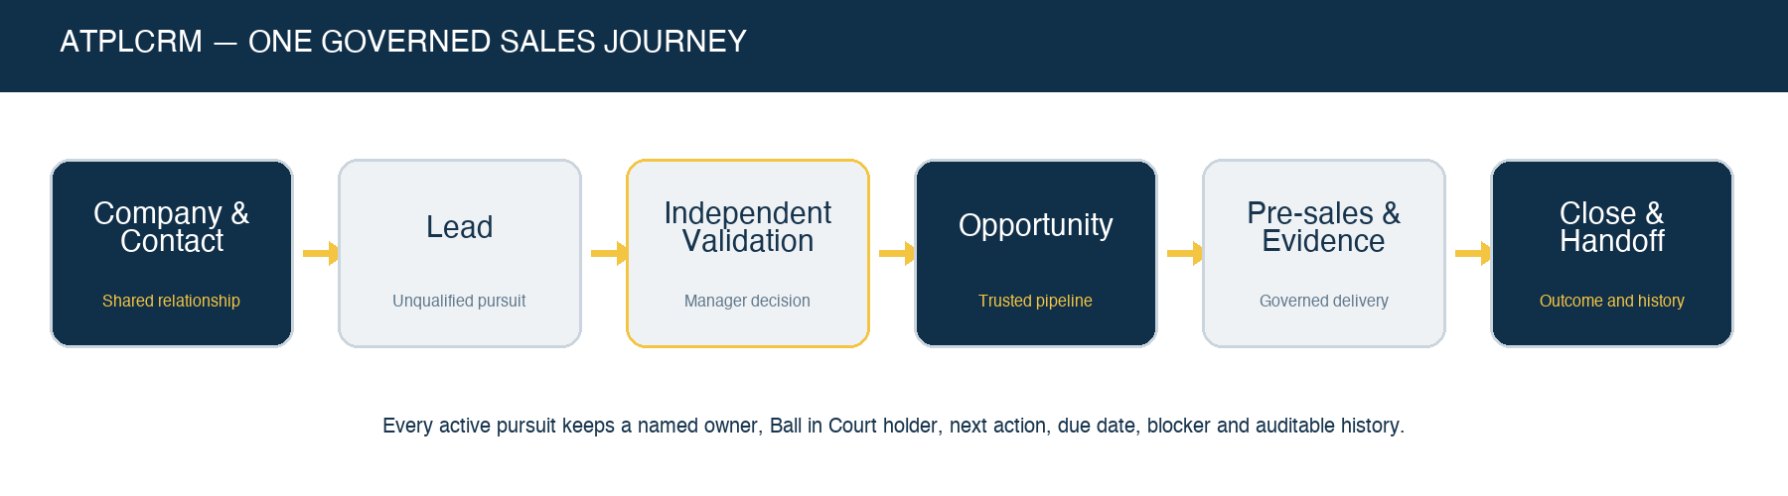
ATPLCRM sales journey
Both local editions are deployed:
Edition | URL | Environment file | Compose project | Currency behavior
International | http://localhost:8082 | .env | atplcrm-international | USD reporting with USD, AED, SAR, INR, BHD, EUR and GBP deal currencies
United States | http://localhost:8083 | .env.us | atplcrm-us | USD only

The current API version is 0.16.0. The Alembic head is 0013_demo_readiness. PostgreSQL, Redis, artifacts and queues persist in separate Docker volumes for each edition.

2. Current product state
The local implementation includes:
- Role-aware Overview, My Work and Needs Attention screens.
- Cmd/Ctrl+K global command search, direct record opening and complete-result handoff.
- Recently opened records, preserved list filters/page and clear detail return navigation.
- Companies, contacts, consent, engagement, do-not-contact and collision warnings.
- Activity logging with client/internal separation and paginated histories.
- Lead board/list, active-status drag-and-drop, independent validation, nurture, disqualification and idempotent conversion.
- Opportunity board/list, governed drag-and-drop, accessible selector, concurrency protection and seven milestones.
- Atomic action completion, Ball in Court handoffs, blockers, team and stakeholders.
- Fixed deal currencies/rates, value history, probability override, partner terms, net values and complete Won/Lost/Hold capture.
- Pre-sales assignment, acceptance, contributors, review, evidence, delivery, capacity and cost.
- Managed uploads, Microsoft-link metadata, selected-email registration, attachments, versions, approval and client-shared registers.
- CSV/Excel import, dry run, mapping, partial results, duplicate review/merge and data-quality dashboard.
- Server-calculated pipeline, forecast, funnel, bottleneck, blocker, outcome, erosion, movement, people, partner and pre-sales reports.
- Permission-safe drill-down and CSV/Excel exports with visible progress.
- Local user/reference/rate/calendar administration, notifications and scheduled automation.
- Responsive UI with independently scrollable navigation and keyboard-accessible alternatives.

3. Technology and architecture
Browser
-> unprivileged Nginx web container
-> React 19 + TypeScript + Vite static application
-> same-origin /api reverse proxy
-> FastAPI modular monolith
-> SQLAlchemy 2 + PostgreSQL 17 system of record
-> Redis 7 broker/state
-> Celery worker
-> Celery Beat scheduler

One-shot migrate container -> Alembic -> PostgreSQL
Private artifact volume -> FastAPI governed document routes
Layer | Implementation
Web | React 19, TypeScript, Vite, custom ATPLCRM CSS, Lucide icons
API | FastAPI, Pydantic, SQLAlchemy
Database | PostgreSQL 17 with Alembic migrations and Decimal financial values
Background work | Celery 5.6 and Redis 7
Local edge | Unprivileged Nginx serving the Vite build and proxying /api
Packaging | Docker Compose with db, redis, migrate, api, worker, scheduler, web
Tests | Pytest API workflows and Playwright browser acceptance
CI | .github/workflows/ci.yml

Kafka is intentionally absent. Introduce Azure Event Hubs/Kafka only if a real ordered, replayable cross-service stream becomes necessary.

4. Repository map
ATPLCRM/
├── apps/api/
│ ├── atplcrm/ FastAPI routes, models, services, security and tasks
│ ├── alembic/versions/ Database migrations through 0013_demo_readiness
│ └── tests/ API and authorization workflows
├── apps/web/
│ ├── src/ React application and components
│ └── tests/ Playwright browser flows
├── docs/ Status, plan, traceability, verification and handbooks
├── exports/ Shareable plan and Azure architecture diagrams
├── infra/ API/web Dockerfiles and Nginx configuration
├── scripts/ Bootstrap, demo operations, backup and benchmark tools
├── compose.yaml
├── Makefile
└── README.md
Important frontend files:
File | Responsibility
apps/web/src/App.tsx | Shell, dashboards, boards, detail workflows, administration and major forms
apps/web/src/GlobalSearch.tsx | Top-bar command search and keyboard shortcut
apps/web/src/RecordList.tsx | Server lists, filters, saved views, bulk assignment and export
apps/web/src/ReportsCenter.tsx | Management reports, drill-down and export
apps/web/src/DataTools.tsx | Search, import, duplicates and quality
apps/web/src/DocumentCenter.tsx | Artifacts, selected email, versions and sharing
apps/web/src/styles.css | Responsive ATPLCRM visual system

Important API modules include api.py, commercial.py, documents.py, notifications.py, presales.py, productivity.py, reporting.py, security.py, services.py, models.py and tasks.py.

5. Local credentials and secrets
Seeded accounts:
User | Email | Access level
System Administrator | admin@atplcrm.local | Administrator
Alex Morgan | alex@atplcrm.local | Manager / Head of Sales
Maya Patel | maya@atplcrm.local | Standard / Account Executive
James Chen | james@atplcrm.local | Manager / Head of Pre-Sales
Omar Hassan | omar@atplcrm.local | Standard / Technical Lead
Sarah Williams | sarah@atplcrm.local | Executive

All local users use DEMO_PASSWORD from the selected environment file. Do not put its value in source control, documentation, screenshots or defects.
- International password: .env
- US password: .env.us
- Disposable test password: .env.test
APP_SECRET, database password and demo password are generated by scripts/bootstrap.py and excluded from Git.

6. Start, stop and verify

International
cd /Users/n22/Desktop/ATPLCRM
python3 scripts/bootstrap.py # only when .env does not exist
docker compose --env-file .env up -d --build --wait
curl --fail http://localhost:8082/api/health/

United States
python3 scripts/bootstrap.py --instance US # only when .env.us does not exist
docker compose --env-file .env.us up -d --build --wait
curl --fail http://localhost:8083/api/health/

Status and logs
python3 scripts/demo.py status --instance INTERNATIONAL
python3 scripts/demo.py status --instance US
docker compose --env-file .env ps
docker compose --env-file .env logs --tail=100 api worker scheduler

Stop without deleting data
docker compose --env-file .env down
docker compose --env-file .env.us down
Never add -v unless deletion of the edition’s persistent database, queue and artifacts is explicitly intended.

7. Backup and reset
Create a backup:
python3 scripts/demo.py backup --instance INTERNATIONAL
python3 scripts/demo.py backup --instance US
Guarded reset, which backs up first:
python3 scripts/demo.py reset --instance INTERNATIONAL --confirm RESET-ATPLCRM
python3 scripts/demo.py reset --instance US --confirm RESET-ATPLCRM
Backups are stored under backups/ with restrictive permissions. Production backup retention and restore rehearsal remain future Azure operational work.

8. Development workflow

Frontend
cd apps/web
npm ci
npm run build
npm run test:e2e
The production build runs TypeScript checking before Vite bundling. Browser tests create and modify synthetic data, so use a disposable deployment for repeated full runs.

API
docker compose --env-file .env exec -T api pytest -q
docker compose --env-file .env exec -T api alembic current
For a focused test:
docker compose --env-file .env exec -T api \
pytest -q tests/test_reporting.py::test_complete_reporting_drilldowns_exports_and_role_scope

Release practice
- Check git status and keep generated secrets, local data and unrelated exports out of commits.
- Apply a migration before API startup when schema changes are introduced.
- Run tests proportionate to the change; always run the production web build for UI changes.
- Rebuild both Docker editions for shared-code changes.
- Verify /api/health/, API version and web availability on ports 8082 and 8083.
- Update status, verification, requirements, handoff and user/demo documents in the same release.
- Commit and push main only after the deployed result is reviewable.

9. Data and workflow rules that must be preserved
- Lead and Opportunity remain separate records linked through a persistent pursuit context.
- Lead conversion is independent, idempotent and preserves all history.
- Dragging a lead may change only active statuses; Closed requires Convert, Nurture or Disqualify.
- Opportunity stage movement uses evidence, role gates, row locks and optimistic versions.
- Every active pursuit requires an owner, Ball in Court holder, next action, type and due date.
- Completing an action atomically stores immutable history and creates the next action.
- Internal work must never update the last client-interaction date.
- Value and action history remain append-only.
- Each opportunity stores its currency and FX rate; reference-rate edits do not silently revalue existing deals.
- Management pipeline and forecast use net USD after partner deductions; Hold is excluded.
- Restricted records enforce field visibility on the server, including reports and exports.
- Client sharing requires appropriate approval, evidence and named recipients.
- All reads and writes remain tenant-scoped.

10. Current verification evidence
The full v0.15 data-bearing regression completed on 16 September 2026 and remains applicable to the v0.16 UI-focused release:
- 46 API regression tests passed.
- Four demo-readiness focus tests passed.
- Clean PostgreSQL install reached 0013_demo_readiness.
- Disposable scale profile covered 20,006 contacts, 5,000 leads and 5,000 opportunities.
- The v0.16 production web build passed with 1,585 transformed modules.
- The focused v0.16 reporting/export contract passed.
- International and US Docker deployments reported API 0.16.0 and healthy services.
- The lead drag-and-drop and side-navigation follow-up build passed and was deployed to both editions.
See docs/VERIFICATION.md and docs/PERFORMANCE_ACCEPTANCE.md for exact evidence and limitations.

11. Known boundaries and remaining roadmap
Area | Remaining work
Identity | Microsoft Entra OIDC, MFA/Conditional Access mapping and connected user lifecycle
Database security | Separate runtime/migration database roles and complete database-level tenant/role constraints
Microsoft services | Activate Graph, Outlook, SharePoint/OneDrive and Azure Blob adapters in an approved tenant
Azure platform | Bicep infrastructure, Front Door/WAF, Container Apps, PostgreSQL Flexible Server, managed Redis, Key Vault and Monitor
Production operations | Production backup/restore rehearsal, alerting, concurrency/load testing, DR and support procedures
Accessibility | Formal screen-reader and contrast certification
AI | Approved Azure OpenAI adapter, grounded summaries/extraction, user review controls and evaluations
Currency administration | UI for adding a new ISO currency; current UI edits the seven seeded International currencies
Connected acceptance | Real migrated data, regional configuration parity, production performance and financial reconciliation

The local release must continue to be described as client-demo-ready, not production-ready or fully PRD-complete.

12. Azure target
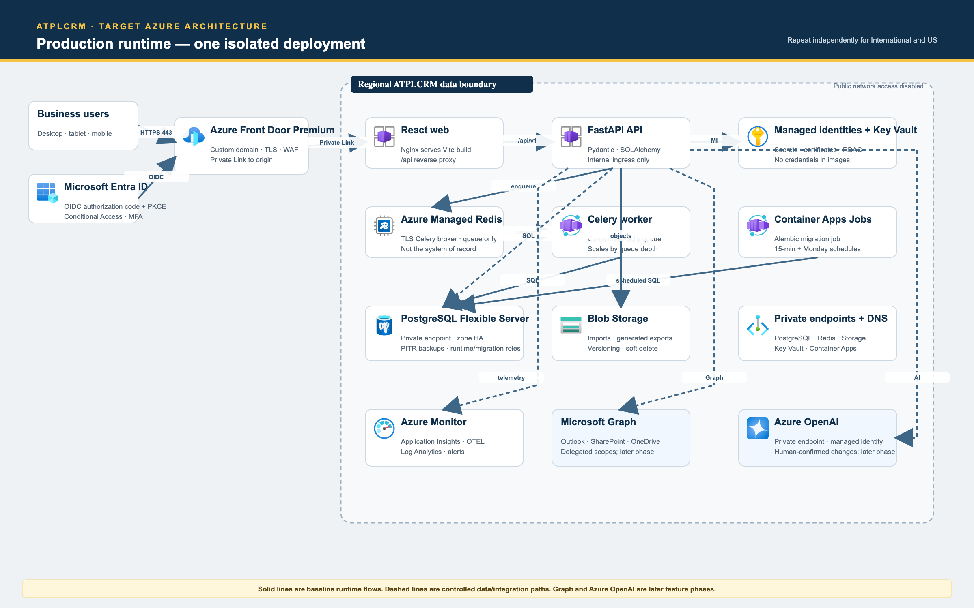
Azure production target
The approved target architecture uses separate International and US data planes with shared source and release controls:
- Azure Front Door Premium and WAF.
- Azure Container Apps for web/API/workers/scheduler.
- Separate Azure Database for PostgreSQL Flexible Server instances.
- Azure Managed Redis.
- Azure Blob Storage for governed artifacts.
- Microsoft Entra ID and Key Vault.
- Azure Monitor/Application Insights.
- Azure OpenAI only after identity, consent and evaluation controls are approved.
Architecture diagrams are under exports/architecture/. Azure deployment is intentionally deferred while the local demo is the active target.

13. Documentation index
Document | Purpose
README.md | Setup, feature summary and operator entry point
docs/PROJECT_HANDOFF.md | Engineering and operational transfer baseline
docs/ATPLCRM_v0.16_COMPLETE_DEMO_HANDBOOK.md | Complete presenter narrative and feature walkthrough
docs/ATPLCRM_v0.16_Complete_Client_Demo_Handbook.docx | Editable client-demo handbook
docs/CLIENT_DEMO_GUIDE.md | Condensed 30-minute route
docs/ATPLCRM_MANUAL_E2E_TESTING.md | Complete manual acceptance cases
docs/ATPLCRM_v0.16_Manual_E2E_Testing_Handbook.docx | Editable manual-test handbook
docs/IMPLEMENTATION_STATUS.md | Delivered scope and deliberate limits
docs/IMPLEMENTATION_PLAN.md | As-built architecture and Azure roadmap
exports/ATPLCRM_Implementation_Plan.docx | Shareable Word plan with architecture visuals
docs/REQUIREMENTS_MATRIX.md | PRD traceability
docs/VERIFICATION.md | Release verification evidence
docs/PERFORMANCE_ACCEPTANCE.md | Local scale benchmark and reproduction steps

14. Immediate next-owner checklist
- ☐ Clone/pull main and confirm no secrets are tracked.
- ☐ Read README, this handoff, implementation status and requirements matrix.
- ☐ Start both editions and confirm health/version.
- ☐ Sign in as Administrator, Manager and Standard personas.
- ☐ Walk the complete demo handbook once before a client meeting.
- ☐ Verify backup creation before changing demonstration data.
- ☐ Use the manual handbook for any release acceptance.
- ☐ Keep Azure/Entra/Graph/AI work behind explicit environment and security acceptance.
- ☐ Update all documentation and both Word editions with every future release.

15. Handoff acceptance
Item | Recipient sign-off
Repository and branch received | ______________________________
Local secrets transferred through an approved private channel | ______________________________
International deployment started and verified | ______________________________
US deployment started and verified | ______________________________
Admin/manager/standard workflows reviewed | ______________________________
Backup and guarded reset demonstrated | ______________________________
Known boundaries and Azure roadmap accepted | ______________________________
Open risks/issues recorded | ______________________________

