**AGILE METHODOLOGY**

**AND BANKING DOMAIN**

**ANNAPOORNA PAI**

APPRENTICE

TIETOEVRY

INTRODUCTION

The workshop focused on the application of Agile methodology in creating a comprehensive digitalization brochure for banks. This report outlines the detailed process, steps, and outcomes of this creative endeavor. Emphasizing the iterative and collaborative nature of Agile, showcasing how it allowed for flexibility and quick adaptation to changes in the project. Highlights key Agile steps like sprint planning, daily standups, and retrospectives.

Discusses how user stories were used to define features in the brochure, and how the continuous feedback loop in Agile ensured that the final product met the evolving needs of the project. Demonstrating how diverse skills contributed to a well-rounded product.

Includes visuals such as timelines or a project board to visually represent the Agile process. Concludes by summarizing the benefits of using Agile methodology for a creative project like this, emphasizing adaptability, collaboration, and customer satisfaction.

AGILE METHODOLOGY OVERVIEW

Agile, as a flexible and iterative project management approach, was employed to ensure adaptability and responsiveness throughout the brochure development. It involved breaking down the project into smaller, manageable tasks, emphasizing collaboration, and incorporating continuous feedback.

WORKSHOP STRUCTURE (PROCESS EXECUTION)

1. Sprint Planning

- Identifying key features and objectives (EPICS) for the brochure.

- Creating user stories to define functionalities.

- Prioritization of tasks based on MoSCoW Principle.

2. Daily Stand-ups

- Conduction of daily meetings to discuss progress, challenges, and next steps.

- Fostering a collaborative environment, ensuring everyone was aligned with project goals.

3. Sprint Review

- Working through multiple iterations to refine and enhance the brochure.

- Incorporating feedback from team members and stakeholders and also including customer feedback during each iteration.

4. Retrospectives

- Regular retrospectives to reflect on the process and identify areas for improvement.

- Adjusting strategies based on retrospective findings to optimize workflow.

RELEASE PLAN

An Agile release plan is a dynamic document crucial for project management in the Agile methodology. It serves as a roadmap for delivering increments of a product, providing a structured approach to software development. The plan is iterative, adapting as the project progresses and incorporating feedback from each sprint.

Initially, the team collaborates to define features and user stories, breaking down the project into manageable tasks. These tasks are then estimated for effort, helping to allocate resources effectively. Prioritization is key, with high-value features taking precedence.

The release plan typically spans multiple sprints, outlining the scope of each and detailing the features to be delivered. It provides stakeholders with a clear timeline and helps manage expectations. Regular reviews during sprint planning and retrospectives ensure that the plan remains aligned with project goals.

Additionally, the release plan highlights potential risks and dependencies, allowing the team to proactively address challenges. As an evolving document, the release plan fosters adaptability, a core tenet of Agile development, enabling teams to respond to changing requirements and deliver value incrementally throughout the project lifecycle.

OUTCOMES

The Agile methodology facilitated a dynamic and adaptive development process, resulting in a bank brochure that effectively showcased the digitalization of banks. The final product reflected the continuous refinement and improvement inherent in Agile practices.

Here are the depictions:

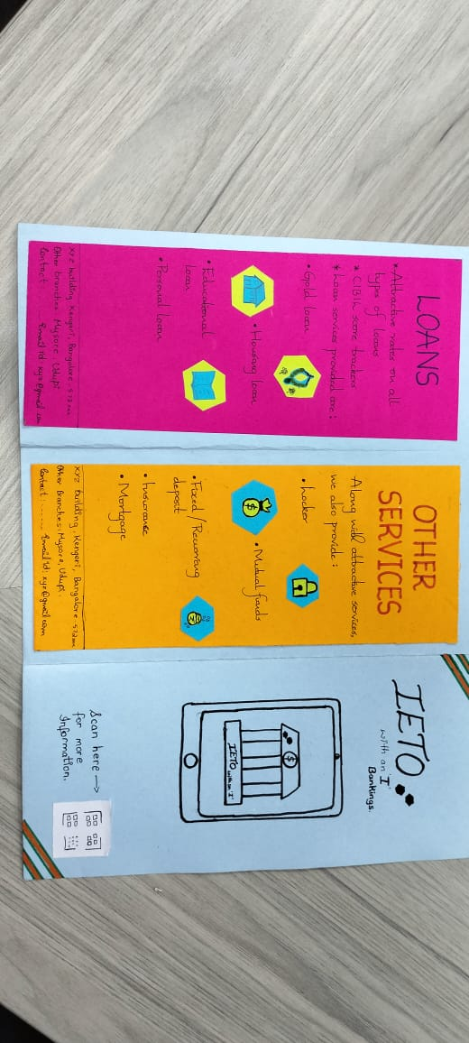

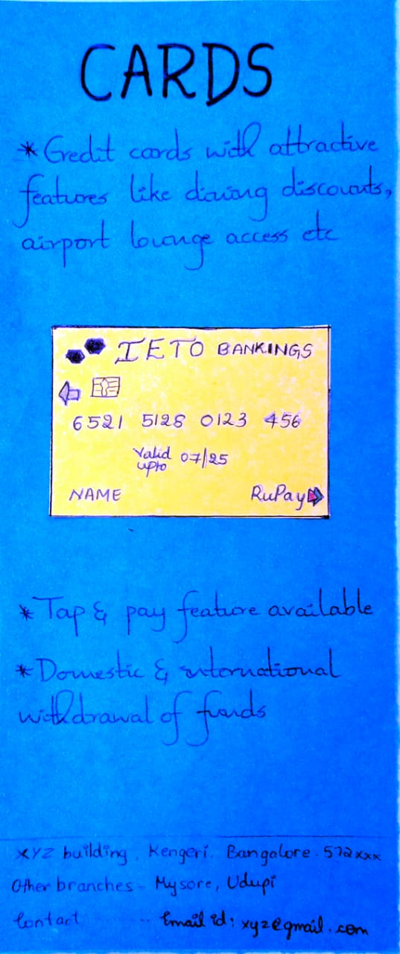

CONCLUSION

Knowledge gained:

* Teamwork.
* Roles and responsibility.
* Agile values and principles.
* Adapting to changes and developments.

In conclusion, the workshop's application of Agile methodology proved instrumental in the successful development of a creative and impactful digitalization brochure for banks. The iterative, collaborative, and customer-focused nature of Agile contributed to a well-rounded and responsive project development process. This experience underscores the value of Agile in creative endeavors, emphasizing adaptability and collaboration as key drivers of project success.