PET ADOPTION MANAGEMENT SYSTEM

1. PET API ENDPOINTS

1.1 Add a New Pet

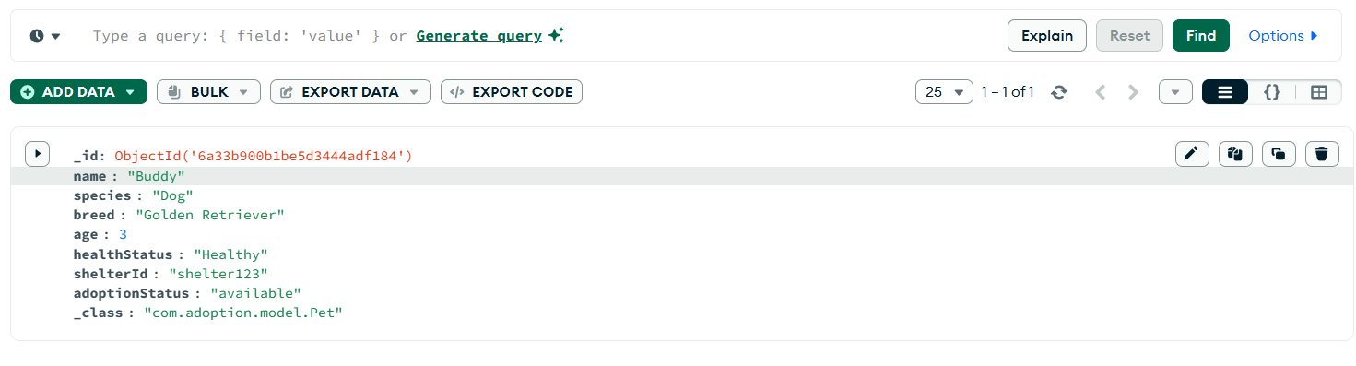

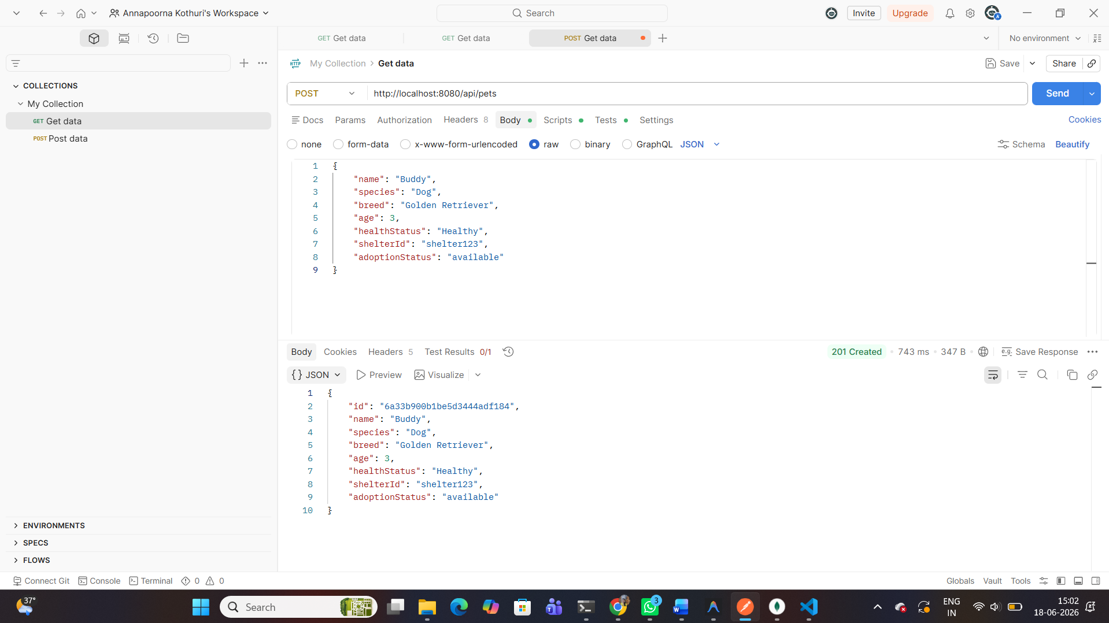

1.2 Get All Pets
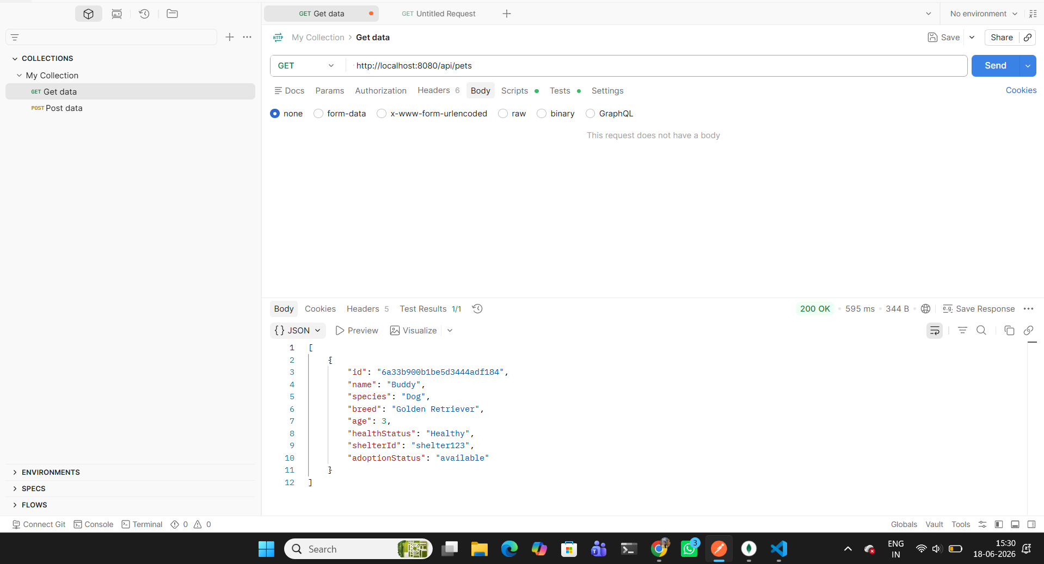

1.3 Get Pet by ID
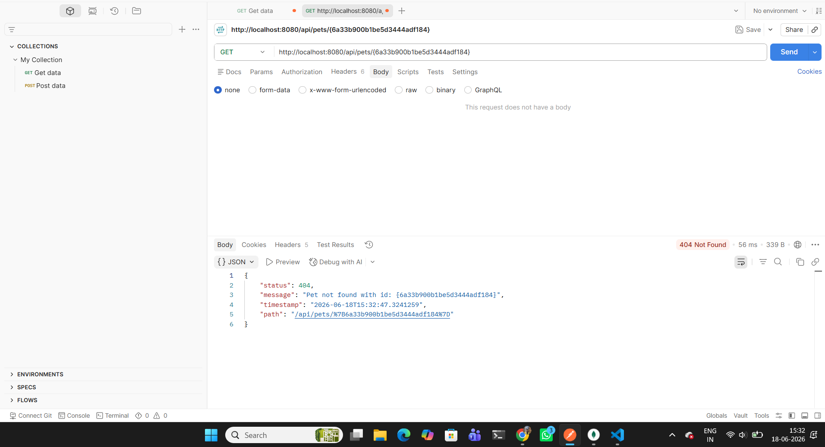

1.4 Get Pets by Species
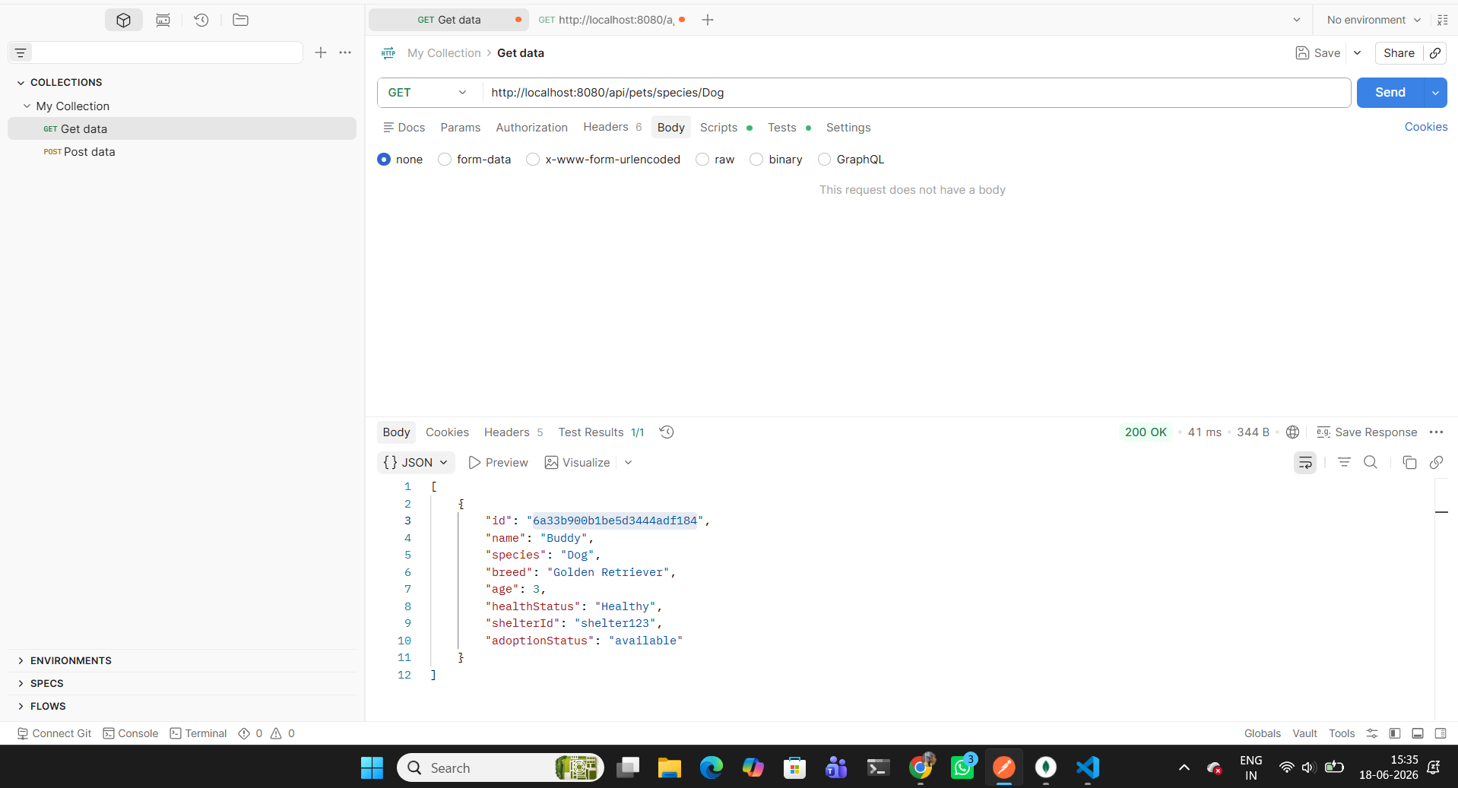

1.5 Get Pets by Adoption Status
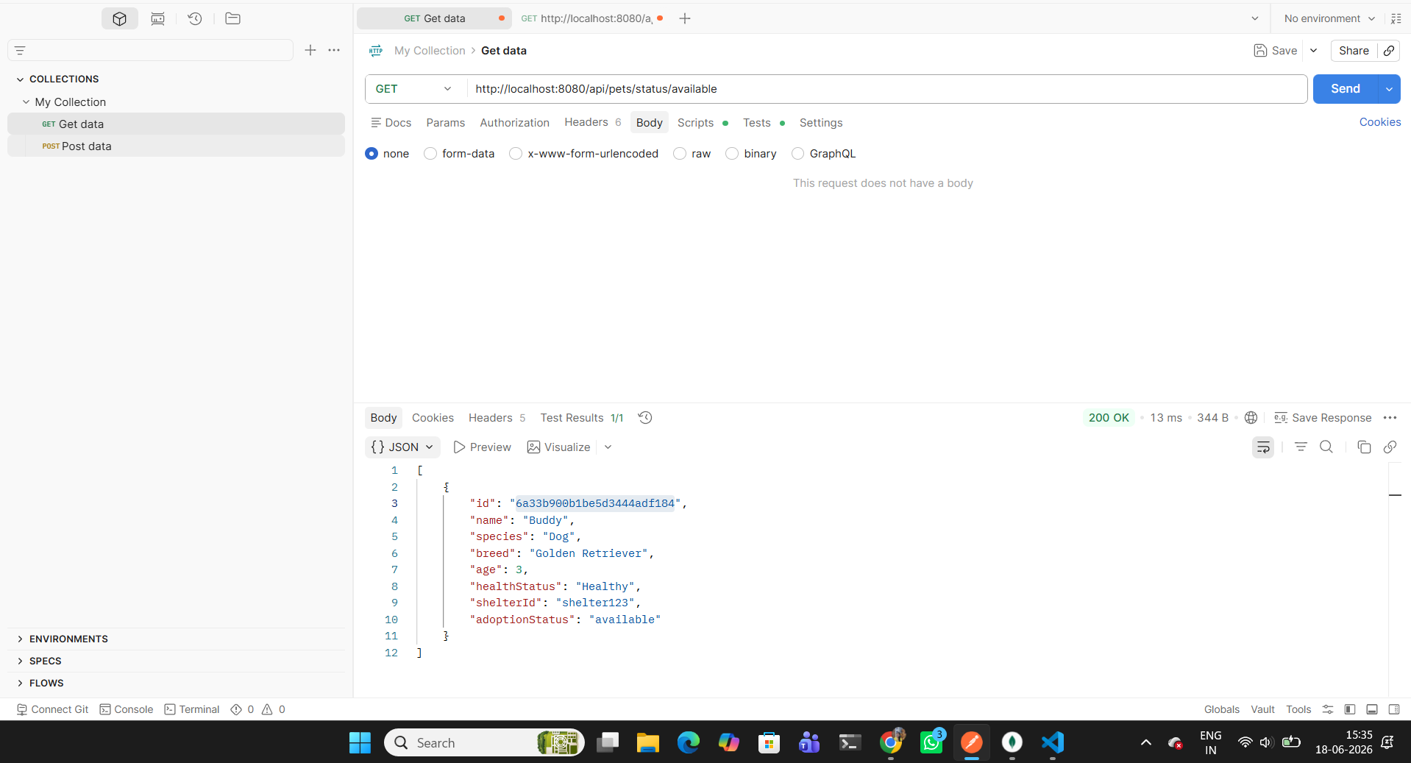

1.6 Update Pet
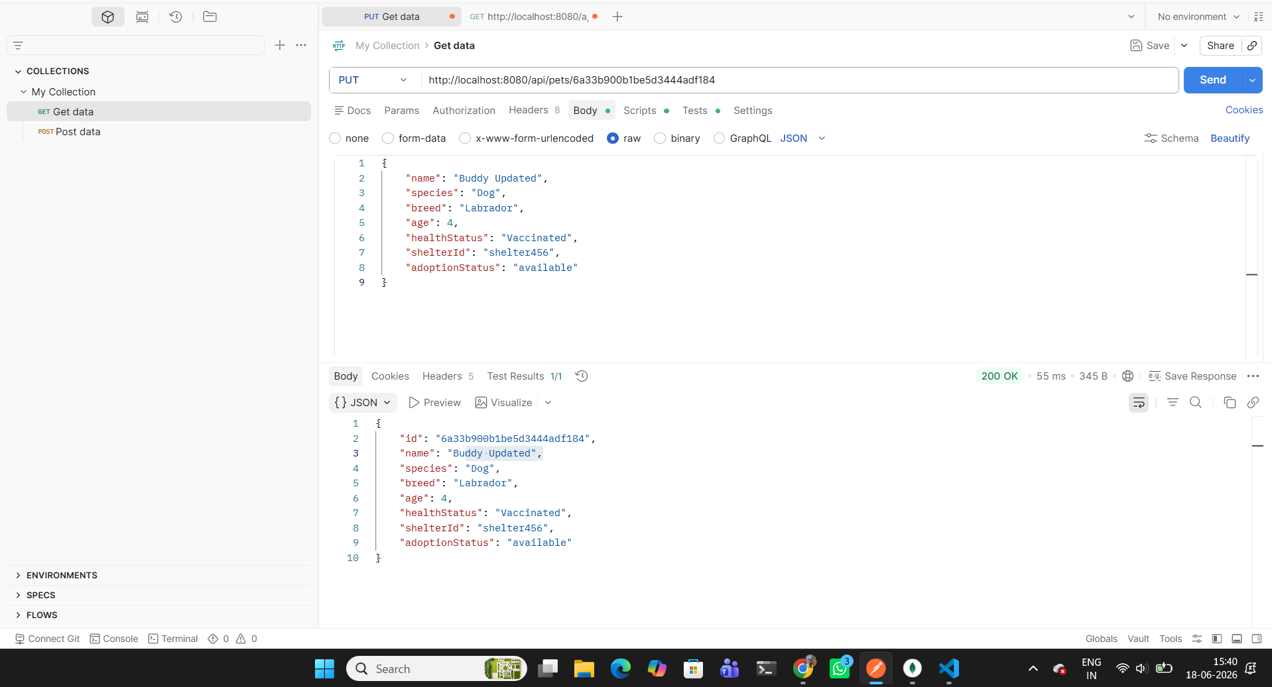

1.7 Delete Pet
