import com.mongodb.client.*;
import com.mongodb.client.model.Filters;
import com.mongodb.client.model.Updates;
import org.bson.Document;
public class crud_operations {
public static void main(String[] args) {

MongoClient mongoClient = MongoClients.create("mongodb://localhost:27017");

MongoDatabase database = mongoClient.getDatabase("CollegeDB");

MongoCollection<Document> collection =
database.getCollection("Students");

Document student = new Document("id", 101)
.append("name", "Anu")
.append("department", "CSE")
.append("cgpa", 8.2);
collection.insertOne(student);
System.out.println("Document Inserted Successfully");

System.out.println("\nStudent Records:");
FindIterable<Document> students = collection.find();
for (Document doc : students) {
System.out.println(doc.toJson());
}

collection.updateOne(
Filters.eq("id", 101),
Updates.set("cgpa", 9.1)
);
System.out.println("\nDocument Updated Successfully");

Document updatedStudent =
collection.find(Filters.eq("id", 101)).first();
System.out.println("\nUpdated Record:");
System.out.println(updatedStudent.toJson());

collection.deleteOne(Filters.eq("id", 101));
System.out.println("\nDocument Deleted Successfully");
// Close connection
mongoClient.close();
}
}

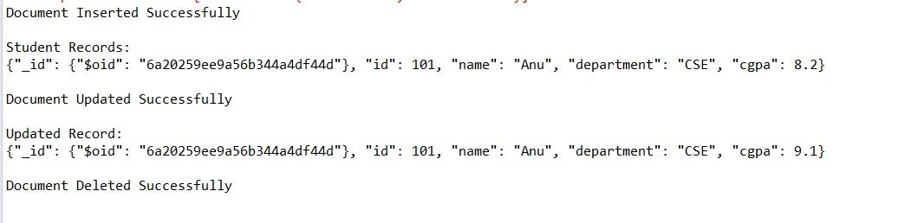

import com.mongodb.client.*;
import com.mongodb.client.model.Filters;
import com.mongodb.client.model.Updates;
import org.bson.Document;

public class crud_operations {

public static void main(String[] args) {

MongoClient mongoClient = MongoClients.create("mongodb://localhost:27017");

MongoDatabase database = mongoClient.getDatabase("CollegeDB");

MongoCollection<Document> collection =
database.getCollection("Students");

collection.deleteMany(new Document());

collection.insertMany(java.util.Arrays.asList(
new Document("id", 1).append("name", "Anu"),
new Document("id", 2).append("name", "Jeevan"),
new Document("id", 3).append("name", "Mani")
));

System.out.println("Documents Inserted Successfully");

System.out.println("\nStudent Records:");

FindIterable<Document> students = collection.find();

for (Document doc : students) {
System.out.println(doc.toJson());
}

Document student = collection.find(Filters.eq("id", 2)).first();

System.out.println("\nSpecific Document:");
System.out.println(student.toJson());

collection.updateOne(
Filters.eq("id", 2),
Updates.set("name", "Jeevan Kumar")
);

System.out.println("\nDocument Updated Successfully");

Document updatedStudent =
collection.find(Filters.eq("id", 2)).first();

System.out.println("\nUpdated Record:");
System.out.println(updatedStudent.toJson());

collection.deleteOne(Filters.eq("id", 2));

System.out.println("\nDocument Deleted Successfully");

System.out.println("\nRemaining Documents:");

FindIterable<Document> remainingStudents = collection.find();

for (Document doc : remainingStudents) {
System.out.println(doc.toJson());
}

mongoClient.close();
}
}

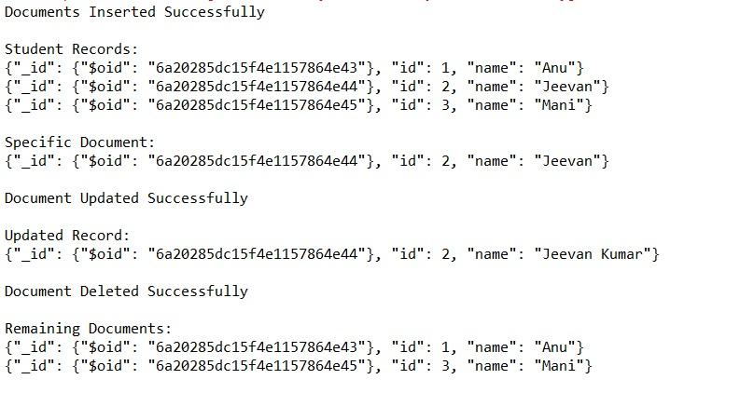

import com.mongodb.client.*;
import com.mongodb.client.model.Filters;
import com.mongodb.client.model.Updates;
import org.bson.Document;

import java.util.Arrays;

public class crud_operations {
public static void main(String[] args) {

MongoClient mongoClient = MongoClients.create("mongodb://localhost:27017");

MongoDatabase database = mongoClient.getDatabase("CollegeDB");

MongoCollection<Document> collection =
database.getCollection("Students");

Document student1 = new Document("id", 101)
.append("name", "Anu")
.append("department", "CSE")
.append("cgpa", 8.5);

Document student2 = new Document("id", 102)
.append("name", "Jeevan")
.append("department", "ECE")
.append("cgpa", 8.8);

Document student3 = new Document("id", 103)
.append("name", "Mani")
.append("department", "IT")
.append("cgpa", 8.2);

collection.insertMany(Arrays.asList(student1, student2, student3));

System.out.println("Documents Inserted Successfully");

System.out.println("\nStudent Records:");

FindIterable<Document> students = collection.find();

for (Document doc : students) {
System.out.println(doc.toJson());
}

collection.updateMany(
Filters.in("name", "Anu", "Jeevan", "Mani"),
Updates.inc("cgpa", 0.5)
);

System.out.println("\nDocuments Updated Successfully");

System.out.println("\nUpdated Records:");

FindIterable<Document> updatedStudents =
collection.find(Filters.in("name", "Anu", "Jeevan", "Mani"));

for (Document doc : updatedStudents) {
System.out.println(doc.toJson());
}

collection.deleteMany(
Filters.in("name", "Anu", "Jeevan", "Mani")
);

System.out.println("\nDocuments Deleted Successfully");

mongoClient.close();
}
}

