**Public consultation ‘drop-in’ event – 18th February 2017**

**Feedback summary report**

**Overview**:

The drop-in was intended as an information giving event, at the point following our pre-consultation with users, stakeholders and the district – but well before the beginning of the formal ‘community asset transfer’ process on 1st March.

The event was well publicised, with press releases over the previous month, and a social media campaign building up to local radio interviews on the day, added to leafleting of the market, local businesses, etc.

**Our goals were:**

* Clarify our reasons for reviewing, and all of the options that are open
* Make clear the process we will follow, in particular the timeline for Option 2 (asset transfer process)
* To share our pre-consultation surveys and research
* Give another opportunity for the public to question officers & give their views.

**Over 350 people attended the day**, between 9.30am and 2pm. A postcode analysis map of where they came from is in appendix A.

**106 written comments** were received on the day and are in appendix B. This group was significantly leaning towards keeping the venue public with it’s current mixed offer. Many believe firmly that the building belongs to the public and cannot ‘morally’ be sold. There was a great deal of interest and scrutiny of costs – with some calls for further clarity on running costs and better business management by SDC.

There was also a significant acceptance of financial pressures, however, and that as long as the venue remained open and offered accessible entertainment/community facilities, it was not important WHO ran it, but SDC should protect the leasehold to prevent future sale/loss from the community.

The public were generally very engaged, and seemed very receptive and inquisitive – significantly helped by the layout of the event, which had a relaxed atmosphere. Subrooms staff added a cafe woven between the stands of information, and decorated the room and ceiling hung with historical posters etc.

We were supported by the Stroud Town Council working group, who provided a volunteer to help register visitors, and had their own table to publicise their public meetings in support of finding solutions over coming weeks. This spirit of cooperation has been a strength of the whole process so far, and added to the day.

**Appendix A**

Number of visitors per postcode are represented by larger coded dots (close-up map of Stroud Town also available):

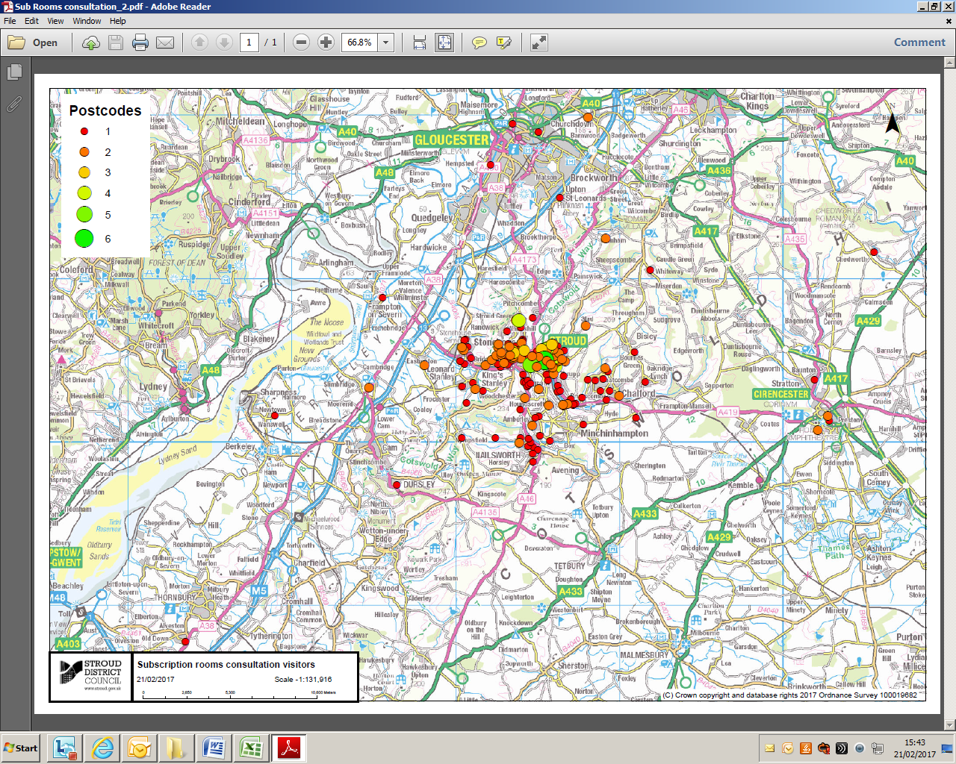

**Appendix B**

|  |
| --- |
| **Subscription Rooms - Comments from open day 18th Feb** |
| This building was built by public subscription for the people of stroud. It has served them well. Never sell. |
| Change the name. |
| Membership scheme with benefits; e.g. Discount. |
| Subscription Rooms - the clue's in the name! We've already paid for this, and it's a wonderful facility for all the people of Stroud. Retain it and make more use of it! |
| There's been enough privatisation of public 'services' - I'm not keen on this option. However, shouldn't all the arts/cultural venues be considered/put on the table and savings made elsewhere |
| Commercial sponsor with ad. Rights. |
| Comment on Option 2 and Option 3 either disposing of or leaseholding it surely are very different things? Pursue Option 1 (keep the Sub Rooms), but if Option 2 or 3 are discussed, keep it as a leasehold!! |
| Certainly keep this lovely building for shows but engage artists who have more popularity and you receive more income. |
| Big lottery funding? |
| What is the cost annually per household paying property tax? (To subsidise the running of the community asset?). |
| Cover forecourt as all weather cafe. |
| Do not part with this building. The public want it to remain in their hands. |
| Sub Rooms is a unique venue in Stroud. There is no other space large enough to put on large events. It is also the only large dance floor in the area. Only comparable is Cheltenham Town Hall. |
| The Subs and forecourt are central to Stroud's image nationally and also internationally. If a commercial user takes it on they will use the forecourt for parking! |
| The Subscription Rooms is also the central place for tourists to come. The TIC is in here. The heart of Stroud. |
| The Sub Rooms is a fantastic venue which has not been utilised - needs to stay within Council control but bring innovative management in. Have more plays, more dances, more use of discussion groups. What about craft fair/exhibition - could there be a really good restaurant. Information/tourist centre essential. |
| Part of the town. Old building. Got potential. Could be restored. Entertainment for town. DiY overhaul. |
| Please don't sell this lovely building. Keep it for the local people who love it. |
| Quite a lot of the budget is staff costs and running costs from the Council. These would continue largely unchanged if the Subscription Rooms is sold. Relatively small savings. Huge loss to our lives. |
| No way - must be allowed into private hands. |
| Get more interesting performers in, fewer cover bands. Don't sell your assets. And how many laws are you breaking to get to Cheltenham in 20 minutes? |
| Get a business manager - the income is there. Expenses too high; e.g. Rent out the cafe. Don't subsidise it. |
| The Subs has hugely improved since Mr Twitchetts opening hours increased. From being a rather dead quiet space, it now feels lively and welcoming. The importance of this should not be underestimated. |
| Why not crowd fund and ask local people to 'subscribe' again? Many would prefer to pay a small annual subscription to be a 'friend of the Subs' rather than see it sold or reduced. |
| This should be retained as a public asset - run by the Council. What next, Stratford Park? |
| Look at overheads more closely - running costs £207k! Let out George Room for private parties including children's - rental income. |
| Doesn't matter who owns it as long as it's public cultural venue. |
| Option 1 - Programmes too staid for Stroud. It's a typical local authority venue in a non-typical town. Rather boring in fact. Lacking in atmosphere - can't be changed with difficult management. |
| The Sub Rooms needs to stay as a publicly owned arts venue. It is invaluable. Its central location gives the town a vibrant feeling. Its diverse range of arts provision is so important to so many lives. Many people love attending dances/workshops/events. It is often the high spot of their week and is good for there physical and mental health. |
| Better marketing would help the Subscription Rooms make more money from ticket sales. |
| The Sub Rooms needs to stay as an arts venue. Increase greater links with schools and young people, youth projects? |
| Wedding venue. |
| If there is money for the canal, there is money for the Sub Rooms. Worth every penny. |
| The Subs is the heart of Stroud, the only large venue in a growing town and the main destination for tourists to the area. The TIC needs to be a bigger part of the discussion and funding needs to be found. |
| Get a social enterprise to open an up market 'Foodie' restaurant that can also hold live music. Good food will always draw people and especially visitors from out of town. Make the restaurant cook and provide food for poorest in our community - so still socially responsible. |
| Daytime/pm - modern dance, jazz, dance classes inc. For 60+ years. |
| Sorry, chairs too uncomfortable/unergonomic (esp. Front bar at bottom) so don't attend because of that - a shame, I know. |
| Option 2 - Somebody else please do it. Stop wasting money. |
| Don't sell of the family silver for shot term gains. Fight the government for proper taxation. |
| The Council wastes hundreds of thousands of pounds doing re-surfacing of roads/alterations etc. every year! Put that money into saving and running this facility. It makes sense. |
| Option 3 - No go. Why has SDC purchased The Ship at Brimscombe? |
| Option 1 - If costs to hire were lower, more events would happen i.e. Wedding venue, art/flower shows, charity bazaars? |
| Option 2 - Trust maybe? Not a commercial business as it will eventually lose it public interest. |
| Stop wasting money on audits, fact finding and spend on point of use venues. |
| Could the present-day Mr Twitchetts cafe (which I use regularly and like) be run as a private concern to generate income? |
| Reduce hire fees, advertise space for hire better, host mid-week/weekday classes and events e.g. Tea dances, yoga etc. Make it less complicated to hire the spaces to host own events. Weddings/receptions. |
| Where will canal users/visitors go if not the Sub Rooms? |
| I've lived in the area for 30 years. The Sub Rooms is the best is has ever been. Why are we having this conversation? |
| Increase the ticket prices (keep concessions). |
| Excellent building. Local people happy to use it at an affordable cost. |
| Hot desk/pop up office space - use ballroom. Host film events for an alternative to the cinema. Cater more to over 60's. Have reserved seating and charge more for better seats. |
| We live locally and use the Sub Rooms at lot. We think the best option is to run it on the same lines as the Leisure Centre which is now excellent. Thank you. |
| Love the Sub Rooms as it is, please don't change too much. |
| Would really like to see venue kept in public ownership. |
| Option 1 or Option 2. Not Option 3 (when it's gone, it's gone). Regain the asset run efficiency. |
| Fight the continual government cut-backs/erosion of community assets and values! |
| Don't privatise the Sub Rooms - demand more government funding. |
| Increase profitability of TIC. Host more events for tourists/provide a 'History of Stroud' exhibition. Use the balcony more - to eat and drink. Redevelop 'dressing rooms' space. |
| Resist the cuts rather than sell of the Sub Rooms. |
| Would it be possible to have more big name speakers e.g. Ian McEwan, George Monbiot, which both filled the ballroom. These must be money raisers. |
| More detailed accounts over longer period needed. |
| I heard a rumour that Twitchetts was closing. Aren't you already doing death by cuts? |
| If SDC are reviewing cost of this lovely building, why have they bought The Ship at Brimscombe? |
| Agree with other comments that diversification of use could be considered (like the example of use for wedding receptions) ahead of deciding to sell, which would be a tragedy. |
| Take into account the public/social use of space and keep this building publicly owned/managed. |
| Option 1 - please keep in Council ownership but farm out this management and running to a company who can generate and expand its use. Also, charge a bit more for events. They are probably under costed when comparing against the competition. |
| We must keep some public funded arts venue in our town. We cannot let everything go to private ownership and profit. |
| Option 1 - please keep in Council ownership - been supporting Sub Rooms for years and still would like to see bands and activities happening for locals! Charge more for this venue - all happy to pay! |
| A truly remarkable building - we need to keep it as it is. A local attraction for Stroud. |
| Stroud needs the Subscription Rooms. If it goes there will be a knock-on effect to Stroud. It has so much to offer that is not available elsewhere. Interested that staff cost high - how many people do you employ? I have not seen many but those you have are great. How about bringing in more plays - utilising the top room more. |
| Stroud will lose its identity if we don't make this place a community asset. Don't shut it down please! |
| Your data on users must make clear that non-paying users are not being counted. |
| Save money by doing away with other subsides, e.g. Bus travel. Keep this venue! Sack a few councillors and use their wages. |
| Option 1 is the only option but without cessation of services - that would kill it. Other aspects could be very helpful and bring much that is constructive for Stroud and Sub Rooms. |
| "Big yellow taxi". Cirencester would die for a venue like this. |
| Organise a 'Public Review' on how to get more out of government. |
| SDC should retain building as central asset and architectural identify for the town. Cost as is are very little in the grand order of things. The Sub Rooms have a central role in the cultural and arts provision in Stroud. SVA and other venues are very particular. The Sub Rooms are open and wider in appeal and potential. Don't lose an important asset, encourage it to flourish by giving it a secure and well supported future for this and other generations. Consider friends group/funding, charitable status (funding for educational aspects) , dedicated marketing/funding position. The right people can make a difference. |
| Options needs to allow lots of different activities, e.g. Dance/music/pop-up restaurant/art space etc. Not just one! |
| This is an excellent facility which must be kept to serve the community. |
| It must continue its great work in serving the community. |
| The information available today should have been available on line prior to the event to allow meaningful consultation - can still put on line now for people who could not come here. |
| The survey comparing people's view of funding for the Sub Rooms with bin collection is a total nonsense. It should have compared Sub Rooms with other forms of funding for entertainment, e.g. Pools etc. |
| Looks like the decision has already been made to put out to third party. |
| Would you be consulting on stopping collecting bins if fewer respondents 'valued' the service?! This is a false comparison (bin collection vs Sub Rooms). |
| Cut back on other vanity projects i.e. Brimscombe and invest in trying to make Sub rooms run commercially. SDC can't run a business. |
| It was built by subscriptions. It would be immoral to sell it. |
| Keep the Sub Rooms for the people of Stroud and mount a resistance to aggressive government cuts. |
| The Sub Rooms has been a fantastic venue for folk music, celidhs, morris events and wassails. Bring people from far and wide and keep it for Stroud. |
| Fantastic venue. Should be utilised more. Belongs to the people of Stroud! |
| Keep the Sub Rooms for Stroud. It's a vital part of our community. A fantastic family and cultural venue with an amazing history! |
| A valuable venue for myriad genres. Whatever the financial considerations, the town needs a flexible space of this size for performances. Alternative uses would rob the town and community of a very suitable asset. There are intangible benefits that don't appear on the spreadsheet in £s. |
| Option 1 - invest, good management team to bring the public in, use the rooms better, pay functions - in the right part of the building. |
| Don't lose our iconic venue! |
| Don't sell it - have more celidhs! |
| The people raised the funds for the Sub Rooms. We shouldn't have it taken away from us! |
| There is a lot of space which is not being utilised to its full capacity - i.e. The bar area next to the hall. Could this not be used for different groups? |
| Do you have a 'friends of' system where you can pay a bit each year? |
| Stroud's big feature is its strong cultural outreach habits. If this unique building can become a centre of excellence in providing events of all sorts for this I expect it will draw people from near and far for it. Subscribers! |
| Use different booking agents and promoters to find better range and quality of acts - not the same range. |
| Invest in the PA sound system - renting equipment is wasting money, and better acts will come if facilities are up to it |
| Focus of the venue needs to be something different to the usual, something special to raise attention outside Stroud and be a destination |
| New seating - seats unsupportive and not tiered - need tiered racks that pull out from one end of room. |
| Move TIC (or a sub office of it) to Platform Two of Stroud Station - empty room there would be ideal to direct people. |
| Needs much better marketing - invest in marketing and the bums on seats will follow |
| Other funding sources - no effort to locate new sources of funds accessible while still owned by SDC? |
| Friends of the Subs scheme, like the museum has - adds volunteer force and income from other funding sources? |