**Database Engineer Capstone Project**

**Content**

This document contains the solutions to the following exercises and tasks:

Exercise-1: Committing the project (Task-1,2,3)

Exercise-2: Create a virtual table to summarize data (Task-1,2,3)

**Overview**

Exercise Task Description Evidence

------------------ -------------------------------------------- -----------------------------------------------------

Exercise-1 Task-1 Create a normalized ER diagram LittleLemonDM.png

Exercise-1 Task-2 Implement the Little Lemon data model LittleLemonDB.sql

Exercise-1 Task-3 Write ‘show databases’ SQL code show_databases_result.png

Exercise-2 Task-1 Create a virtual table

Exercise-2 Task-2

Exercise-2 Task-3

**Exercise-1: Committing the project**

**Task-1 Create a normalized ER diagram**

First the conceptual model, then the logical model, finally the physical model was created.

The data type and length was considered for all columns. Primary and foreign keys were designed.

The normalization process steps were performed. The final version is in 3rd normal form.

**Evidence(s):**

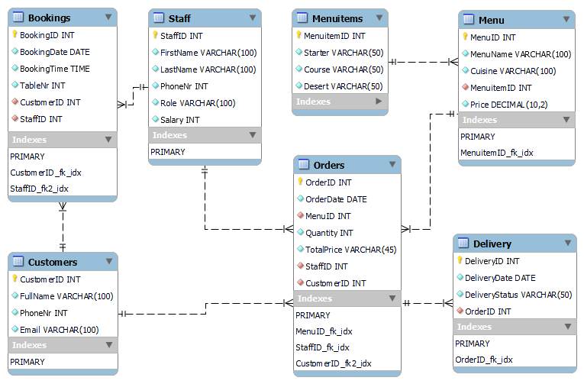

**Task-2 Implement the Little Lemon data model**

The data model was implemented using the forward engineer feature in MySQL Workbench.

**Evidence(s):**



**Task-3 Write the ‘show databases’ SQL code**

Create SQL statement to show the databases.

The SQL statement and the result was also captured.

The created database littlelemon is highlighted in the picture.

**Evidence(s):**

**Exercise-2: Create a virtual table to summarize data**

**Task-1 Create a virtual table**

First the conceptual model, then the logical model, finally the physical model was created.

The data type and length was considered for all columns. Primary and foreign keys were designed.

**Evidence(s):**

**insert data**

(run after the tables are created, and then run in case the tables are dropped)

--------------------------------------------------------------------

use littlelemon;

**insert into menuitems**

values

(0,'Pumpkin soup','Rucola salad','Fruit yogurt'),

(0,'Bacon and egg','Steak','Apple pie'),

(0,'Cucumber','Rice','Icecream')

(0,'Musaka','Feta cheese','Vanile pudding'),

(0,'Italian soup','Italian pizza','Italian Cake');

**verify the insert**

--------------------------------------------------------------------

select * from menuitems;

select * from menus;

select * from bookings;

select * from customers;

select * from staff;

select * from orders;

--------------------------------------------------------------------

--------------------------------------------------------------------

**drop tables**

(run in case the ER diagram or the database has to be re-created)

--------------------------------------------------------------------

use littlelemon;

drop table bookings;

drop table orders;

drop table menu;

drop table staff;

drop table customers;

--------------------------------------------------------------------