# <How to post json data using HttpClient in Win10 UWP apps>

## Introduction

This sample demonstrates how to post json data to web server using HttpClient in Win10 UWP apps.

This sample is upgraded from [How to use HTTPClient to post Json data to WebService in Windows Store apps](https://code.msdn.microsoft.com/How-to-use-HttpClient-to-b9289836).

## Sample prerequisites

To open and run this sample, ensure the following requisites have been reached:

* Microsoft Windows 10(10.0.14393) or above.
* Microsoft Visual Studio 2015 Update3 or later version(s).
* Microsoft Visual Studio has installed UWP developer component.
* Microsoft Visual Studio has installed Web developer component.

## Building the sample

* Open the sample solution “**CSPostJsonViaHttpClient.sln**” using Visual Studio.
* In Solution Explorer, right click project “**CSPostJsonViaHttpClient**” and select **Set as StartUp Project**.

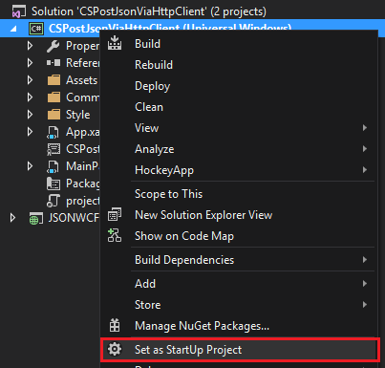

* Right click project “**JSONWCFService**” and choose **Rebuild**, to restore references.

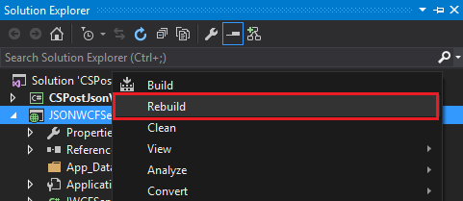

## Running the sample

* Use Visual studio to open the sample solution, then press **F5 Key** or select **Debug -> Start Debugging** from the menu.
* When the app is running, you can see WCF service running.

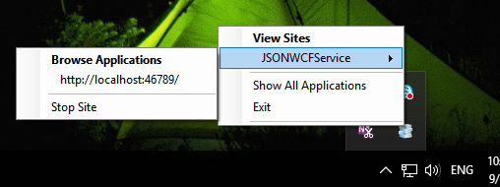

And the UWP sample app is running.

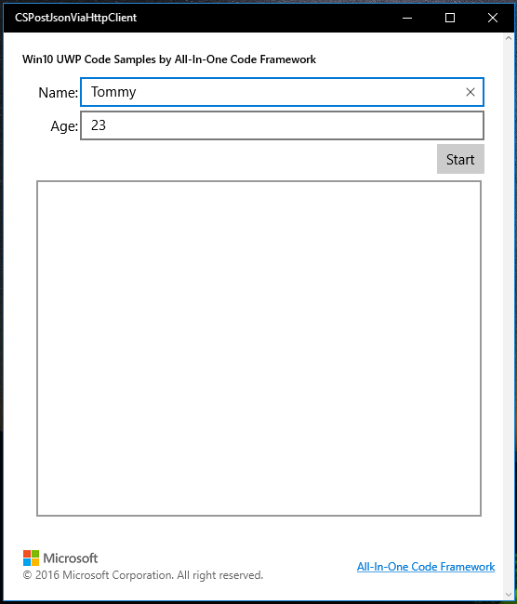

* Click the button “**Start**”.

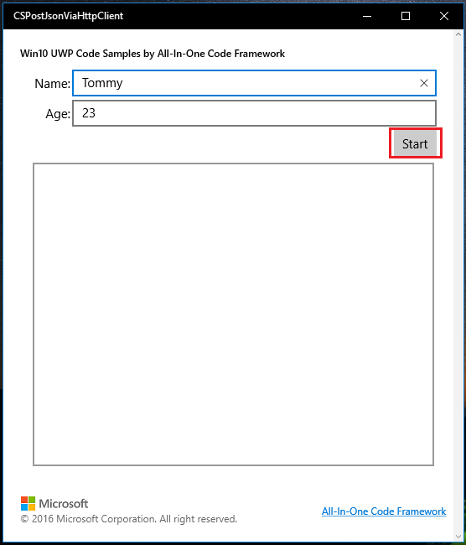

* The app will send a json data to WCF service, and set result of WCF service to UI.

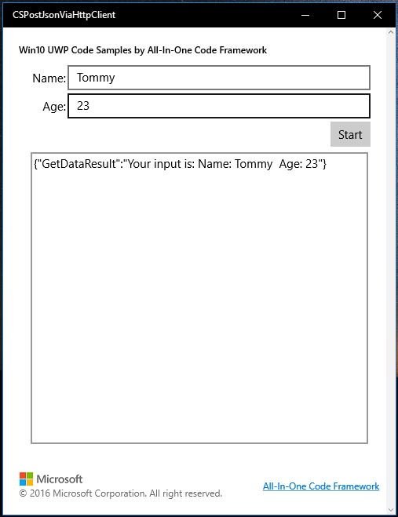

## Using the code

httpClient = new HttpClient();

string resourceAddress = "http://localhost:46789/WCFService.svc/GetData";

string jsonStr = JsonConvert.SerializeObject(new { Name = ViewModel.Name, Age = ViewModel.Age });

httpClient.DefaultRequestHeaders.Accept.Add(new System.Net.Http.Headers.MediaTypeWithQualityHeaderValue("application/json"));

HttpResponseMessage wcfResponse = await httpClient.PostAsync(resourceAddress, new StringContent(jsonStr, Encoding.UTF8, "application/json"));

string responseText = await wcfResponse.Content.ReadAsStringAsync();

ViewModel.ServerResult = responseText;

## More information

HttpClient Class

<http://msdn.microsoft.com/en-us/library/system.net.http.httpclient.aspx>

Json.NET

<http://www.newtonsoft.com/json>