Team Si: Benjamin Olson, Anna Waldron, Victor Shaw, Jorge Alvarez.

Kanban Board Submission

The Kanban Board provided a little bit of both in general and communication wise. We all met together either in person or in a voice call and worked on a google document. As we were mostly working together or could at least see who was working on what, there wasn’t too much need for the Kanban Board. It did help us a bit with scheduling, but the project was small enough that we weren’t reliant on the structure the board provided. It was also nice to see where we were at progress wise.

For G1-G3 we worked in a very similar manner as G4, we met in person or communicated in a voice call while we worked on tasks together. We used Google docs where we could all instantly see each other’s changes for all assignments. The difference was that we realized that the project would take a bit longer than previous ones, so we split it into two meetings.

We see the value of the Kanban Board, especially for larger projects with multiple components that rely on each other being complete. We most likely will not use the Kanban Board as it is more trouble than it is worth, though if there is a larger project and the value it brings outweighs the extra work it requires, we will use it. We also could see the value of using a Kanban board if we decided to work on this project separately, each completing our own components to combine at certain dates throughout the time we had to work on this project.

November 1st Screenshot:

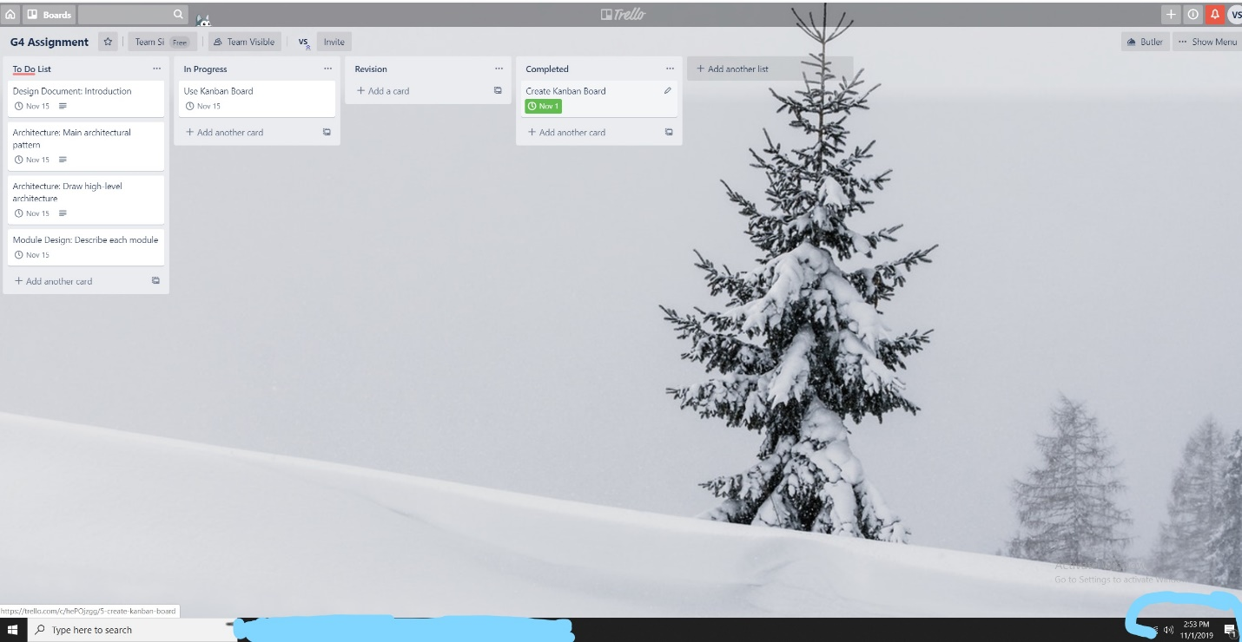

November 14th Screenshot:

