Test Plan – BMI Calculator
Program Name: BMI Calculator (Imperial Units)
Author: Anna Sarova
Objective: Verify correct BMI calculation, category determination, and input validation.
Testing Technology: pytest
Reason for Choice:
- Lightweight and Python-native
- Supports testing of exceptions and multiple scenarios
- Easy to integrate with IDE or command-line execution

1. Test Plan Scope
- Test the BMI calculation for various valid inputs
- Test category determination (Underweight, Normal, Overweight)
- Test input validation for negative weights or zero height
- Ensure program does not crash and raises proper errors on invalid input

2. Test Cases
Test Case | Description | Input | Expected Output | Notes
TC1 – Normal BMI | Valid input in normal range | Weight = 150 lbs, Height = 5’7” (67 in) | BMI ≈ 23.5,  Category = Normal weight | Standard valid input
TC2 – Underweight BMI | Valid input underweight | Weight = 100 lbs, Height = 5’7” (67 in) | BMI ≈ 15.7,  Category = Severely Underweight | Lower BMI boundary
TC3 – Overweight BMI | Valid input overweight | Weight = 200 lbs, Height = 5’7” (67 in) | BMI ≈ 31.3,  Category = Overweight | Upper BMI boundary
TC4 – Zero Height | Invalid input | Weight = 150 lbs, Height = 0 in | Should raise ZeroDivisionError | Test division by zero handling
TC5 –Passing String | Invalid input | Weight = 150 lbs, Height = sixty in | Should raise TypeError | Test input validation

TC1 – Normal BMI:
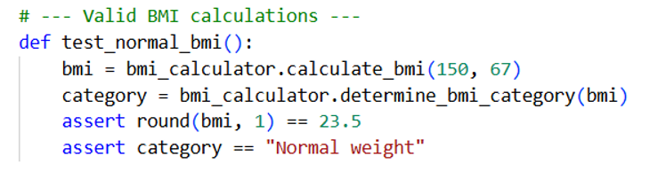
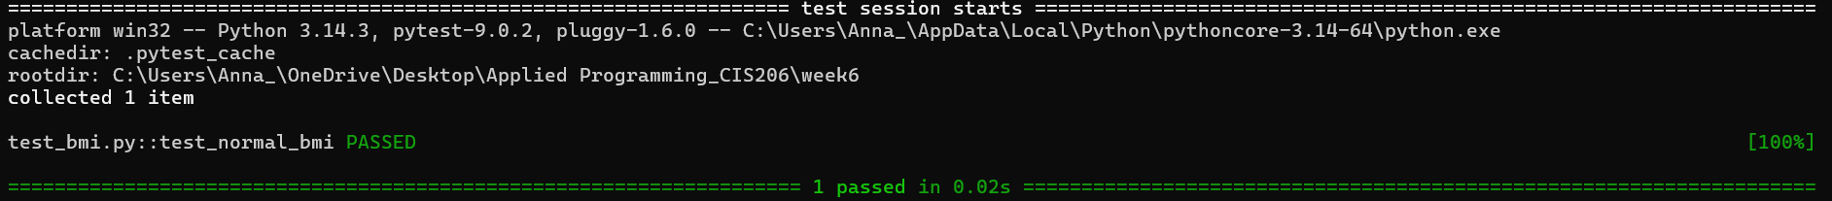

TC2 – Underweight BMI:
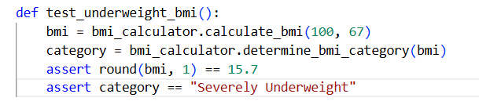
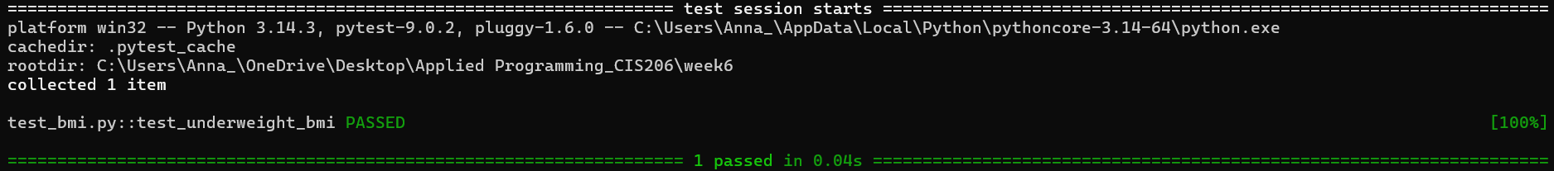

TC3 – Overweight BMI:
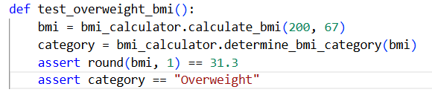
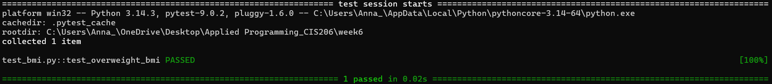
TC4 – Zero Height:
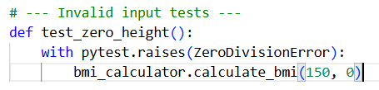
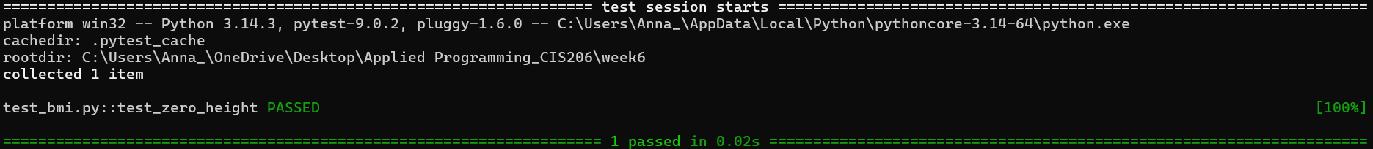
TC5 –Passing String:
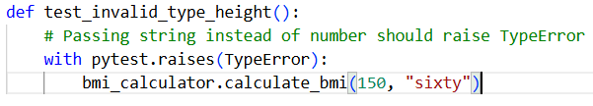
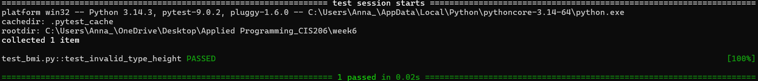

This is the screenshot of all tests run:
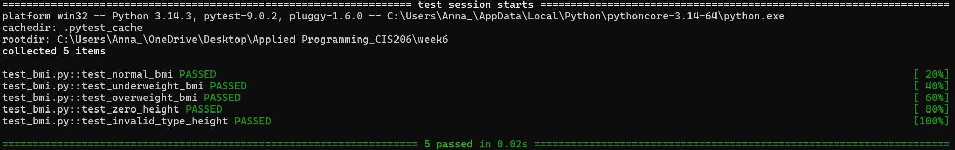

Screenshot of test_bmi.py file:
